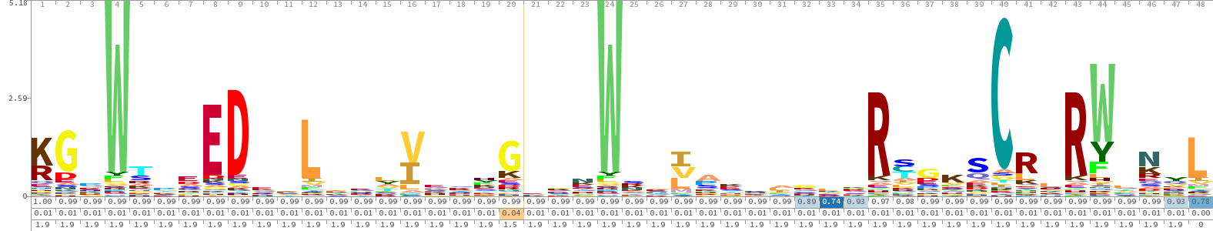
Figure S1 Special Hidden Markov Model (HMM) of CsMYB gene in cucumber. The special HMM of CsMYB gene in cucumber was built according to the MYB HMM (PF00249) from PFam with the parameter (E < = 1.2 × 10-8). Then the logo of special model was visualizated online by SKylign.
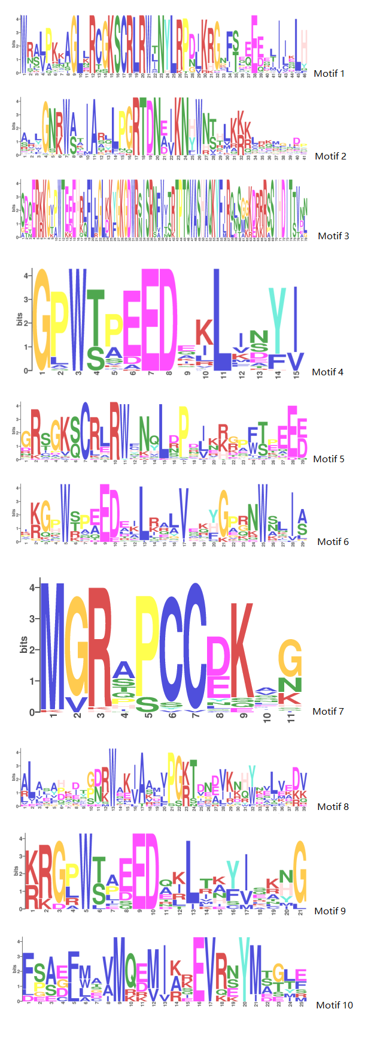
Figure S2 Sequence logo of conserved Motif 1 to Motif 10
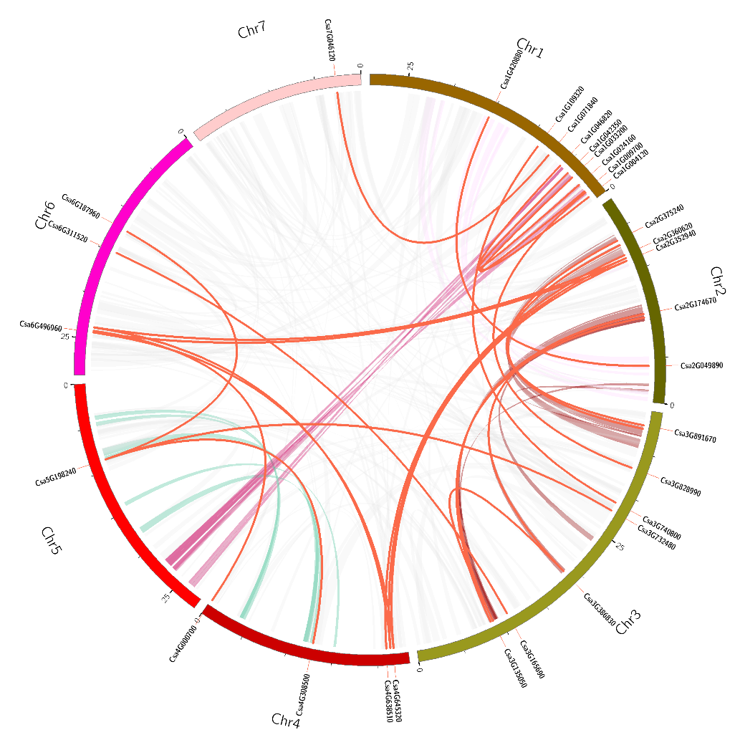
Figure S3 Circos diagram of CsMYB genes in cucumber. Twenty-five pairs of CsMYB genes showed collinearity and linkage relationships in cucumber

Figure S4 Exon length distribution analysis of the cucumber MYB genes. (A) Exon length values were analysed using Boxplot. Each box represents the exon size range in which 50% of the values for a particular exon are grouped. The mean value is shown as a dotted line and the median as a continuous line. The number of exons in CsMYB gene family members varied from 1 to 19. (B) First, second and third exon lengths distribution of CsMYB genes using 3D Scatter Plot.
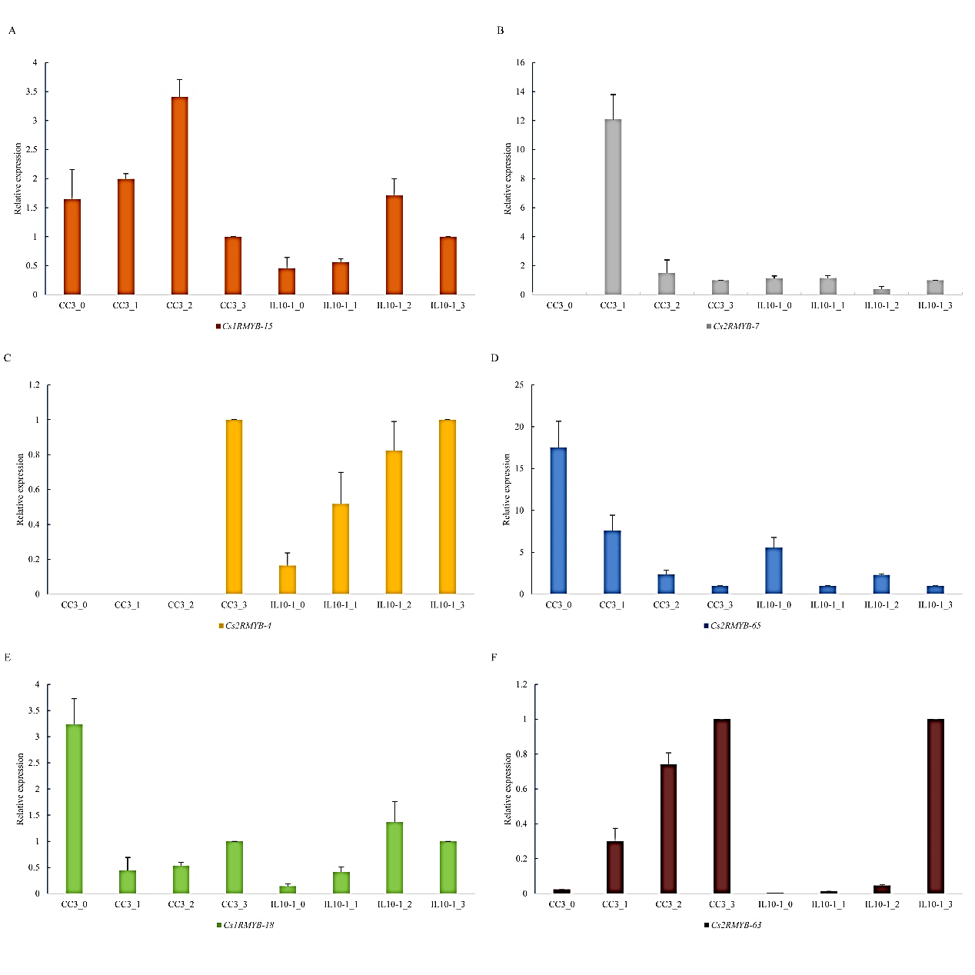Figure S5 Relative RT-qPCR assay of six CsMYB family genes randomly picked from RNA-seq data in CC3 and IL10-1 at 0, 1, 2, 3 days post inoculation with M. incognita. (A), (B), (C), (D), (E), and (F) represented Cs1RMYB-15, Cs2RMYB-7, Cs2RMYB-4, Cs2RMYB-65, Cs1RMYB-18, and Cs2RMYB-63, respectively. The default expression value for each gene was Actin gene. The default expression value for each gene was from 0 dpi plants. Error bars indicate the standard deviation from the mean (three replicates).

Table S1 The sequence and characterise of motif
Motif | sequence | width | sites | E-value
1 | W[RN][AS][LV]PK[KL]AGL[LK]RCGKSCRLRW[TLI]NYLRP[DN][IL] | 46 | 50 | 2.0e-1645
 | KRGNF[ST]E[EQ]E[ED]E[LIT]I[IL]XLH
2 | [AS]LLGN[RK]W[AS]TIAR[LQ]LPGRTDN[EAD][IV]KN[HY]WN | 41 | 50 | 3.0e-1094
 | [TS][HT]LK[KR][KR]L[RK][KQ]MGIDP
3 | S[DE][QH]ER[KR]KG[IVT][PA]WTE[ED]EH[RK][LQ]FL[LM]GL | 78 | 9 | 6.2e-438
 | [KD]K[YF]GKGDWR[SN]ISRNFV[IVT][TS]RTPTQVASHAQK
 | YF[IL]R[QL][LN]S[GM][GNK]K[DE][RK][RK]RSSIHDIT[TS]V[ND][LN]
4 | GPW[TS][PA]EEDE[KI]LI[NS]Y[IV] | 15 | 50 | 1.9e-419
5 | GRSGK[SQ]CRLRW[CF]N[QY]L[DNR]PD[ILV][KN][RKH][GR] | 29 | 40 | 7.2e-556
 | P[FW][TS][EP]EE[DE]
6 | I[KR]G[PH]W[STR]P[EA]EDE[IK]L[RK]A[LA]VE[KQ][YHF]GP | 29 | 34 | 6.2e-387
 | [RG]NW[SN]LI[AS]
7 | MGRAPCC[DE]KX[GN] | 11 | 44 | 1.7E-255
8 | AL[AI]XA[HDP]X[DI]T[GP][DN][RK]WAK[IV]AA[LM] | 39 | 17 | 2.3E-167
 | [VI]PG[KR]TDN[DEA][VI]K[NK][HQ][YW]X[EV]LVE[DK][VK]
9 | [KR]RG[PL]W[TS][AP]EED[AQ][KI]LT[AK][YF][IV]XK[HN]G | 21 | 12 | 9.2E-60
10 | F[SP][AS][EDG][FL][MLW]A[VA]MQ[ED][MV]I[AKR][KR]E | 25 | 8 | 1.3E-50
 | VR[NES]YM[AST][GT][LT][EF]

Table S2 Correspondence between the published MYB gene (R2R3-MYB_v1) in cucumber (Li et al., 2012) and identified genes (CsMYB_v2) in cucumber
R2R3-MYB_v1 | CsMYB_v2 | R2R3-MYB_v1 | CsMYB_v2
Csa012797 | Csa5G148680.1 | Csa010143 | Csa6G491690.1
Csa001869 | Csa7G413890.1 | Csa011496 | Csa2G355030.1
Csa002643 | Csa3G816030.1 | Csa012498 | Csa5G171690.1
Csa002717 | Csa3G824850.1 | Csa012824 | Csa5G152790.1
Csa003349 | Csa7G046120.1 | Csa015272 | Csa3G303630.1
Csa003581 | Csa2G360620.1 | Csa016676 | Csa4G022940.1
Csa003827 | Csa1G046820.1 | Csa017164 | Csa1G109320.1
Csa004708 | Csa3G740800.1 | Csa017450 | Csa3G826690.1
Csa005181 | Csa1G008430.1 | Csa017539 | Csa5G160120.1
Csa005219 | Csa1G004120.1 | Csa017970 | Csa4G305350.1
Csa007739 | Csa6G121970.1 | Csa019830 | Csa3G076520.1
Csa008131 | Csa5G425400.1 | Csa022057 | Csa3G168940.1
Csa008771 | Csa3G199590.1 | Csa013585 | Csa7G045590.1
Csa009345 | Csa4G645320.1 | Csa008474 | Csa6G105150.1
Csa009412 | Csa4G638510.1 | Csa018305 | Csa5G209490.1
Csa009484 | Csa4G641690.1 | Csa000784 | Csa6G538700.1
Csa009573 | Csa5G651640.1 | Csa019344 | Csa7G375780.1
Csa009688 | Csa5G637660.1

Table S3 Primers Sequencs of the three random picked genes
Primer Name | Primer Sequence (5’-3’)
ACTIN-F | ATTGTTCTCAGTGGTGGTTCTAC
ACTIN-R | CCTTTGAGATCCACATCTGCT
Cs1RMYB-15-F | ATACTTCGACTGGGATTTCG
Cs1RMYB-15-R | GTTCGGAACATTCAAGTCAC
Cs1RMYB-18-F | GACTGCTGAAGAAGACAGAC
Cs1RMYB-18-R | TCTTTTGCCTTTTTCTGTTGC
Cs2RMYB-4-F | TCGATAAGTTTGGGAAAGGG
Cs2RMYB-4-R | CCACCGCCATTATTAACTGA
Cs2RMYB-7-F | CAGGTTGAGATGGCTTAACT
Cs2RMYB-7-R | TCTGGATGTGGTTATTTGGG
Cs2RMYB-63-F | AATCATTGACGTTCACCGTA
Cs2RMYB-63-R | TCAAGACCCTGAGCAATAAG
Cs2RMYB-65-F | TAATGCCAGGAAGAACAGAC
Cs2RMYB-65-R | TTGACCTCTCAATTTCCCTG

