Supplementary Material

Figure S1 – FTIR-ATR Spectra untreated and treated films with EtOH.
Figure S2 - FTIR-ATR Spectra untreated and treated films with MeOH.

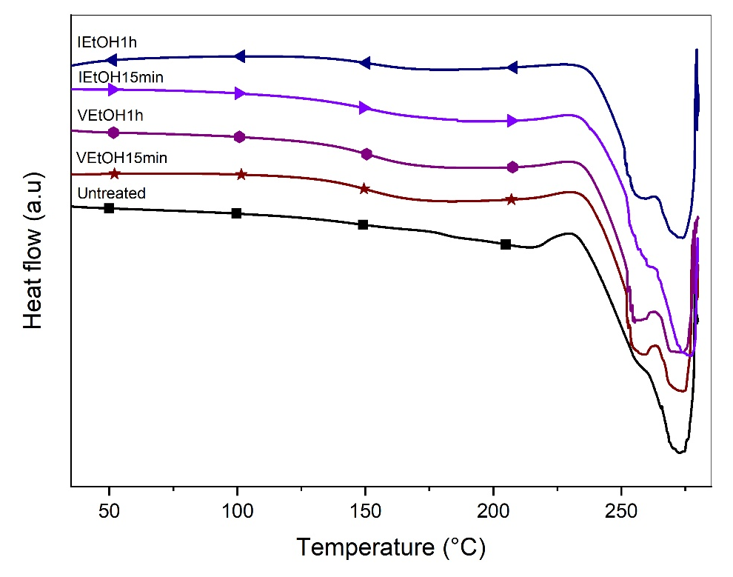
Figure S3 - DSC Curves untreated and treated films with EtOH.
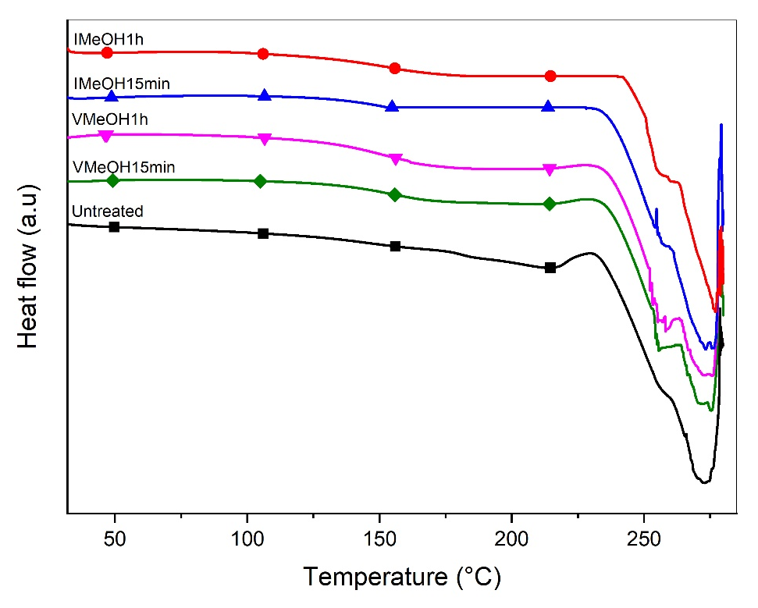
Figure S4 - DSC Curves untreated and treated films with MeOH.

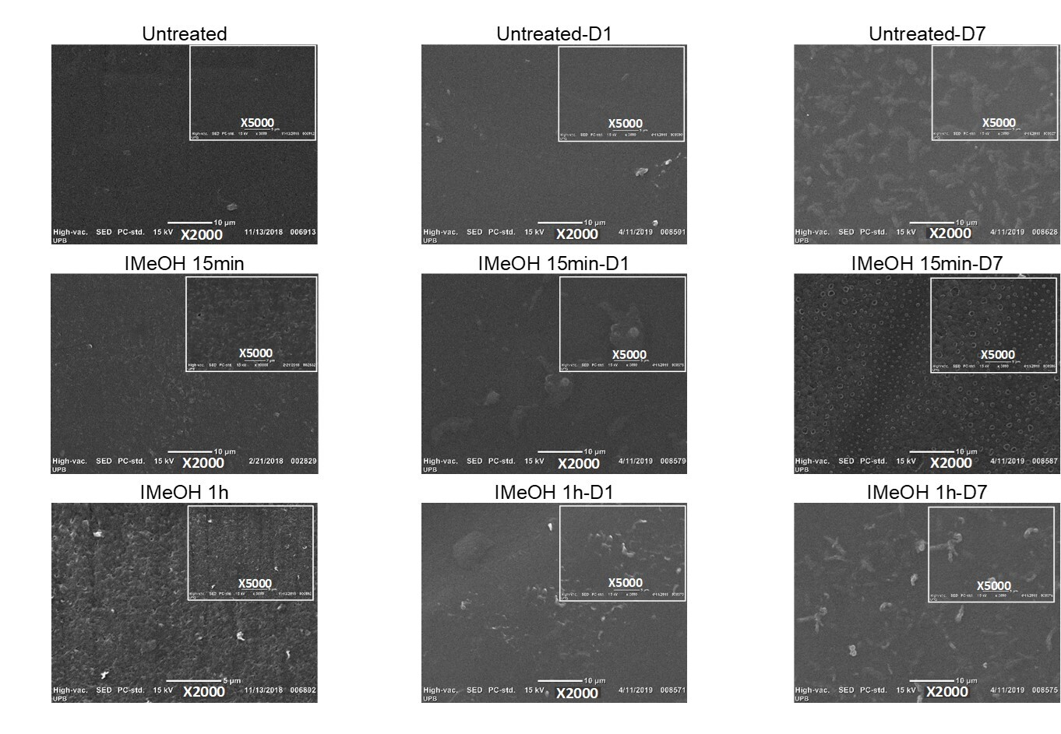
Figure S5 – SEM untreated, treated films IMeOH, before and after the degradation.

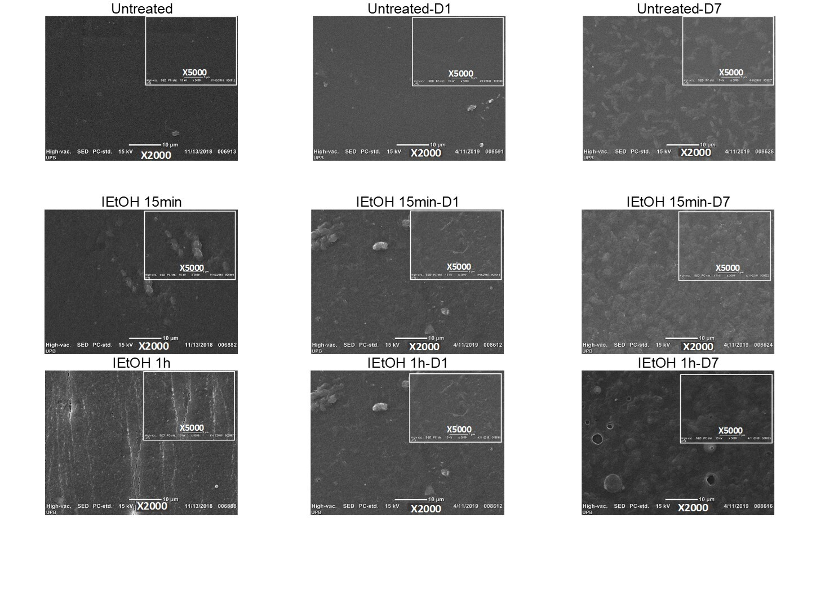
Figure S6 – SEM untreated, treated films IEtOH, before and after the degradation.

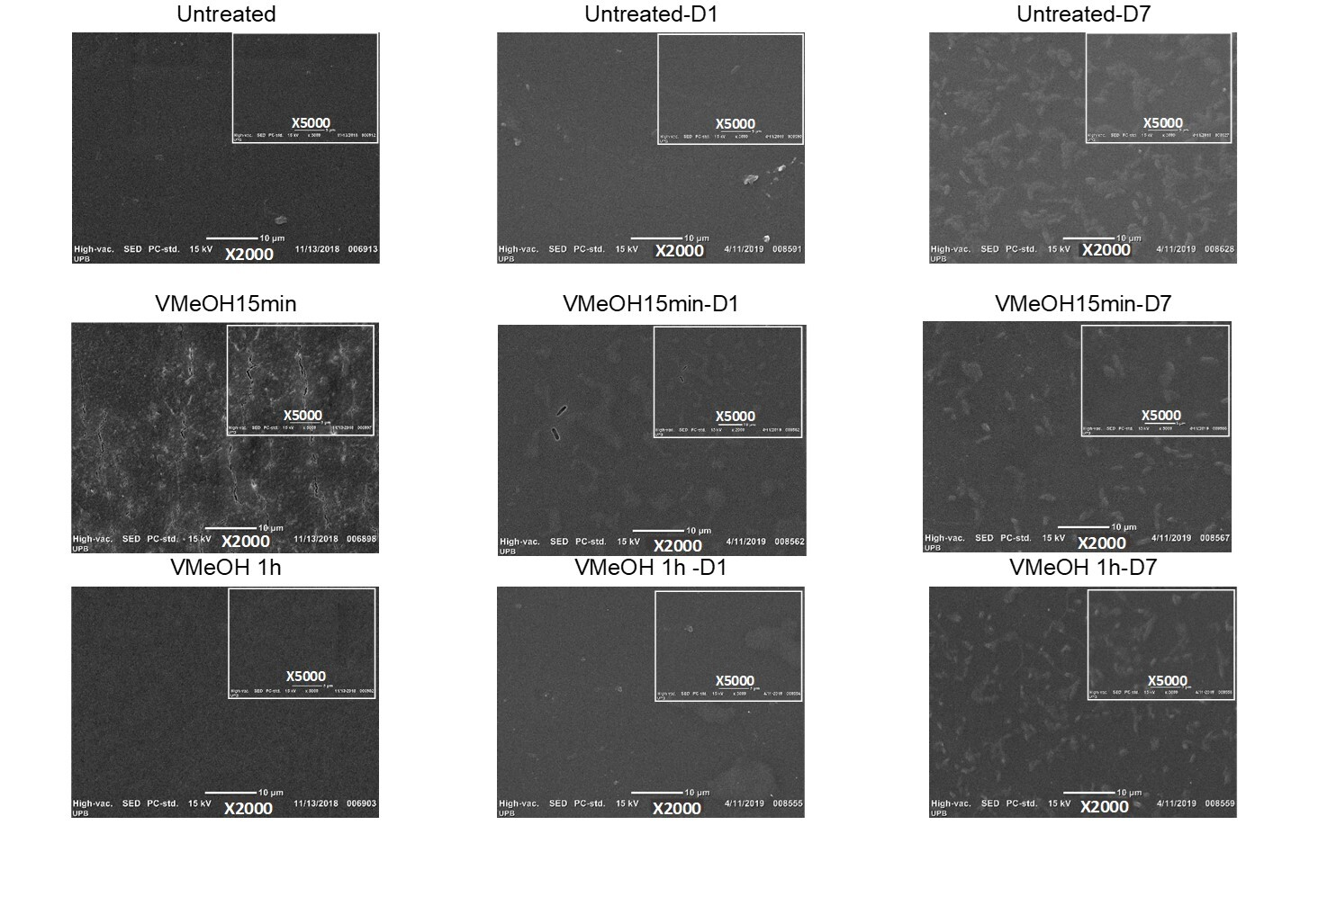
Figure S7 – SEM untreated, treated films VMeOH, before and after the degradation.

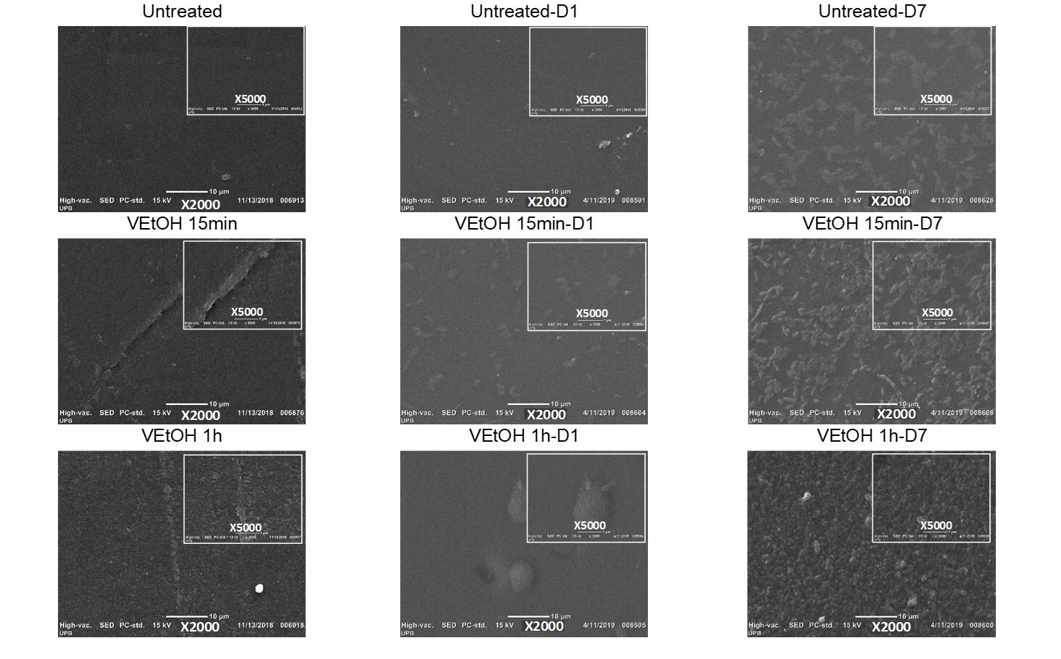
Figure S8 – SEM untreated, treated films VEtOH, before and after the degradation.
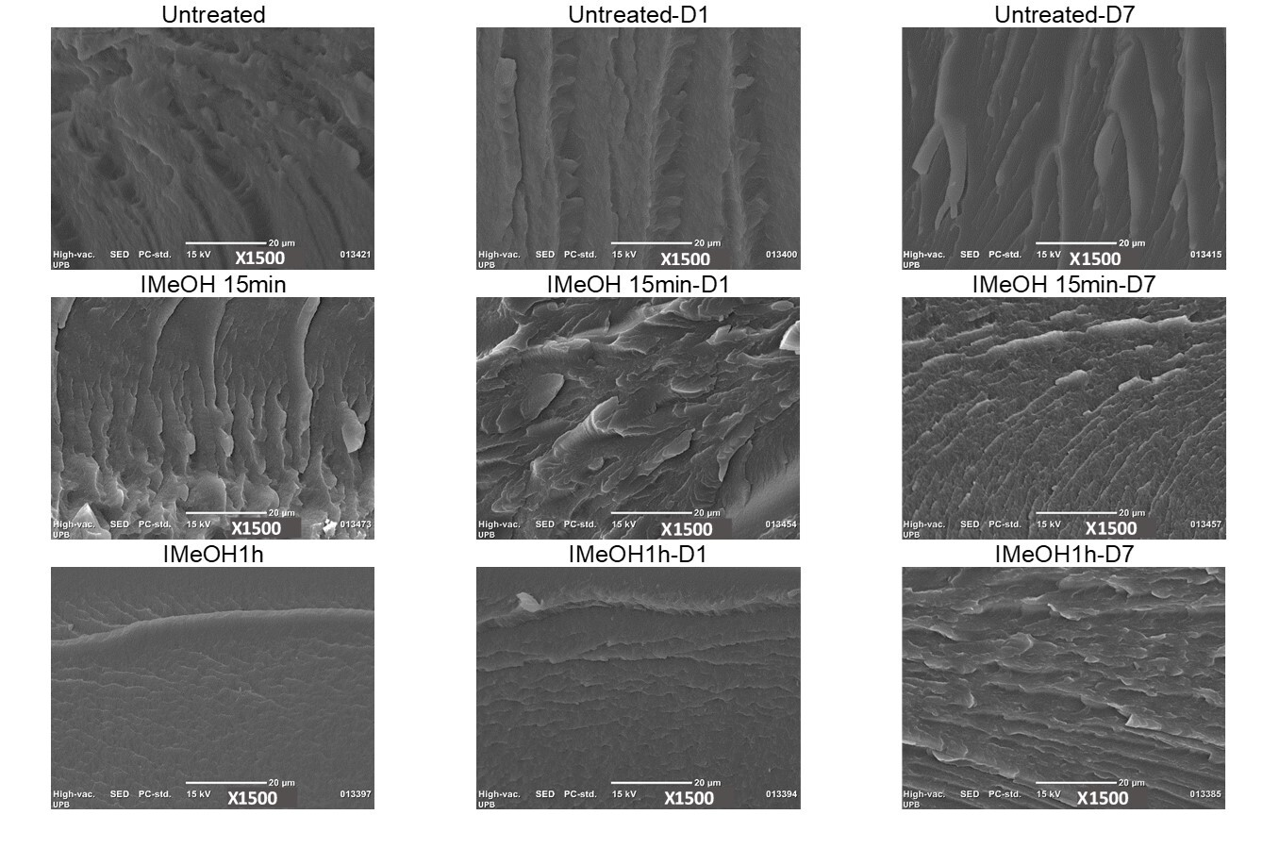
Figure S9 – SEM cross-section untreated, treated films IMeOH, before and after the degradation.

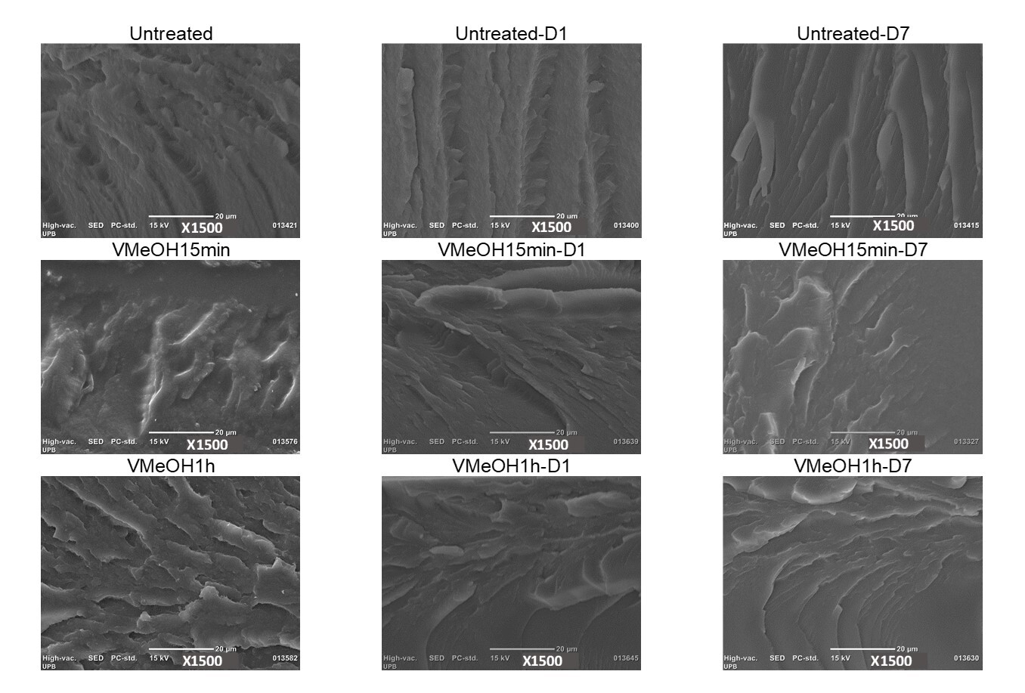
Figure S10 – SEM cross-section untreated, treated films VMeOH, before and after the degradation.

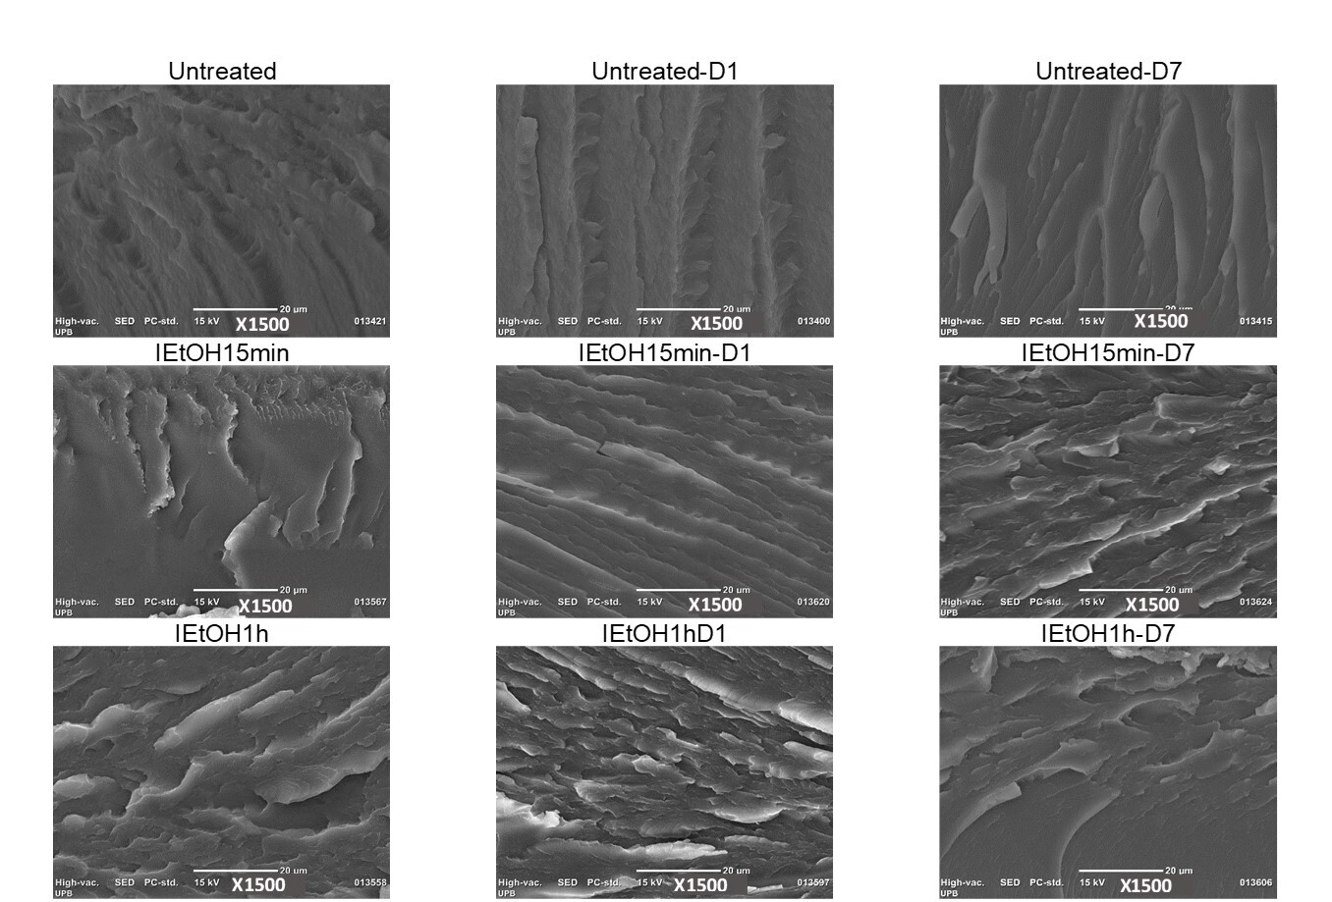
Figure S11 – SEM cross-section untreated, treated films IEtOH, before and after the degradation.

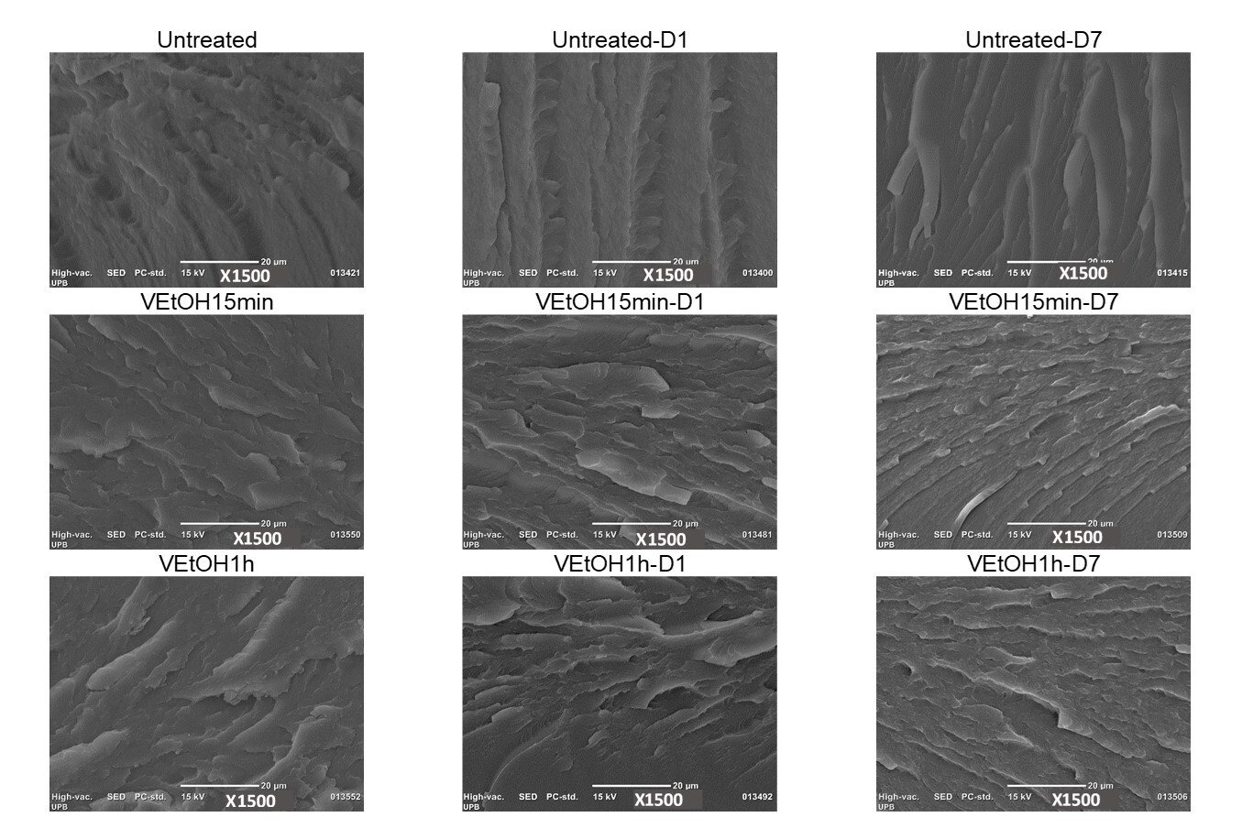
Figure S12 – SEM cross-section untreated, treated films VEtOH, before and after the degradation.

