Supplementary Material
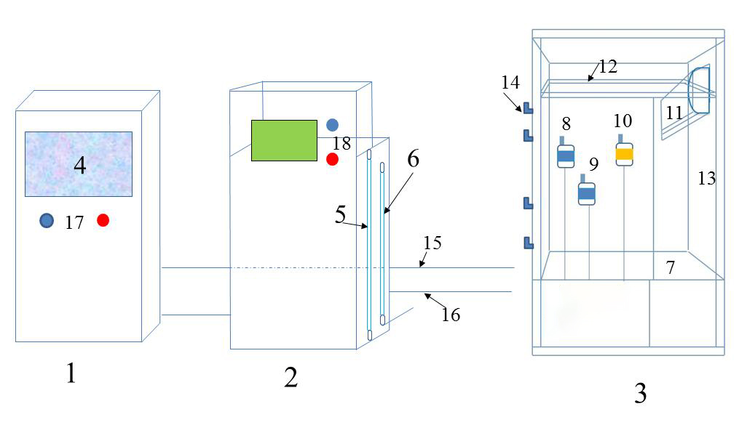

Fig. S1 | The automatically controlled-environment facility consists of the CO₂ control system equipment (1), the CO₂ generator (2) and nine chambers (3). 4, the liquid crystal display (LCD) screen; 5, Na₂CO₃ feeding inlet; 6, H₂SO₄ feeding inlet; 7, polyvinyl chloride (PVC) for the floor; 8, the outside temperatures and humidity sensors; 9, the inside temperatures and humidity sensors; 10, the inside CO₂, sensors; 11, the temperature control system; 12, CO₂ pipes; 13, toughened glass (10mm, Transmittance: 99%); 14, doorknob of the chamber; 15, signal lines connected the sensors to the control system equipment; 16, CO₂ pipes connected the chambers to the CO₂ generator. 17, power switch for the CO₂ control system equipment; 18, power switch for the CO₂ generator.

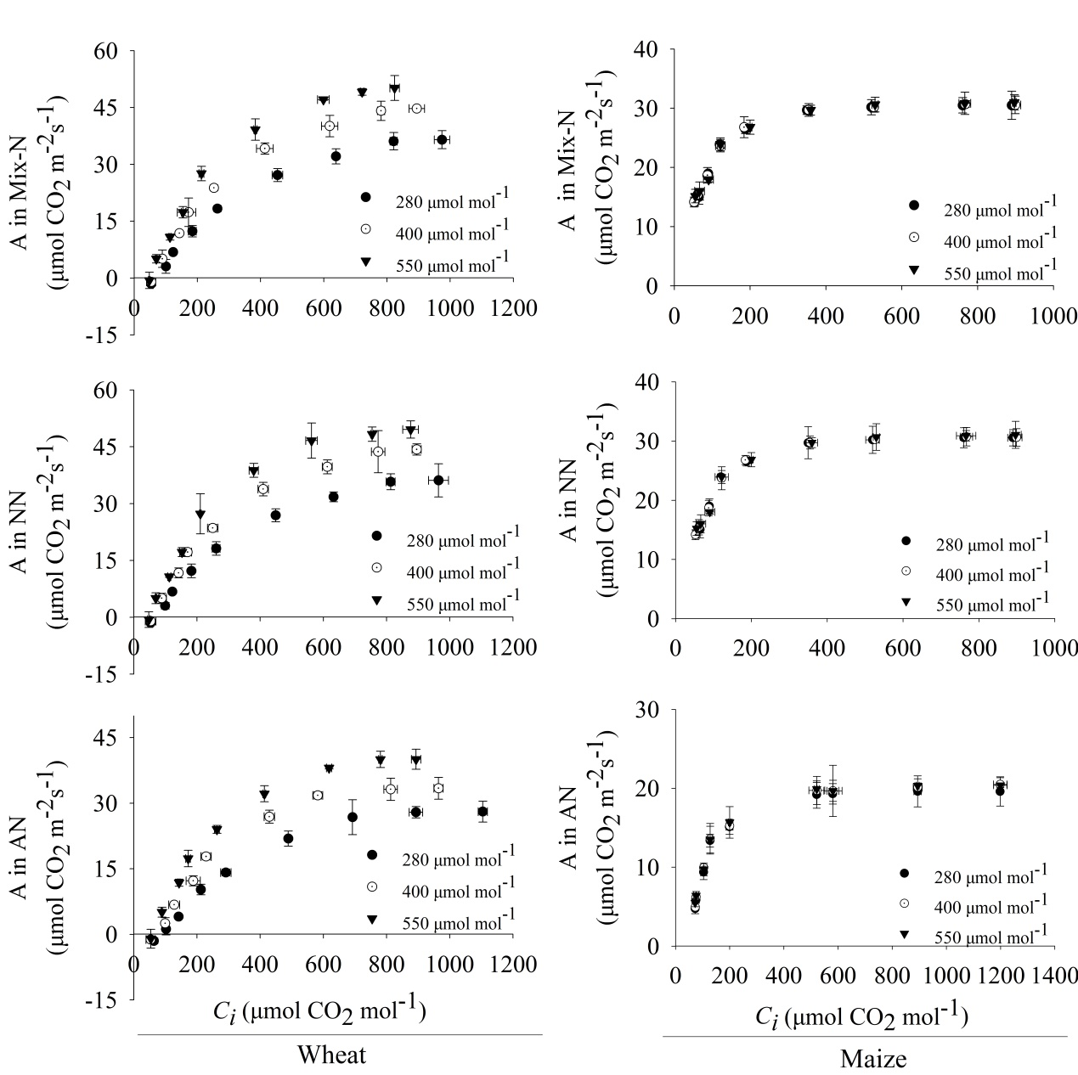
Fig. S2 | Effects of different CO₂ levels on A/Ci curves in newly expanded leaves of C₃ wheat and C₄ maize seedlings after 21 days of treatment with different N-sources. Data are means ± SE (n = 3). NN refers to NO₃– as a N source; AN refers to NH₄⁺ as a N source; Mix-N refers a mixture of NO₃– and NH₄⁺.

