Supplementary Material

Enantioselectivity-evaluation of chiral copper(II) complex coordinated by novel chiral tetradentate ligand for free amino acids by mass spectrometry coupled with the isotopically labeled enantiomer method
Takashi Nakakoji¹, Hirofumi Sato², Hiroyuki Miyake¹*, Satoshi Shinoda¹, Hiroshi Tsukube¹, Hideya Kawasaki³, Ryuichi Arakawa³, Daisuke Ono², Motohiro Shizuma²*
¹Department of Chemistry, Graduate School of Science, Osaka City University, Osaka, Japan
²Osaka Research Institute of Industrial Science and Technology, Osaka, Japan
³Faculty of Chemistry, Materials and Bioengineering, Kansai University, Suita, Japan
* Correspondence:
Hiroyuki Miyake
miyake@sci.osaka-cu.ac.jp
Motohiro Shizuma
shizuma@omtri.or.jp

Contents
1 ¹H-NMR spectra of compounds (Figures S1–S9)
2 High resolution mass spectra of compounds (Figures S10–S18)
3 ESI mass spectra of the mass spectrometry/enantiomer-labeled (MS/EL) method of CuCl₂/L3/R-Val/S-Val-d₈ and CuCl₂/L8/ R-Val/S-Val-d₈ in water/methanol (Figures S19–S26)
4 ESI mass spectra of the MS/EL method of CuCl₂/L/R-AA/S-AA-d_{n} in water/ methanol (Figures S27–S42)
5 Deuterated amino acids (Table S1)
6 DFT calculation of copper(II)-ligand complex [Cu(L)(MeOH)₂]²⁺ (Figure S43)
7 Bond length of Cu-O, Cu-N, and Cu-(MeOH) of copper(II)-ligand complex [Cu(L)(MeOH)₂]²⁺ by DFT (Table S2)
8 Coordinates of copper(II)-ligand complex [Cu(L)(MeOH)₂]²⁺ by DFT (Tables S3-S4)

¹H-NMR spectra of compounds
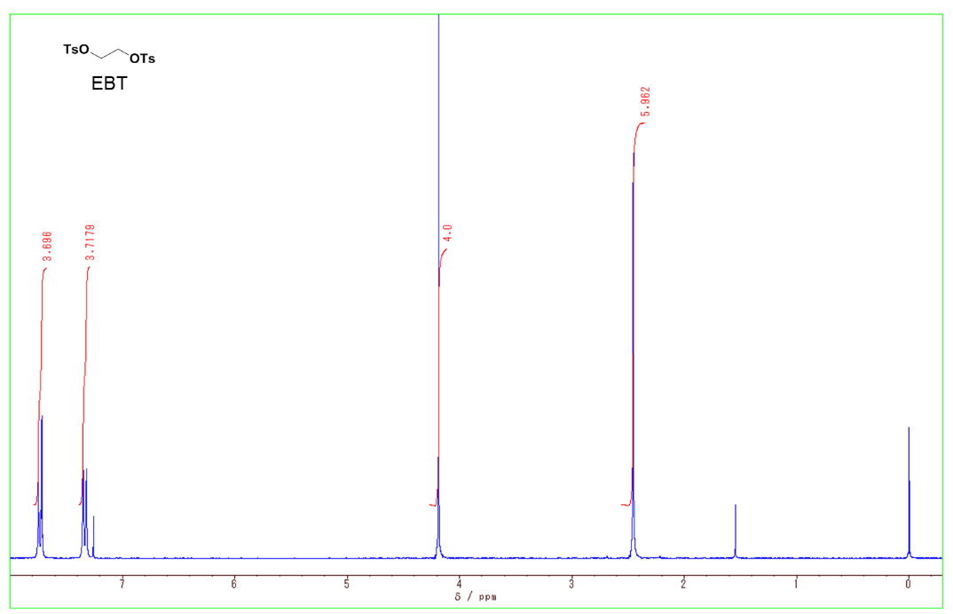
Figure S1. ¹H NMR (270 MHz, CDCl₃, 293 K) spectrum of ethylene bistsylate

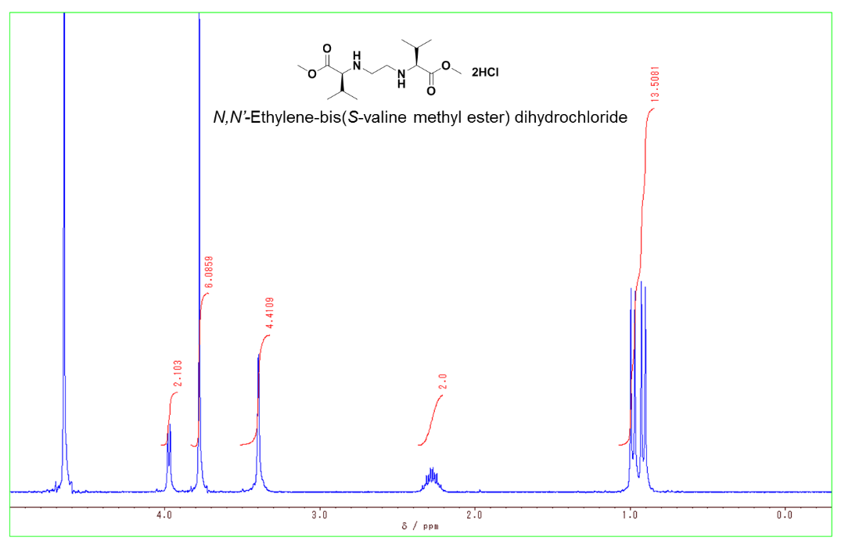
Figure S2. ¹H NMR (270 MHz, CDCl₃, 293 K) spectrum of N,N´-ethylene-bis(S-valine methyl ester) dihydrochloride

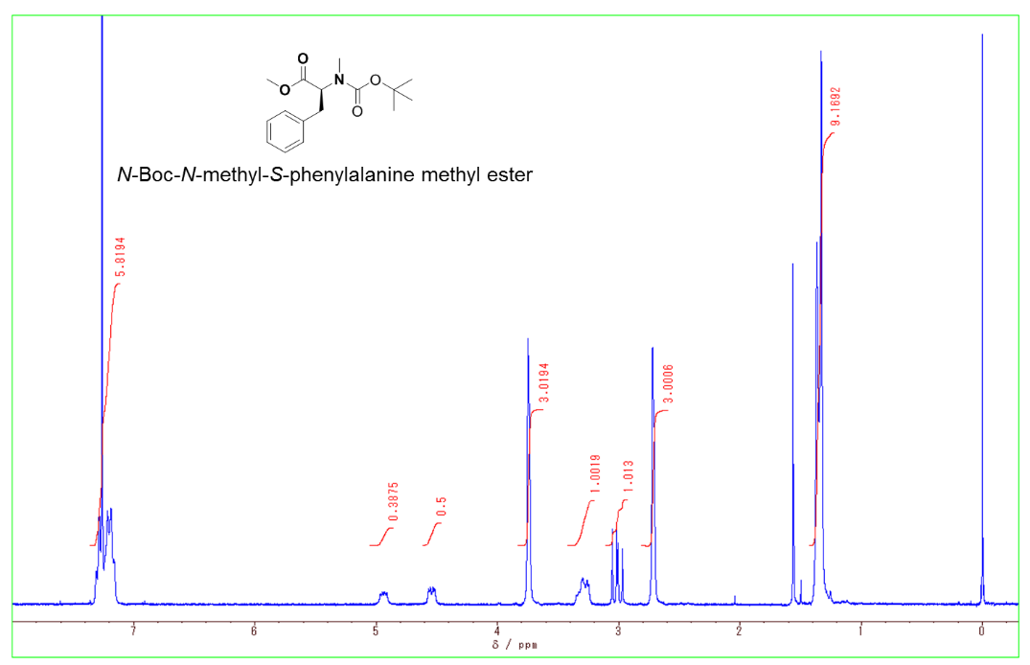
Figure S3. ¹H NMR (270 MHz, CDCl₃, 293 K) spectrum of N-Boc-N-methyl-S-phenylalanine methyl ester

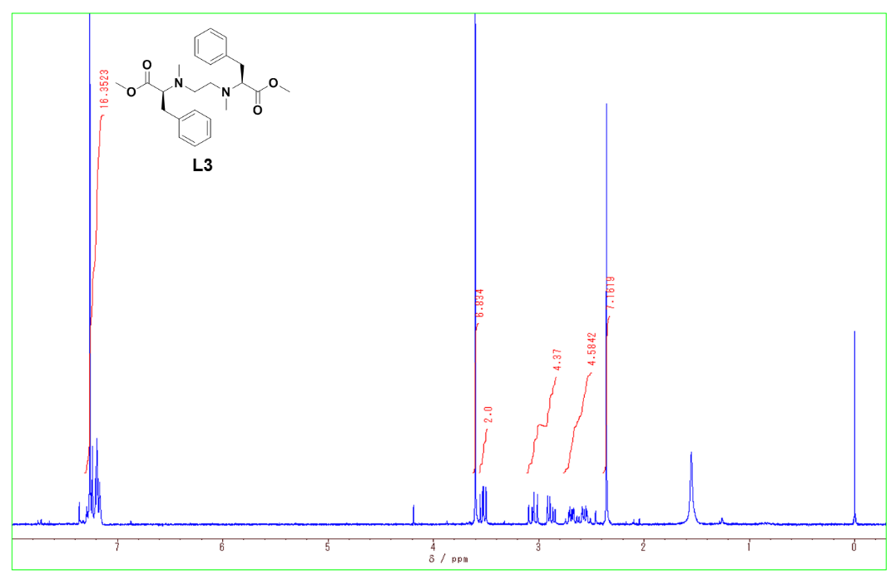
L3
Figure S4. ¹H NMR (270 MHz, CDCl₃, 293 K) spectrum of L3

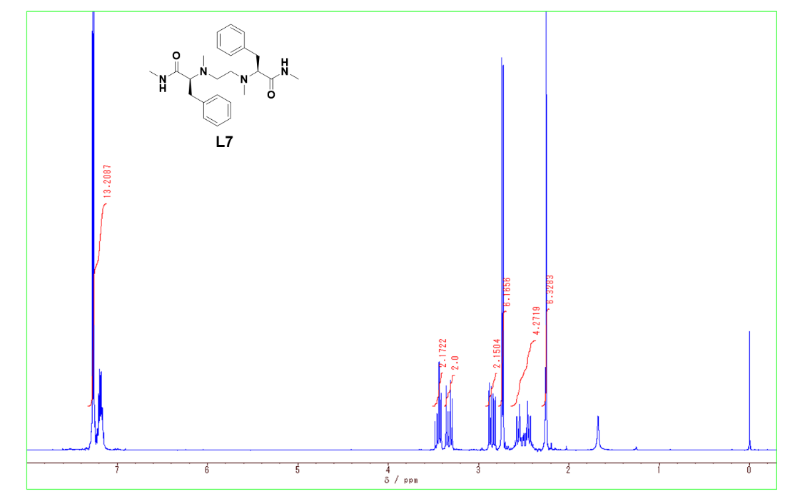
L4
Figure S5. ¹H NMR (300 MHz, CDCl₃, 293 K) spectrum of L4

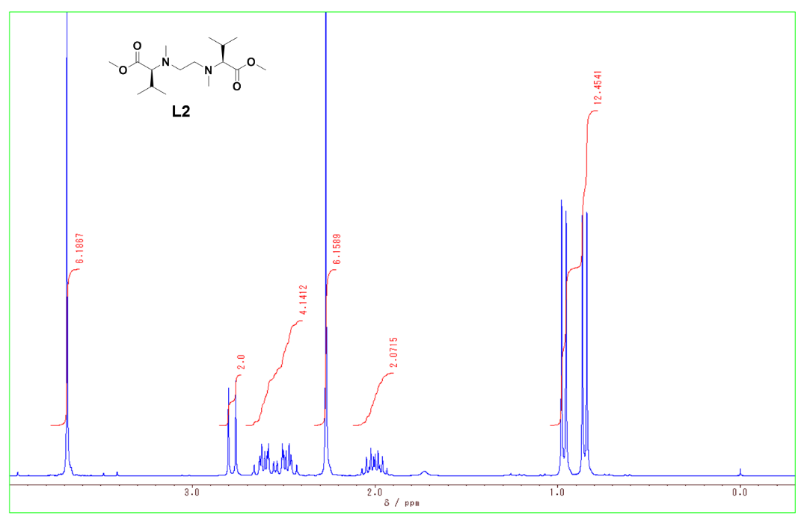
L5
Figure S6. ¹H NMR (270 MHz, CDCl₃, 293 K) spectrum of L5

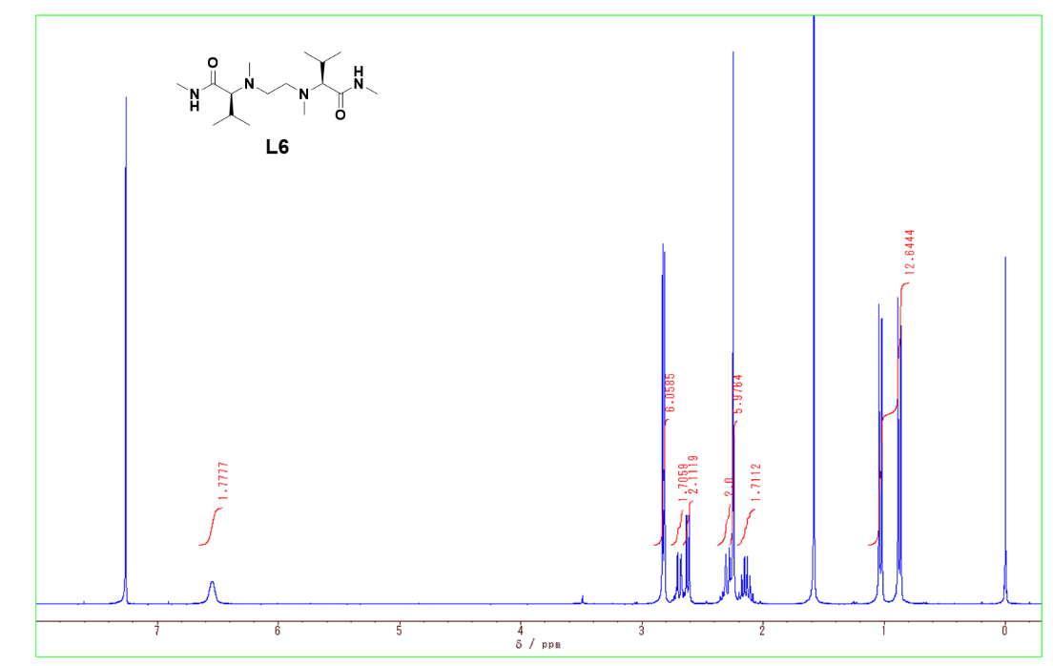
L6
Figure S7. ¹H NMR (300 MHz, CDCl₃, 293 K) spectrum of L6

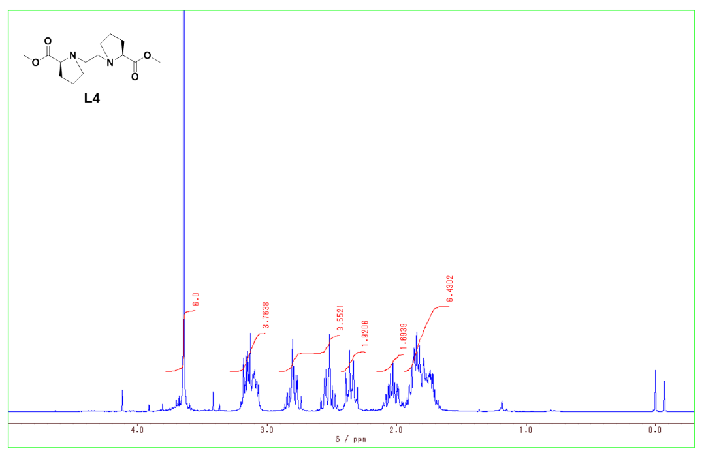
L7
Figure S8. ¹H NMR (300 MHz, CDCl₃, 293 K) spectrum of L7

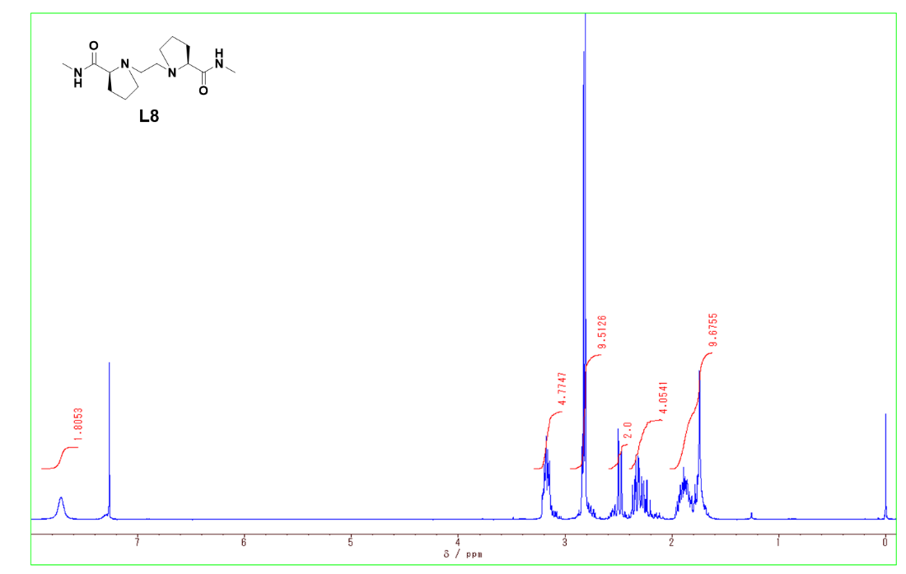
L8
Figure S9. ¹H NMR (300 MHz, CDCl₃, 293 K) spectrum of L8

High resolution mass spectra of compounds

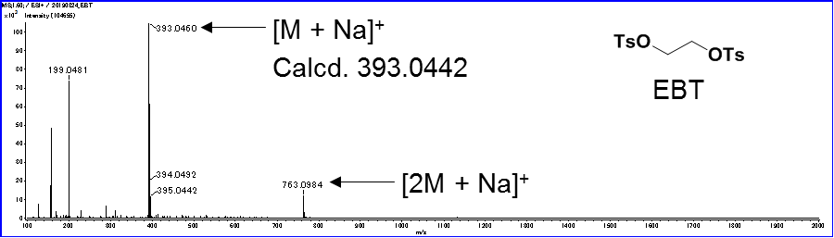
Figure S10. High resolution mass spectrum of ethylene bistsylate

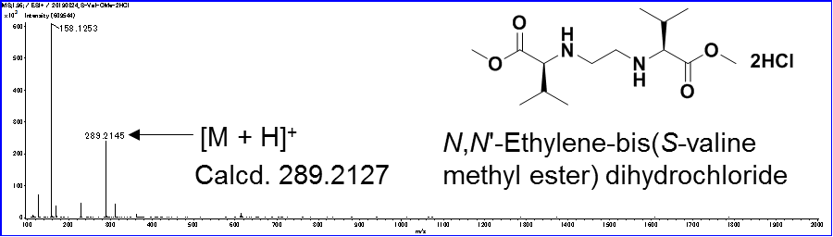
Figure S11. High resolution mass spectrum of N,N´-ethylene-bis(S-valine methyl ester) dihydrochloride

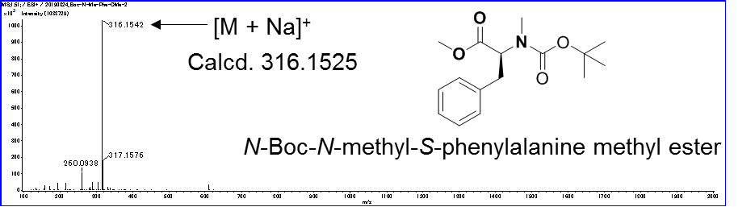
Figure S12. High resolution mass spectrum of N-Boc-N-methyl-S-phenylalanine methyl ester

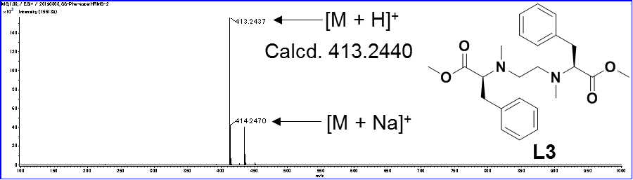
L3
Figure S13. High resolution mass spectrum of L3

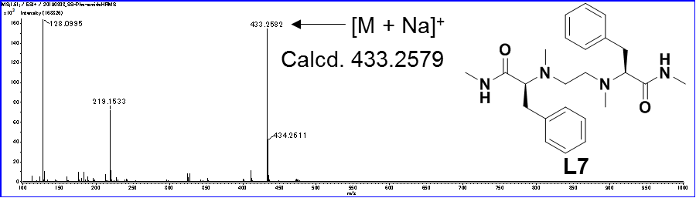
L4
Figure S14. High resolution mass spectrum of L4

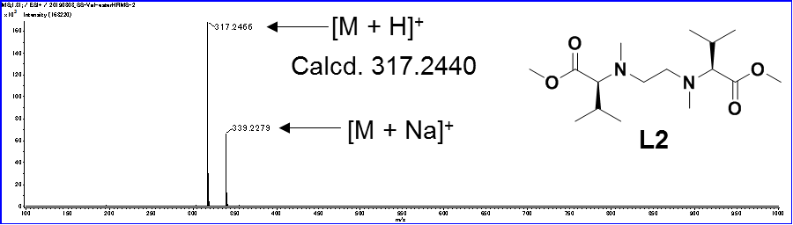
L5
Figure S15. High resolution mass spectrum of L5

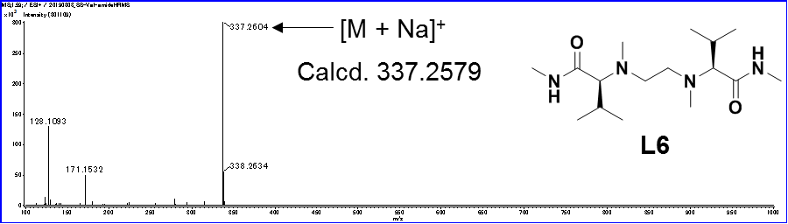
L6
Figure S16. High resolution mass spectrum of L6

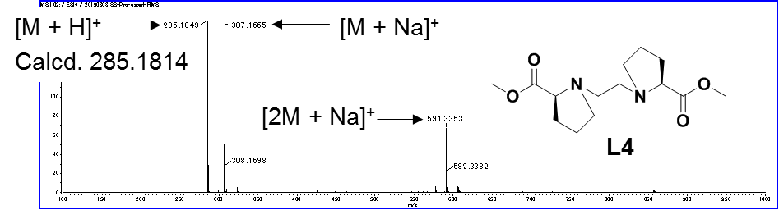
L7
Figure S17. High resolution mass spectrum of L7

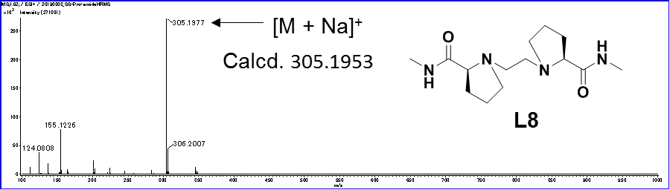
L8
Figure S18. High resolution mass spectrum of L8

ESI mass spectra of the MS/EL method of CuCl₂/L3/R-Val/S-Val-d₈ and CuCl₂/L8/ R-Val/S-Val-d₈ in water/methanol

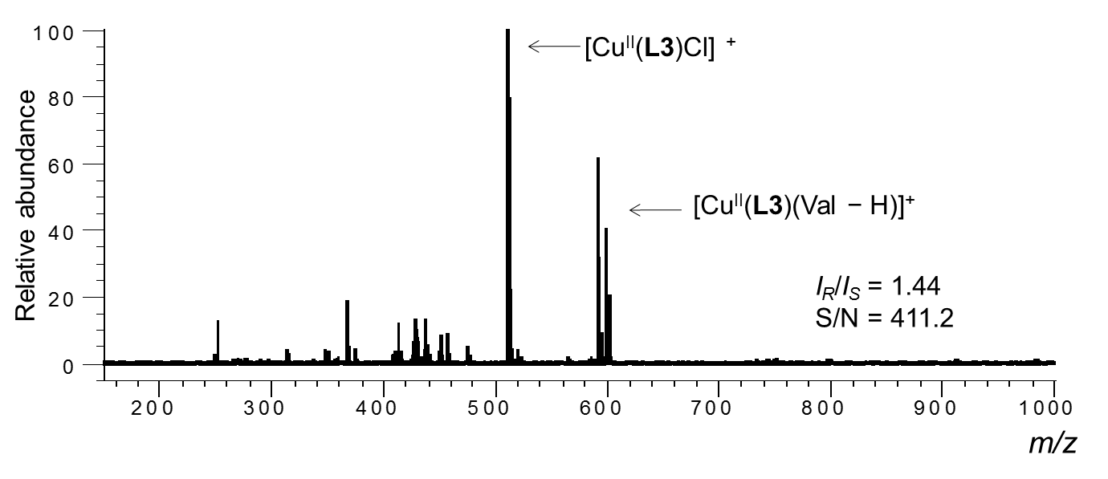
Figure S19. ESI mass spectra of a mixed solution of CuCl₂/L3/R-Val/S-Val-d₈ in water/methanol. The sample solution was prepared by mixing 1.00 mL of in situ prepared complex solution in methanol ([CuCl₂]₀ = 1.2 × 10⁻⁴ M and [L3]₀ = 1.0 × 10⁻⁴ M) and a solution of an equimolar mixture of R-Val and S-Val-d₈ ([R-Val]₀ = S-Val-d₈]₀ = 5.0 × 10⁻⁴ M and [K₂CO₃]₀ = 1.0 × 10⁻³ M) in water. The resulting mole ratio of each component [CuCl₂]₀/[L3]₀/[R-Val]₀/[S-Val-d₈]₀ (the amount of adding aqueous solution) = 1.2/1.0/0.25/0.25 (50 μL).

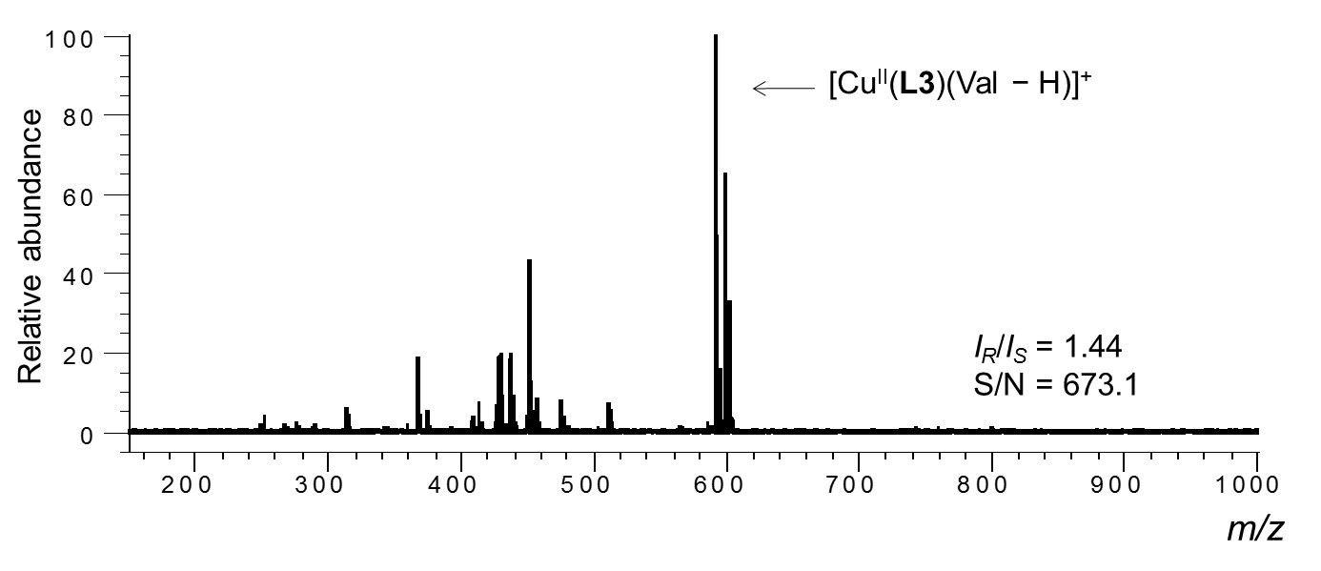
Figure S20. ESI mass spectra of a mixed solution of CuCl₂/L3/R-Val/S-Val-d₈ in water/methanol. The sample solution was prepared by mixing 1.00 mL of in situ prepared complex solution in methanol ([CuCl₂]₀ = 1.2 × 10⁻⁴ M and [L3]₀ = 1.0 × 10⁻⁴ M) and a solution of an equimolar mixture of R-Val and S-Val-d₈ ([R-Val]₀ = S-Val-d₈]₀ = 5.0 × 10⁻⁴ M and [K₂CO₃]₀ = 1.0 × 10⁻³ M) in water. The resulting mole ratio of each component [CuCl₂]₀/[L3]₀/[R-Val]₀/[S-Val-d₈]₀ (the amount of adding aqueous solution) = 1.2/1.0/0.5/0.5 (100 μL).
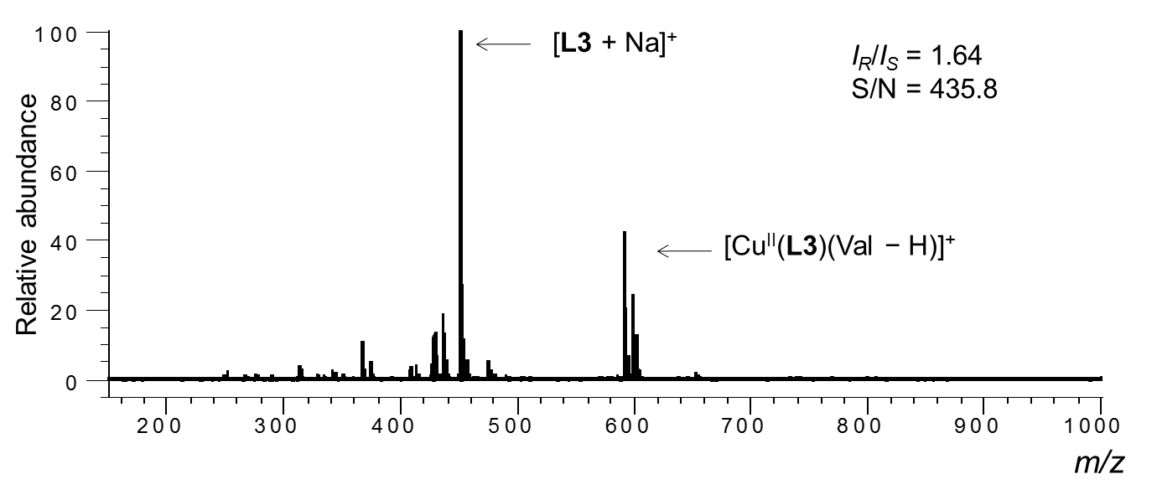
Figure S21. ESI mass spectra of a mixed solution of CuCl₂/L3/R-Val/S-Val-d₈ in water/methanol. The sample solution was prepared by mixing 1.00 mL of in situ prepared complex solution in methanol ([CuCl₂]₀ = 1.2 × 10⁻⁴ M and [L3]₀ = 1.0 × 10⁻⁴ M) and a solution of an equimolar mixture of R-Val and S-Val-d₈ ([R-Val]₀ = S-Val-d₈]₀ = 5.0 × 10⁻⁴ M and [K₂CO₃]₀ = 1.0 × 10⁻³ M) in water. The resulting mole ratio of each component [CuCl₂]₀/[L3]₀/[R-Val]₀/[S-Val-d₈]₀ (the amount of adding aqueous solution) = 1.2/1.0/0.75/0.75 (150 μL).

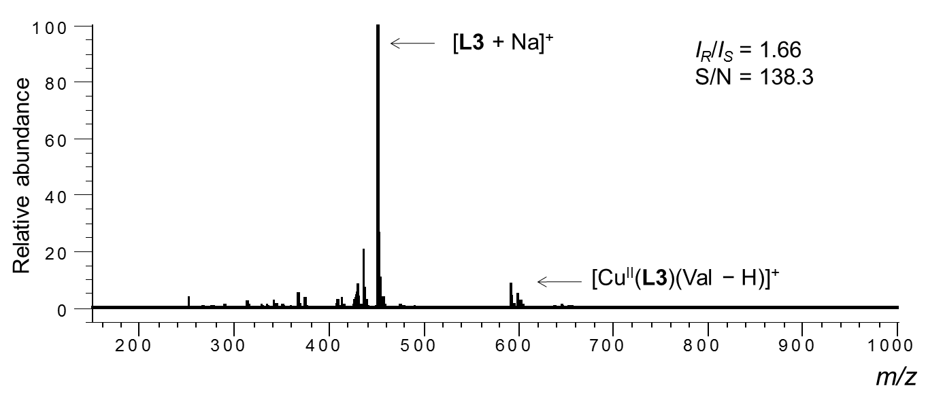
Figure S22. ESI mass spectra of a mixed solution of CuCl₂/L3/R-Val/S-Val-d₈ in water/methanol. The sample solution was prepared by mixing 1.00 mL of in situ prepared complex solution in methanol ([CuCl₂]₀ = 1.2 × 10⁻⁴ M and [L3]₀ = 1.0 × 10⁻⁴ M) and a solution of an equimolar mixture of R-Val and S-Val-d₈ ([R-Val]₀ = S-Val-d₈]₀ = 5.0 × 10⁻⁴ M and [K₂CO₃]₀ = 1.0 × 10⁻³ M) in water. The resulting mole ratio of each component [CuCl₂]₀/[L3]₀/[R-Val]₀/[S-Val-d₈]₀ (the amount of adding aqueous solution) = 1.2/1.0/1.0/1.0 (200 μL).

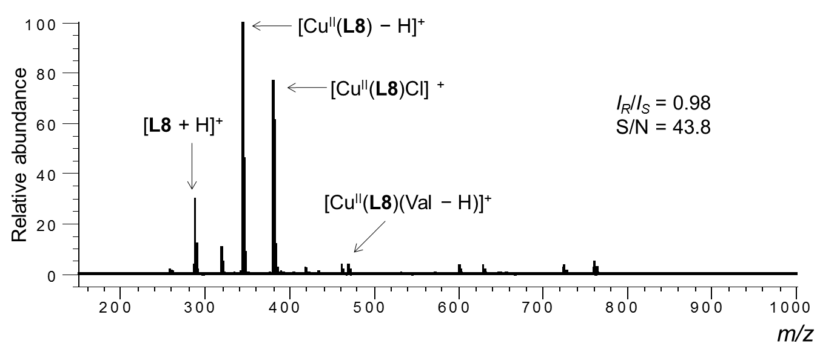
Figure S23. ESI mass spectra of a mixed solution of CuCl₂/L8/R-Val/S-Val-d₈ in water/methanol. The sample solution was prepared by mixing 1.00 mL of in situ prepared complex solution in methanol ([CuCl₂]₀ = 1.2 × 10⁻⁴ M and [L8]₀ = 1.0 × 10⁻⁴ M) and a solution of an equimolar mixture of R-Val and S-Val-d₈ ([R-Val]₀ = S-Val-d₈]₀ = 5.0 × 10⁻⁴ M and [K₂CO₃]₀ = 1.0 × 10⁻³ M) in water. The resulting mole ratio of each component [CuCl₂]₀/[L8]₀/[R-Val]₀/[S-Val-d₈]₀ (the amount of adding aqueous solution) = 1.2/1.0/0.25/0.25 (50 μL).

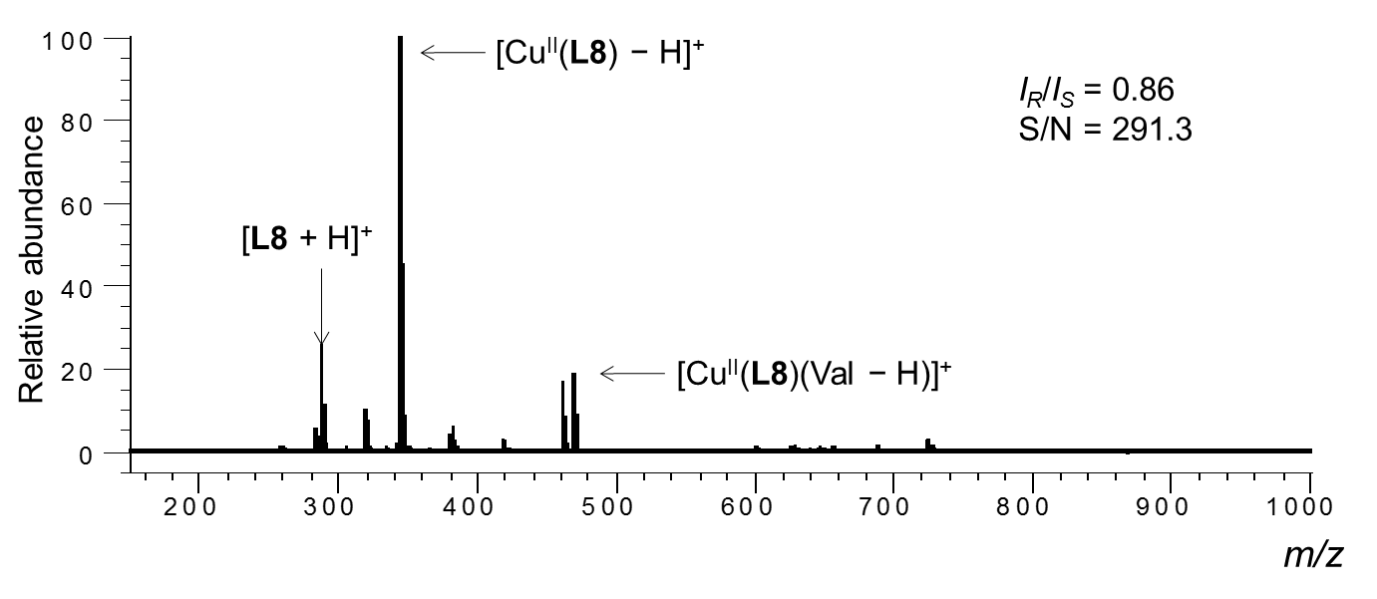
Figure S24. ESI mass spectra of a mixed solution of CuCl₂/L8/R-Val/S-Val-d₈ in water/methanol. The sample solution was prepared by mixing 1.00 mL of in situ prepared complex solution in methanol ([CuCl₂]₀ = 1.2 × 10⁻⁴ M and [L8]₀ = 1.0 × 10⁻⁴ M) and a solution of an equimolar mixture of R-Val and S-Val-d₈ ([R-Val]₀ = S-Val-d₈]₀ = 5.0 × 10⁻⁴ M and [K₂CO₃]₀ = 1.0 × 10⁻³ M) in water. The resulting mole ratio of each component [CuCl₂]₀/[L8]₀/[R-Val]₀/[S-Val-d₈]₀ (the amount of adding aqueous solution) = 1.2/1.0/0.5/0.5 (100 μL).

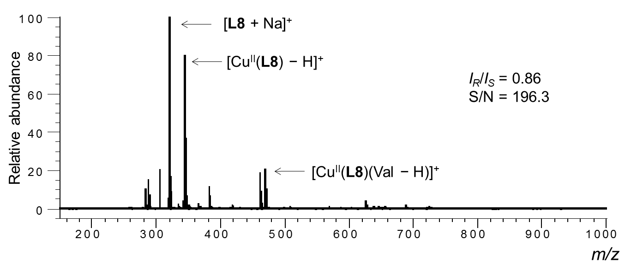
Figure S25. ESI mass spectra of a mixed solution of CuCl₂/L8/R-Val/S-Val-d₈ in water/methanol. The sample solution was prepared by mixing 1.00 mL of in situ prepared complex solution in methanol ([CuCl₂]₀ = 1.2 × 10⁻⁴ M and [L8]₀ = 1.0 × 10⁻⁴ M) and a solution of an equimolar mixture of R-Val and S-Val-d₈ ([R-Val]₀ = S-Val-d₈]₀ = 5.0 × 10⁻⁴ M and [K₂CO₃]₀ = 1.0 × 10⁻³ M) in water. The resulting mole ratio of each component [CuCl₂]₀/[L8]₀/[R-Val]₀/[S-Val-d₈]₀ (the amount of adding aqueous solution) = 1.2/1.0/0.75/0.75 (150 μL).

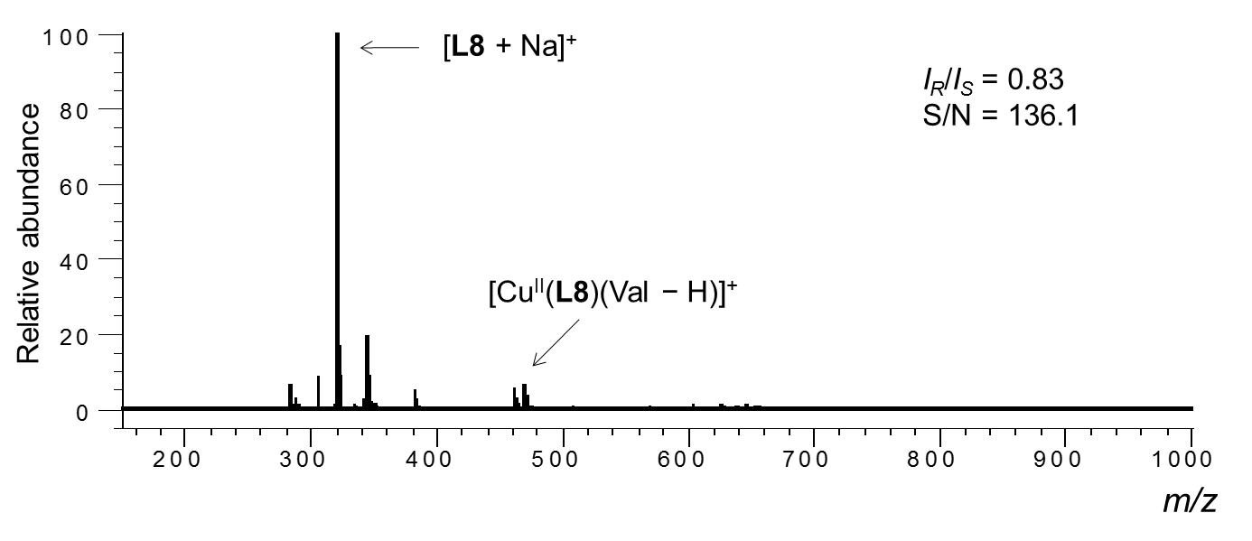
Figure S26. ESI mass spectra of a mixed solution of CuCl₂/L8/R-Val/S-Val-d₈ in water/methanol. The sample solution was prepared by mixing 1.00 mL of in situ prepared complex solution in methanol ([CuCl₂]₀ = 1.2 × 10⁻⁴ M and [L8]₀ = 1.0 × 10⁻⁴ M) and a solution of an equimolar mixture of R-Val and S-Val-d₈ ([R-Val]₀ = S-Val-d₈]₀ = 5.0 × 10⁻⁴ M and [K₂CO₃]₀ = 1.0 × 10⁻³ M) in water. The resulting mole ratio of each component [CuCl₂]₀/[L8]₀/[R-Val]₀/[S-Val-d₈]₀ (the amount of adding aqueous solution) = 1.2/1.0/1.0/1.0 (200 μL).

ESI mass spectra of the MS/EL method of CuCl₂/L/R-AA/S-AA-d_{n} in water/ methanol

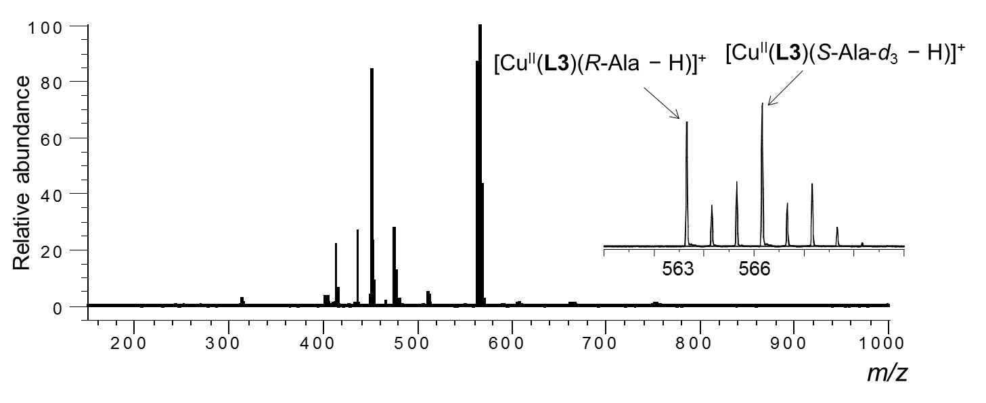
Figure S27. ESI mass spectra of the MS/EL method of CuCl₂/L/R-AA/S-AA-d_{n}- in water/methanol (1/10, v/v). [CuCl₂]₀ = 1.09 × 10⁻⁴ M, [L]₀ = 9.09 × 10⁻⁵ M and [R-AA]₀ = [S-AA-d_{n}]₀ = 4.55 × 10⁻⁵ M. [CuCl₂]₀/[L]₀/[R-AA]₀/[S-AA-d_{n}]₀ = 1.2/1.0/0.5/0.5. [K₂CO₃]₀ = 9.09 × 10⁻⁵ M, L = L3, AA= R-Ala/S-Ala-d₃.

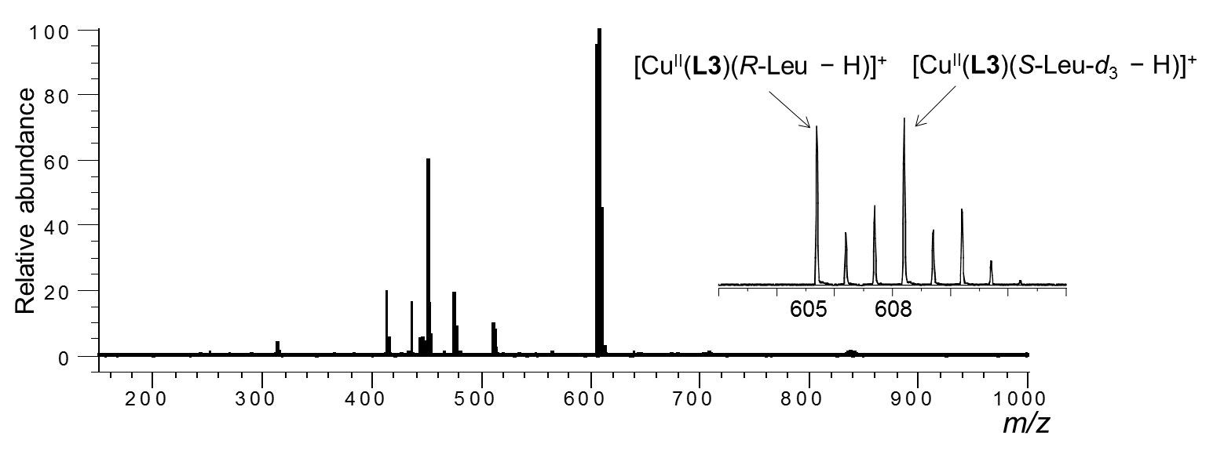
Figure S28. ESI mass spectra of the MS/EL method of CuCl₂/L/R-AA/S-AA-d_{n}- in water/methanol (1/10, v/v). [CuCl₂]₀ = 1.09 × 10⁻⁴ M, [L]₀ = 9.09 × 10⁻⁵ M and [R-AA]₀ = [S-AA-d_{n}]₀ = 4.55 × 10⁻⁵ M. [CuCl₂]₀/[L]₀/[R-AA]₀/[S-AA-d_{n}]₀ = 1.2/1.0/0.5/0.5. [K₂CO₃]₀ = 9.09 × 10⁻⁵ M, L = L3, AA= R-Leu/S-Leu-d₃.

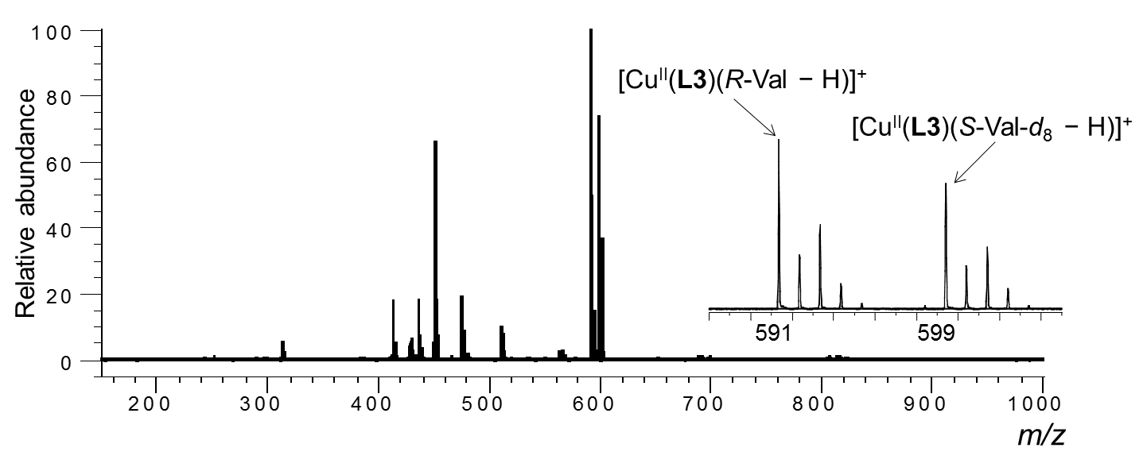
Figure S29. ESI mass spectra of the MS/EL method of CuCl₂/L/R-AA/S-AA-d_{n}- in water/methanol (1/10, v/v). [CuCl₂]₀ = 1.09 × 10⁻⁴ M, [L]₀ = 9.09 × 10⁻⁵ M and [R-AA]₀ = [S-AA-d_{n}]₀ = 4.55 × 10⁻⁵ M. [CuCl₂]₀/[L]₀/[R-AA]₀/[S-AA-d_{n}]₀ = 1.2/1.0/0.5/0.5. [K₂CO₃]₀ = 9.09 × 10⁻⁵ M, L = L3, AA= R-Val/S-Val-d₈.

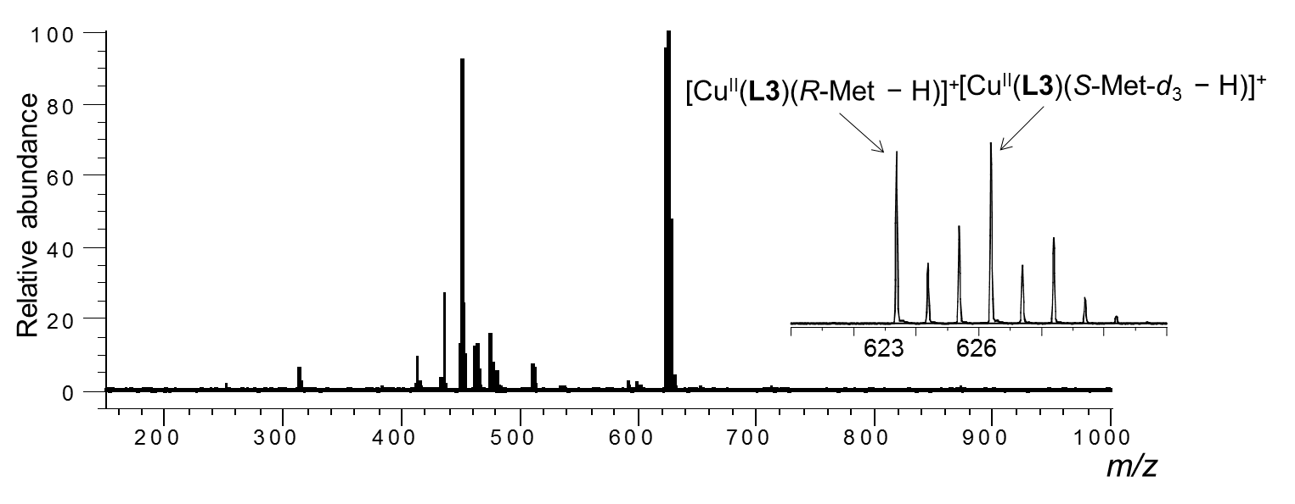
Figure S30. ESI mass spectra of the MS/EL method of CuCl₂/L/R-AA/S-AA-d_{n}- in water/methanol (1/10, v/v). [CuCl₂]₀ = 1.09 × 10⁻⁴ M, [L]₀ = 9.09 × 10⁻⁵ M and [R-AA]₀ = [S-AA-d_{n}]₀ = 4.55 × 10⁻⁵ M. [CuCl₂]₀/[L]₀/[R-AA]₀/[S-AA-d_{n}]₀ = 1.2/1.0/0.5/0.5. [K₂CO₃]₀ = 9.09 × 10⁻⁵ M, L = L3, AA= R-Met/S-Met-d₃.

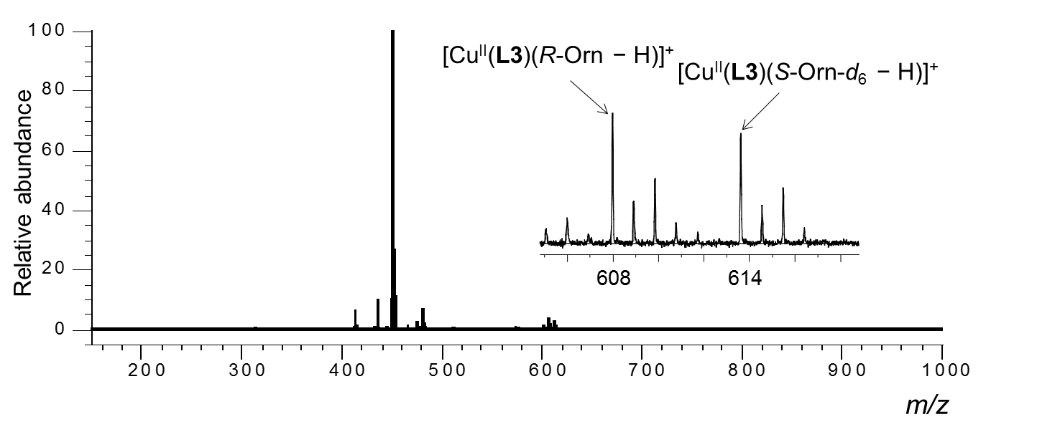
Figure S31. ESI mass spectra of the MS/EL method of CuCl₂/L/R-AA/S-AA-d_{n}- in water/methanol (1/10, v/v). [CuCl₂]₀ = 1.09 × 10⁻⁴ M, [L]₀ = 9.09 × 10⁻⁵ M and [R-AA]₀ = [S-AA-d_{n}]₀ = 4.55 × 10⁻⁵ M. [CuCl₂]₀/[L]₀/[R-AA]₀/[S-AA-d_{n}]₀ = 1.2/1.0/0.5/0.5. [K₂CO₃]₀ = 9.09 × 10⁻⁵ M, L = L3, AA= R-Orn/S-Orn-d₆.

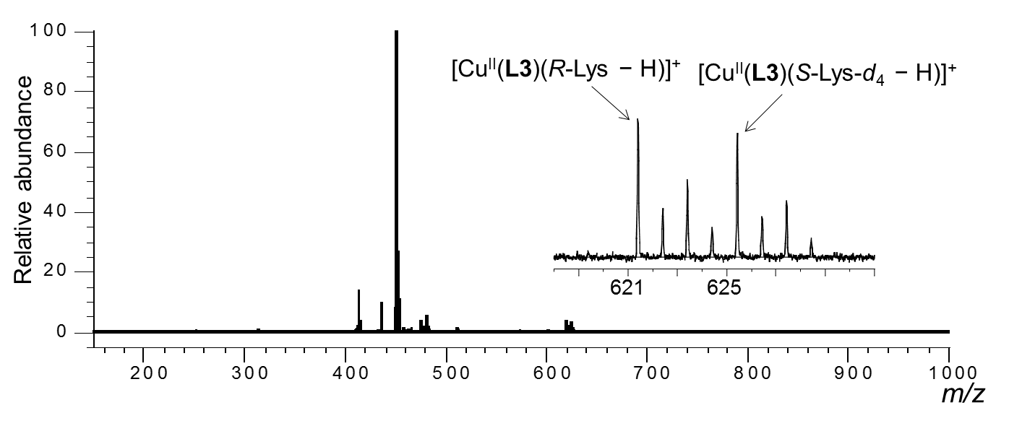
Figure S32. ESI mass spectra of the MS/EL method of CuCl₂/L/R-AA/S-AA-d_{n}- in water/methanol (1/10, v/v). [CuCl₂]₀ = 1.09 × 10⁻⁴ M, [L]₀ = 9.09 × 10⁻⁵ M and [R-AA]₀ = [S-AA-d_{n}]₀ = 4.55 × 10⁻⁵ M. [CuCl₂]₀/[L]₀/[R-AA]₀/[S-AA-d_{n}]₀ = 1.2/1.0/0.5/0.5. [K₂CO₃]₀ = 9.09 × 10⁻⁵ M, L = L3, AA= R-Lys/S-Lys-d₄.

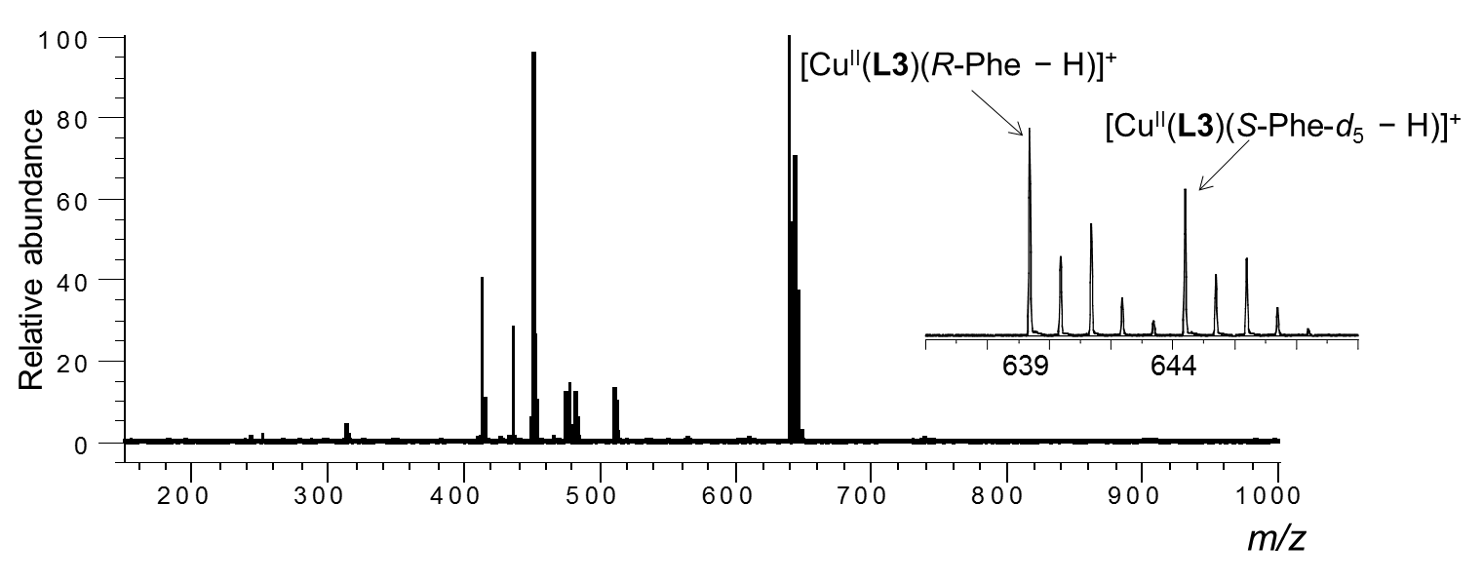
Figure S33. ESI mass spectra of the MS/EL method of CuCl₂/L/R-AA/S-AA-d_{n}- in water/methanol (1/10, v/v). [CuCl₂]₀ = 1.09 × 10⁻⁴ M, [L]₀ = 9.09 × 10⁻⁵ M and [R-AA]₀ = [S-AA-d_{n}]₀ = 4.55 × 10⁻⁵ M. [CuCl₂]₀/[L]₀/[R-AA]₀/[S-AA-d_{n}]₀ = 1.2/1.0/0.5/0.5. [K₂CO₃]₀ = 9.09 × 10⁻⁵ M, L = L3, AA= R-Phe/S-Phe-d₅.

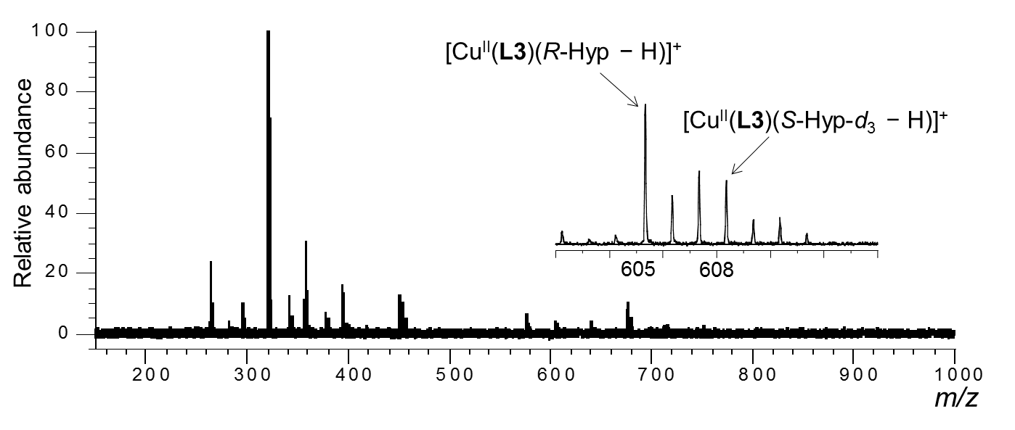
Figure S34. ESI mass spectra of the MS/EL method of CuCl₂/L/R-AA/S-AA-d_{n}- in water/methanol (1/10, v/v). [CuCl₂]₀ = 1.09 × 10⁻⁴ M, [L]₀ = 9.09 × 10⁻⁵ M and [R-AA]₀ = [S-AA-d_{n}]₀ = 4.55 × 10⁻⁵ M. [CuCl₂]₀/[L]₀/[R-AA]₀/[S-AA-d_{n}]₀ = 1.2/1.0/0.5/0.5. [K₂CO₃]₀ = 9.09 × 10⁻⁵ M, L = L3, AA= R-Hyp/S-Hyp-d₃.

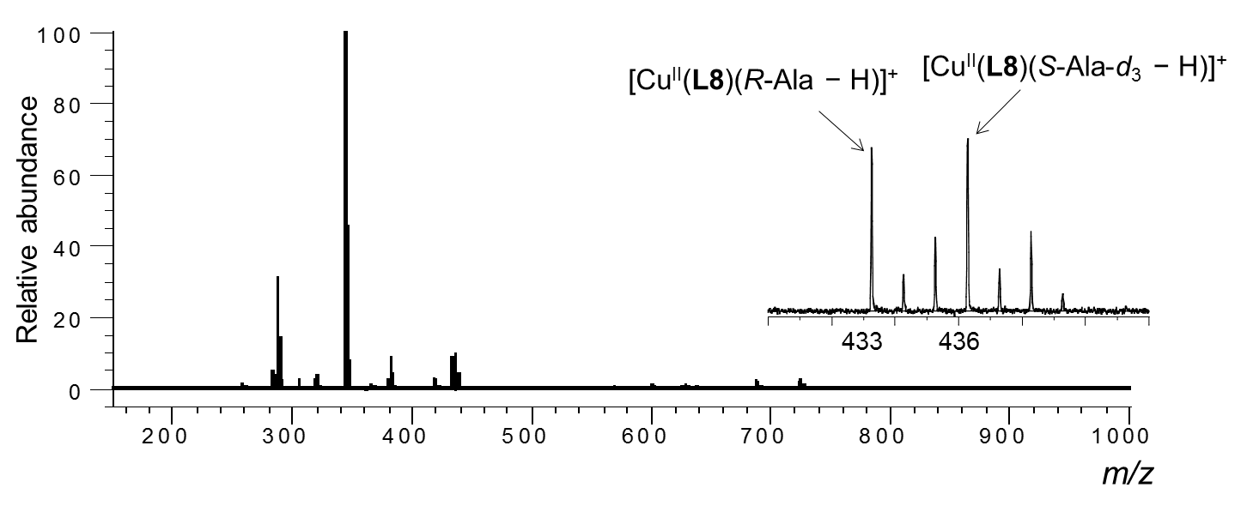
Figure S35. ESI mass spectra of the MS/EL method of CuCl₂/L/R-AA/S-AA-d_{n}- in water/methanol (1/10, v/v). [CuCl₂]₀ = 1.09 × 10⁻⁴ M, [L]₀ = 9.09 × 10⁻⁵ M and [R-AA]₀ = [S-AA-d_{n}]₀ = 4.55 × 10⁻⁵ M. [CuCl₂]₀/[L]₀/[R-AA]₀/[S-AA-d_{n}]₀ = 1.2/1.0/0.5/0.5. [K₂CO₃]₀ = 9.09 × 10⁻⁵ M, L = L8, AA= R-Ala/S-Ala-d₃.

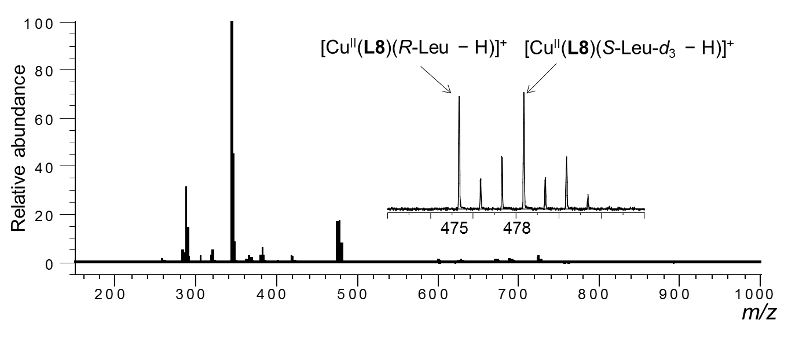
Figure S36. ESI mass spectra of the MS/EL method of CuCl₂/L/R-AA/S-AA-d_{n}- in water/methanol (1/10, v/v). [CuCl₂]₀ = 1.09 × 10⁻⁴ M, [L]₀ = 9.09 × 10⁻⁵ M and [R-AA]₀ = [S-AA-d_{n}]₀ = 4.55 × 10⁻⁵ M. [CuCl₂]₀/[L]₀/[R-AA]₀/[S-AA-d_{n}]₀ = 1.2/1.0/0.5/0.5. [K₂CO₃]₀ = 9.09 × 10⁻⁵ M, L = L8, AA= R-Leu/S-Leu-d₃.

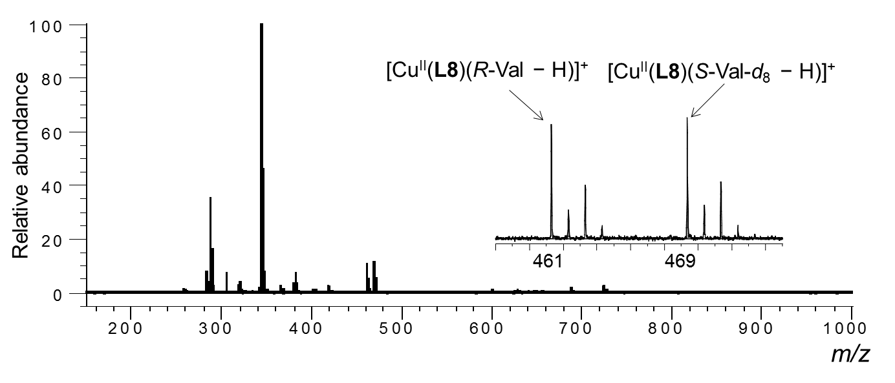
Figure 37. ESI mass spectra of the MS/EL method of CuCl₂/L/R-AA/S-AA-d_{n}- in water/methanol (1/10, v/v). [CuCl₂]₀ = 1.09 × 10⁻⁴ M, [L]₀ = 9.09 × 10⁻⁵ M and [R-AA]₀ = [S-AA-d_{n}]₀ = 4.55 × 10⁻⁵ M. [CuCl₂]₀/[L]₀/[R-AA]₀/[S-AA-d_{n}]₀ = 1.2/1.0/0.5/0.5. [K₂CO₃]₀ = 9.09 × 10⁻⁵ M, L = L8, AA= R-Val/S-Val-d₈.

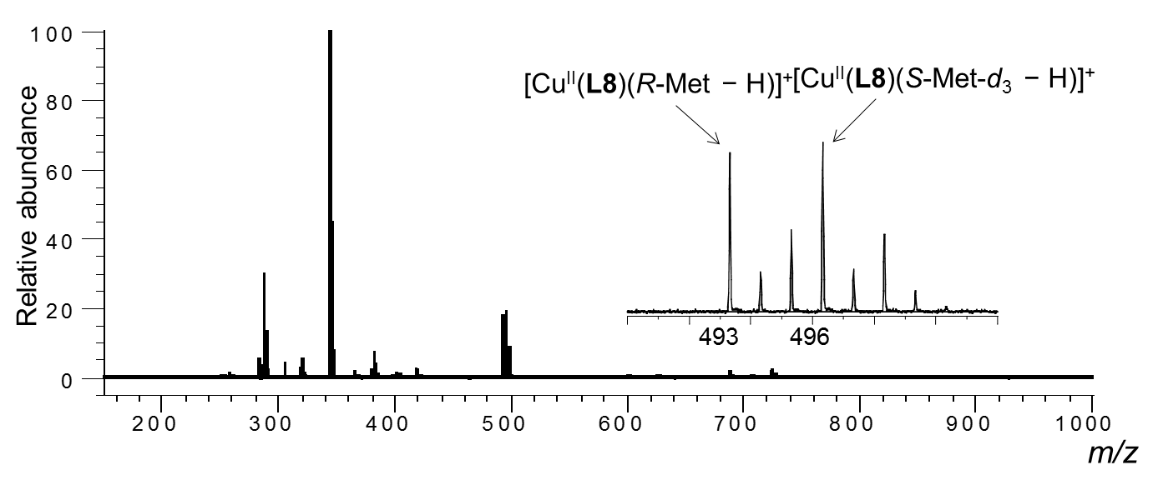
Figure S38. ESI mass spectra of the MS/EL method of CuCl₂/L/R-AA/S-AA-d_{n}- in water/methanol (1/10, v/v). [CuCl₂]₀ = 1.09 × 10⁻⁴ M, [L]₀ = 9.09 × 10⁻⁵ M and [R-AA]₀ = [S-AA-d_{n}]₀ = 4.55 × 10⁻⁵ M. [CuCl₂]₀/[L]₀/[R-AA]₀/[S-AA-d_{n}]₀ = 1.2/1.0/0.5/0.5. [K₂CO₃]₀ = 9.09 × 10⁻⁵ M, L = L8, AA= R-Met/S-Met-d₃.

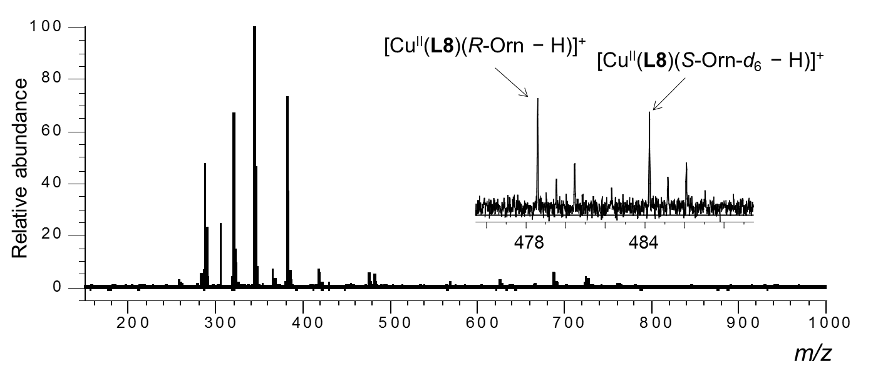
Figure S39. ESI mass spectra of the MS/EL method of CuCl₂/L/R-AA/S-AA-d_{n}- in water/methanol (1/10, v/v). [CuCl₂]₀ = 1.09 × 10⁻⁴ M, [L]₀ = 9.09 × 10⁻⁵ M and [R-AA]₀ = [S-AA-d_{n}]₀ = 4.55 × 10⁻⁵ M. [CuCl₂]₀/[L]₀/[R-AA]₀/[S-AA-d_{n}]₀ = 1.2/1.0/0.5/0.5. [K₂CO₃]₀ = 9.09 × 10⁻⁵ M, L = L8, AA= R-Orn/S-Orn-d₆.

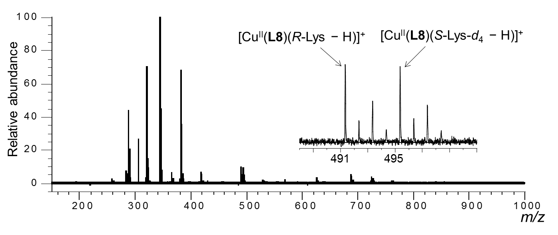
Figure S40. ESI mass spectra of the MS/EL method of CuCl₂/L/R-AA/S-AA-d_{n}- in water/methanol (1/10, v/v). [CuCl₂]₀ = 1.09 × 10⁻⁴ M, [L]₀ = 9.09 × 10⁻⁵ M and [R-AA]₀ = [S-AA-d_{n}]₀ = 4.55 × 10⁻⁵ M. [CuCl₂]₀/[L]₀/[R-AA]₀/[S-AA-d_{n}]₀ = 1.2/1.0/0.5/0.5. [K₂CO₃]₀ = 9.09 × 10⁻⁵ M, L = L8, AA= R-Lys/S-Lys-d₄.
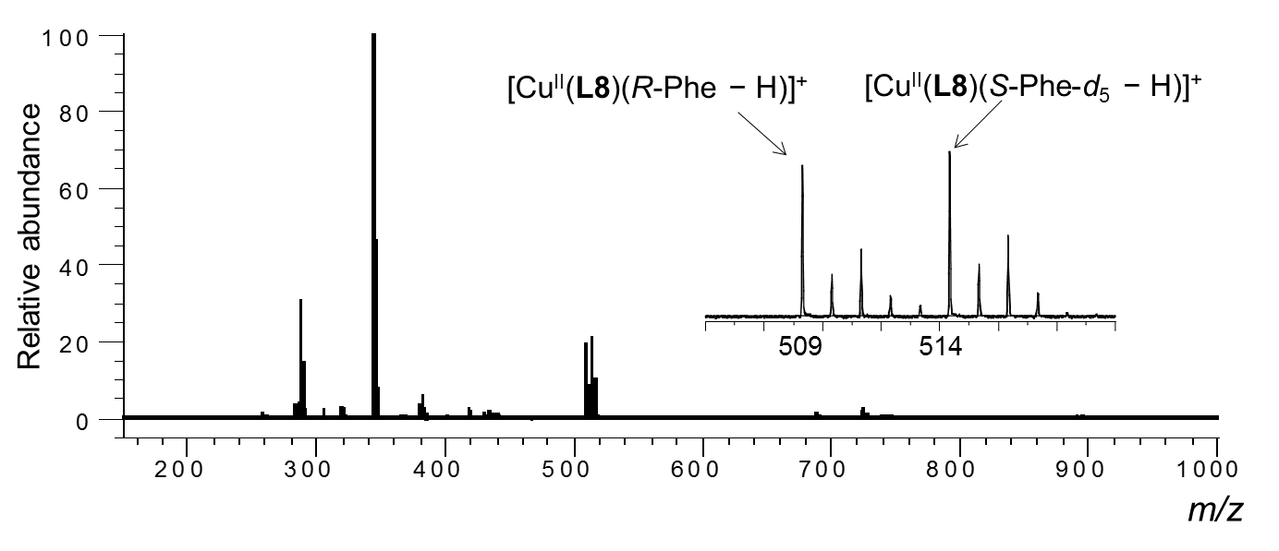
Figure S41. ESI mass spectra of the MS/EL method of CuCl₂/L/R-AA/S-AA-d_{n}- in water/methanol (1/10, v/v). [CuCl₂]₀ = 1.09 × 10⁻⁴ M, [L]₀ = 9.09 × 10⁻⁵ M and [R-AA]₀ = [S-AA-d_{n}]₀ = 4.55 × 10⁻⁵ M. [CuCl₂]₀/[L]₀/[R-AA]₀/[S-AA-d_{n}]₀ = 1.2/1.0/0.5/0.5. [K₂CO₃]₀ = 9.09 × 10⁻⁵ M, L = L8, AA= R-Phe/S-Phe-d₅.

.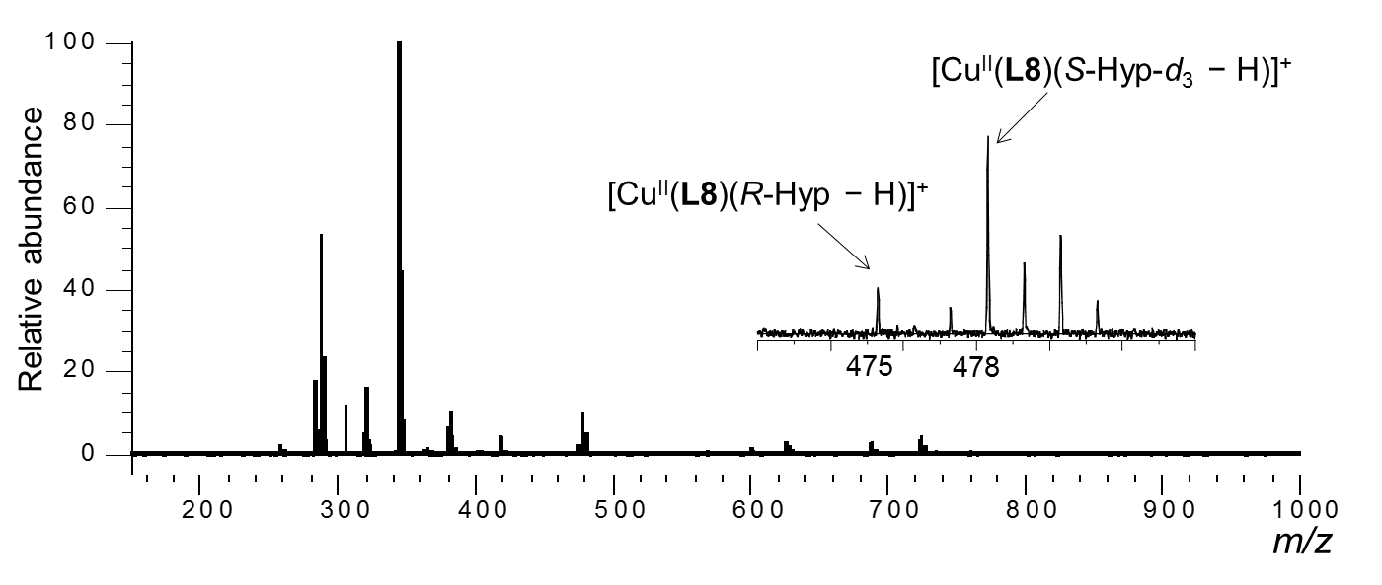
Figure S42. ESI mass spectra of the MS/EL method of CuCl₂/L/R-AA/S-AA-d_{n}- in water/methanol (1/10, v/v). [CuCl₂]₀ = 1.09 × 10⁻⁴ M, [L]₀ = 9.09 × 10⁻⁵ M and [R-AA]₀ = [S-AA-d_{n}]₀ = 4.55 × 10⁻⁵ M. [CuCl₂]₀/[L]₀/[R-AA]₀/[S-AA-d_{n}]₀ = 1.2/1.0/0.5/0.5. [K₂CO₃]₀ = 9.09 × 10⁻⁵ M, L = L8, AA= R-Hyp/S-Hyp-d₃.

Deuterated amino acids
Table S1. The structure and D contents of deuterated amino acids

DFT calculation of copper(II)-ligand complex [Cu(L)(MeOH)₂]²⁺
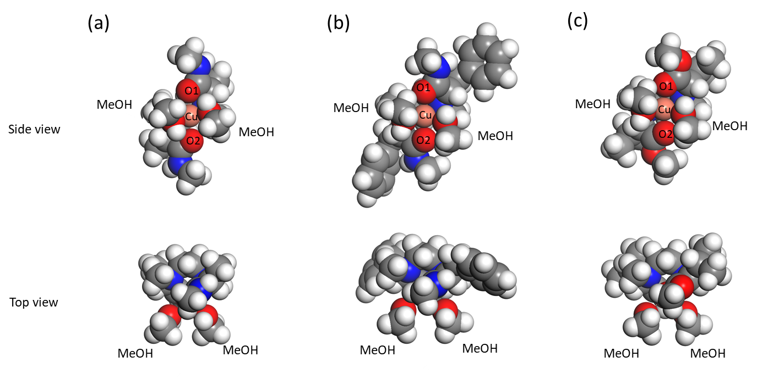
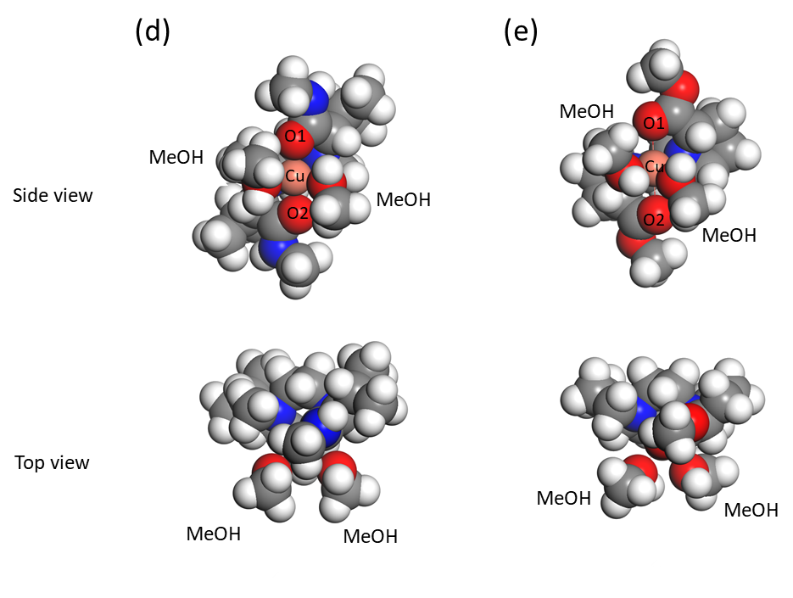
Figure S43. DFT calculation of the copper(II)-ligand complex [Cu(L)(MeOH)₂]²⁺ in methanol. L: (a) L2, (b) L4, (c) L5, (d) L6, (e) L7.

Bond length of Cu-O, Cu-N, and Cu-(MeOH) of copper(II)-ligand complex [Cu(L)(MeOH)₂]²⁺ by DFT

Table S2. Bond length (Å) of Cu- Cu-O, Cu-N, and Cu-(MeOH) of copper(II)-ligand complex [Cu(L)(MeOH)₂]²⁺ by DFT
Complex ion | Cu-O1 | Cu-O2 | Cu-OMe1 | Cu-OMe2 | Cu-N1 | Cu-N2
[Cu(L1)(MeOH)₂]²⁺ | 2.15 | 2.15 | 2.22 | 2.22 | 2.28 | 2.27
[Cu(L2)(MeOH)₂]²⁺ | 2.13 | 2.13 | 2.28 | 2.28 | 2.28 | 2.29
[Cu(L3)(MeOH)₂]²⁺ | 2.14 | 2.13 | 2.24 | 2.26 | 2.32 | 2.34
[Cu(L4)(MeOH)₂]²⁺ | 2.10 | 2.08 | 2.25 | 2.31 | 2.39 | 2.31
[Cu(L5)(MeOH)₂]²⁺ | 2.08 | 2.09 | 2.25 | 2.22 | 2.31 | 2.50
[Cu(L6)(MeOH)₂]²⁺ | 2.03 | 2.04 | 2.31 | 2.25 | 2.32 | 2.47
[Cu(L7)(MeOH)₂]²⁺ | 2.51 | 2.55 | 2.15 | 2.22 | 2.15 | 2.14
[Cu(L8)(MeOH)₂]²⁺ | 2.51 | 2.44 | 2.19 | 2.22 | 2.18 | 2.14

N2
OMe2
OMe1
N1
O2
O1

Coordinates of copper(II)-ligand complex [Cu(L)(MeOH)₂]²⁺ by DFT

Table S3. Final Coordinates (Angstroms) of [Cu^{II}(L1)(MeOH)₂]²⁺ complex calculated by DFT

ATOM X Y Z

1 O 1.230108 5.241101 26.225605
2 O -1.186360 3.690428 26.899695
3 H -0.597456 3.040821 26.492167
4 N -0.857349 6.938234 26.762265
5 O 1.278230 5.812985 24.069263
6 C 0.735559 5.828697 25.264595
7 C -0.068021 8.102401 27.235840
8 H -0.557073 9.038433 26.948140
9 H 0.903503 8.086407 26.746884
10 C -0.586523 6.587320 25.346190
11 C -2.302717 7.108494 27.020437
12 H -2.472766 7.271194 28.080966
13 H -2.832219 6.208597 26.716832
14 H -2.705929 7.965558 26.472725
15 C -2.380806 3.011511 27.343335
16 H -2.155271 2.329212 28.163956
17 H -2.817708 2.456105 26.512087
18 H -3.076335 3.774352 27.681235
19 C 2.498497 5.017613 23.909544
20 H 3.274156 5.413021 24.558345
21 H 2.764613 5.129567 22.865303
22 H 2.281890 3.981867 24.153149
23 C -0.688675 7.753788 24.364248
24 H -1.662892 8.231644 24.456440
25 H -0.594720 7.380708 23.346652
26 H 0.087145 8.498413 24.530775
27 O -1.241841 5.247100 29.736141
28 O 1.156754 3.661084 29.054411
29 H 0.555109 3.025327 29.464917
30 N 0.872088 6.915048 29.213472
31 O -1.289164 5.809201 31.895287
32 C -0.743031 5.823537 30.701797
33 C 0.108457 8.098318 28.744130
34 H 0.618404 9.022200 29.034592
35 H -0.862933 8.102258 29.233468
36 C 0.590844 6.562510 30.627339
37 C 2.321488 7.057301 28.960428
38 H 2.497664 7.224293 27.901560
39 H 2.830620 6.143829 29.258364
40 H 2.740863 7.901137 29.515873
41 C 2.333846 2.954836 28.605194
42 H 2.088676 2.276999 27.786526
43 H 2.762169 2.390904 29.434936
44 H 3.044313 3.701793 28.262894
45 C -2.519041 5.027053 32.049218
46 H -3.288887 5.433594 31.400463
47 H -2.785787 5.138367 33.093409
48 H -2.313381 3.989828 31.802402
49 C 0.709265 7.723155 31.614544
50 H 1.691743 8.184939 31.527484
51 H 0.605812 7.347548 32.630305
52 H -0.052860 8.481836 31.448427
53 Cu -0.001212 5.219669 27.984368
54 H 1.326656 5.800528 30.898903
55 H -1.336045 5.839338 25.073920

Table S4. Final Coordinates (Angstroms) of [Cu^{II}(L2)(MeOH)₂]²⁺ complex calculated by DFT

ATOM X Y Z

1 O 1.197965 5.239458 26.216214
2 O -1.166049 3.678318 26.860022
3 H -0.522507 3.241932 26.285817
4 N -0.834500 7.008621 26.735277
5 N 1.466307 5.960645 24.095111
6 H 1.122859 6.567487 23.367301
7 C 0.797187 5.918964 25.243337
8 C -0.057108 8.172216 27.225590
9 H -0.538648 9.108718 26.927903
10 H 0.925030 8.157762 26.757452
11 C -0.546614 6.661781 25.319916
12 C -2.281953 7.185445 26.969081
13 H -2.467915 7.336717 28.028380
14 H -2.812793 6.294018 26.644081
15 H -2.667114 8.055122 26.428807
16 C -2.113890 2.691974 27.325681
17 H -1.632103 1.980035 27.997633
18 H -2.543092 2.160131 26.476766
19 H -2.893047 3.228348 27.858505
20 C 2.692973 5.216773 23.812090
21 H 3.563299 5.779624 24.152073
22 H 2.761050 5.073323 22.737094
23 H 2.669124 4.253542 24.312712
24 C -0.682058 7.832619 24.347922
25 H -1.658005 8.298537 24.467430
26 H -0.634407 7.481928 23.317436
27 H 0.085923 8.590245 24.494178
28 O -1.200455 5.261482 29.744549
29 O 1.102333 3.649867 29.104647
30 H 0.439465 3.249756 29.683601
31 N 0.855739 7.002262 29.230123
32 N -1.428043 5.932937 31.885724
33 H -1.072691 6.524214 32.620449
34 C -0.779645 5.917084 30.724895
35 C 0.087255 8.171725 28.740011
36 H 0.575617 9.104901 29.037403
37 H -0.894852 8.164493 29.208219
38 C 0.566182 6.656750 30.645130
39 C 2.304598 7.168979 28.997206
40 H 2.492539 7.321776 27.938450
41 H 2.828933 6.272924 29.320165
42 H 2.696151 8.034594 29.539628
43 C 1.988872 2.612174 28.630490
44 H 1.461128 1.922207 27.970512
45 H 2.404607 2.064451 29.476169
46 H 2.785464 3.106304 28.082547
47 C -2.645150 5.176132 32.175423
48 H -3.524633 5.742725 31.866217
49 H -2.690992 5.007852 33.247901
50 H -2.627327 4.225238 31.651686
51 C 0.705090 7.828229 31.616420
52 H 1.682451 8.290658 31.495809
53 H 0.657482 7.480176 32.647784
54 H -0.060439 8.587862 31.468642
55 Cu -0.003422 5.293080 27.979432
56 H 1.306660 5.900195 30.921291
57 H -1.288795 5.906516 25.044918

Table S5. Final Coordinates (Angstroms) of [Cu^{II}(L3)(MeOH)₂]²⁺ complex calculated by DFT

ATOM X Y Z

1 O 1.015186 5.090006 26.294653
2 O -1.842080 3.723773 27.056156
3 N -1.032978 6.916750 26.650586
4 O 1.515601 6.031180 24.336132
5 C 0.721393 5.834590 25.358969
6 C -0.264682 8.059022 27.196667
7 H -0.728821 9.007970 26.912779
8 H 0.729314 8.052800 26.753268
9 C -0.634133 6.535105 25.276080
10 C -2.491385 7.101117 26.780680
11 H -2.995697 6.202313 26.434304
12 H -2.842937 7.964433 26.208000
13 H -2.745934 7.257963 27.825743
14 C -2.798796 2.930799 27.798462
15 H -2.379555 1.956016 28.048898
16 H -3.711158 2.804206 27.214434
17 H -3.019485 3.479187 28.707722
18 C 2.737019 5.236893 24.286721
19 H 3.216220 5.520635 23.357262
20 H 2.478473 4.182040 24.286485
21 H 3.367184 5.476270 25.138319
22 C -0.732161 7.656964 24.221898
23 H -0.038534 8.459984 24.466912
24 C -0.485644 7.215695 22.795573
25 H -1.738050 8.076660 24.296001
26 O -1.592155 5.248826 29.661158
27 O 0.884490 3.588723 29.085193
28 N 0.585925 6.850261 29.224222
29 O -1.733827 5.860275 31.799909
30 C -1.118953 5.820712 30.639445
31 C -0.148752 8.033706 28.718383
32 H 0.348100 8.960262 29.027116
33 H -1.142050 8.039289 29.164968
34 C 0.247594 6.495174 30.618712
35 C 2.043831 6.972173 29.036512
36 H 2.264886 7.142618 27.986878
37 H 2.524164 6.045706 29.344048
38 H 2.462856 7.804535 29.612389
39 C 2.007799 2.813380 28.611387
40 H 2.370005 3.299047 27.709516
41 H 1.697782 1.794539 28.376716
42 H 2.798883 2.797396 29.362140
43 C -3.003994 5.137803 31.878726
44 H -2.824148 4.082524 31.693215
45 H -3.698183 5.546142 31.149849
46 H -3.358486 5.306880 32.889533
47 C 0.390093 7.645462 31.650387
48 H -0.537349 8.212148 31.713765
49 C 0.823548 7.209689 33.026372
50 H 1.148015 8.327788 31.261772
51 Cu -0.327519 5.121010 27.944112
52 H 0.940244 5.696070 30.895468
53 H -1.322362 5.736248 24.989850
54 C 2.042055 6.543217 33.216637
55 C 2.476048 6.199639 34.494915
56 C 1.698374 6.519147 35.608593
57 C 0.484533 7.182281 35.430837
58 C 0.051379 7.521455 34.150511
59 C -1.042880 6.041467 22.274148
60 C -0.731991 5.624084 20.981046
61 C 0.116468 6.384681 20.177219
62 C 0.644179 7.577033 20.671425
63 C 0.342277 7.984287 21.969202
64 H 2.669345 6.302474 32.366901
65 H 3.422179 5.690067 34.623373
66 H 2.035549 6.259444 36.603805
67 H -0.123580 7.440258 36.287936
68 H -0.890025 8.039586 34.020423
69 H -1.706684 5.435116 22.876645
70 H -1.157268 4.704997 20.599214
71 H 0.356626 6.052788 19.175091
72 H 1.299144 8.179912 20.055826
73 H 0.780715 8.895544 22.356044
74 H 0.399652 3.066046 29.736551
75 H -1.539277 3.208113 26.297960

Table S6. Final Coordinates (Angstroms) of [Cu^{II}(L4)(MeOH)₂]²⁺ complex calculated by DFT

ATOM X Y Z

1 O 0.895752 5.039247 26.355279
2 O -1.828285 3.598416 27.152931
3 N -1.086588 6.915778 26.621920
4 N 1.588037 5.882059 24.407574
5 C 0.687879 5.791881 25.376302
6 C -0.350225 8.067991 27.185816
7 H -0.840424 9.011403 26.919880
8 H 0.644022 8.098395 26.743739
9 C -0.655718 6.528743 25.259418
10 C -2.545774 7.071347 26.739132
11 H -3.031174 6.152794 26.417442
12 H -2.919655 7.912858 26.145615
13 H -2.803262 7.249240 27.780550
14 C -2.645634 2.705928 27.942022
15 H -2.131770 1.759391 28.117350
16 H -3.592690 2.522118 27.432799
17 H -2.826230 3.205201 28.888622
18 C 2.794120 5.063975 24.392781
19 H 3.387389 5.349996 23.529206
20 H 2.535353 4.007525 24.325311
21 H 3.373336 5.226361 25.299808
22 C -0.733634 7.674131 24.221944
23 H -0.052889 8.477317 24.501710
24 C -0.464508 7.290026 22.781493
25 H -1.741565 8.087145 24.290532
26 O -1.590389 5.223445 29.702322
27 O 0.993381 3.548409 29.031777
28 N 0.529365 6.850662 29.196232
29 N -1.777478 5.850418 31.854537
30 C -1.123626 5.820506 30.696922
31 C -0.239257 8.017431 28.707447
32 H 0.224215 8.953413 29.038253
33 H -1.234529 7.977501 29.146881
34 C 0.250140 6.509364 30.608853
35 C 1.975828 6.984369 28.939306
36 H 2.149021 7.088666 27.873068
37 H 2.485582 6.085765 29.278583
38 H 2.402400 7.859325 29.440367
39 C 1.952255 2.711519 28.346633
40 H 2.154058 3.182354 27.389748
41 H 1.543659 1.713418 28.189110
42 H 2.874441 2.644303 28.926984
43 C -3.057810 5.189167 32.081891
44 H -2.916324 4.164046 32.426983
45 H -3.621882 5.179559 31.154692
46 H -3.601574 5.750761 32.836993
47 C 0.447559 7.686003 31.602226
48 H -0.451788 8.300542 31.642815
49 C 0.866590 7.272197 32.992524
50 H 1.234839 8.324231 31.195219
51 Cu -0.376238 5.097081 27.995161
52 H 0.964674 5.723827 30.860313
53 H -1.351068 5.744183 24.951319
54 C 2.009719 6.482117 33.184633
55 C 2.423366 6.122999 34.463238
56 C 1.697364 6.546980 35.576825
57 C 0.565299 7.340101 35.401496
58 C 0.152628 7.700409 34.118049
59 C -1.015234 6.138239 22.201264
60 C -0.683964 5.774165 20.898530
61 C 0.178461 6.566171 20.140617
62 C 0.703461 7.733141 20.691595
63 C 0.382236 8.089292 22.001454
64 H 2.592568 6.153264 32.333528
65 H 3.309277 5.514606 34.591016
66 H 2.013903 6.267085 36.572560
67 H 0.001575 7.679632 36.260175
68 H -0.719338 8.331304 33.991082
69 H -1.686478 5.507783 22.769241
70 H -1.105876 4.874317 20.470547
71 H 0.428130 6.280843 19.127070
72 H 1.366244 8.362538 20.112360
73 H 0.814426 8.984558 22.431343
74 H 0.573406 3.029559 29.729401
75 H -1.546789 3.136660 26.352488
76 H -1.337732 6.287762 32.649939
77 H 1.412136 6.479356 23.614575

Table S7. Final Coordinates (Angstroms) of [Cu^{II}(L5)(MeOH)₂]²⁺ complex calculated by DFT

ATOM X Y Z

1 O 1.117995 5.185168 26.329153
2 O -1.735851 3.669707 27.103378
3 N -0.926436 6.967067 26.663593
4 O 1.585610 5.987573 24.307867
5 C 0.809081 5.872670 25.352774
6 C -0.149186 8.092976 27.239511
7 H -0.598718 9.048105 26.951415
8 H 0.851616 8.072125 26.816161
9 C -0.536550 6.589021 25.273397
10 C -2.383808 7.182623 26.787462
11 H -2.912097 6.308875 26.413031
12 H -2.707537 8.071258 26.234450
13 H -2.644952 7.322595 27.833616
14 C -2.574753 2.817002 27.916210
15 H -2.081351 1.862979 28.104221
16 H -3.528570 2.649612 27.414541
17 H -2.738706 3.338741 28.852765
18 C 2.831362 5.228702 24.322308
19 H 3.325684 5.494507 23.396672
20 H 2.607230 4.167587 24.359321
21 H 3.427986 5.526699 25.178864
22 C -0.711830 7.654459 24.151404
23 C 0.282111 8.816086 24.120211
24 H -1.698893 8.088278 24.335443
25 O -1.400948 5.291200 29.631003
26 O 1.037008 3.623003 28.879632
27 N 0.716256 6.968871 29.322173
28 O -1.613498 5.764987 31.785545
29 C -0.962966 5.823546 30.651440
30 C -0.057853 8.092563 28.764501
31 H 0.393024 9.051612 29.038060
32 H -1.054072 8.081060 29.202618
33 C 0.373552 6.574230 30.704971
34 C 2.160052 7.009834 29.029339
35 H 2.321049 6.999279 27.954038
36 H 2.628718 6.124377 29.452136
37 H 2.641926 7.905213 29.432588
38 C 1.997668 2.714019 28.290765
39 H 2.295419 3.135658 27.336777
40 H 1.543385 1.735853 28.139950
41 H 2.865728 2.625611 28.944225
42 C -2.844682 4.983463 31.809104
43 H -2.597574 3.931926 31.693400
44 H -3.503660 5.319216 31.014478
45 H -3.276047 5.174749 32.784861
46 C 0.393458 7.653654 31.852516
47 H -0.588596 8.134071 31.867151
48 C 1.442639 8.751859 31.684563
49 Cu -0.249345 5.147955 27.910495
50 H 1.103274 5.803173 30.970482
51 H -1.233000 5.786746 25.007116
52 H 0.603638 3.170009 29.613880
53 H -1.486203 3.181992 26.307471
54 C 0.639793 6.980677 33.216858
55 C -0.785825 6.965856 22.775799
56 H 0.562452 7.727916 34.009564
57 H -0.065310 6.180353 33.430650
58 H 1.652896 6.567885 33.242918
59 H 2.452970 8.340632 31.669169
60 H 1.298100 9.359295 30.794241
61 H 1.377443 9.421314 32.543988
62 H 0.196164 9.469258 24.986896
63 H 0.072483 9.420937 23.235400
64 H 1.315650 8.478274 24.042989
65 H -1.143962 7.682148 22.034055
66 H -1.471646 6.114920 22.792053
67 H 0.194375 6.612683 22.454199

Table S8. Final Coordinates (Angstroms) of [Cu^{II}(L6)(MeOH)₂]²⁺ complex calculated by DFT

ATOM X Y Z

1 O 1.132714 5.215996 26.361286
2 O -1.685044 3.677104 27.099452
3 N -0.915165 6.944979 26.692470
4 N 1.510217 5.738885 24.224586
5 C 0.779977 5.826773 25.323685
6 C -0.187030 8.098417 27.263188
7 H -0.676886 9.032076 26.969888
8 H 0.811665 8.116101 26.837004
9 C -0.534271 6.607027 25.294720
10 C -2.377134 7.068944 26.850324
11 H -2.847607 6.155640 26.493680
12 H -2.773776 7.925001 26.294535
13 H -2.618496 7.196756 27.903129
14 C -2.539896 2.842269 27.909518
15 H -2.060092 1.884410 28.115443
16 H -3.492244 2.676200 27.403189
17 H -2.705939 3.375217 28.839867
18 C 2.741313 4.960369 24.176698
19 H 3.231708 5.177258 23.231879
20 H 2.528699 3.892166 24.243026
21 H 3.382145 5.256360 25.006455
22 C -0.686515 7.756028 24.244184
23 C 0.392669 8.846120 24.202327
24 H -1.619294 8.243035 24.538593
25 O -1.258148 5.176186 29.648478
26 O 1.178420 3.628080 28.941677
27 N 0.726820 7.011257 29.339853
28 N -1.754199 5.831924 31.710269
29 C -0.936246 5.831470 30.668239
30 C -0.088568 8.104087 28.786479
31 H 0.325794 9.080366 29.055231
32 H -1.082257 8.050651 29.226481
33 C 0.402865 6.593929 30.720873
34 C 2.162546 7.090659 29.026006
35 H 2.311345 7.034653 27.950641
36 H 2.672665 6.245981 29.480406
37 H 2.613967 8.018938 29.383160
38 C 2.068216 2.701216 28.281075
39 H 2.350392 3.155329 27.336218
40 H 1.567254 1.750034 28.100019
41 H 2.956625 2.540772 28.894004
42 C -2.973098 5.032107 31.729478
43 H -2.733492 3.976087 31.604167
44 H -3.642038 5.340565 30.926131
45 H -3.457830 5.184667 32.689177
46 C 0.453956 7.643930 31.883001
47 H -0.531432 8.110761 31.955062
48 C 1.453985 8.788613 31.708125
49 Cu -0.142798 5.159993 27.956960
50 H 1.140572 5.823386 30.956116
51 H -1.267473 5.854755 24.991199
52 H 0.719948 3.167192 29.656010
53 H -1.415761 3.175756 26.319246
54 H -1.545259 6.392610 32.519763
55 H 1.253809 6.269326 23.409114
56 C 0.777875 6.939471 33.217907
57 C -0.928649 7.202807 22.824733
58 H 0.631448 7.635422 34.045606
59 H 0.175335 6.054003 33.415911
60 H 1.822918 6.621831 33.222945
61 H 2.481110 8.428588 31.639381
62 H 1.246480 9.412398 30.840940
63 H 1.394791 9.433103 32.587402
64 H 0.438775 9.440882 25.110950
65 H 0.161790 9.528715 23.382551
66 H 1.389765 8.444148 24.012441
67 H -1.490521 7.937244 22.246594
68 H -1.493492 6.268136 22.838031
69 H -0.002147 7.038255 22.269163

Table S9. Final Coordinates (Angstroms) of [Cu^{II}(L7)(MeOH)₂]²⁺ complex calculated by DFT

ATOM X Y Z

1 O 0.233872 0.213637 -0.505720
2 O 3.640405 0.251073 0.328218
3 H 3.487999 1.203367 0.423172
4 N 1.414622 -2.226797 0.156131
5 O -0.583550 -0.744279 -2.376489
6 C 0.234700 -0.676036 -1.345868
7 C 0.146113 -2.706028 0.782208
8 H -0.076806 -3.731170 0.478644
9 H -0.679743 -2.079899 0.452113
10 C 1.243829 -1.800640 -1.263168
11 C 2.396787 -3.342188 0.031589
12 H 2.361084 -3.975343 0.912951
13 H 3.394417 -2.913529 -0.043037
14 C 5.016816 -0.029522 0.700623
15 H 5.177135 0.196031 1.756009
16 H 5.685750 0.566863 0.082516
17 H 5.187153 -1.085790 0.518179
18 C -1.573290 0.321491 -2.551418
19 H -1.122842 1.108351 -3.150582
20 H -1.887772 0.700798 -1.585551
21 H -2.393885 -0.147621 -3.082547
22 C 1.093250 -3.101939 -2.055406
23 H 1.395799 -2.970028 -3.091551
24 H 0.058592 -3.443576 -2.048194
25 O 3.188319 -1.632344 3.121284
26 O 1.810904 1.675165 1.853126
27 H 2.327088 1.986699 2.609739
28 N 0.469533 -1.233866 2.734855
29 O 2.772136 -2.326533 5.230890
30 C 2.453272 -1.740528 4.094698
31 C 0.273627 -2.649946 2.289029
32 H -0.617627 -3.084620 2.743884
33 H 1.126578 -3.243647 2.607823
34 C 1.075549 -1.127683 4.091412
35 C -0.844949 -0.569586 2.960612
36 H -1.536293 -0.805287 2.156805
37 H -0.676495 0.505463 2.967607
38 C 0.818017 2.678020 1.515477
39 H 1.316246 3.573624 1.145687
40 H 0.216269 2.915344 2.390891
41 H 0.196301 2.251105 0.736933
42 C 4.124794 -2.856649 5.385246
43 H 4.018419 -3.730676 6.018085
44 H 4.727974 -2.095111 5.873134
45 H 4.539202 -3.117532 4.417756
46 C -0.024447 -1.574059 5.062118
47 H 0.116257 -1.132212 6.046531
48 H -0.029030 -2.656920 5.179341
49 Cu 1.878111 -0.476818 1.317389
50 C -1.311159 -1.069240 4.351648
51 C 2.012981 -4.077570 -1.278787
52 H 2.910446 -4.319700 -1.846111
53 H 1.496263 -5.013697 -1.069306
54 H -2.036757 -1.875135 4.253329
55 H -1.788756 -0.259992 4.901672
56 H 1.262093 -0.060645 4.254323
57 H 2.188469 -1.331287 -1.553178

Table S10. Final Coordinates (Angstroms) of [Cu^{II}(L8)(MeOH)₂]²⁺ complex calculated by DFT

ATOM X Y Z

1 O 0.215967 0.158645 -0.389633
2 O 3.376857 0.358747 0.072234
3 H 3.328929 1.286664 0.345256
4 N 1.474057 -2.232408 0.219898
5 N -0.596998 -0.737272 -2.311168
6 H -0.512743 -1.485116 -2.984833
7 C 0.242143 -0.716237 -1.277397
8 C 0.220956 -2.764452 0.826911
9 H 0.063073 -3.808367 0.546564
10 H -0.630347 -2.194835 0.461470
11 C 1.302743 -1.797846 -1.195169
12 C 2.503366 -3.302127 0.100249
13 H 2.478600 -3.948265 0.972636
14 H 3.482957 -2.830862 0.054263
15 C 4.769772 -0.014831 -0.006017
16 H 5.215671 -0.058030 0.987996
17 H 5.300403 0.708525 -0.622865
18 H 4.815927 -0.993343 -0.473794
19 C -1.626189 0.270291 -2.537115
20 H -1.453294 0.767245 -3.491572
21 H -1.592051 0.994817 -1.731736
22 H -2.605700 -0.207275 -2.560102
23 C 1.223479 -3.097595 -2.003918
24 H 1.532590 -2.948891 -3.036981
25 H 0.209616 -3.500951 -2.007439
26 O 3.132834 -1.339268 3.286880
27 O 2.032687 1.690052 2.052154
28 H 2.617185 1.864168 2.802246
29 N 0.393385 -1.235645 2.764191
30 N 2.683294 -2.324038 5.295081
31 H 1.968358 -2.498307 5.986367
32 C 2.350833 -1.611813 4.217499
33 C 0.301730 -2.666168 2.338308
34 H -0.570600 -3.153145 2.777247
35 H 1.184315 -3.196036 2.691190
36 C 0.937073 -1.072362 4.144939
37 C -0.966560 -0.645266 2.918296
38 H -1.608159 -0.953866 2.097911
39 H -0.868798 0.438696 2.887462
40 C 1.268260 2.876894 1.731624
41 H 1.940449 3.704856 1.510097
42 H 0.614026 3.137215 2.562190
43 H 0.677364 2.634992 0.854191
44 C 4.015477 -2.839248 5.572414
45 H 3.966604 -3.918153 5.715034
46 H 4.410417 -2.379418 6.478196
47 H 4.664436 -2.609542 4.733816
48 C -0.180934 -1.576022 5.066105
49 H -0.109550 -1.141335 6.062109
50 H -0.150528 -2.661483 5.166993
51 Cu 1.798755 -0.411809 1.372401
52 C -1.460239 -1.124195 4.308541
53 C 2.181640 -4.037968 -1.227319
54 H 3.098573 -4.222669 -1.785164
55 H 1.709735 -5.002051 -1.041807
56 H -2.167760 -1.947679 4.218255
57 H -1.963592 -0.310545 4.827873
58 H 1.045453 0.005629 4.294985
59 H 2.230335 -1.287905 -1.468580

