Supplementary Material

Supplementary Figures and Tables

Fig. S1. Boundaries of the 290 ecodistricts (in orange) across Canada that included cropland in at least one of the years (1996, 2001, or 2006) of our analysis and that were used for analysing spatial and temporal patterns in ecosystem service correlations and bundles.

Fig. S2. Boundaries of the fifty-three Census Agricultural Regions (CAR) used to calculate seeded-to-harvested crop area changes.
Table S1. Calorie content data for the nine crops used in the calculation of crop calories produced across Canada.

Crop | Calorie content (Mcal tonne × 10³)
Barley | 3.36*
Canola | 4.94*
Corn (feed and grain) | 3.58*
Field peas | 3.41*
Flaxseed | 5.34†
Oats | 3.85*
Rye | 3.19*
Soybean | 3.60*
Wheat | 3.28*
*Value from Cassidy et al. 2013
†Value from the Canadian Nutrient File: https://food-nutrition.canada.ca/cnf-fce/index-eng.jsp

Table S2. Livestock calorie content and Canada-specific yield per animal data used in the calculation of calories per animal to calculate livestock calories produced across Canada.

Animal product | Calorie content (kcal g⁻¹) | Yield (kg animal⁻¹) |  |  | Calories per animal (Mcal animal⁻¹)
 |  | 1996 | 2001 | 2006 | 1996 | 2001 | 2006
Beef | 3.17 | 289.9 | 331.6 | 319.8 | 919.0 | 1,051.2 | 1,013.8
Milk | 0.64 | 6,377.3 | 7,429.9 | 7,890.3 | 4,081.5 | 4,755.1 | 5,050.0
Pork | 2.70 | 80.9 | 83.6 | 87.2 | 218.4 | 225.7 | 235.4
Poultry | 2.34 | 1.5 | 1.5 | 1.6 | 3.5 | 3.6 | 3.8
Eggs | 1.45 | 15.2 | 15.2 | 15.4 | 22.1 | 22.1 | 22.4
Turkeys | 1.16 | 6.8 | 7.4 | 7.7 | 7.9 | 8.6 | 9.0

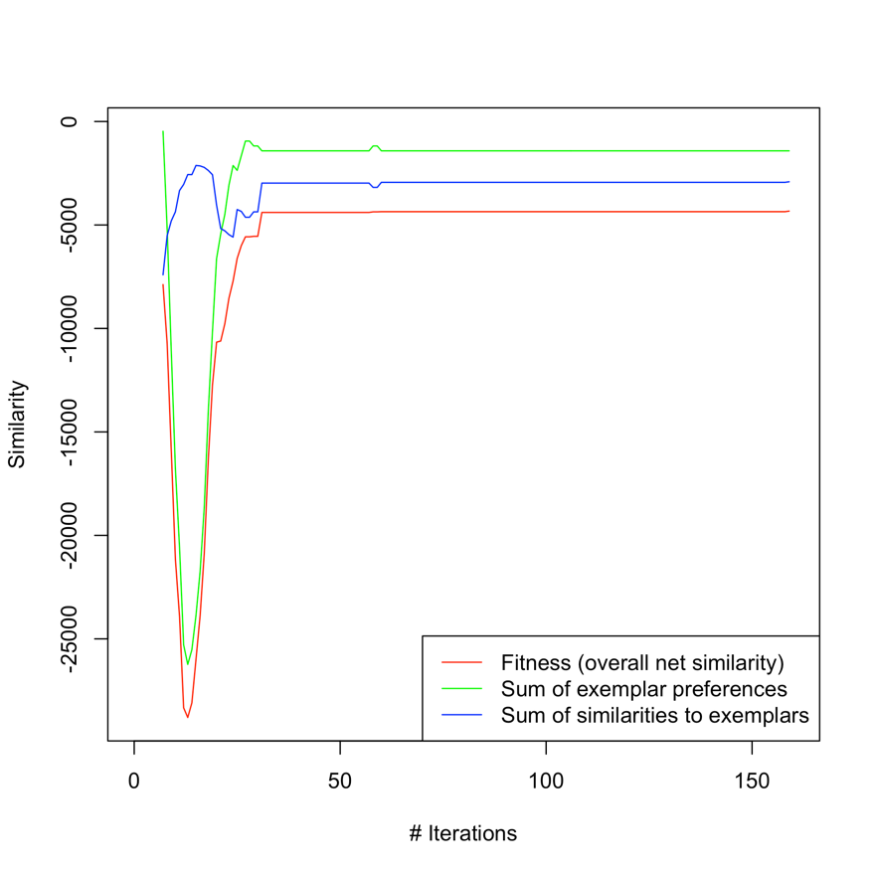
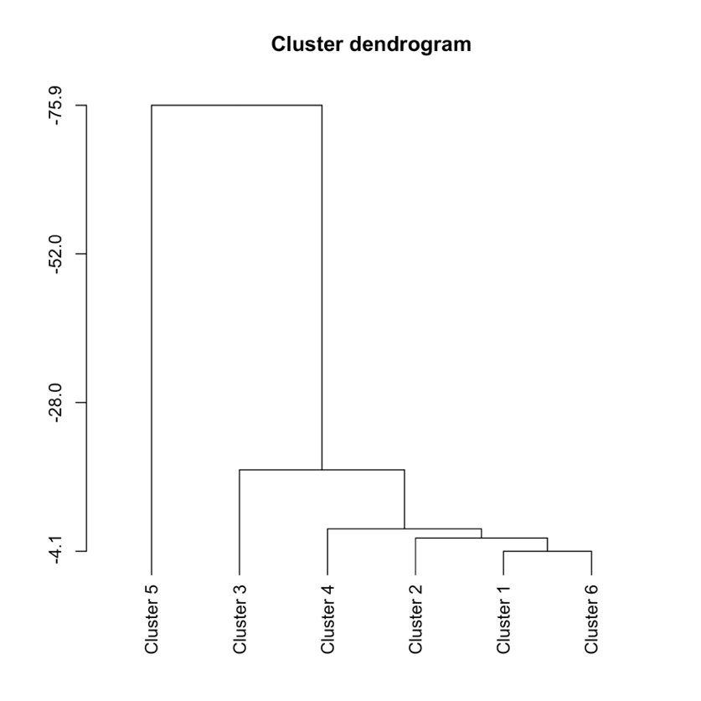
Figure S3. Diagnostic plots from affinity propagation clustering analysis for snapshot ecosystem service bundle types. (A) Similarity measures of affinity propagation across algorithm iterations showing convergence after ~30 iterations, and (B) dendrogram of the snapshot clusters where the height of the vertical bar between clusters represents how different the clusters are (Cluster 1 = Prairie wheat, Cluster 2 = Low input, Cluster 3 = Livestock + corn/soy, Cluster 4 = Field crops + livestock, Cluster 5 = Intensive agriculture, Cluster 6 = Mixed field crops).
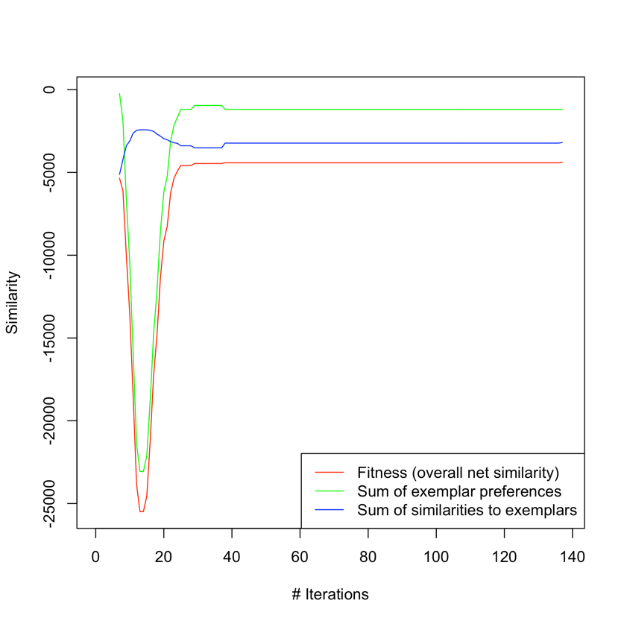
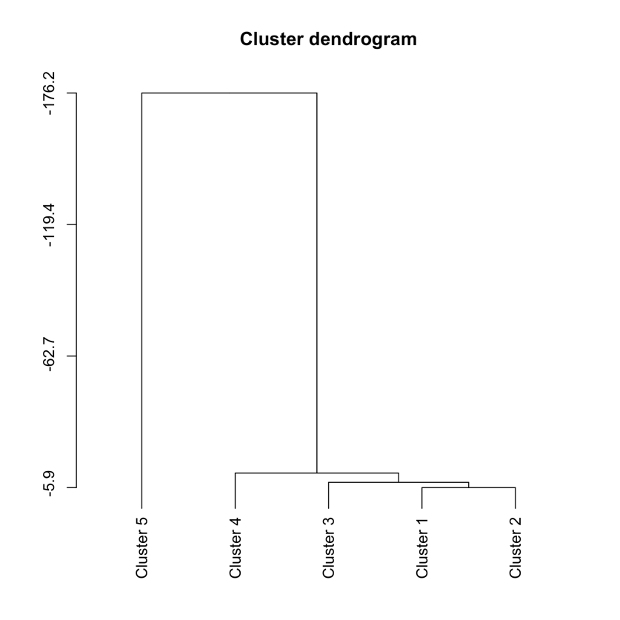
Figure S4. Diagnostic plots from affinity propagation clustering analysis for change ecosystem service bundle types. (A) Similarity measures of affinity propagation across algorithm iterations showing convergence after ~40 iterations, and (B) dendrogram of the snapshot clusters where the height of the vertical bar between clusters represents how different the clusters are (Cluster 1 = Crop loss, Cluster 2 = Service stability, Cluster 3 = Increasing crops & soil, Cluster 4 = Animals to crops, Cluster 5 = Improved ammonia).
Table S3. Moran’s I values for spatial clustering of ecosystem service indicators for agricultural ecodistricts in each year of the analysis.

Ecosystem Service Indicator | 1996 |  | 2001 |  | 2006
 | Observed Moran’s I | P-value | Observed Moran’s I | P-value | Observed Moran’s I | P-value
Crops | 0.105 | 0.000 | 0.128 | 0.000 | 0.087 | 0.000
Livestock | 0.084 | 0.000 | 0.073 | 0.000 | 0.067 | 0.000
Ammonia | 0.088 | 0.000 | 0.070 | 0.000 | 0.078 | 0.000
Dust | 0.177 | 0.000 | 0.156 | 0.000 | 0.178 | 0.000
Soil C | 0.222 | 0.000 | 0.256 | 0.000 | 0.243 | 0.000
Soil erosion | 0.085 | 0.000 | 0.071 | 0.000 | 0.060 | 0.000
N | 0.090 | 0.000 | 0.092 | 0.000 | 0.076 | 0.000
P | 0.089 | 0.000 | 0.076 | 0.000 | 0.051 | 0.000

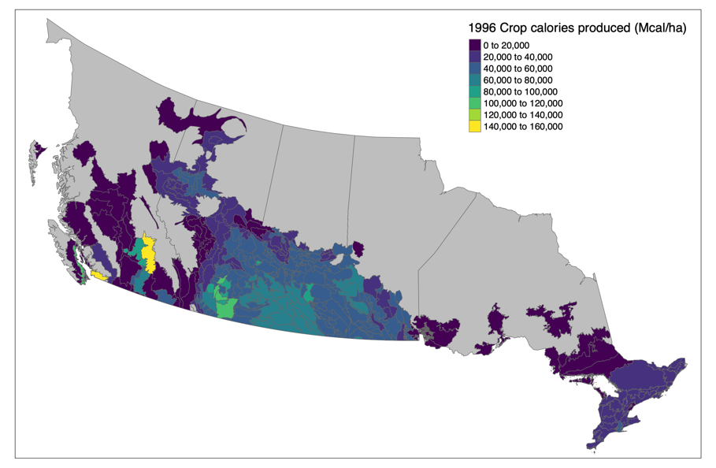
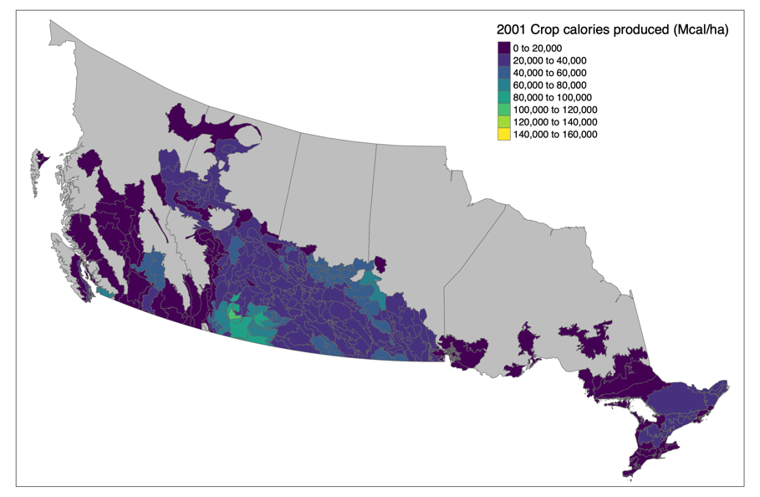
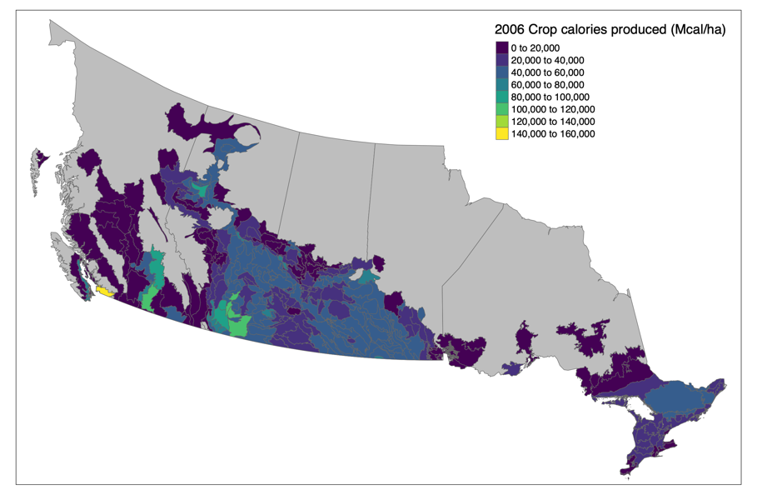
Fig. S5. Crop calories produced (Mcal ha⁻¹) in each ecodistrict in 1996, 2001, and 2006.
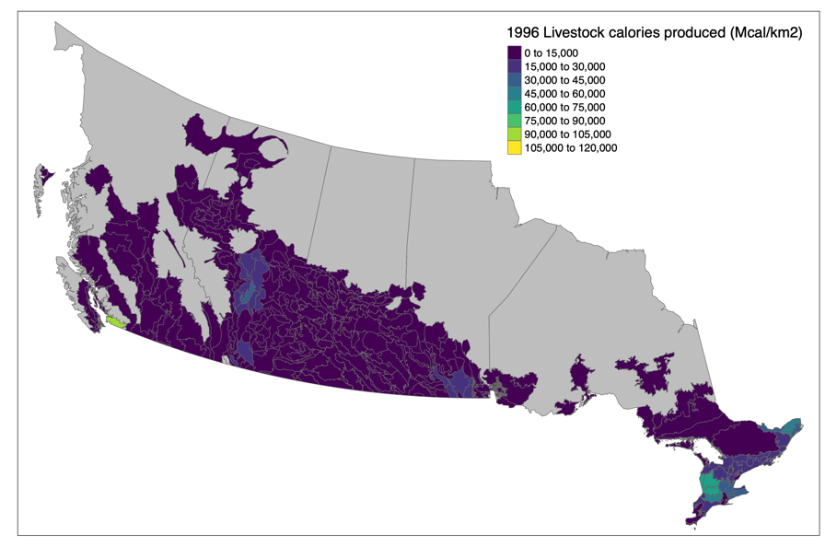
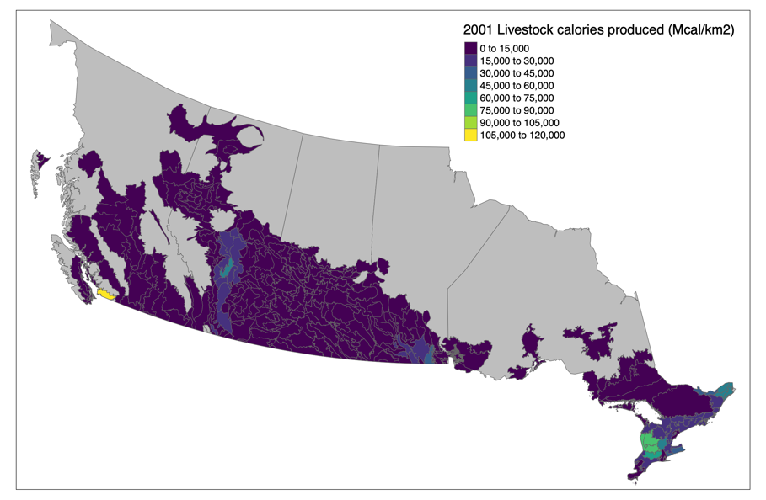
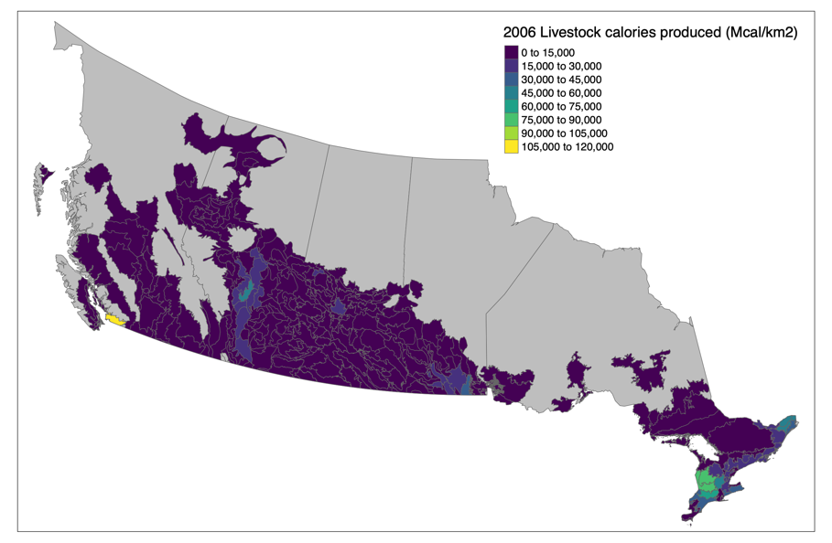
Fig. S6. Livestock calories produced (Mcal km²) in each ecodistrict in 1996, 2001, and 2006.
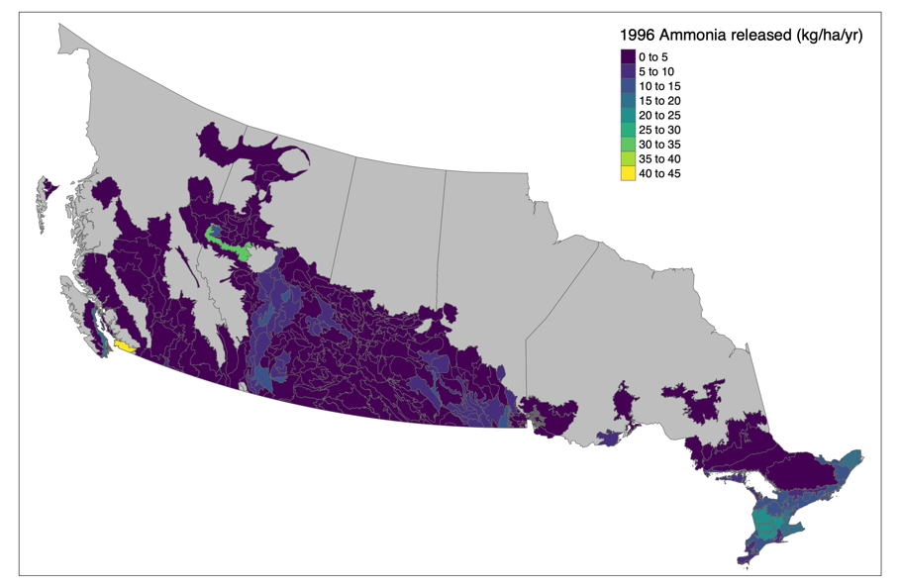
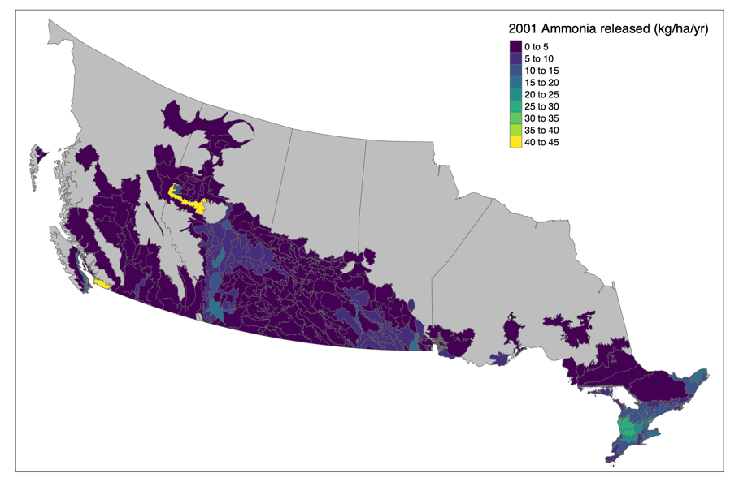
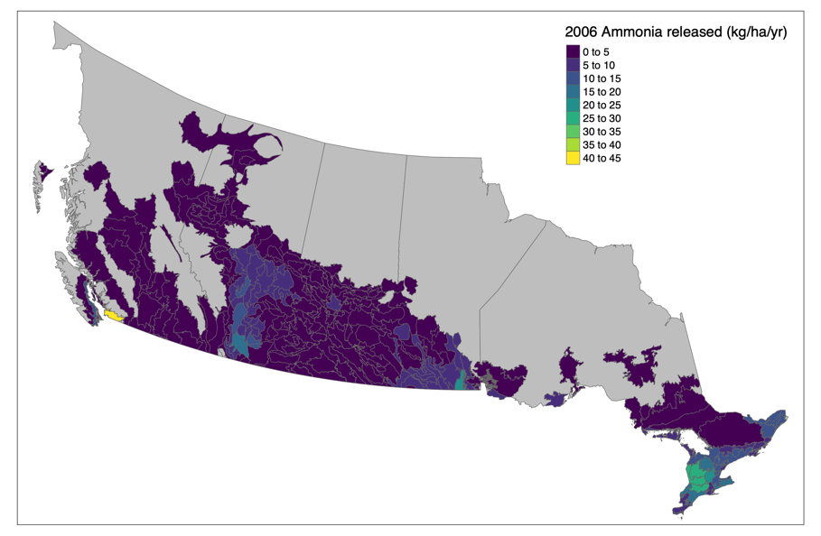

Fig. S7. Ammonia released (kg ha⁻¹ yr⁻¹) in each ecodistrict in 1996, 2001, and 2006.
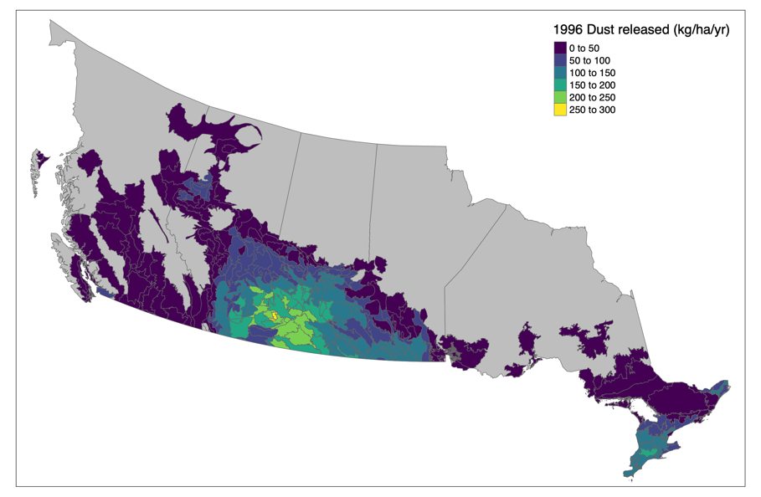
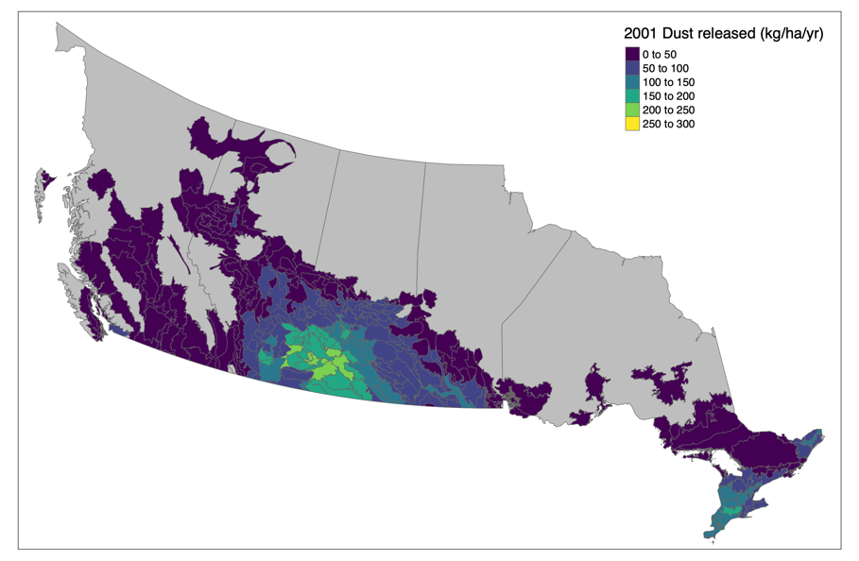
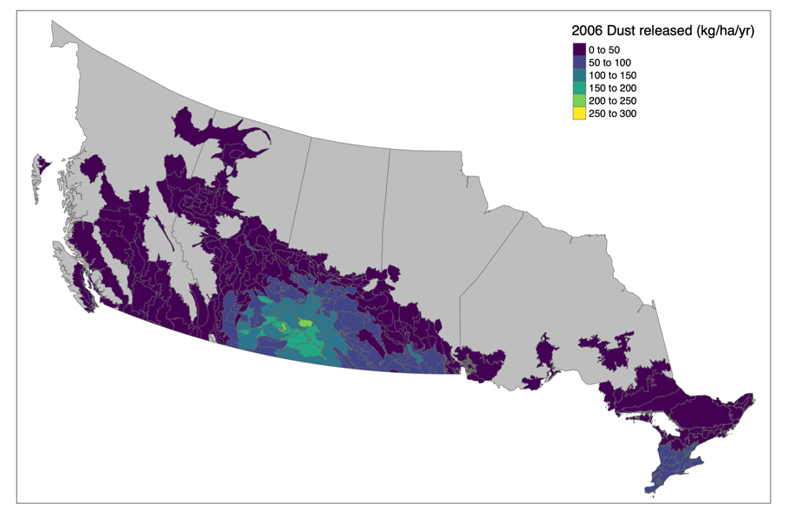
Fig. S8. Dust released (kg ha⁻¹ yr⁻¹) in each ecodistrict in 1996, 2001, and 2006.
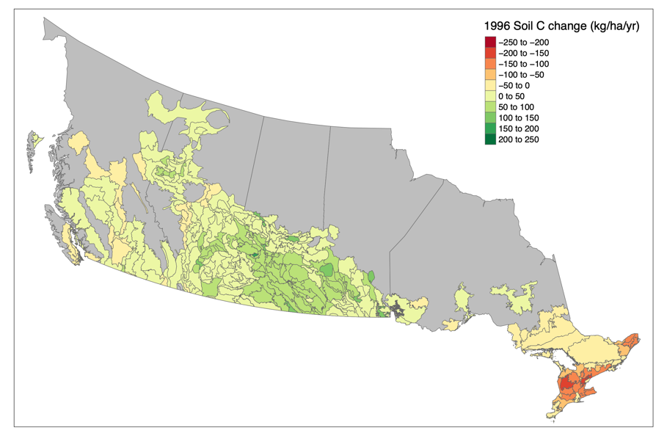
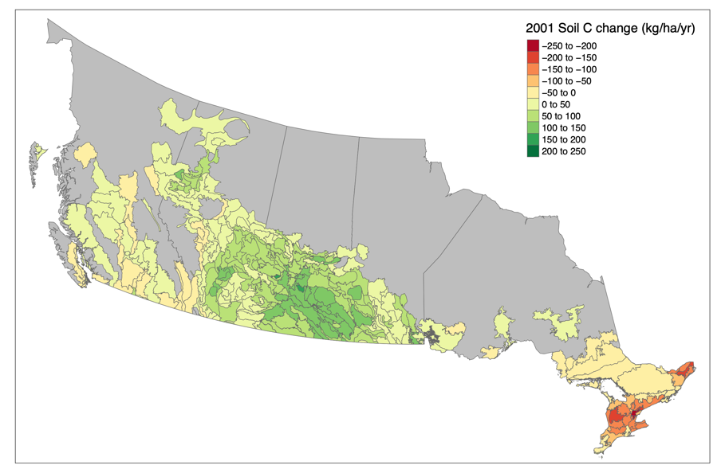
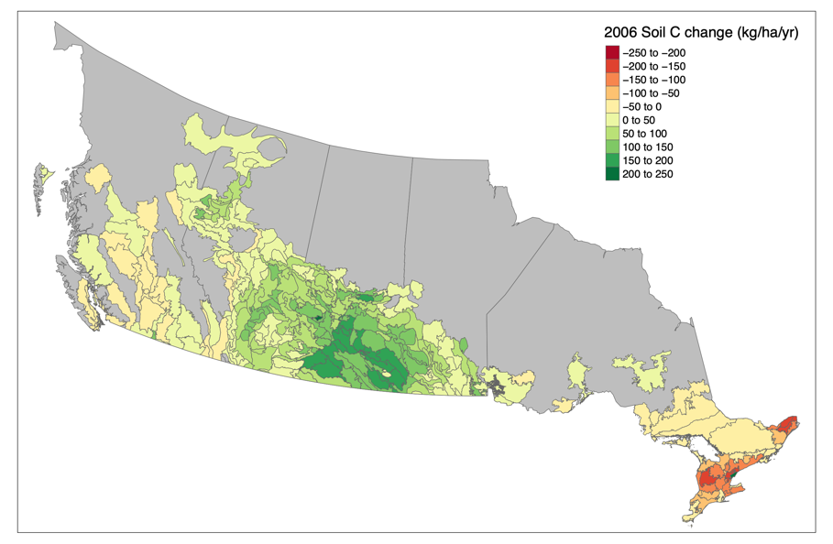
Fig. S9. Soil carbon change (kg ha⁻¹ yr⁻¹) in each ecodistrict in 1996, 2001, and 2006.

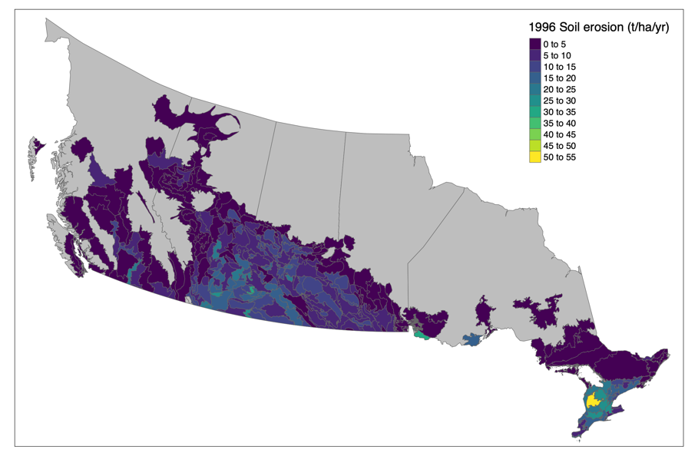
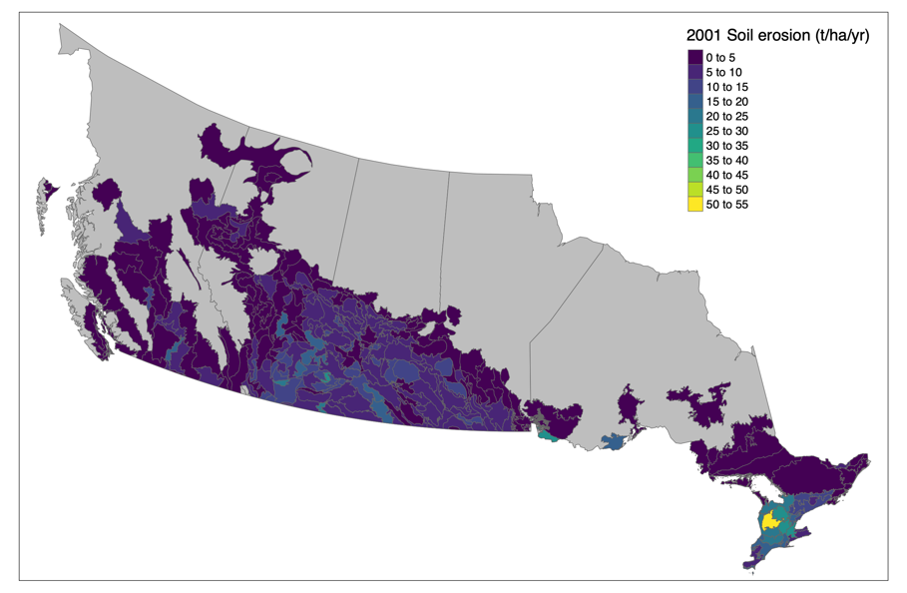
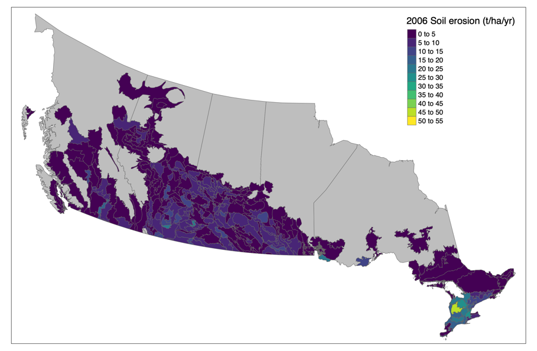
Fig. S10. Soil erosion (tons ha⁻¹ yr⁻¹) in each ecodistrict in 1996, 2001, and 2006.
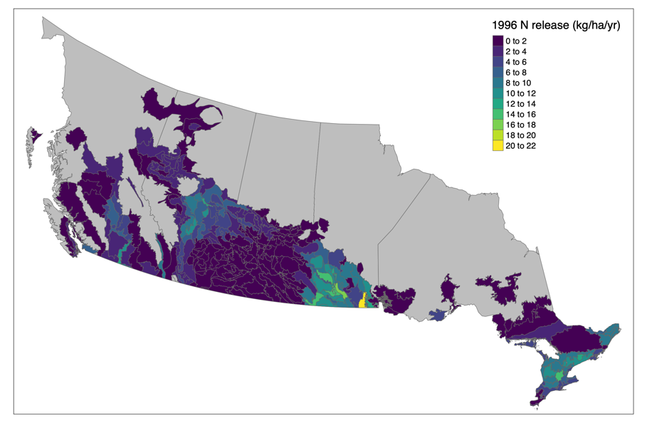
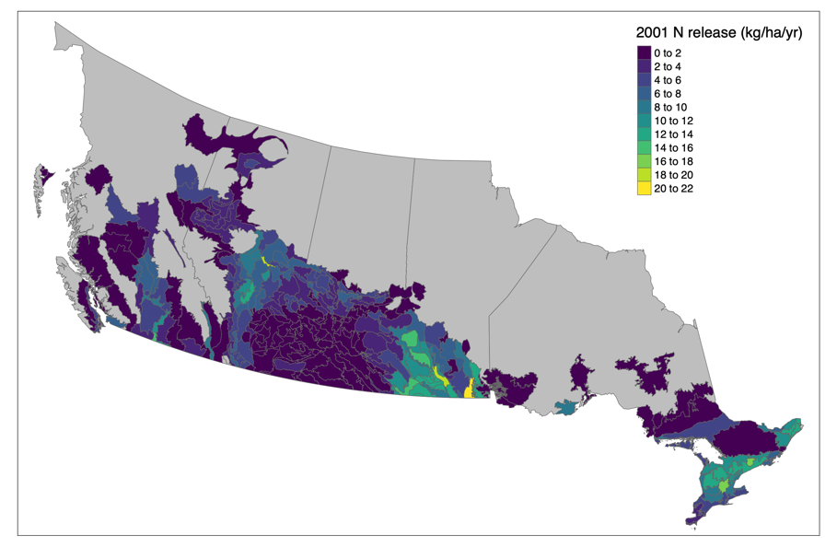
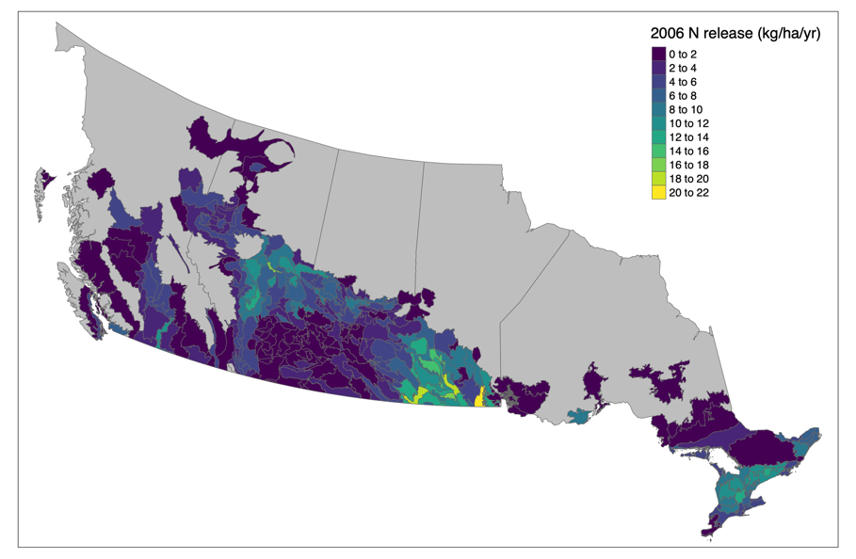
Fig. S11. Nitrogen release to surface water (kg ha⁻¹ yr⁻¹) in each ecodistrict in 1996, 2001, and 2006.

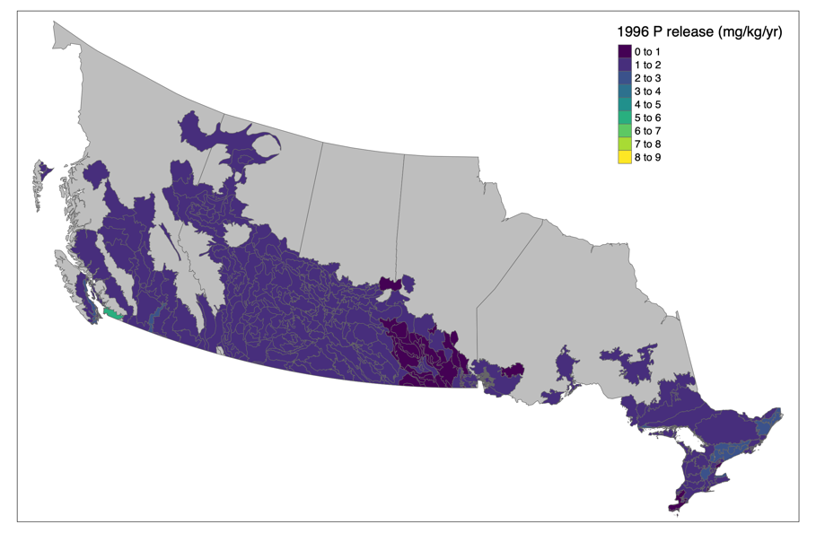
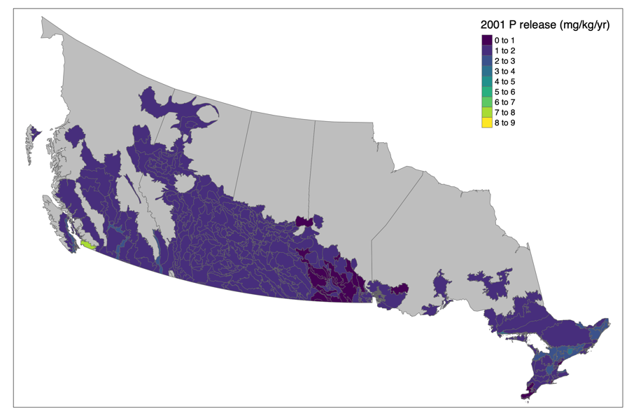
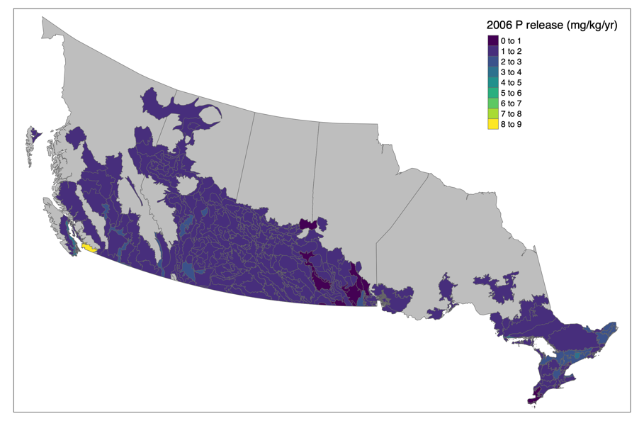
Fig. S12. Phosphorus release to surface water (mg kg⁻¹ water yr⁻¹) in each ecodistrict in 1996, 2001, and 2006.
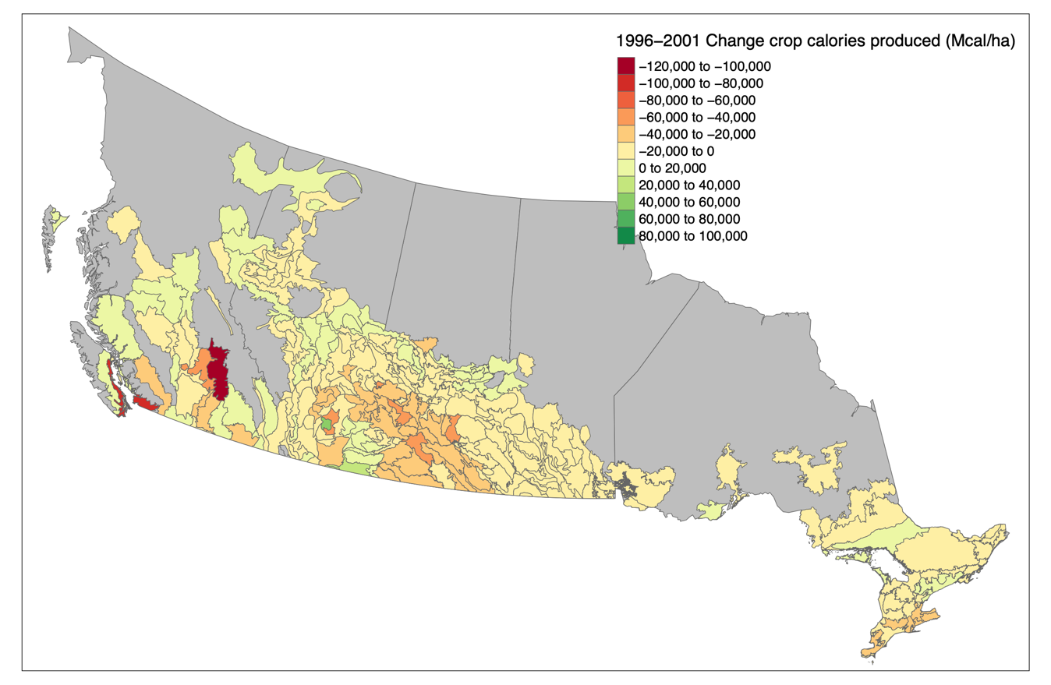
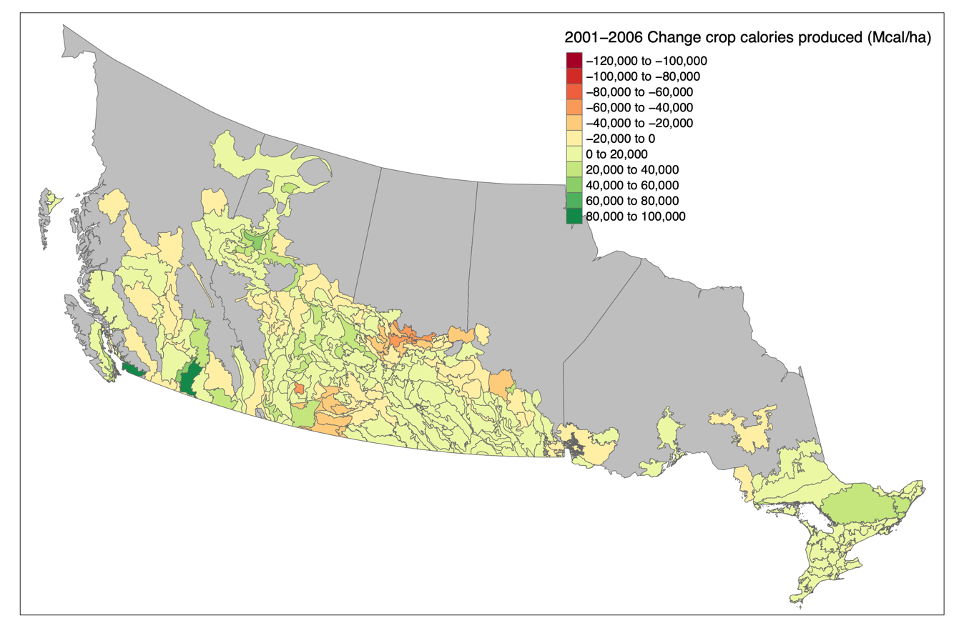
Fig. S13. Change in crop calories produced (Mcal ha⁻¹) in each ecodistrict between 1996-2001 and 2001-2006.
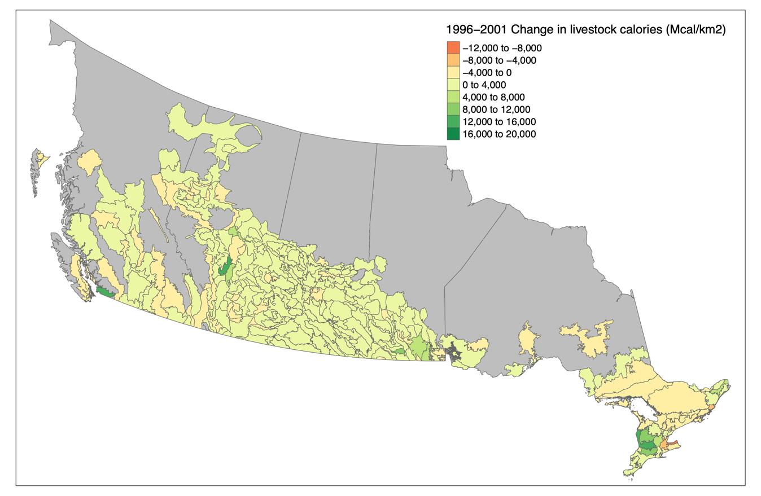
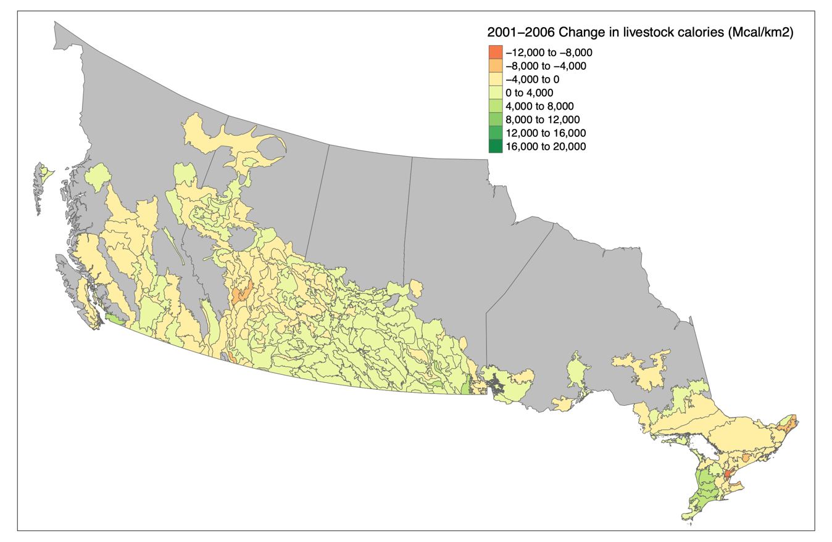
Fig. S14. Change in livestock calories produced (Mcal ha⁻¹) in each ecodistrict between 1996-2001 and 2001-2006.
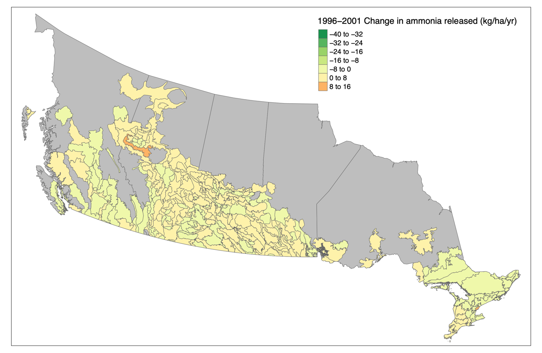
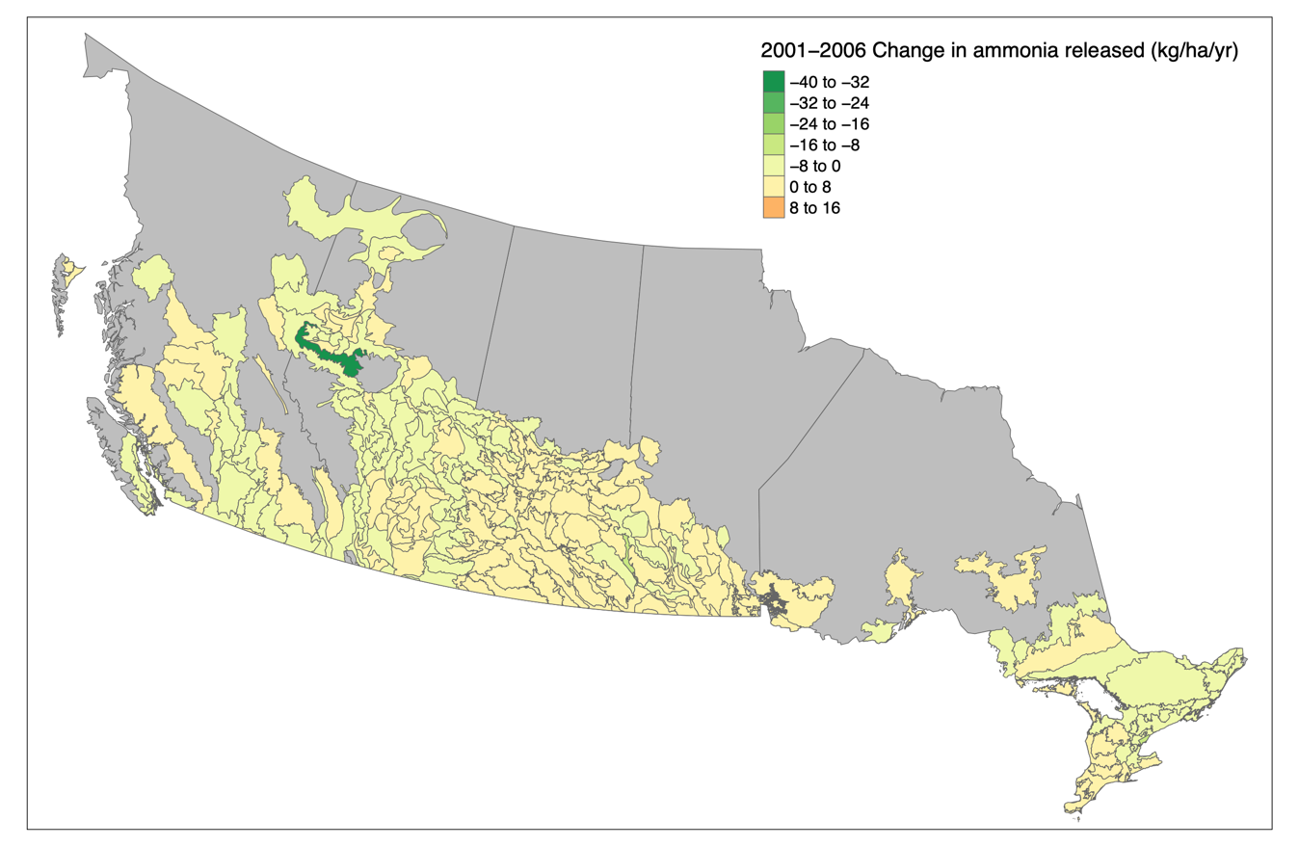
Fig. S15. Change in ammonia released (kg ha⁻¹ yr⁻¹) in each ecodistrict between 1996-2001 and 2001-2006.
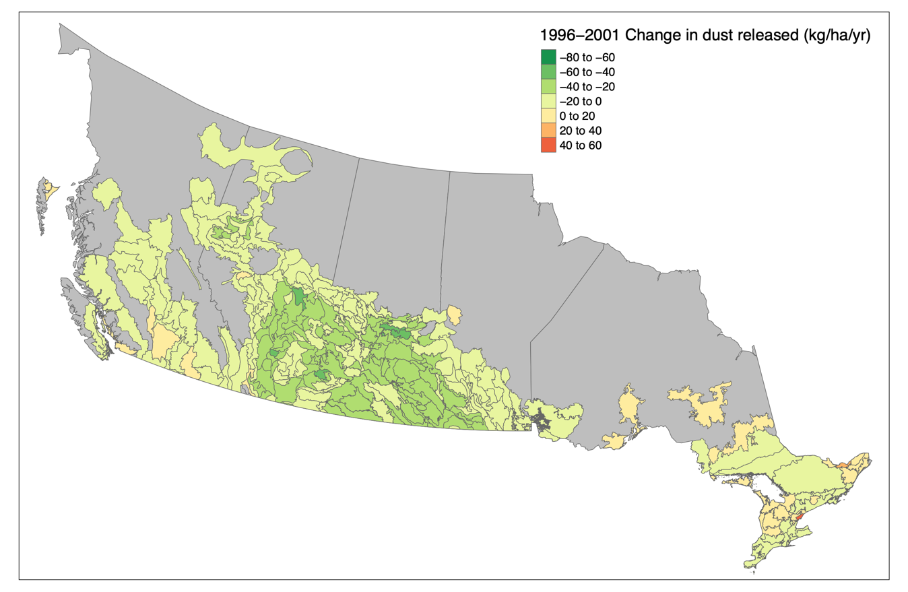
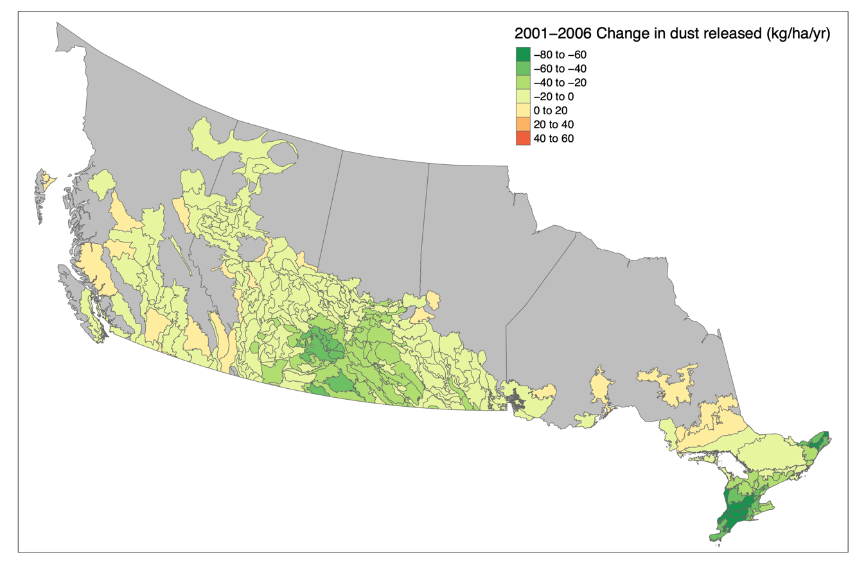
Fig. S16. Change in dust released (kg ha⁻¹ yr⁻¹) in each ecodistrict between 1996-2001 and 2001-2006.
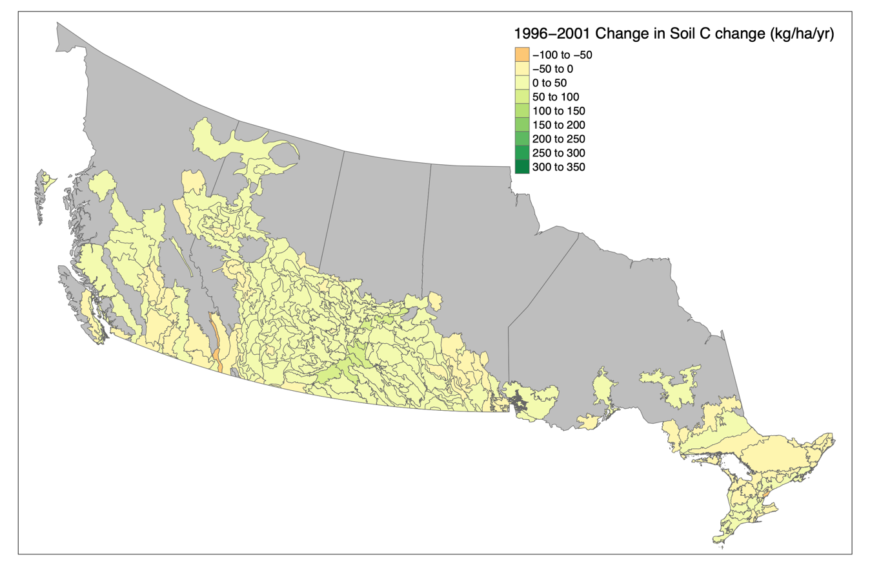
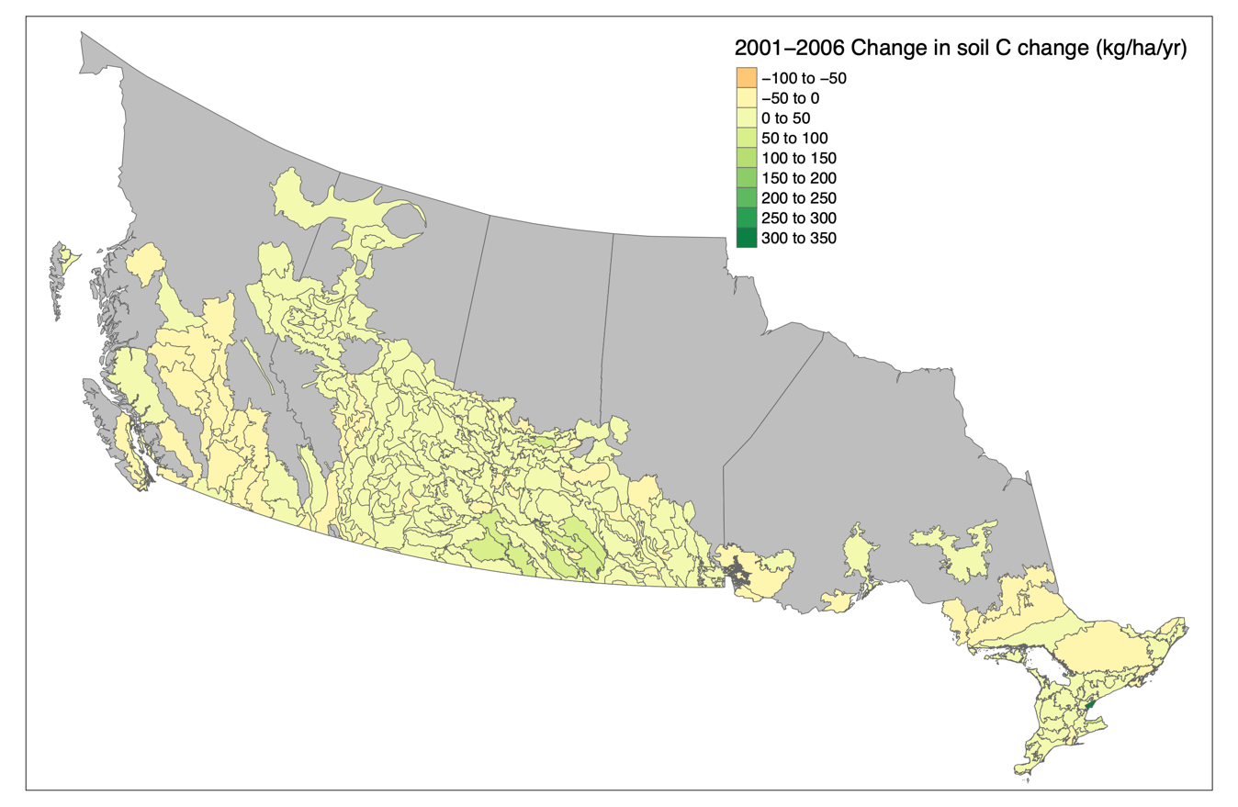
Fig. S17. Change in soil carbon change (kg ha⁻¹ yr⁻¹) in each ecodistrict between 1996-2001 and 2001-2006.
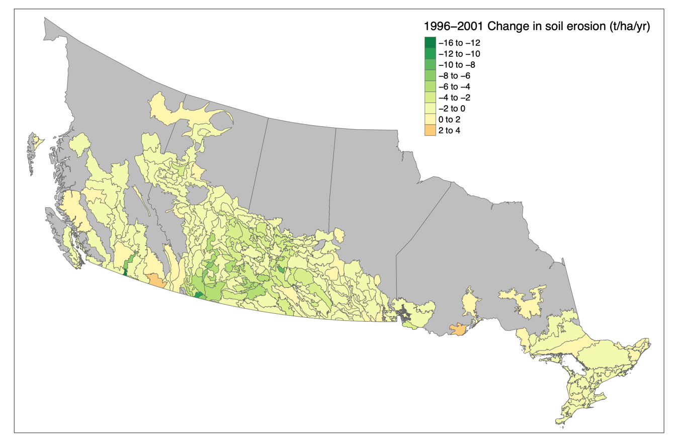
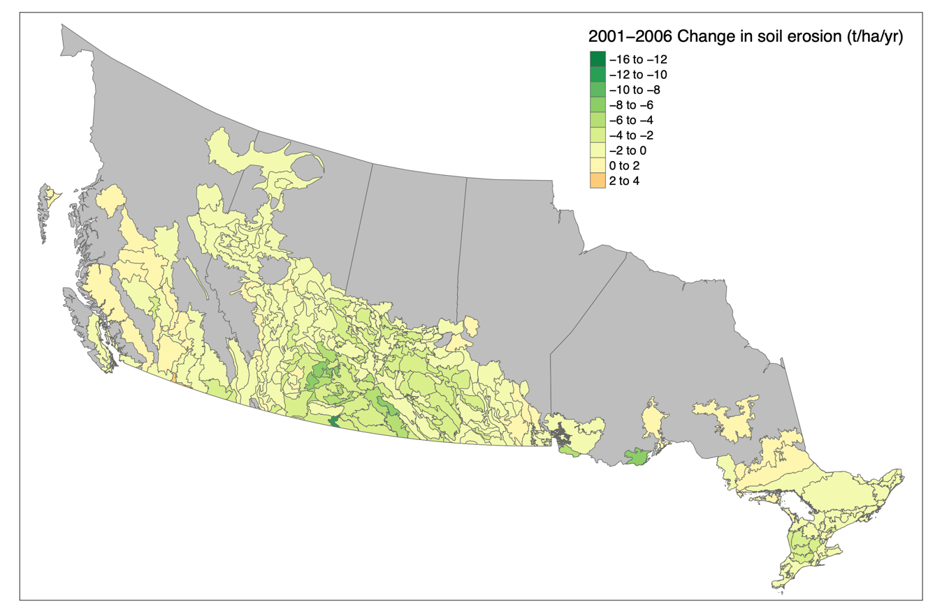
Fig. S18. Change in soil erosion (tons ha⁻¹ yr⁻¹) in each ecodistrict between 1996-2001 and 2001-2006.
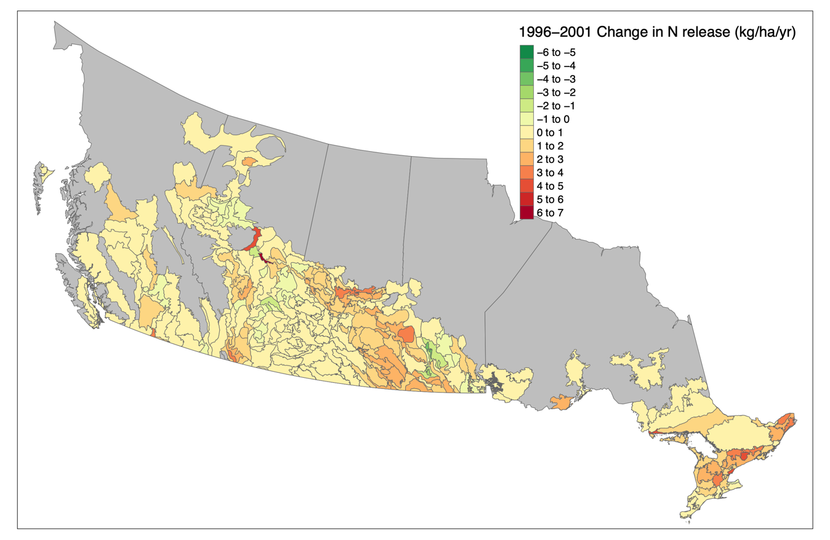
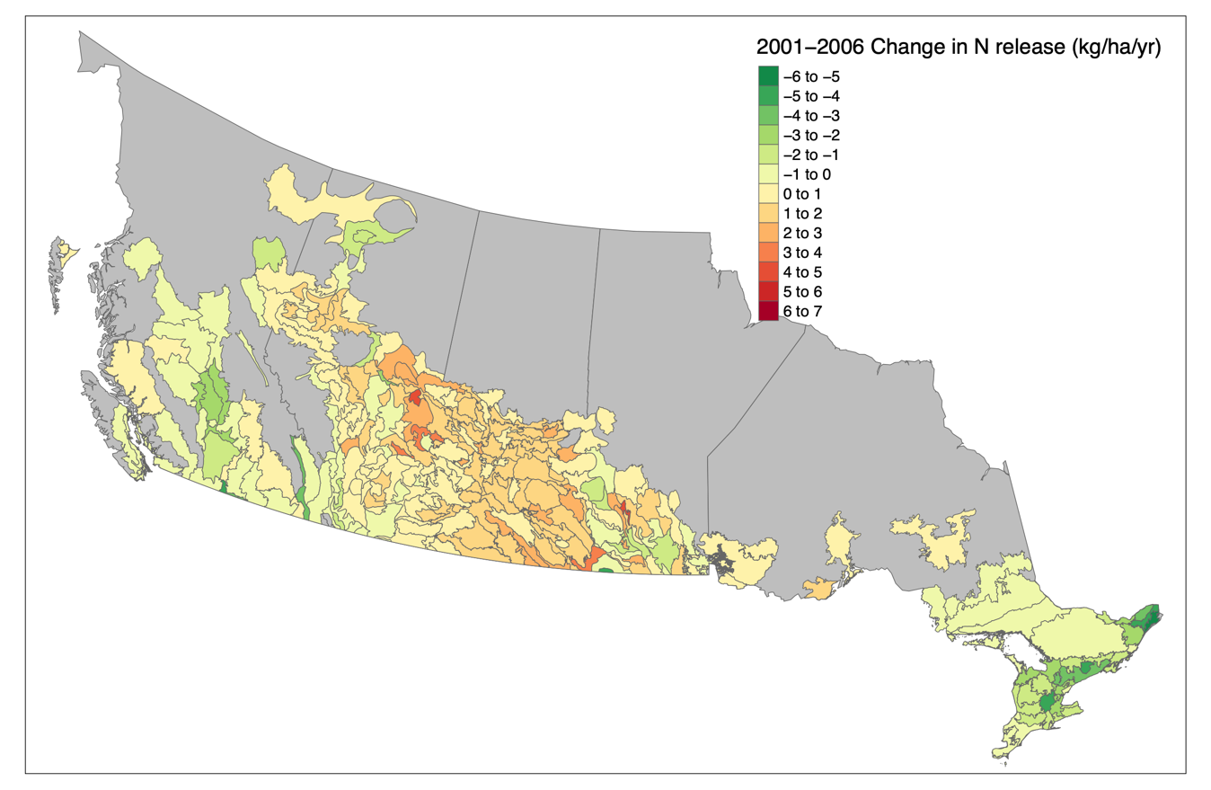
Fig. S19. Change in nitrogen released to surface water (kg ha⁻¹ yr⁻¹) in each ecodistrict between 1996-2001 and 2001-2006.
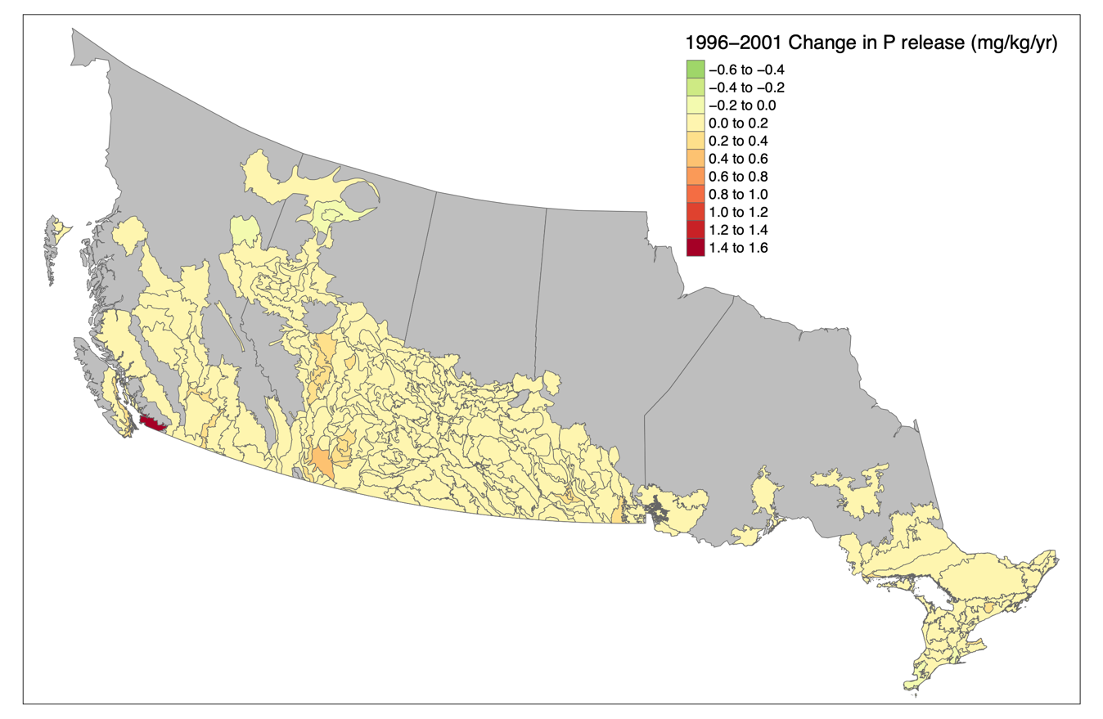
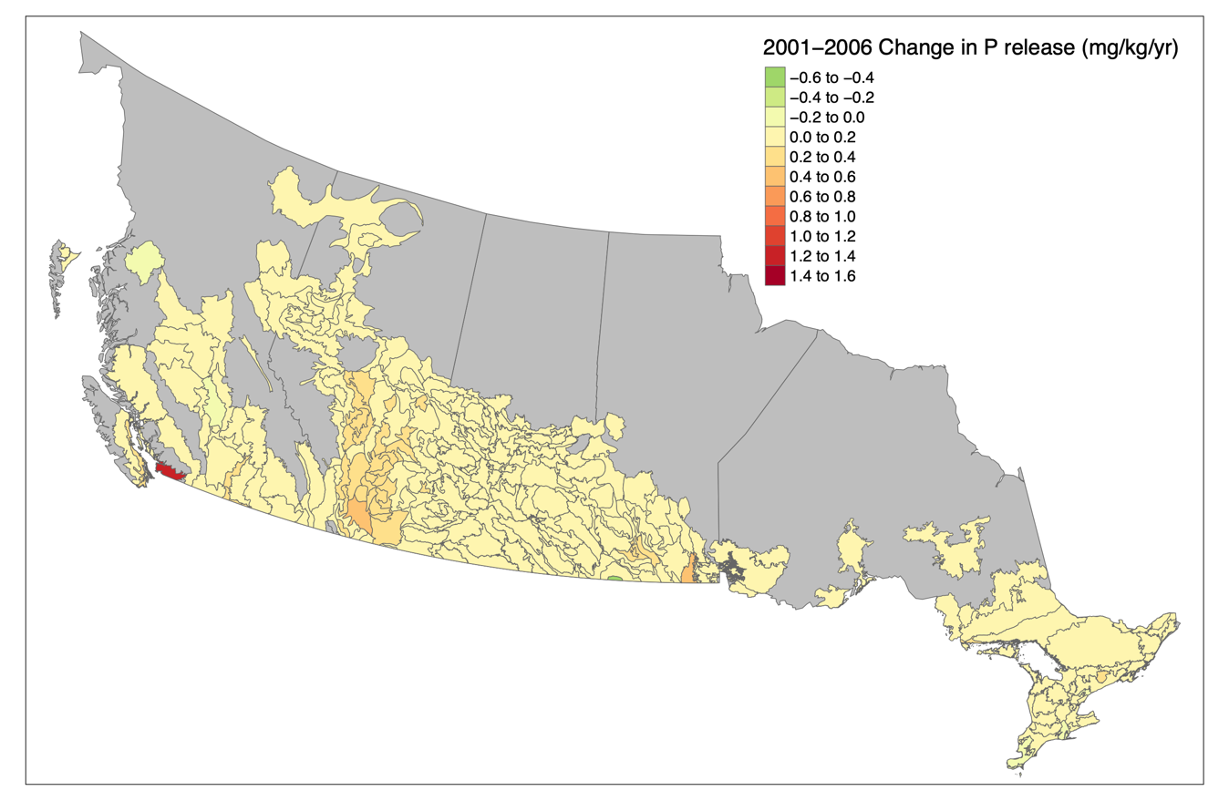
Fig. S20. Change in phosphorus released to surface water (mg kg⁻¹ water yr⁻¹) in each ecodistrict between 1996-2001 and 2001-2006.
Table S4. Snapshot and change pairwise correlations between ecosystem service indicators for all three individual years of the analysis (1996, 2001, and 2006) and two time steps (1996-2001 and 2001-2006) as well as overall changes in correlation strength and directions.

Ecosystem Service Pair | Snapshot Correlations |  |  |  | Change Correlations
 | 1996 | 2001 | 2006 | Change | 1996-2001 | 2001-2006 | Change
Crops–Livestock | 0.24* | 0.25* | 0.37* | None | -0.20* | 0.35* | –/+
Crops–Ammonia | -0.08 | -0.16* | -0.33* | •/– | 0.09 | -0.34* | •/–
Crops–TSP | -0.73* | -0.50* | -0.45* | None | -0.35* | 0.58* | –/+
Crops–Soil C | 0.59* | 0.56* | 0.40* | None | -0.26* | 0.49* | –/+
Crops–P | 0.05 | 0.11 | -0.13 | None | 0.03 | -0.25* | •/–
Crops–Erosion | -0.50* | -0.33* | -0.27* | None | -0.27* | 0.55* | –/+
Crops–N | 0.35* | 0.04 | -0.10 | +/• | -0.11 | -0.36* | •/–
Livestock–NH3 | -0.81* | -0.80* | -0.81* | None | -0.54* | -0.57* | None
Livestock–TSP | -0.46* | -0.49* | -0.49* | None | 0.35* | 0.21* | None
Livestock–Soil C | 0.03 | 0.07 | 0.09 | None | 0.33* | 0.18* | +/•
Livestoc–-P | -0.37* | -0.41* | -0.45* | None | -0.14 | 0.09 | None
Livestock–Erosion | -0.42* | -0.43* | -0.44* | None | 0.29* | 0.23* | None
Livestock–N | -0.42* | -0.47* | -0.54* | None | -0.19* | -0.31* | •/–
NH3–TSP | 0.25* | 0.30* | 0.33* | None | -0.32* | -0.28* | None
NH3–Soil C | 0.05 | 0.04 | -0.03 | None | -0.32* | -0.16 | –/•
NH3–P | 0.30* | 0.32* | 0.38* | None | -0.01 | -0.09 | None
NH3–Erosion | 0.29* | 0.32* | 0.40* | None | -0.20* | -0.25* | None
NH3–N | 0.58* | 0.61* | 0.64* | None | 0.05 | 0.31* | •/+
TSP–Soil C | -0.45* | -0.44* | -0.54* | None | 0.82* | 0.55* | None
TSP–P | 0.11 | 0.17* | 0.17* | None | 0.10 | -0.02 | None
TSP–Erosion | 0.66* | 0.66* | 0.59* | None | 0.64* | 0.65* | None
TSP–N | -0.32* | -0.16* | 0.00 | –/• | -0.09 | -0.16 | None
Soil C–P | 0.32* | 0.28* | 0.22* | None | 0.26* | -0.16 | +/•
Soil C–Erosion | -0.20* | -0.18* | -0.13 | –/• | 0.58* | 0.49* | None
Soil C–N | 0.27* | 0.25* | 0.03 | +/• | -0.10 | -0.33* | •/–
P–Erosion | 0.34* | 0.32* | 0.35* | None | -0.03 | -0.08 | None
P–N | 0.11 | 0.17* | 0.23* | •/+ | 0.03 | 0.08 | None
Erosion–N | -0.09 | 0.04 | 0.19* | None | -0.11 | -0.46* | •/–

Table S5. Comparison of the numbers of ecosystem service pairs in different correlation categories for spatial and temporal correlations. Strong correlations correspond to this greater than 0.2 or less than -0.2. Weak correlations are those less than 0.2 and greater than -0.2. Statistical significance was evaluated at P < 0.01 with a Chi-square test. Values on the diagonal from top left to bottom right represent no change in correlation direction or strength between spatial and temporal correlations.

Spatial Pairwise Correlation | Temporal Pairwise Correlation
 | Strongly + | Weakly + | Nonsig. | Weakly – | Strongly –
Strongly + | 2 | 1 | 5 | 0 | 2
Weakly + | 1 | 0 | 0 | 0 | 0
Nonsignificant | 1 | 0 | 2 | 1 | 2
Weakly – | 1 | 0 | 1 | 0 | 0
Strongly – | 3 | 0 | 4 | 0 | 2

