SUPPLEMENTARY DATA

Supplementary table 1. Main characteristics of the XP-C patients involved in the study
The three patients had regular follow-up after initial diagnosis at the Dermatology Department, Pediatric Unit, Bordeaux Hospital (Reference Center for Rare diseases of the Skin) for careful examination of pre-cancerous lesions. Genotyping was performed on whole blood at the first visit, after obtaining informed consent from the parents. XPC gene analysis was performed by Sanger sequencing as previously described [60], and bi-allelism was confirmed by parental testing. Five different XPC gene defects were identified, each resulting in a premature stop, due to either a small deletion (XP-C1-homozygous XPC prevalent mutation, XP-C2-allele 2, XP-C3-allele 2) or a non-sense (XP-C3-allele 1). Such gene defects are the common rule in XPC disease [60]. RNA analysis was performed in patient 2, in order to confirm the splicing defect (allele 1: deletion at the splice site).
Patient id | Geographic origin | Main clinical features | XPC gene defect (NM_004628.4) | Age at diagnosis
XP-C1 | Morocco | Early skin photosensitivity | c.1643_1644del, p. (Val548Alafs*25) homozygous | 2 y
XP-C2 | Portugal | Moderate skin photosensitivity - multiple lentigines | [c.413-3delC, p.?], [c.1086del, p. (Ser363Alafs*163)]  compound heterozygous | 14 y
XP-C3 | West Indies/Chile | Skin photosensitivity -multiple lentigines - precancerous lesions | [c.1243C>T, p. (Arg415*)], [c.2287del, p.(Leu763Cys*4)]  compound heterozygous | 6 y

Supplementary table 2. Reverse and forward primers used in RT-qPCR. The primers were used at a concentration of 2 µM in a mix with MESA Blue qPCR MASTER-MIX, distilled water and 5µL of each cDNA. Amplification integrity was checked at the end of each run by melting-curve analysis.

Primers | Forward | Reverse
XPC | CCATGAGGACACACACAAGG | TCCAATGAACCACTTCACCA
OGG1 | TGGAAGAACAGGGCGGGCTA | ATGGACATCCACGGGCACAG
MYH | CCAGAGAGTGGAGCAGGAAC | TTTCTGGGGAAGTTGACCAC
APE1 | GCTGCCTGGACTCTCTCATC | GCTGTTACCAGCACAAACGA
LIG3 | GCTCAGCAGGAGATGGTTTC | TCTAGGTCCCGTGCCATATC
XRCC1 | CAGCCCTACAGCAAGGACTC | GCTGTGACTGGGGATGTCTT
Polβ | GAGAAGAACGTGAGCCAAGC | CGTATCATCCTGCCGAATCT

Supplementary table 3. Measurement of LD50 for normal and XP-C primary fibroblasts upon exposure to different UVB-doses. LD50 represents the UVB dose that will reduce 50% of the in-vitro cell survival. It is calculated after short-cytotoxicity test that represents cellular viability vs. UVB doses. The results represent the average of three different experiments, n=3.

Fibroblasts | LD50 J/cm² | LD50 for all together J/cm²
Normal N=3 | 0.147 | 0.1355
XP-C1 | 0.179
XP-C2 | 0.064
XP-C3 | 0.152

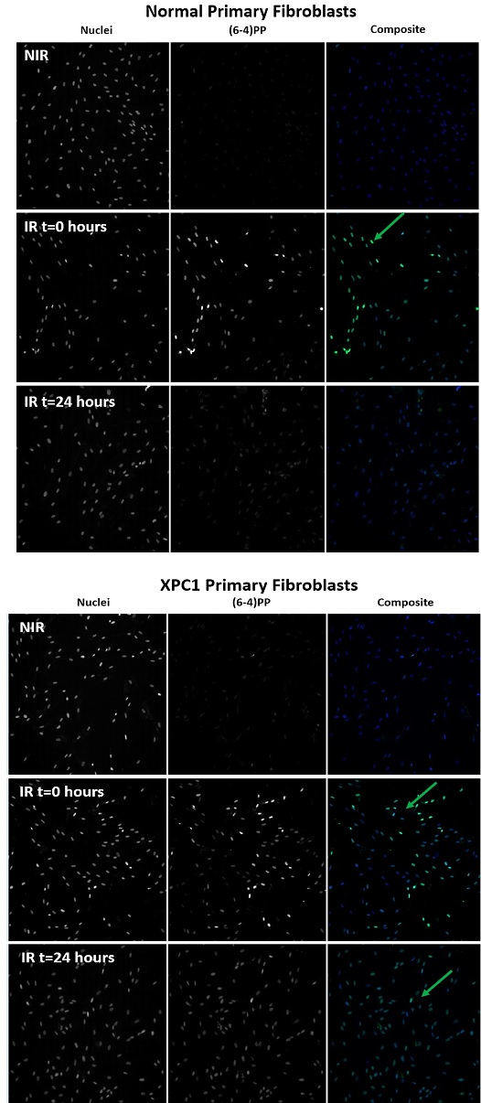
Supplementary figure 1. Immunocytochemistry images showing the 6-4PP photoproducts in normal and XP-C primary fibroblast, XP-C1. This was done at 0 and 24 hours post-UVB-irradiation where anti-(6-4) PP was used to detect how (6-4) PPs is repaired by time in control and mutated fibroblasts. Green color represents the presence of (6-4) PPs in the nuclei. Nuclei were visualized by Hoechst staining. As shown above, no lesions were detected in all fibroblasts without UVB stress. Upon UVB treatment, lesions appear at t=0 hours to be repaired almost completely in the normal fibroblasts but still present in XP-C fibroblast (XP-C1).

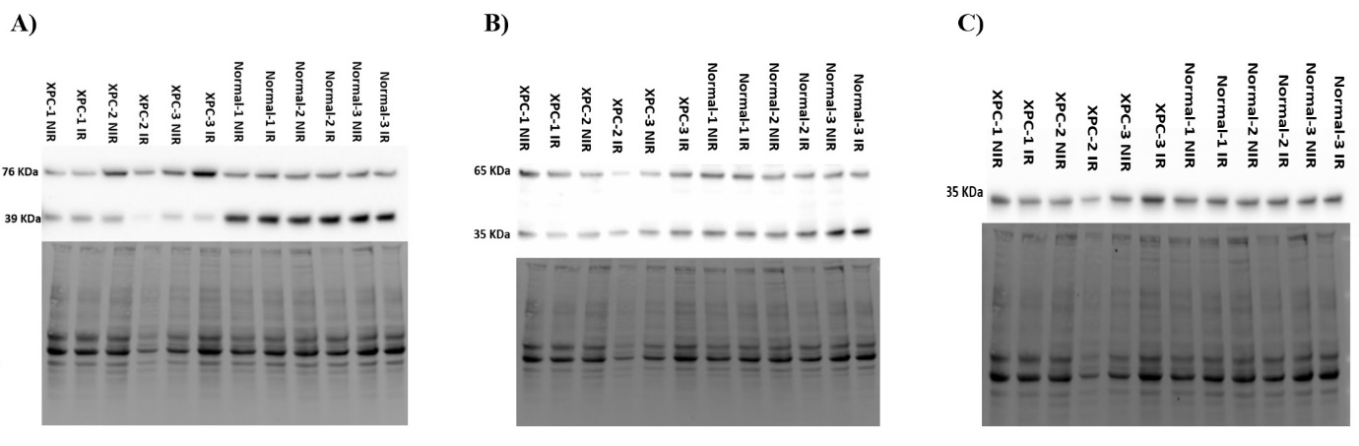
Supplementary figure 2. OGG1, MYH, and APE1 protein expression in normal and XP-C primary fibroblasts at basal and UVB-irradiation levels. A) OGG1 protein expression (76 and 39 KDa, 2 isoforms) is downregulated at basal and UVB-irradiation levels in XP-C fibroblasts compared to normal (N=3), B) MYH protein expression (65 and 35 KDa, complete and degraded protein) is downregulated at basal and UVB-irradiation levels in XP-C fibroblasts compared to normal (N=3), C) APE1 protein expression (35 KDa) is downregulated at basal and UVB-irradiation levels in XP-C2 fibroblast compared to normal (N=3). Proteins’ level intensities were detected at 4 hours post UVB-irradiation and were quantified using Image LabTM software. Target proteins’ expression was normalized to the total protein extract.
IR, irradiated, NIR, Non-Irradiated

