Supplementary Material

Supplementary Figure 1. The mutation sites in the VH and VL regions compared with omalizumab (*represent mutation sites).

Supplementary Table 1. Summary of biophysical and biological comparability assessment between L0H0 and omalizumab.

Supplementary Figure 2. Free IgE suppression in cynomolgus monkeys.

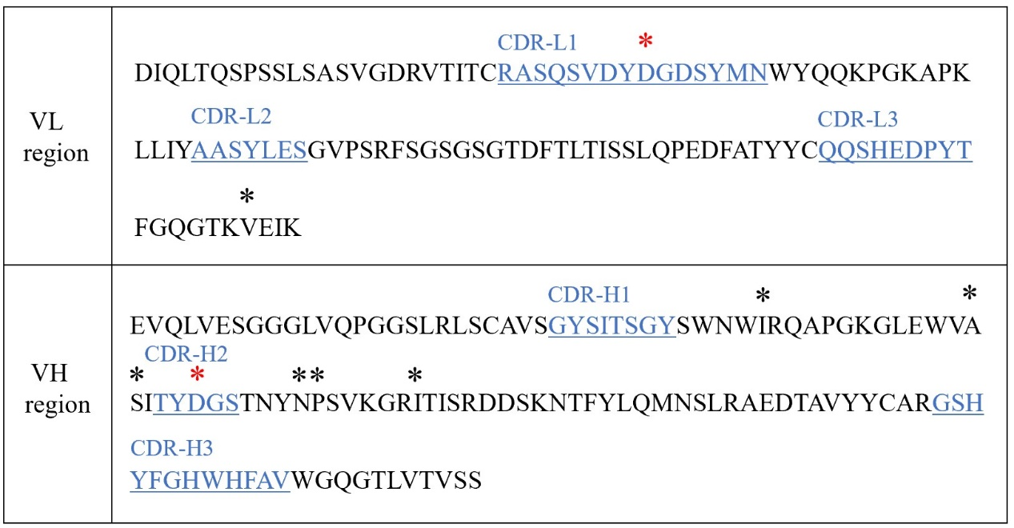Supplementary Figure 1. The mutation sites in the VH and VL regions compared with omalizumab (*represent mutation sites). Compared with the sequence of omalizumab, two amino acids in the CDRs of omalizumab were removed to improve antibody stability (*in red), Meanwhile, seven murine amino acids in the framework region of omalizumab were replaced with human source to minimize the potential immunogenicity (*in black).

Supplementary Table 1. Summary of biophysical and biological comparability assessment between L0H0 and omalizumab
Category | Assay |  | Sample name
 |  |  | L0H0 | omalizumab
Biophysical characteristics | SEC-HPLC | Monomer (%) | 99.7 | 99.6
 | nrCE-SDS | IgG (%) | 97.7 | 97.6
 | rCE-SDS | LC+HC (%) | 98.4 | 98.2
 | DSF | Fab Tm (℃) | 88.5 | 88.0
 | iCIEF | pI value | 7.5 | 7.5
 | Charge variants assay by iCIEF | Acidic peaks (%) | 10.6 | 12.2
 |  | Main peak (%) | 80.6 | 79.3
 |  | Basic peaks (%) | 8.9 | 8.5
Biological activity | Affinity to IgE (nM) |  | 0.40 | 0.47
 | Blocking activity (nM) |  | 1.85 | 1.59
 | Affinity to FcRn (μM) |  | 0.09 | 0.10

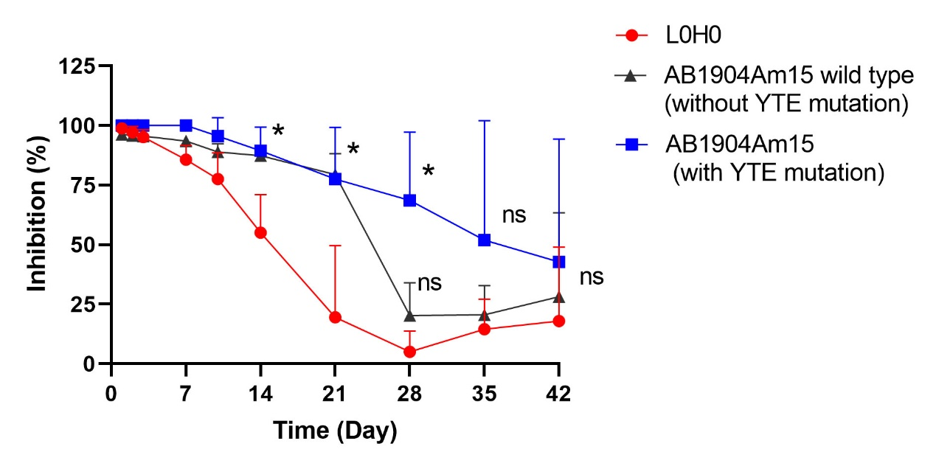Supplementary Figure 2. Free IgE suppression in cynomolgus monkeys. Cynomolgus monkeys received a single dose of 10 mg/kg test antibody via subcutaneous administration (n=3/group). Serum samples were collected at the following time points: pre-dose, 1,2, 3, 7, 10, 14, 21, 28, 35, and 42 days post dose. Serum concentrations of free IgE were measured by an ELISA method. Results were presented as mean ± SD (*P < 0.05, ns, no significance, performed by t-test).

