The response of estuarine ammonia-oxidizing communities to constant and fluctuating salinity regimes
J.P. Santos^{1,2 *}, A.G.G. Sousa¹, H. Ribeiro^{1,3} and C. Magalhães^{1,4,5,6}
¹ CIIMAR - Centro Interdisciplinar de Investigação Marinha e Ambiental, Universidade do Porto, Terminal de Cruzeiros do Porto de Leixões, Av. General Norton de Matos s/n, 4450-208, Matosinhos, Portugal
² Department F.A. Forel for Environmental and Aquatic Sciences, Section of Earth and Environmental Sciences and Institute for Environmental Sciences, University of Geneva, Carl-Vogt 66, CH-1211 Geneva, Switzerland
³ Abel Salazar Institute of Biomedical Sciences, University of Porto (ICBAS-UP), Rua Jorge Viterbo Ferreira, 228, Porto 4050-313, Portugal
⁴ FCUP - Faculdade de Ciências da Universidade do Porto, Porto, Portugal
⁵ School of Science & Engineering, University of Waikato, Hamilton, New Zealand
⁶ Ocean Frontier Institute, Dalhousie University, Halitax, NS, Canada

Correspond author:
*Corresponding author: joaofs21@gmail.com

Supplementary Figures

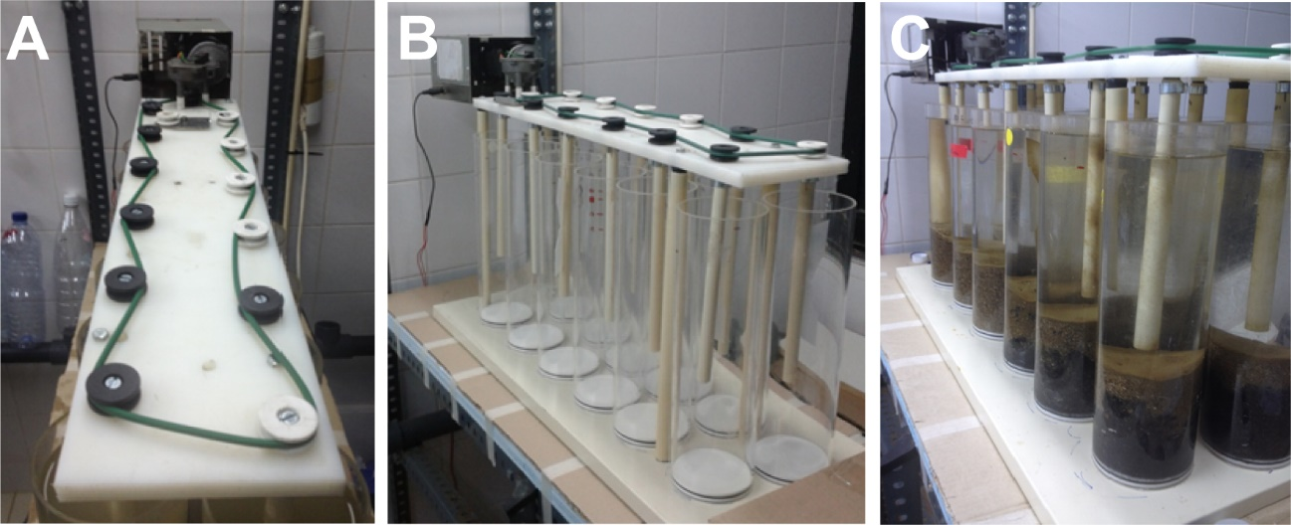
Figure S1. Pictures of the upper part (Figure S1-A) of the autonomous water agitation system for 12 acrylic reactors before (Figure S1-B) and during the incubation (Figure S1-C) experiment.

Figure S2. Hierarchical cluster analysis using the average linkage of Bray-Curtis similarity for the presence or absence of archaeal amoA transcripts (cDNA) and genes (DNA) under different salinity treatments (constant – CR_C and AF_C, and fluctuation – CR_Δ and AF_Δ) from Afurada (Figure S2-A) and Crestuma (Figure S2-B) sediments. Archaeal amoA genes include initial in situ sediment (AF_i and CR_i samples). The relative “richness” of amoA transcripts and genes is given based on the number of bands of each PCR-DGGE and RT-PCR-DGGE profile generated (gray bars).

Figure S3. Hierarchical cluster analysis using the average linkage of Bray Curtis similarities for the presence or absence of β-proteobacterial amoA transcripts (cDNA) and genes (DNA) under different salinity treatments (constant – CR_C and AF_C, and fluctuation – CR_Δ and AF_Δ) from Afurada (Figure S3-A) sediments and only proteobacterial amoA genes for Crestuma (Figure S3-B) sediments. Proteobacterial amoA genes include initial in situ sediment (AF_i and CR_i samples). The relative “richness” of amoA transcripts and genes is given based on the number of bands of each PCR-DGGE and RT-PCR DGGE profile generated (gray bars).

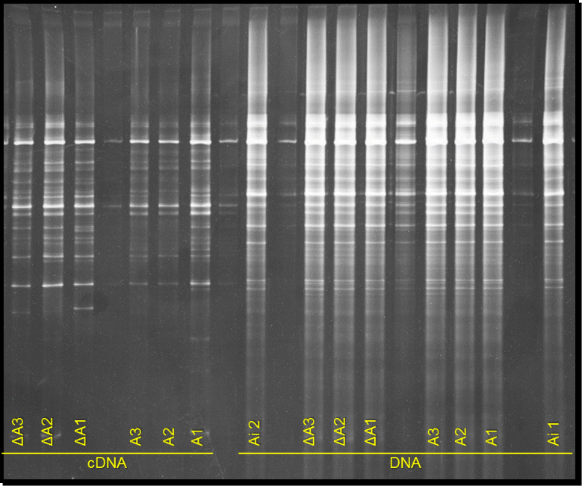
AF_Δ1
AF_Δ2
AF_Δ3
AF_C3
AF_C2
AF_C1
AF_i2
AF_C3
AF_C2
AF_C1
AF_Δ1
AF_Δ2
AF_Δ3
AF_i1

Figure S4. Image of the DGGE gel of amoA gene fragments and transcripts amplified from ammonia-oxidizing archaea on Afurada sediment samples exposed to different salinity conditions (constant salinity (AF_C1, AF_C2 and AF_C3) and fluctuation salinity (AF_ Δ1, AF_Δ2 and AF_Δ3)) as well initial Afurada sediment (AF_i1 and AF_i2).

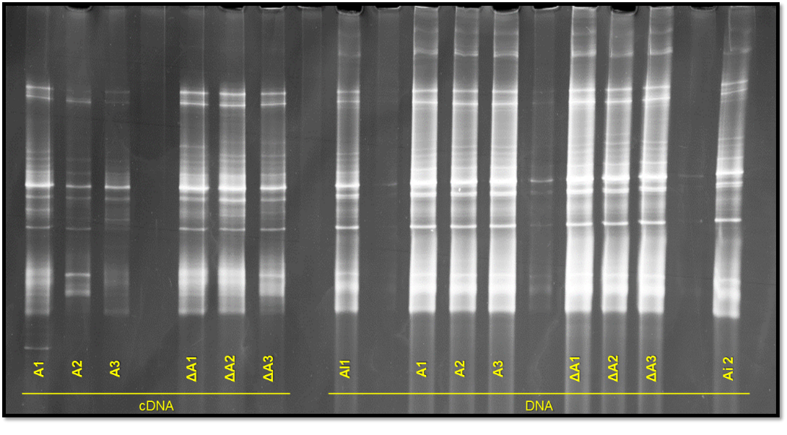
AF_C1
AF_C2
AF_C3
AF_ Δ 1
AF_ Δ 2
AF_ Δ 3
AF_i1
AF_ Δ 1
AF_ Δ 2
AF_ Δ3
AF_C3
AF_C2
AF_C1
AF_i2

Figure S5. Image of the DGGE gel of amoA gene fragments and transcripts amplified from ammonia-oxidizing bacteria on Afurada sediment samples exposed to different salinity conditions (constant salinity (AF_C1, AF_C2 and AF_C3) and fluctuation salinity (AF_Δ1, AF_Δ2 and AF_Δ3)) as well initial Afurada sediment (AF_i1 and AF_i2).
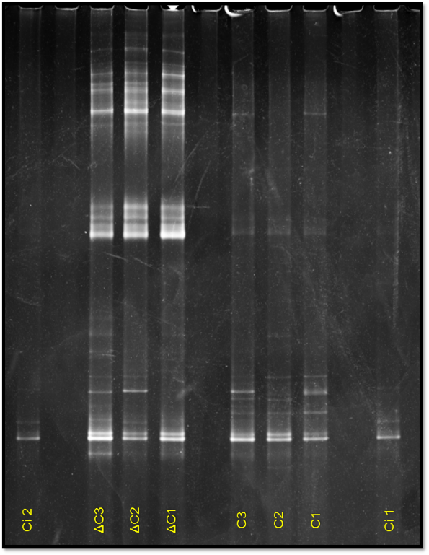
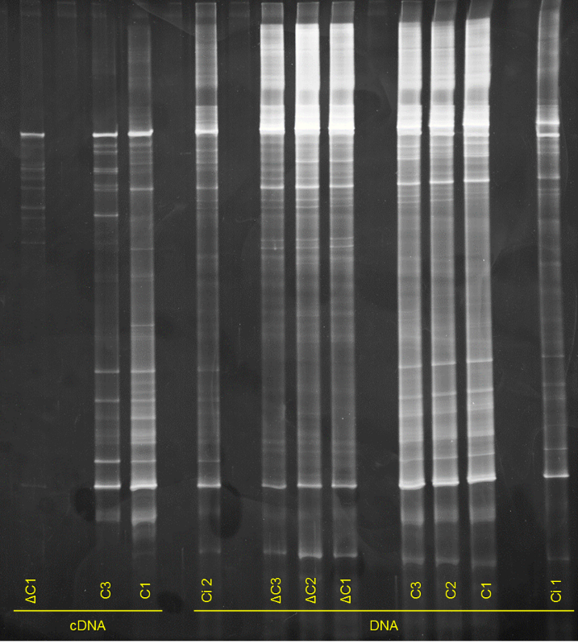
B
CR_i1
CR_i2
CR_C1
CR_C2
CR_C3
CR_ Δ3
CR_ Δ2
CR_ Δ1
DNA
CR_C1
CR_C3
CR_i2
CR_C1
CR_C2
CR_C3
CR_i1
CR_ Δ 2
CR_ Δ3
CR_ Δ1
CR_ Δ1
A

Figure S6. Image of the DGGE gel of amoA gene fragments and transcripts (Figure S6-A) amplified from ammonia-oxidizing archaea on Crestuma sediment samples exposed to different salinity conditions (constant salinity (CR_1, CR_2 and CR_3) and fluctuation salinity (CR_Δ1, CR_Δ2 and CR_Δ3)) as well initial Crestuma sediment (CR_i1 and CR_i2). Image of the DGGE gel of amoA gene fragments (Figure S6-B) amplified from ammonia-oxidizing bacteria on Crestuma sediment samples exposed to different salinity conditions (constant salinity (CR_1, CR_2 and CR_3) and fluctuation salinity (CR_Δ1, CR_Δ2 and CR_Δ3)) as well initial Crestuma sediment (CR_i1 and CR_i2).

Figure S7. Box plot representing the average relative abundance of the different ammonia-oxidizing genera identified in the different salinity treatments (constant – AF_C and CR_C, and fluctuation – AF_Δ and CR_Δ; n=2).

Supplementary Tables

Table S1. Salinity and temperature mean values from 36 days of daily monitoring in constant salinity treatments reactors from Afurada (AF_C₁, AF_C₂ and AF_C₃) and Crestuma (CR_C₁, CR_C₂ and CR_C₃) and in fluctuation salinity reactors from Afurada (AF_Δ₁, AF_Δ₂ and AF_Δ₃) and Crestuma (CR_Δ₁, CR_Δ₂ and CR_Δ₃).
Reactor | Number of water  renewal’s | Salinity (psu) |  |  |  | Temperature (°C)
 |  | Mean | Min | Max | SD | Mean | SD
AF_C₁ | 69 | 15.3 | 15.0 | 16.1 | 0.2 | 18.8 | 2.2
AF_C₂ | 69 | 15.3 | 15.0 | 16.1 | 0.2 | 18.8 | 2.2
AF_C₃ | 69 | 15.3 | 15.0 | 16.1 | 0.2 | 18.8 | 2.2
AF_∆₁ | 69 | 15.5 | 1.5 | 29.2 | 9.4 | 18.8 | 2.2
AF_∆₂ | 69 | 15.5 | 1.5 | 29.3 | 9.5 | 18.8 | 2.2
AF_∆₃ | 69 | 15.5 | 1.5 | 29.1 | 9.4 | 18.8 | 2.2
CR_C₁ | 69 | 0.2 | 0.1 | 1.7 | 0.2 | 18.8 | 2.2
CR_C₂ | 69 | 0.2 | 0.1 | 1.4 | 0.2 | 18.8 | 2.2
CR_C₃ | 69 | 0.1 | 0.1 | 1.3 | 0.2 | 18.8 | 2.2
CR_∆₁ | 69 | 15.5 | 1.4 | 29.3 | 9.5 | 18.8 | 2.2
CR_∆₂ | 69 | 15.4 | 1.3 | 29.3 | 9.5 | 18.8 | 2.2
CR_∆₃ | 69 | 15.5 | 1.2 | 29.3 | 9.6 | 18.8 | 2.2

Site | Incubation condition | ID | µmol N mL⁻¹ cm⁻² h⁻¹
Afurada | Constant salinity | AF_C1 | 0.0048
 |  | AF_C2 | 0.0036
 |  | AF_C3 | 0.0036
 | Salinity fluctuation | AF_Δ1 | 0.0033
 |  | AF_Δ2 | 0.0035
 |  | AF_Δ3 | 0.0040
Crestuma | Constant salinity | CR_C1 | 0.0048
 |  | CR_C2 | 0.0062
 |  | CR_C3 | 0.0055
 | Salinity fluctuation | CR_Δ1 | 0.0014
 |  | CR_Δ2 | N/A
 |  | CR_Δ3 | 0.0013
Table S2. Potential nitrification rates ([¹⁵N]O₂⁻ + [¹⁵N]O₃⁻ produced) in triplicate treatments after the addition of 20 µM of [¹⁵N]H₄⁺ in Afurada (AF_C and and AF_Δ) and Crestuma (CF_C and and CR_Δ) reactors. N/A – not available.

Table S3. Potential nitrification rates ([¹⁵N]O₂⁻ + [¹⁵N]O₃⁻ produced) measured in triplicate slurries after the addition of 100 µM of [¹⁵N]H₄⁺ in Afurada (AF_C and and AF_Δ) and Crestuma (CF_C and and CR_Δ) salinity treatments.
Site | Incubation condition | ID | µmol N mL⁻¹ g⁻¹ h⁻¹
Afurada | Constant salinity | AF_C1 | 0.0027
 |  | AF_C2 | 0.0029
 |  | AF_C3 | 0.0030
 | Salinity fluctuation | AF_Δ1 | 0.0051
 |  | AF_Δ2 | 0.0029
 |  | AF_Δ3 | 0.0024
Crestuma | Constant salinity | CR_C1 | 0.0035
 |  | CR_C2 | 0.0027
 |  | CR_C3 | 0.0028
 | Salinity fluctuation | CR_Δ1 | 0.0014
 |  | CR_Δ2 | 0.0012
 |  | CR_Δ3 | 0.0013

Table S4. Relative abundance (%) of the top 20 dominant phyla in downstream (AF) and upstream (CR) in situ sediments (AF_i, CR_i) and laboratory experiments (AF_C, AF_Δ, CR_C and CR_Δ). The values correspond to the relative abundance of the two replicates (1 and 2) analyzed per each salinity treatment (CR_C, CR_Δ, AF_C and AF_Δ).
Phylum | Relative abundance (%) in the different treatments
 | AF_i | AF_C1 | AF_C2 | CR_i | CR_C2 | CR_C3 | AF_Δ1 | AF_ Δ2 | CR_ Δ1 | CR_Δ2
Proteobacteria | 39.5 | 47.2 | 50.1 | 41.4 | 45.9 | 46.3 | 45.9 | 53.4 | 70.8 | 61.9
Bacteroidetes | 31.0 | 12.5 | 14.5 | 23.5 | 15.3 | 13.8 | 12.8 | 13.5 | 14.3 | 15.7
Planctomycetes | 3.7 | 12.5 | 8.5 | 7.6 | 9.6 | 9.2 | 13.6 | 7.2 | 6.1 | 7.6
Cyanobacteria | 14.8 | 7.2 | 6.7 | 5.7 | 1.0 | 0.7 | 14.9 | 9.1 | 0.8 | 0.6
Acidobacteria | 1.7 | 5.2 | 4.7 | 5.7 | 7.9 | 7.6 | 2.0 | 3.8 | 1.5 | 3.1
Nitrospirae | 1.0 | 1.8 | 2.1 | 3.0 | 7.1 | 10.7 | 1.5 | 1.5 | 1.0 | 1.9
Verrucomicrobia | 2.0 | 0.7 | 0.8 | 5.0 | 3.8 | 3.2 | 0.5 | 0.8 | 0.7 | 1.6
Thaumarchaeota | 2.3 | 3.7 | 3.2 | 0.4 | 0.4 | 0.7 | 3.0 | 2.4 | 0.5 | 0.4
Gemmatimonadetes | 0.3 | 1.3 | 1.1 | 2.7 | 3.0 | 2.1 | 0.6 | 1.0 | 2.2 | 3.3
Chloroflexi | 1.4 | 2.1 | 2.1 | 1.1 | 1.7 | 1.9 | 1.9 | 2.4 | 0.3 | 0.9
Actinobacteria | 0.9 | 1.4 | 1.3 | 1.0 | 1.0 | 0.8 | 1.0 | 1.5 | 0.4 | 1.2
Latescibacteria | 0.3 | 1.1 | 1.0 | 0.3 | 1.0 | 1.0 | 0.4 | 0.8 | 0.2 | 0.3
Armatimonadetes | 0.1 | 0.0 | 0.0 | 0.9 | 0.5 | 0.5 | 0.0 | 0.0 | 0.1 | 0.2
Firmicutes | 0.2 | 0.4 | 0.5 | 0.1 | 0.1 | 0.0 | 0.2 | 0.3 | 0.0 | 0.0
Spirochaetes | 0.2 | 0.2 | 0.2 | 0.1 | 0.1 | 0.1 | 0.1 | 0.3 | 0.0 | 0.0
Lentisphaerae | 0.1 | 0.1 | 0.2 | 0.0 | 0.0 | 0.0 | 0.1 | 0.1 | 0.3 | 0.3
Kiritimatiellaeota | 0.1 | 0.3 | 0.4 | 0.1 | 0.0 | 0.0 | 0.2 | 0.3 | 0.0 | 0.0
Deinococcus-Thermus | 0.1 | 0.1 | 0.1 | 0.3 | 0.1 | 0.1 | 0.0 | 0.0 | 0.1 | 0.1
Rokubacteria | 0.0 | 0.0 | 0.0 | 0.2 | 0.1 | 0.2 | 0.0 | 0.0 | 0.1 | 0.2
Omnitrophicaeota | 0.0 | 0.1 | 0.1 | 0.1 | 0.3 | 0.2 | 0.0 | 0.1 | 0.0 | 0.0
Other | 0.5 | 2.1 | 2.4 | 0.7 | 1.3 | 1.1 | 1.2 | 1.5 | 0.3 | 0.6

Table S5. Relative abundance (%) of the nitrifying genera found in downstream (AF) and upstream (CR) in situ sediments (AF_i, CR_i) and laboratory experiments (AF_C, AF_Δ, CR_C and CR_Δ). The values correspond to the relative abundance of the two replicates (1 and 2) analyzed per each salinity treatment (CR_C, CR_Δ, AF_C and AF_Δ).
Group | Family | Genus | Relative abundance (%) in the different treatments
 |  |  | AF_i | AF_C1 | AF_C2 | CR_i | CR_C2 | CR_C3 | AF_Δ1 | AF_Δ2 | CR_C1 | CR_C2
AOB | Nitrosomonadaceae | Nitrosomonas | 0.2 | 0.3 | 0.4 | 0.0 | 0.2 | 0.2 | 0.2 | 0.3 | 0.2 | 0.2
AOA | Nitrosopumilaceae | "Ca. Nitrosotenuis" | 0.0 | 0.0 | 0.0 | 0.1 | 0.2 | 0.3 | 8.8 | 0.0 | 0.0 | 0.0
 |  | "Ca. Nitrosopumilus" | 0.8 | 2.1 | 1.9 | 0.0 | 0.0 | 0.0 | 1.5 | 1.3 | 0.1 | 0.0
 |  | "Ca. Nitrosoarchaeum" | 0.1 | 0.1 | 0.1 | 0.2 | 0.2 | 0.3 | 0.1 | 0.1 | 0.4 | 0.3
NOB | Nitrospiraceae | Nitrospina | 0.0 | 0.0 | 0.1 | 0.0 | 0.0 | 0.0 | 0.0 | 0.0 | 0.0 | 0.0
 |  | Nitrospira | 1.0 | 1.8 | 2.1 | 3.0 | 7.1 | 10.7 | 1.5 | 1.5 | 1.0 | 1.9

