SUPPLEMENTARY DATA

Calculation of Oil Viscosity Increase with Weathering
Oil viscosity increases with weathering. In order to provide an estimate of the change in viscosity of oils, weathering data on several oils (Alaska North Slope, Louisiana, and Alberta Sweet Mixed) were combined and were correlated with time (Fingas, 2013; ESTS, 2018). The data are applicable to medium crude oils as typified by the oils chosen. The data are plotted as shown in Figure S1 and regression used to derive a generalized equation.
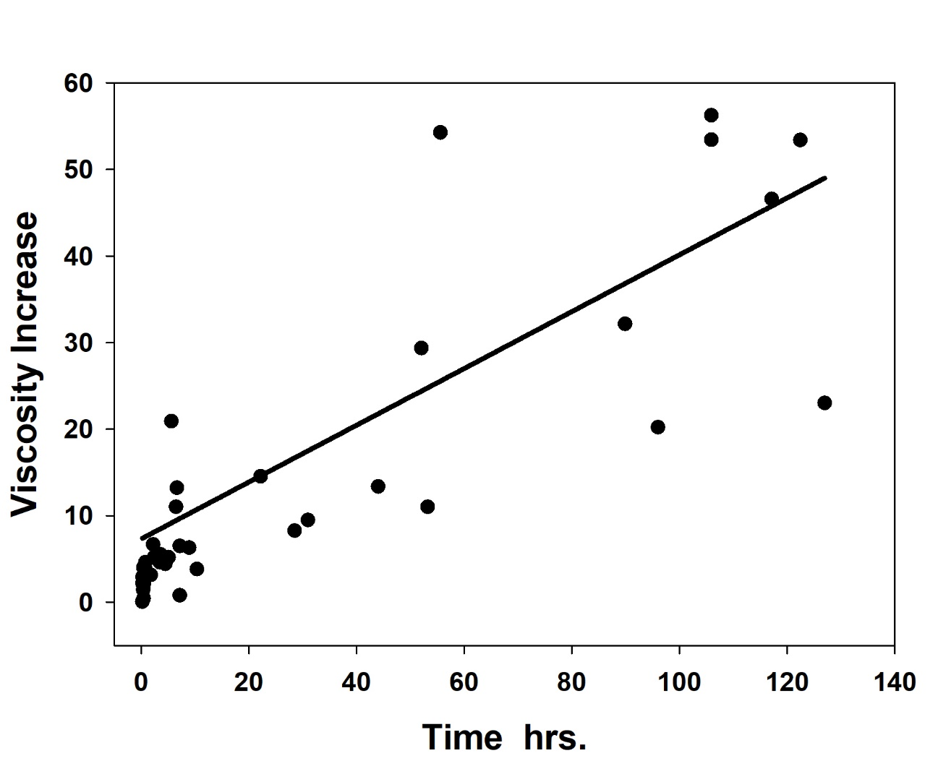
Figure S1. A plot of the three oils viscosity with hours weathering. The line is a regression line created using SigmaPlot 14. The regression analysis yielded the following simplified relationship (R² = 0.85):
(1)
where µ is the adjusted or viscosity of the weathered oil, µ_{start} is the starting oil viscosity, and t_{hrs} is the time in hours that the oil has weathered At 0 t, µ= µ_{start}.

Discrete calculation
Discrete calculations can be made by following simple steps in a spread sheet. The steps are outlined in Table S1 and an example given in Table S2.
The discrete calculation for the purposes of performing a regression curve was calculated for the following times; 0, 1, 2,4, 6, 8, 10, 16, 18 hours. It was performed for the following viscosities; 10, 20, 40 80, 160, 320 and 500 mPa.s. The following wind speeds were modelled: 7, 10, 18 and 24 m/s. These were considered to be minimum inputs to achieve a realistic input to regression. The coarse inputs result in some oscillation in the numbers past about 4 hours, however this is smoothed out in the regression.

References
ESTS, Oil Properties Data Base, http://www.etc-cte.ec.gc.ca/databases/oilproperties/, Accessed December, 2018.
Fingas, M., “Modeling Oil and Petroleum Evaporation,” Journal of Petroleum Science Research. (JPSR), 2, 3, July, 2013.

