Supplementary Material
Enhancing the heterologous fructosyltransferase activity of Kluyveromyces lactis: developing a scaled-up process and abolishing invertase by CRISPR/Cas9 genome editing

Jan Philipp Burghardt^{1,2}, Rong Fan³, Markus Baas¹, Dustin Eckhardt¹, Doreen Gerlach³, Peter Czermak^{1,2,3}*
¹Institute of Bioprocess Engineering and Pharmaceutical Technology, University of Applied Sciences Mittelhessen, Giessen, Germany
²Faculty of Biology and Chemistry, Justus Liebig University, Giessen, Germany
³Department of Bioresources of Fraunhofer Institute for Molecular Biology and Applied Ecology IME, Giessen, Germany
* Correspondence:
Prof. Dr.-Ing. Peter Czermak
peter.czermak@lse.thm.de

Measuring the K_{L}a and oxygen saturation concentration
To determine the K_{L}a in the Infors3 system, aeration was switched off and the pO₂ curve was recorded (Supplementary Figure 1A). The logarithm of the difference between the starting pO₂ value and the pO₂ at time t (pO_{2,(t)}) of gassing out was calculated and plotted against the time (Supplementary Figure 1B). The slope corresponds to the K_{L}a after extrapolation to 1 min⁻¹.
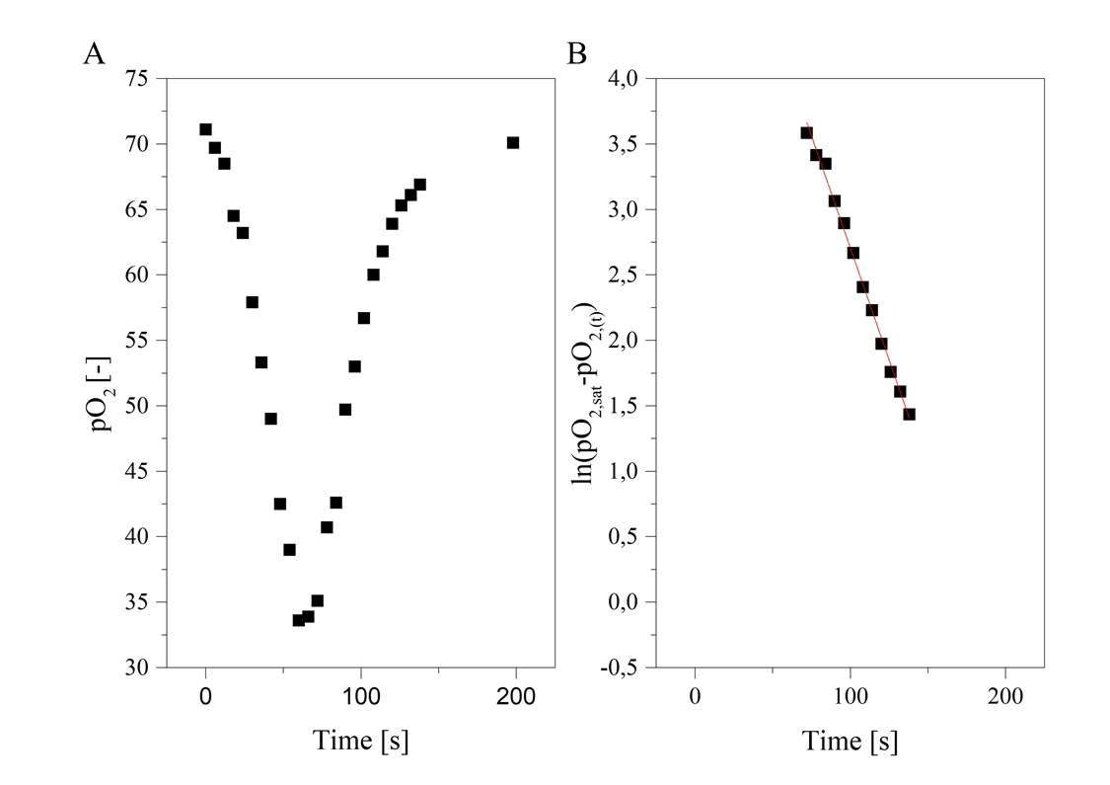
Supplementary Figure 1: Representative A pO₂ curve and B logarithmic differences between the starting pO₂ and pO2_{(t)} at time t of a measurement. The curves were recorded during outgassing with K. lactis (ΔOD₆₀₀ = 30–40) with an aeration rate of 0.5 vvm and an agitation rate of 1200 rpm in a working volume of 3.43 L.
The K_{L}a calculations were repeated in a response surface design by investigating an aeration range of 0.5–1.5 vvm and an agitation range of 800–1200 rpm (Supplementary Figure 2). ANOVA of the K_{L}a predictive model showed the model is significant (p = 0.0005) with a non-significant lack of fit (p = 0.9066).

rpm 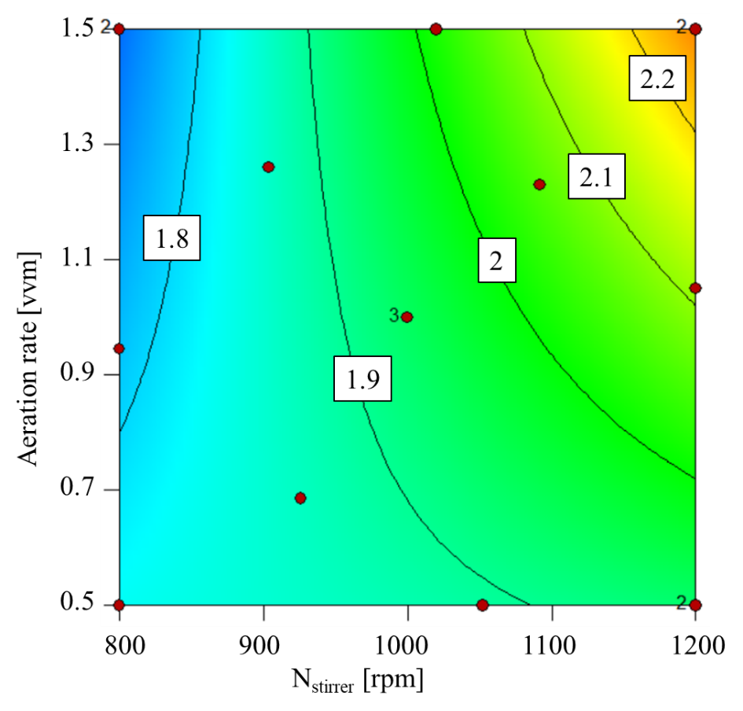
Supplementary Figure 2: Contour plot of the predictive model for K_{L}a (min⁻¹) with the influencing factors stirrer speed and aeration rate within the experimental limits.

Determination of oxygen solubility in the fermentation medium: Probe response of DO to increased H₂O₂ volumes
The oxygen saturation was determined as described by Vendruscolo et al. (2012). The probe response after adding known amounts of H₂O₂ is shown in Supplementary Figure 3. The probe was calibrated to 100% by aeration with air to equilibrium. The oxygen was gassed out with nitrogen before each measurement.
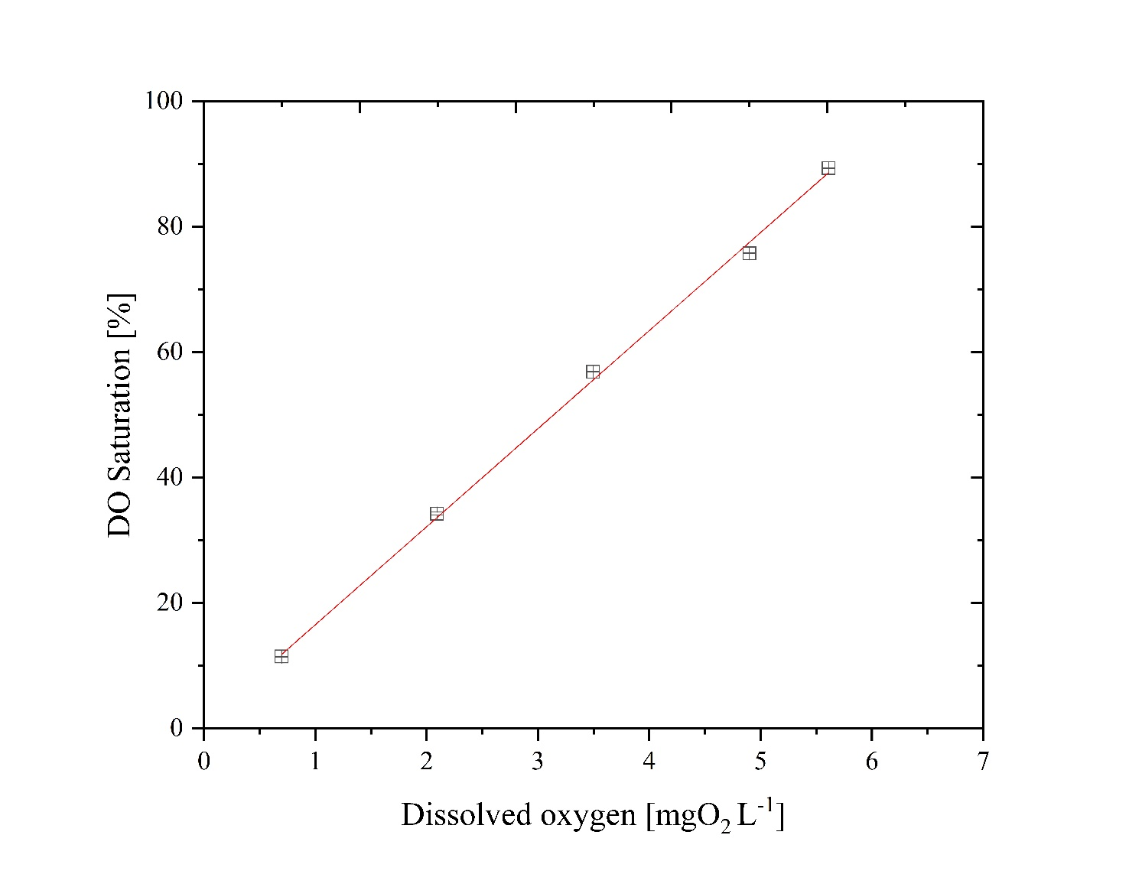
Supplementary Figure 3: Probe response of dissolved oxygen at 30 °C in cell-free fermentation medium.
The experimental data points were fitted to Supplementary Eq. 1 (R² = 0.99921):

DO saturation = 0.9 + DO $×$ 15.63 Supplementary Equation 1

Using Supplementary Eq.1, the oxygen solubility at 100% saturation in the cell-free fermentation medium was 6.34 mg_{O2} L⁻¹.

Determination of oxygen solubility in the fermentation medium: Estimation during the cultivation of K. lactis
To estimate the oxygen solubility, the aeration was switched off during fermentation with a known CDW. Based on the percentage decrease of the DO, the saturation concentration of oxygen was determined assuming that the DO probe response at 100% corresponds to the saturation concentration of O₂ in the medium when aerated with air. Shortly before recording the DO drop, the average $\overline{OTR}$ value was determined by exhaust gas analysis (Supplementary Eq.2). We assumed that $\overline{OTR}$ = $\overline{OUR}$ because, during $\overline{OTR}$ recording, the change of DO was negligible (< 2%).
$\overline{OTR}= \overline{OUR}=0.53\left[\frac{g_{O_{2}}}{L × h}\right]=8.83\left[\frac{{mg}_{O_{2}}}{L × min}\right]$ Supplementary Equation 2
With the known oxygen uptake rate and CDW, the specific oxygen uptake rate $q_{O_{2}}$was determined (Supplementary Eq. 3).
$q_{O_{2}}=\frac{\overline{OUR}}{\overline{CDW}}=\frac{8.83 \left[\frac{{mg}_{O_{2}}}{L × min}\right]}{2.46 \left[ \frac{g_{CDW}}{L }\right]}=3.59 \left[\frac{{mg}_{O_{2}}}{g_{CDW} × min}\right]$ Supplementary Equation 3
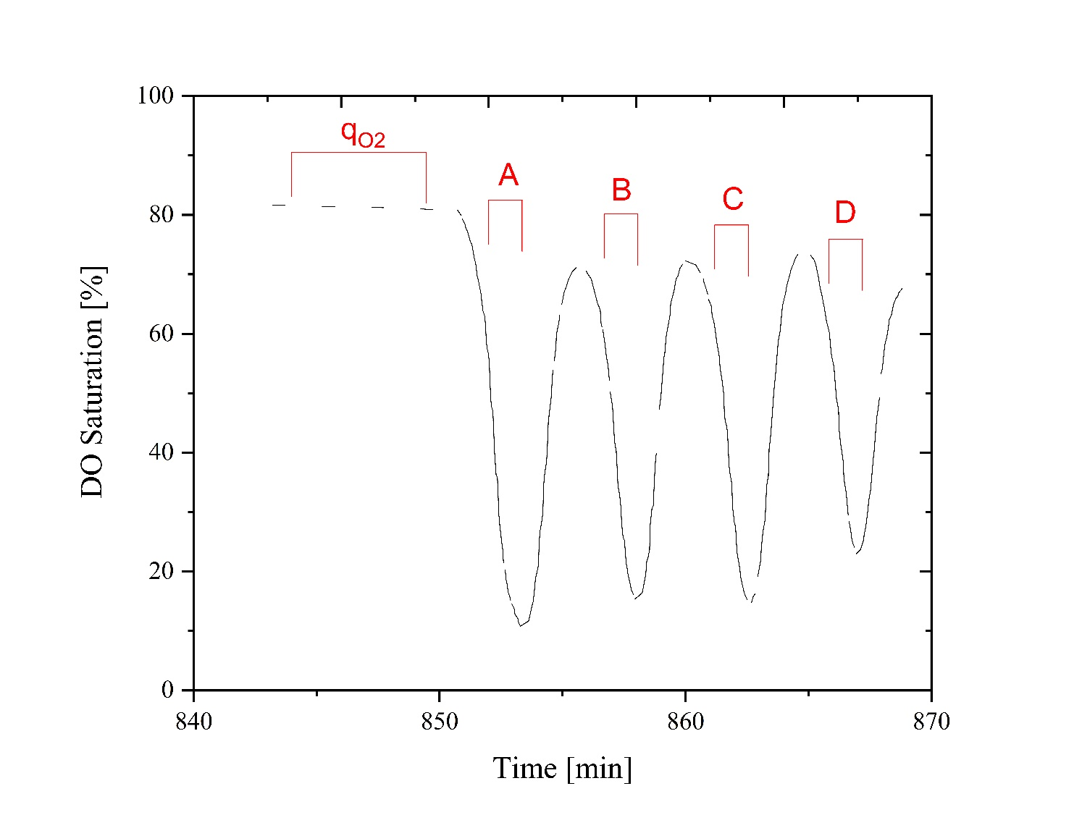
Supplementary Figure 4: DO saturation curve during the fermentation of K. lactis. The curve was recorded during fermentation with an aeration rate of 1 vvm air and an agitation rate of 1000 rpm in a working volume of 3.43 L: $q_{O_{2}}$ indicates the range in which the $\overline{OUR}$ value was recorded, A-D shows the test intervals in which $c_{L}^{*}$ was recorded.

As shown in Supplementary Figure 4, the oxygen solubility was determined four times (A-D) during fermentation with K. lactis. For this purpose, the aeration was switched off and the saturation concentration was determined based on the decreasing DO value. The calculation is shown schematically in Supplementary Figure 5 and in the following derivation:
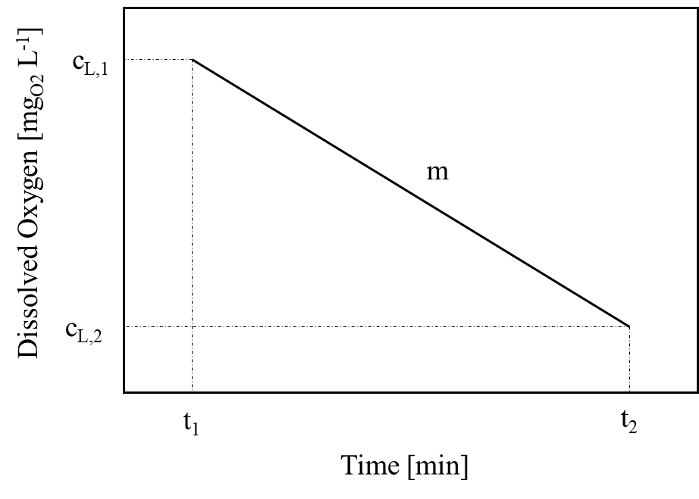
Supplementary Figure 5: Schematic DO response during determination of $c_{L}^{*}.$
The percentage DO can be expressed as the ratio of the DO concentration to the saturation concentration of oxygen in the medium, according to Supplementary Eq. 4.
$\%DO= \frac{c_{L}}{c_{L}^{*}} ×100\%$ Supplementary Equation 4
The decreasing DO follows a linear relationship. The y and x values (Supplementary Eq. 5) are displayed as intervals in which the linear decrease is valid. The slope (m) corresponds to the previously determined specific oxygen uptake ($q_{O_{2}}$) and the CDW from the corresponding test interval.
$Δy= -m ×Δx+b$ Supplementary Equation 5
where $Δy$ = c_{L,2}-c_{L,1} $\left[\frac{{mg}_{O_{2}}}{L}\right]$ and $Δx$ =$Δt$ = t₂- t₁ [min]. With $=q_{O_{2}}×CDW$ $\left[\frac{{mg}_{O_{2}}}{L × min}\right]$; b = c_{L,1} ; c_{L,1} = $\frac{{DO}_{1}}{100\%}× c_{L}^{*}\left[\frac{{mg}_{O_{2}}}{L}\right]$ and c_{L,2} = $\frac{{DO}_{2}}{100\%}× c_{L}^{*}\left[\frac{{mg}_{O_{2}}}{L}\right]$ .
This leads to Supplementary Eq. 6:
$\frac{{DO}_{2}-{DO}_{1}}{100\%}×c_{L}^{*}=-m × ∆t+ \frac{{DO}_{1}}{100\%} × c_{L}^{*}$ Supplementary Equation 6
Division by $c^{*}$and rearrangement of the equation leads to Supplementary Eq. 7:
$c_{L}^{*}=\frac{-m × ∆t}{\frac{{DO}_{2}-{DO}_{1}-{DO}_{1}}{100\%}} \left[\frac{{mg}_{O_{2}}}{L}\right]$ Supplementary Equation 7

Supplementary Table 1: Results of $c_{L}^{*}$ during fermentation: $q_{O_{2}}=3.59 \frac{{mg}_{O_{2}}}{g_{CDW} × min}$ .
Outgassing interval [-] | CDW [g L⁻¹] | DO₁ [%] | DO₂ [%] | Δt [min] | $c_{L}^{*}$ $\left[\frac{{mg}_{O_{2}}}{L}\right]$
A | 2.55 | 43.2 | 31.5 | 0.40 | 6.67
B | 2.61 | 60.7 | 37.8 | 0.58 | 6.50
C | 2.69 | 67.6 | 48.5 | 0.58 | 6.46
D | 2.75 | 56.3 | 38.0 | 0.40 | 5.29

Based on the results in Supplementary Table 1 the saturation concentration of oxygen was determined as 6.23 ± 0.63 mg_{O2} L⁻¹.

Literature
Vendruscolo, Francielo; Rossi, Márcio José; Schmidell, Willibaldo; Ninow, Jorge Luiz (2012): Determination of Oxygen Solubility in Liquid Media. In: ISRN Chemical Engineering 2012, S. 1–5. DOI: 10.5402/2012/601458.

