SUPPLEMENTARY MATERIAL

GROUP 1- patients with M variants

Part 1…  Patient |  | Ethnicity | Family history | Clinical presentation in family members | Age at clinical onset (years) | Age at genetic diagnosis (years) | Age at first detection of proteinuria (years) | uPr/uCr (mg/mg) at onset | Peak of uPr/uCr (before RAASi) | uPr/uCr al last FUP | BP at onset | BP at last FUP
1 |  | Caucasian | paternal | HD when he was 16 years old | 2 | 8 | - | - | - | 0,12 | 90/65 | 110/65
2 |  | Caucasian | no | na | 12 | 16 | - | - | - | 0,18 | 103/55 | 124/85
3 |  | Caucasian | maternal | ESKD at age of 47 y | 13 | 13 | - | - | - | 0,17 | 107/66 | 113/74
4 |  | Caucasian | maternal | HD at 60 years of age, SNHL, | 41 | 42 | - | - | - | 0,2 | 105/60 | 110/67
5 |  | Caucasian | maternal | Only microscopic hematuria | 12 | 14 | - | - | - | 0,10 | 98/57 | 100/64
6 |  | Caucasian | paternal | SNHL e HD when he was 31 | 23 | 42 | - | - | - | 0,19 | 121/72 | 125/82
7 |  | Caucasian | mother | Only microscopic hematuria | 6 | 46 | - | - | - | <0,2 | 108/54 | 120/80
8 |  | Caucasian | maternal | Only microscopic hematuria | 16 | 17 | - | - | - | 0,19 | 120/80 | 123/78
9 |  | Caucasian | no | na | 1 | 8 | - | - | - | 0,2 | 73/41 | 103/61
10 |  | Caucasian | paternal | HD from 18 years of age | 3 | 15 | 9 | 0,35 | 0,53 | 0,67 | 95/55 | 115/78

Part 2…  Patient | SNHL | Age at SNHL (years) | Ocular abnormalities | Renal biopsy performed in: | Diagnosis at electron microscopy | eGFR at onset | eGFR at last FUP | CKD | Age at CKD | ESKD | Age at ESKD | Length of FUP | Age at last FUP
1 | no | n.a. | no | Patient | AS | 137 | 120 | no | n.a. | n.a. | n.a. | 25 | 27
2 | no | n.a. | no | Patient | AS | 139 | 113 | no | n.a. | n.a. | n.a. | 5 | 18
3 | no | n.a. | no | Patient | AS | 110 | 115 | no | n.a. | n.a. | n.a. | 2 | 14
4 | Deficit | 40 | no | Patient | AS | 93 | 132 | no | n.a. | n.a. | n.a. | 2 | 43
5 | no | n.a. | no | Patient | AS | 162 | 117 | no | n.a. | n.a. | n.a. | 2 | 14
6 | Deficit | 36 | no | Patient | AS | 138 | 120 | no | n.a. | n.a. | n.a. | 19 | 42
7 | no | n.a. | no | Patient | AS | 143 | 110 | no | n.a. | n.a. | n.a. | 40 | 46
8 | no | n.a. | no | Patient | AS | 125 | 124 | no | n.a. | n.a. | n.a. | 2 | 18
9 | no | n.a. | no | Patient | AS | 148 | 124 | no | n.a. | n.a. | n.a. | 10 | 11
10 | no | n.a. | no | Patient | AS | 142 | 120 | no | n.a. | n.a. | n.a. | 13 | 16

GROUP 2 – patients with S variants

Part 1…  Patient | Ethnicity | Family history | Clinical presentation in family members | Age at clinical onset (years) | Age at genetic diagnosis (years) | Age at first detection of proteinuria (years) | uPr/uCr (mg/mg) at onset | Peak of uPr/uCr (before RAASi) | uPr/uCr al last FUP | BP at onset | BP at last FUP
1 | Caucasian | maternal | Only microscopic hematuria | 2 | 12 | - | - | - | <0.2 | 89/53 | 98/57
2 | Caucasian | maternal | microscopic hematuria and mild proteinuria at old age | 2 | 45 | - | - | - | <0.2 | 88/56 | 120/70
3 | Caucasian | paternal | HD at 33 years | 10 | 12 | - | - | - | 0,12 | 103/69 | 103/61
4 | Caucasian | paternal | HD when he was 27 yo | 9 | 18 | - | 0,1 | - | 0,15 | 99/59 | 116/73
5 | Caucasian | maternal | n.a. | 4 | 40 | - | - | - | 0,15 | 102/51 | 125/78
6 | Caucasian | paternal | HD when 20 yo | 7 | 8 | 12 | 0,15 | 0,54 | 0,8 | 105/62 | 114/77
7 | Caucasian | no | n.a. | 0,7 | 4 | 5 | 0,54 | 0,79 | 0,5 | 88/54 | 125/60
8 | Caucasian | maternal | Only microscopic hematuria | 27 | 30 | 30 | 0,86 | 1.37 | 1,22 | 120/80 | 120/80
9 | Chinese | Adopted child | Not available | 4 | 6 | 5 | 1,2 | 1,4 | 0,7 | 115/66 | 107/65
10 | Caucasian | maternal | Only microscopic hematuria | 1 | 9 | 8 | 0,19 | 0,64 | 0,7 | 95/50 | 110/56
11 | Caucasian | no | n.a. | 14 | 19 | 14 | 0,57 | 0,69 | 0,68 | 120/60 | 118/72
12 | Caucasian | mother | Only microscopic hematuria | 24 | 27 | 27 | 0,4 | 0,8 | 0,17 | 113/67 | 105/65
13 | Caucasian | son | Early proteinyrua | 22 | 40 | 22 | 1,2 | 5,6 | ESKD | 120/60 | 135/90
14 | Caucasian | maternal | mild proteinuria | 1 | 19 | 13 | 0,12 | 1 | 0,73 | 82/49 | 110/67
Part 2..  Patient | SNHL | Age at SNHL (years) | Ocular abnormalities | Renal biopsy performed in: | Diagnosis at electron microscopy | eGFR at onset | eGFR at last FUP | CKD | Age at CKD | ESKD | Age at ESKD | Length of FUP | Age at last FUP
1 | no | - | no | Patient | AS | 131 | 112 | no | n.a. | n.a. | - | 11 | 13
2 | no | - | no | Patient | AS | 127 | 123 | no | n.a. | n.a. | - | 47 | 49
3 | no | - | no | Father | AS | 180 | 121 | no | n.a. | n.a. | - | 2 | 12
4 | no | - | no | Patient | AS | 146 | 111 | no | n.a. | n.a. | - | 15 | 24
5 | no | - | no | Mother | AS | 156 | 110 | no | n.a. | n.a. | - | 37 | 41
6 | no | - | no | Patient | AS | 161 | 115 | no | n.a. | n.a. | - | 9 | 16
7 | no | - | no | Patient | AS | 177 | 110 | no | n.a. | n.a. | - | 5,3 | 6
8 | no | - | no | Patient | AS | 91 | 75 | yes | 34 | n.a. | - | 8 | 35
9 | Deficit | 8 | no | Patient | AS | 122 | 98 | no | n.a. | n.a. | - | 5 | 9
10 | no | - | no | Patient | AS | 139 | 110 | no | n.a. | n.a. | - | 9 | 10
11 | no | - | no | Patient | AS | 140 | 119 | no | n.a. | n.a. | - | 6 | 20
12 | no | - | no | Patient | AS | 133 | 120 | no | n.a. | n.a. | - | 5 | 29
13 | Prosthesis | 18 | no | Patient | AS | 73.7 | 8 | yes | 22 | yes | 40 | 20 | 42
14 | no | - | no | Patient | AS | 123 | 115 | no | n.a. | no | - | 17 | 20

Table S1: Clinical, laboratory and biopsy findings in our patients. eGFR is expressed as ml/min/ 1.73sm

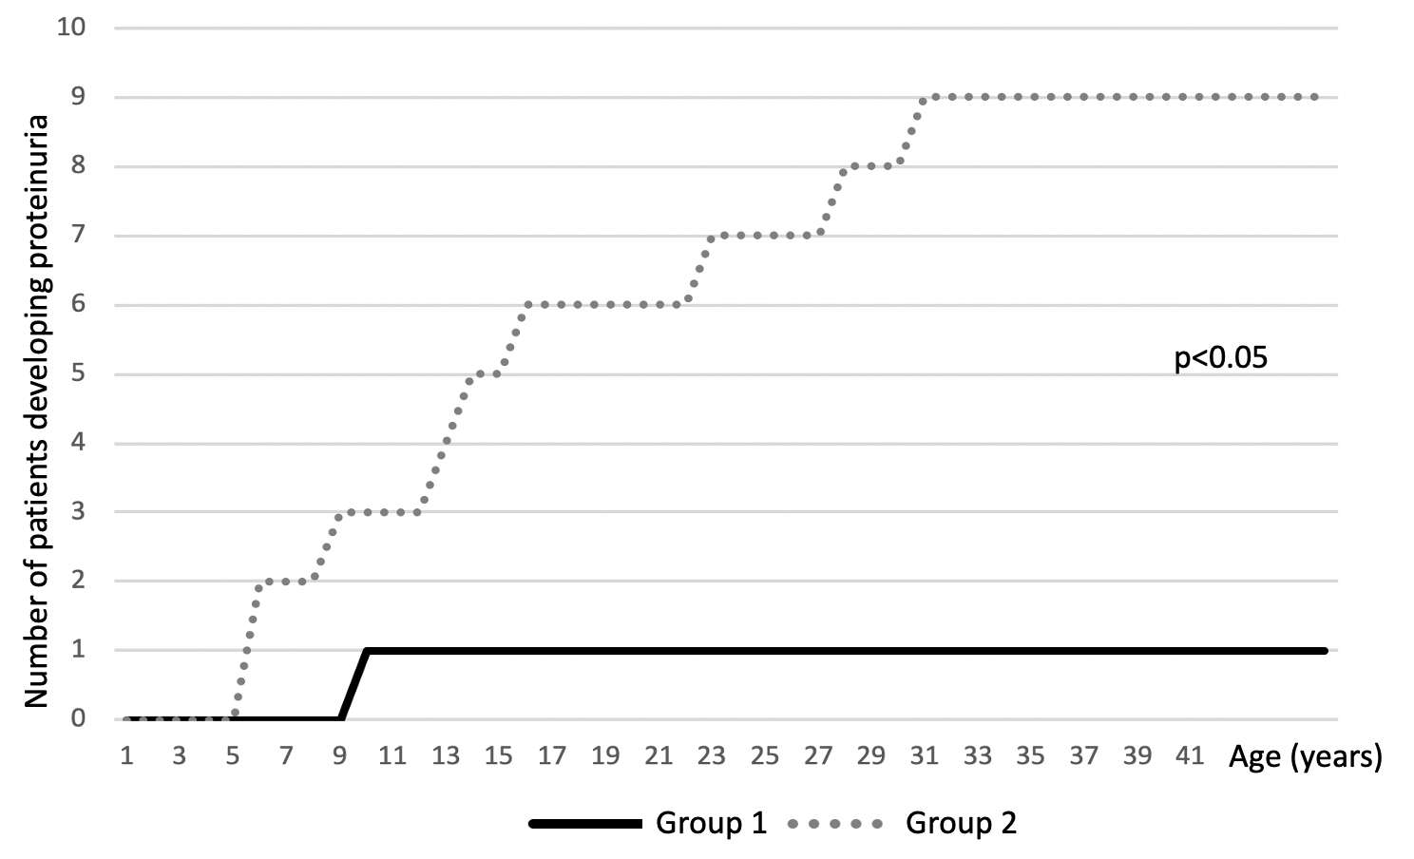
Figure S1. Time to appearance of proteinuria in Groups 1 and 2

