Supplementary material

Title: Puparial cases as toxicological indicators: Bioaccumulation of cadmium and thallium in the forensically important blowfly Lucilia sericata
Journal: Frontiers in Chemistry
DOI: 10.3389/fchem.2020.586067

Julita Malejkoª, Krzysztof Deoniziak^{b*}, Marlena Tomczukª, Joanna Długokenckaª, Beata Godlewska-Żyłkiewicz^{a*}
ª Department of Analytical Chemistry, Faculty of Chemistry, University of Bialystok, Ciołkowskiego 1K, 15-245 Białystok, Poland;
^{b} Laboratory of Insect Evolutionary Biology and Ecology, Faculty of Biology, University of Bialystok, Ciołkowskiego 1J, 15-245 Białystok, Poland
* Corresponding authors (krzysztofdeo@gmail.com, bgodlew@uwb.edu.pl)

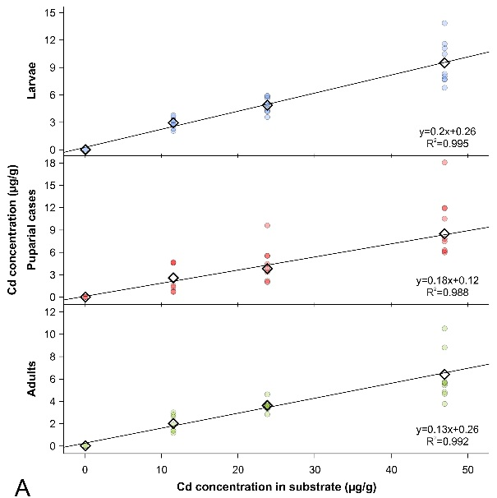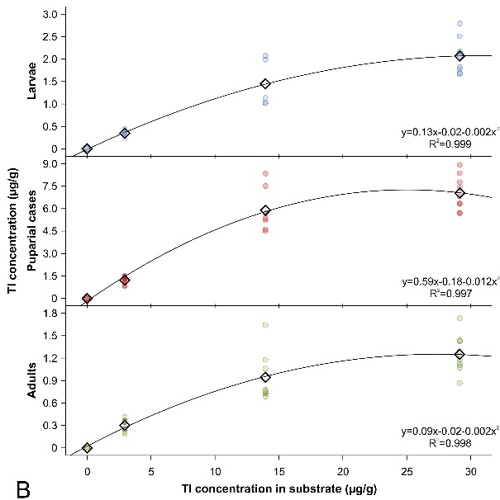
Supplementary Figure 1. Concentration of cadmium (A) and thallium (B) in studied developmental stages of Lucilia sericata in relation to metal concentration in feeding substrate. Diamonds indicate mean values, while circles measurements of individual samples. Trend lines represent a linear (A) and quadric (B) relationship between mean concentration of metal in different developmental stages of Lucilia sericata in relation to metal concentration in feeding substrate.

Supplementary Table 1. Agilent 8800 ICP-QQQ operating conditions.
RF power | 1550 W
Plasma gas flow rate | 15 L min⁻¹
Auxiliary gas flow rate | 0.90 L min⁻¹
Carrier gas flow rate | 1.07 L min⁻¹
Sample depth | 10 mm
Sample inlet flow | 0.35 mL min⁻¹
Monitoredisotope  (integrationtime) | ¹¹¹Cd (1.0 s), ¹¹⁴Cd (1.0 s),  ²⁰⁵Tl (0.3 s), ¹¹⁵In (0.3 s)
Plasmamode | General purpose
Scan type | Single Quad
Cell gasmode | No gas, He (5 mL min⁻¹ flow rate)

Supplementary Table 2. Concentration of cadmium and thallium (mean±SD) in samples of liver substrate, larvae, puparial cases and adults.
 | Substrate | 0 | 1 | 2 | 3
 | Sample | Mean ± SD  (ng g⁻¹d.w.) | Mean ± SD  (µg g⁻¹d.w.) | Mean ± SD  (µg g⁻¹d.w.) | Mean ± SD  (µg g⁻¹d.w.)
Cd | Liver | 94.1 ± 5.9 | 11.566 ± 0.028 | 23.83 ± 0.54 | 46.98 ± 0.56
 | Larvae | 15.4±2.6 | 2.95± 0.56 | 4.89± 0.82 | 9.5 ± 2.4
 | Puparial cases | 19.9± 6.7 | 2.6 ± 1.9 | 3.8 ± 1.4 | 8.5 ± 2.6
 | Adults | 21.1± 5.1 | 2.04± 0.77 | 3.63 ± 0.50 | 5.6± 1.5
Tl | Liver | 1.00 ± 0.75 | 2.943± 0.071 | 13.95± 0.15 | 29.1 ± 2.0
 | Larvae | 0.19 ± 0.15 | 0.348± 0.068 | 1.45± 0.54 | 2.07± 0.38
 | Puparial cases | 0.39 ± 0.21 | 1.20 ± 0.25 | 5.9 ± 1.5 | 7.0 ± 1.2
 | Adults | 0.074± 0.040 | 0.303± 0.078 | 0.94 ± 0.33 | 1.25 ± 0.25

Supplementary Table 3. Bioaccumulation factor of cadmium and thallium (mean±SD) in larvae, puparial cases and adults.
 | Substrate | 0 | 1 | 2 | 3
 | Sample | Mean ± SD | Mean ± SD | Mean ± SD | Mean ± SD
Cd | Larvae | 0.164± 0.028 | 0.255 ± 0.049  0.225 ± 0.166  0.176 ± 0.066 | 0.205 ± 0.034  0.162 ± 0.061  0.152 ± 0.021 | 0.202 ± 0.050  0.181 ± 0.055  0.119 ± 0.031
 | Puparial cases | 0.212± 0.071
 | Adults | 0.225± 0.055
Tl | Larvae | 0.194 ± 0.151 | 0.118 ± 0.023  0.409 ± 0.084  0.103 ± 0.026 | 0.104 ± 0.038  0.422 ± 0.106  0.068 ± 0.024 | 0.071 ± 0.013  0.242 ± 0.039  0.043 ± 0.009
 | Puparial cases | 0.388± 0.207
 | Adults | 0.074± 0.040

