Supplemental Figures and Table

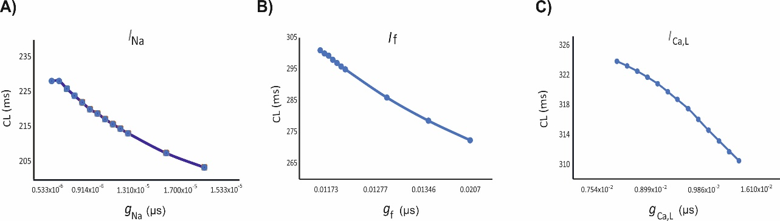
Figure S1. Sensitivity analyses of the change of the CL as a function of the conductance for I_{Na},(A) I_{Ca,L} (B) and I_{f} (C) .

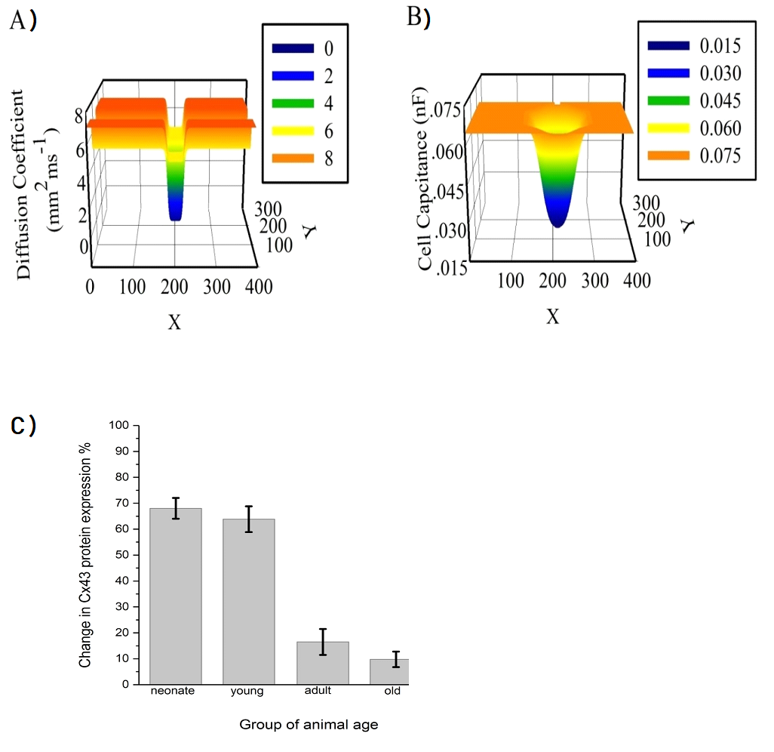Figure S2. The gradient distribution in (A) cell capacitance (C_{m}) and (B) diffusion (D) in both longitudinal and transverse directions of the 2D tissue slice. Figure adapted from [28].The decline of the Cx43 protein expression in the SAN of rat represented as percentage during developmental maturation.(C) [22]

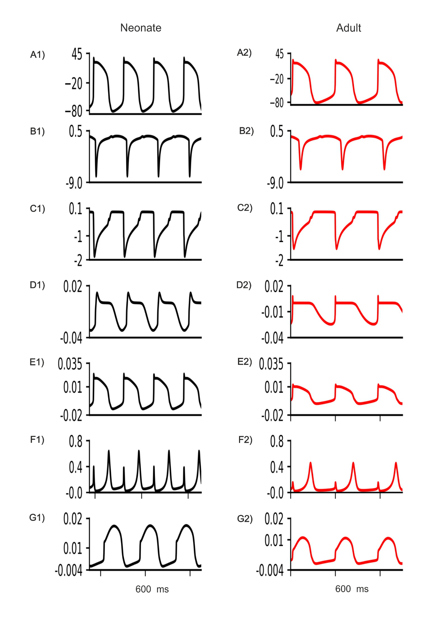
Figure S3. Simulated peripheral SAN action potentials in the neonate (black lines) as compared with the adult (red lines) (Ai-Aii) and their underlying time courses of ionic channel currents I_{Na}, I_{Ca,L}, I_{f}, I_{NaCa}, I_{Kr} and I_{Ks} (Bi-Gii).

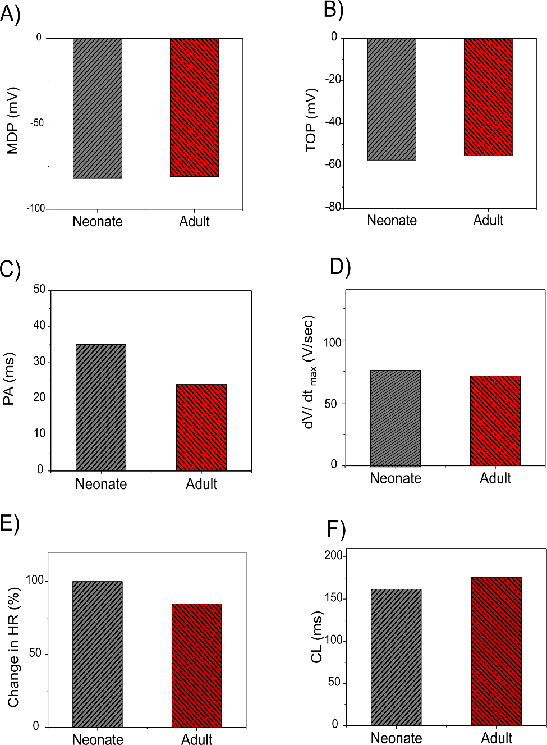
Figure S4. Bar chart comparison of the main AP characteristic of peripheral SAN cells: MDP (A), TOP (B), PA (C), dV/dt_{max} (D), reduction of HR (E), and CL (F) in the neonate (grey) corresponding to the adult (red).

Table S1. AP characteristics of the neonate and adult peripheral SA node cell models.
 | References | PA (mV) | CL (ms) | MDP (mV) | dV/dt_{max} (V/s)
Neonate | Our model | 31.69 | 156.23 | -78.45 | 72.83
Adult | Zhang et al.[26] | 23.07 | 175.39 | -77.96 | 70.16

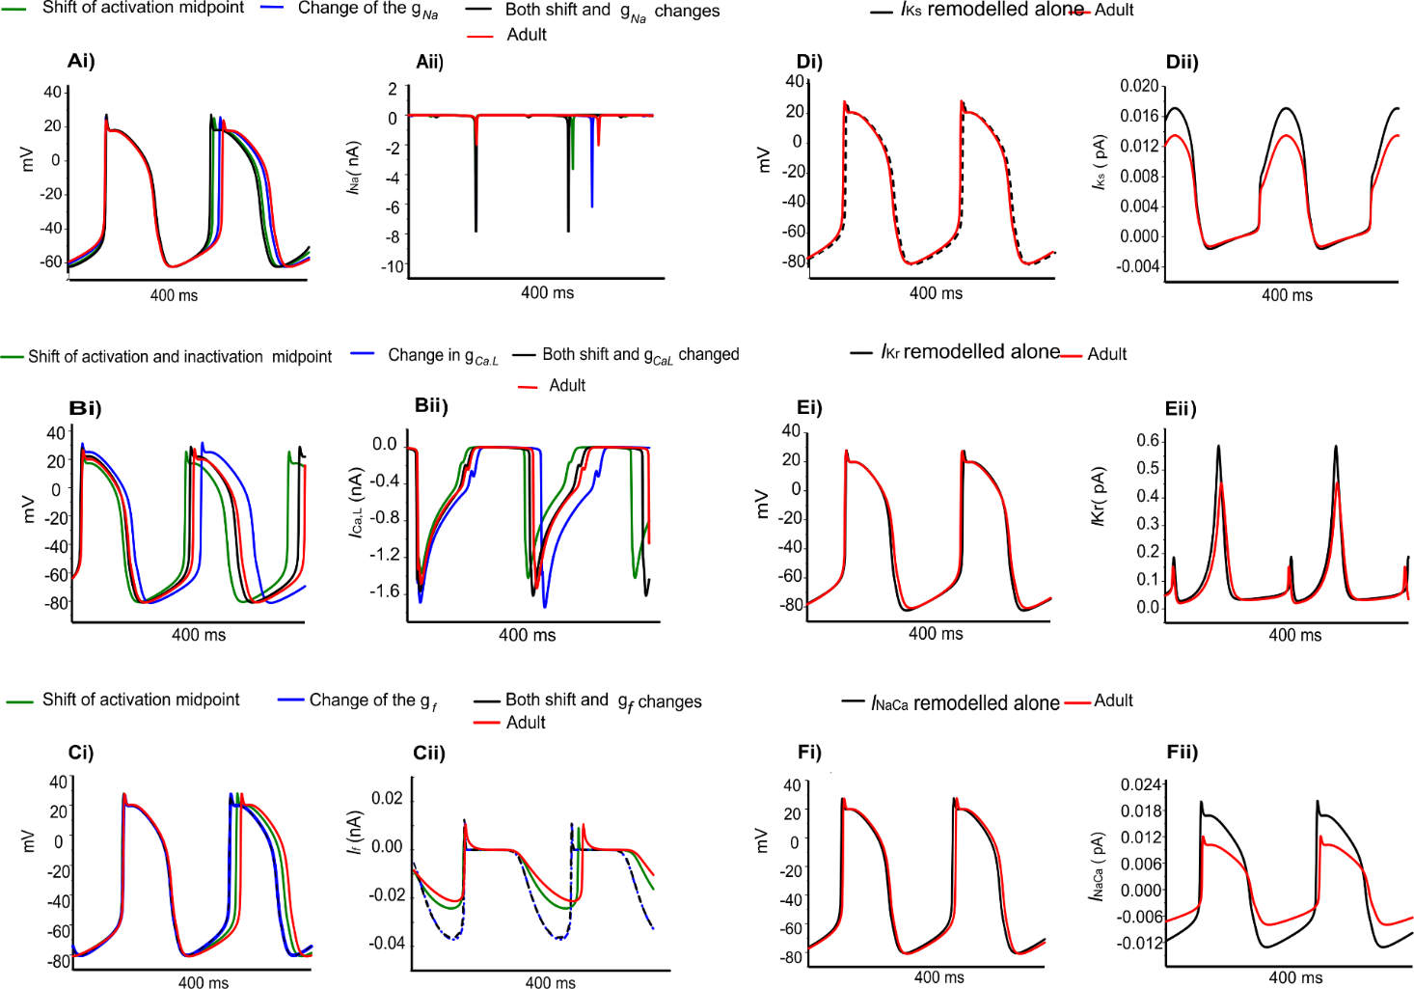
Figure S5. Simulated individual effects of ion-channel remodelling on central SAN action potentials in the adult and the underlying ionic currents (Ai-Aii) I_{Na}, (Bi-Bii) I_{Ca,L}, (Ci-Cii) I_{f}, (Di-Dii) I_{Kr}, (Ei-Eii) I_{Ks} and (Fi-Fii) I_{NaCa}

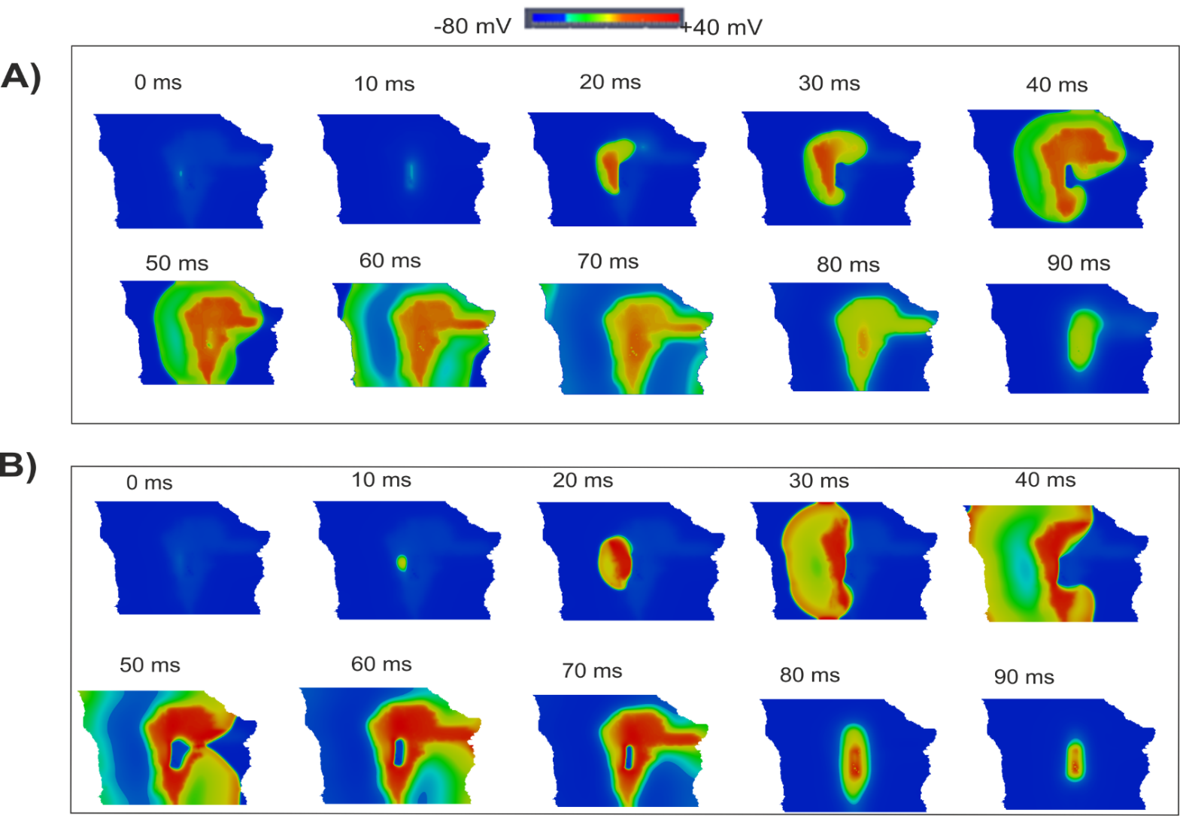
Figure S6. ACh effect at a concentration of 3×10⁻⁸M on the propagation of the SAN and surrounding area of the neonate (A) and adult (B) rabbit 2D tissue. Snapshots of the activation pattern at various timings are shown.

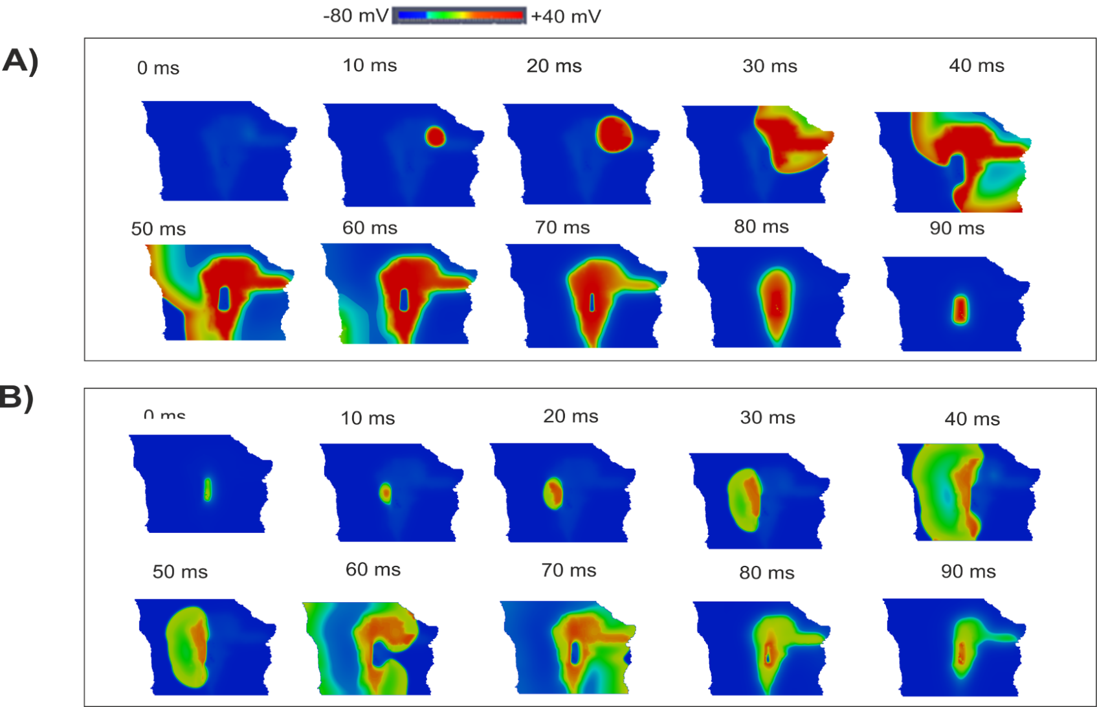
Figure S7. ACh effect at a concentration of 8×10⁻⁸M on the propagation of the SAN and surrounding area of the neonate (A) and adult (B) rabbit 2D tissue. Snapshots of the activation pattern at various times are shown.

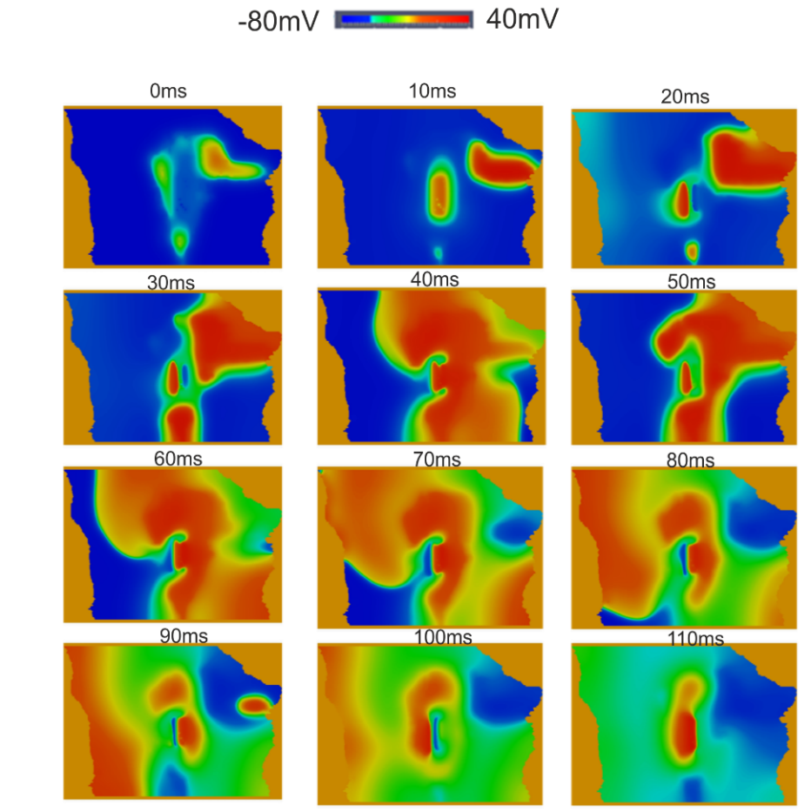
Figure S8. Multi-leading pacemaking sites resulting from ion-channel remodelling in the absence of connexin remodelling. Snapshots of the activation pattern at various timings are shown.

References

22. Jones SA, Lancaster MK, Boyett MR. Ageing-related changes of connexins and conduction within the sinoatrial node. J Physiol [Internet]. 2004 Oct [cited 2017 Jul 26];560(2):429–37. Available from: http://doi.wiley.com/10.1113/jphysiol.2004.072108
26. Zhang H, Holden A V, Kodama I, Honjo H, Lei M, Varghese T, et al. Mathematical models of action potentials in the periphery and center of the rabbit sinoatrial node. Am J Physiol Hear Circ Physiol. 2000;279(2000):H397–H421.
28. Bai X, Wang K, Yuan Y, Li Q, Dobrzynski H, Boyett MR. Mechanism underlying impaired cardiac pacemaking rhythm during ischemia. A simulation study. the American Institute of Physics. 2017 Chaos 27, 093934. doi: 10.1063/1.5002664

