Supplementary Material
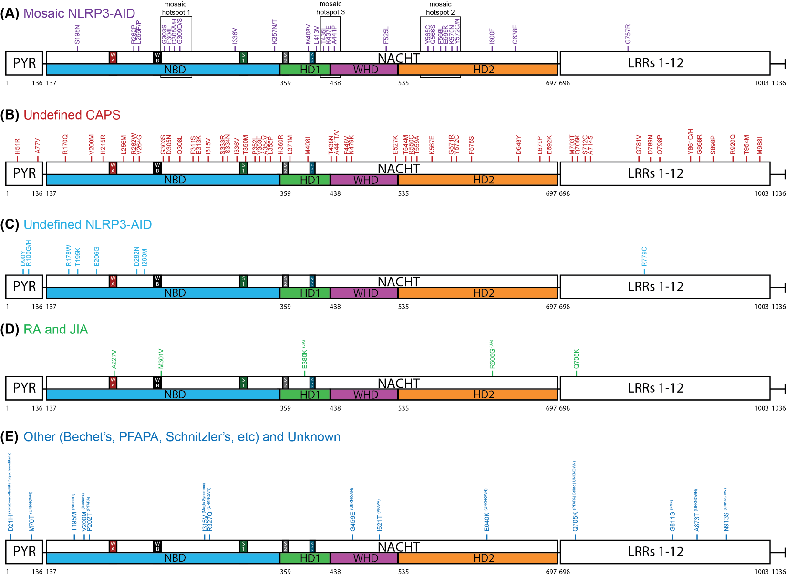
Supplementary Figure 1. NLRP3 Germline Mutant Protein Maps from Additional Diseases
Schematic representation of NLRP3 mutations proteomic locations reported in (A) Mosaic NLRP3-AID, (B) Undefined CAPS, (C) Undefined NLRP3-AID, (D) RA and JIA, and (E) Other and Unknown.
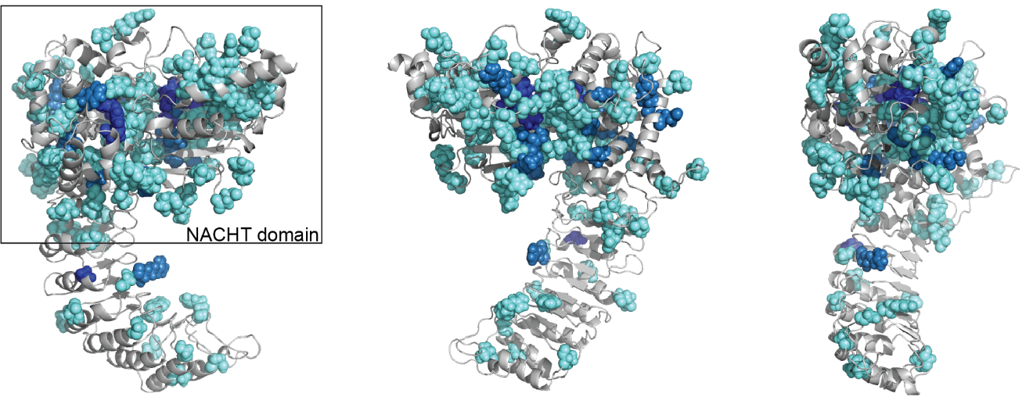
Supplementary Figure 2. Additional NLRP3 Mutation Plot
Representative locations of all germline mutations mapped on our homology model which excludes mutations in the PYR domain and mutations beyond Leu943.

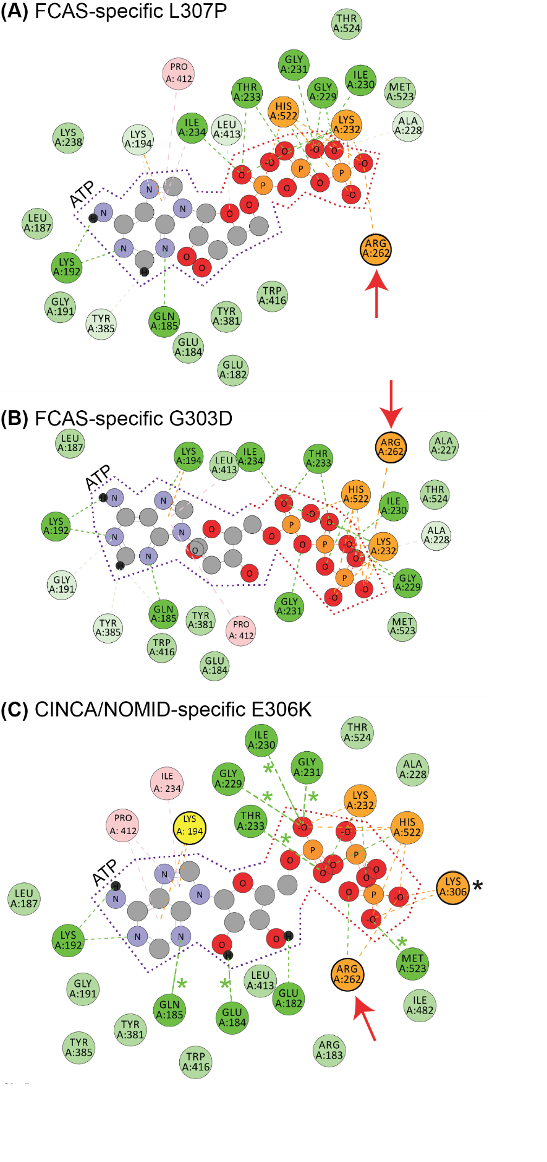
Supplementary Figure 3. Additional ATP Binding 2D Interaction Plots
2D Interaction plots of ATP binding affinity enhancing mutants (A) L307P, (B) G303D and (C) E306K. Black * indicates where the mutation itself is involved in stabilizing ATP; Green * indicate where shifted or new H-bonds occur compared to WT. Arg262 is marked with red arrows.
Supplementary Figure 4. Additional Distribution Plots
(A) Distribution of pathogenic NLRP3 mutation p_{w} scores across amino acid positions. (B) Distribution of non-pathogenic, rare NLRP3 single-nucleotide variant (minor allele frequency < 0.001) p_{w} scores across amino acid positions.

Supplementary Table 1: Bioinformatics Scores of All Reported NLRP3 Germline Mutations
Mutation | PPH2 Score | PolyPhen2  Predictionsª | PROVEAN Score | PROVEAN  Prediction^{b} | SIFT Score | SIFT  Prediction^{c}
W416L | 1 | probablydamaging | -11.16 | Deleterious | 0.033 | Damaging
C261W | 1 | probablydamaging | -7.405 | Deleterious | 0.001 | Damaging
R262W | 1 | probablydamaging | -7.022 | Deleterious | 0 | Damaging
E527V | 1 | probablydamaging | -7 | Deleterious | 0 | Damaging
L307P | 0.988 | probablydamaging | -6.395 | Deleterious | 0 | Damaging
D305A | 1 | probablydamaging | -6.255 | Deleterious | 0.001 | Damaging
R262L | 1 | probablydamaging | -6.124 | Deleterious | 0.001 | Damaging
G757R | 0.997 | probablydamaging | -6.035 | Deleterious | 0 | Damaging
R262P | 1 | probablydamaging | -6.024 | Deleterious | 0.001 | Damaging
T438I | 0.999 | probablydamaging | -5.767 | Deleterious | 0.001 | Damaging
T438P | 0.999 | probablydamaging | -5.7 | Deleterious | 0.001 | Damaging
Y572C | 0.162 | benign | -5.69 | Deleterious | 0.024 | Damaging
D305G | 1 | probablydamaging | -5.595 | Deleterious | 0.004 | Damaging
F525C | 1 | probablydamaging | -5.505 | Deleterious | 0.001 | Damaging
L679P | 1 | probablydamaging | -5.426 | Deleterious | 0.001 | Damaging
E206G | 0.001 | benign | -5.125 | Deleterious | 0.016 | Damaging
T954M | 0.999 | probablydamaging | -5.113 | Deleterious | 0.001 | Damaging
V264G | 0.418 | benign | -5.055 | Deleterious | 0.002 | Damaging
E607V | 0.382 | benign | -5.032 | Deleterious | 0.002 | Damaging
E629G | 0.768 | possiblydamaging | -4.977 | Deleterious | 0.001 | Damaging
D305H | 1 | probablydamaging | -4.972 | Deleterious | 0.032 | Damaging
Y565N | 0.983 | probablydamaging | -4.952 | Deleterious | 0.127 | Tolerated
R605G | 0.882 | possiblydamaging | -4.94 | Deleterious | 0.001 | Damaging
F311S | 0.236 | benign | -4.924 | Deleterious | 0.004 | Damaging
Y443H | 0.999 | probablydamaging | -4.767 | Deleterious | 0 | Damaging
T438A | 0.947 | possiblydamaging | -4.671 | Deleterious | 0.002 | Damaging
F446V | 0.944 | possiblydamaging | -4.667 | Deleterious | 0.005 | Damaging
Y572N | 0.162 | benign | -4.667 | Deleterious | 0.05 | Damaging
T438N | 0.887 | possiblydamaging | -4.621 | Deleterious | 0.001 | Damaging
M661K | 0.992 | probablydamaging | -4.607 | Deleterious | 0.001 | Damaging
G303D | 0.998 | probablydamaging | -4.429 | Deleterious | 0.003 | Damaging
G757A | 0.226 | benign | -4.407 | Deleterious | 0 | Damaging
Y565C | 0.204 | benign | -4.377 | Deleterious | 0.091 | Tolerated
T435I | 0.898 | possiblydamaging | -4.319 | Deleterious | 0.033 | Damaging
P352L | 0.559 | possiblydamaging | -4.319 | Deleterious | 1 | Tolerated
A441P | 0.967 | probablydamaging | -4.156 | Deleterious | 0.002 | Damaging
E527K | 1 | probablydamaging | -4 | Deleterious | 0 | Damaging
G868R | 0.735 | possiblydamaging | -3.905 | Deleterious | 0.005 | Damaging
R779C | 0.995 | probablydamaging | -3.902 | Deleterious | 0.012 | Damaging
K357T | 0.992 | probablydamaging | -3.798 | Deleterious | 0.002 | Damaging
T350M | 0.997 | probablydamaging | -3.763 | Deleterious | 0.055 | Tolerated
Q798P | 0.045 | benign | -3.688 | Deleterious | 0.203 | Tolerated
L634F | 0.998 | probablydamaging | -3.667 | Deleterious | 0 | Damaging
T407P | 0.91 | possiblydamaging | -3.663 | Deleterious | 0.003 | Damaging
D305N | 1 | probablydamaging | -3.624 | Deleterious | 0.005 | Damaging
E569A | 0.077 | benign | -3.608 | Deleterious | 0.067 | Tolerated
A441V | 0.97 | probablydamaging | -3.594 | Deleterious | 0.002 | Damaging
Q308L | 0.236 | benign | -3.504 | Deleterious | 0.037 | Damaging
L355P | 0.975 | probablydamaging | -3.502 | Deleterious | 0.007 | Damaging
E306K | 1 | probablydamaging | -3.49 | Deleterious | 0.044 | Damaging
D31V | 0.999 | probablydamaging | -3.472 | Deleterious | 0.007 | Damaging
G571R | 0.963 | probablydamaging | -3.436 | Deleterious | 0.036 | Damaging
R262Q | 0.998 | probablydamaging | -3.361 | Deleterious | 0.002 | Damaging
F525L | 0.772 | possiblydamaging | -3.333 | Deleterious | 0.026 | Damaging
S333R | 0.051 | benign | -3.264 | Deleterious | 0.007 | Damaging
M408V | 0.431 | benign | -3.194 | Deleterious | 0.044 | Damaging
E313K | 0.796 | possiblydamaging | -3.153 | Deleterious | 0.004 | Damaging
T435A | 0.614 | possiblydamaging | -3.144 | Deleterious | 0.059 | Tolerated
M408I | 0.125 | benign | -3.113 | Deleterious | 0.005 | Damaging
D90Y | 0.916 | possiblydamaging | -3.101 | Deleterious | 0.002 | Damaging
G456E | 0.001 | benign | -3.095 | Deleterious | 0.072 | Tolerated
L573F | 0.994 | probablydamaging | -3.07 | Deleterious | 0.003 | Damaging
E380K | 0.41 | benign | -3.067 | Deleterious | 0.045 | Damaging
K357N | 0.616 | possiblydamaging | -3.065 | Deleterious | 0.002 | Damaging
M523T | 0.017 | benign | -3.02 | Deleterious | 0.001 | Damaging
I600F | 0.004 | benign | -2.979 | Deleterious | 0.005 | Damaging
A354V | 0.989 | probablydamaging | -2.942 | Deleterious | 0.002 | Damaging
E640K | 0.402 | benign | -2.935 | Deleterious | 0.137 | Tolerated
A441T | 0.454 | possiblydamaging | -2.924 | Deleterious | 0.05 | Damaging
S898P | 0 | benign | -2.906 | Deleterious | 0.027 | Damaging
P202T | 0.004 | benign | -2.902 | Deleterious | 0.041 | Damaging
F581Y | 0.978 | probablydamaging | -2.901 | Deleterious | 0 | Damaging
P317L | 0.042 | benign | -2.869 | Deleterious | 0.011 | Damaging
R327W | 0.997 | probablydamaging | -2.861 | Deleterious | 0.004 | Damaging
D648Y | 0.547 | possiblydamaging | -2.839 | Deleterious | 0.061 | Tolerated
Q638E | 0.855 | possiblydamaging | -2.794 | Deleterious | 0 | Damaging
F575S | 0.077 | benign | -2.79 | Deleterious | 0.012 | Damaging
V264A | 0.004 | benign | -2.751 | Deleterious | 0.006 | Damaging
D21H | 1 | probablydamaging | -2.725 | Deleterious | 0.001 | Damaging
A497V | 0.281 | benign | -2.701 | Deleterious | 0.041 | Damaging
G303S | 1 | probablydamaging | -2.596 | Deleterious | 0.416 | Tolerated
S334N | 0.999 | probablydamaging | -2.498 | Neutral | 0.001 | Damaging
M70T | 0.996 | probablydamaging | -2.487 | Neutral | 0.004 | Damaging
N479K | 0.034 | benign | -2.485 | Neutral | 0.023 | Damaging
M664T | 0 | benign | -2.438 | Neutral | 0.044 | Damaging
A354T | 0.944 | possiblydamaging | -2.422 | Neutral | 0.11 | Tolerated
G781V | 0.857 | possiblydamaging | -2.41 | Neutral | 0.164 | Tolerated
R178W | 0.454 | possiblydamaging | -2.393 | Neutral | 0.024 | Damaging
R490K | 0.243 | benign | -2.355 | Neutral | 0.016 | Damaging
A227V | 0.437 | benign | -2.227 | Neutral | 0.014 | Damaging
F525Y | 0.999 | probablydamaging | -2.171 | Neutral | 0.008 | Damaging
G309V | 0.89 | possiblydamaging | -2.065 | Neutral | 0.166 | Tolerated
I574F | 0.93 | possiblydamaging | -2.053 | Neutral | 0.091 | Tolerated
T268P | 0.003 | benign | -2.046 | Neutral | 0.097 | Tolerated
F445L | 0.012 | benign | -2.036 | Neutral | 1 | Tolerated
K437E | 0.946 | possiblydamaging | -2.033 | Neutral | 0.007 | Damaging
G309D | 0.984 | probablydamaging | -2.024 | Neutral | 0.164 | Tolerated
L413V | 0.63 | possiblydamaging | -2.022 | Neutral | 0.005 | Damaging
A376N | 0.056 | benign | -2.021 | Neutral | 0.131 | Tolerated
C150Y | 0 | benign | -1.995 | Neutral | 0.03 | Damaging
I521T | 0.03 | benign | -1.959 | Neutral | 0.482 | Tolerated
E569K | 0.32 | benign | -1.958 | Neutral | 0.276 | Tolerated
I290M | 0.945 | possiblydamaging | -1.931 | Neutral | 0.031 | Damaging
F568L | 0.226 | benign | -1.931 | Neutral | 0.787 | Tolerated
F311Y | 0.98 | probablydamaging | -1.927 | Neutral | 0.017 | Damaging
G571A | 0.249 | benign | -1.919 | Neutral | 0.062 | Tolerated
E356D | 0.991 | probablydamaging | -1.894 | Neutral | 0.011 | Damaging
E690K | 0.011 | benign | -1.876 | Neutral | 0.139 | Tolerated
E629D | 0.589 | possiblydamaging | -1.867 | Neutral | 0.11 | Tolerated
K570N | 0.012 | benign | -1.853 | Neutral | 0.044 | Damaging
L266F | 0.616 | possiblydamaging | -1.726 | Neutral | 0.03 | Damaging
D282N | 0.659 | possiblydamaging | -1.718 | Neutral | 0.208 | Tolerated
T195K | 0 | benign | -1.651 | Neutral | 0.033 | Damaging
P651S | 0.885 | possiblydamaging | -1.649 | Neutral | 0.668 | Tolerated
A77V | 0.304 | benign | -1.613 | Neutral | 0.034 | Damaging
D789N | 0.062 | benign | -1.583 | Neutral | 0.761 | Tolerated
R170Q | 0.003 | benign | -1.571 | Neutral | 0.126 | Tolerated
I174T | 0.027 | benign | -1.554 | Neutral | 0.004 | Damaging
K175E | 0.354 | benign | -1.546 | Neutral | 0.063 | Tolerated
G811S | 0.006 | benign | -1.482 | Neutral | 0.506 | Tolerated
I482F | 0.054 | benign | -1.46 | Neutral | 0.065 | Tolerated
L266P | 0.997 | probablydamaging | -1.416 | Neutral | 0.111 | Tolerated
L371M | 0.998 | probablydamaging | -1.412 | Neutral | 0.005 | Damaging
E692K | 0.145 | benign | -1.398 | Neutral | 0.727 | Tolerated
S728G | 0.996 | probablydamaging | -1.329 | Neutral | 0.138 | Tolerated
H360R | 0.034 | benign | -1.312 | Neutral | 1 | Tolerated
V353L | 0.013 | benign | -1.28 | Neutral | 0.025 | Damaging
V353M | 0.249 | benign | -1.24 | Neutral | 0.008 | Damaging
Y572F | 0.004 | benign | -1.217 | Neutral | 0.995 | Tolerated
G309S | 0.274 | benign | -1.208 | Neutral | 0.53 | Tolerated
D213N | 0.02 | benign | -1.202 | Neutral | 0.069 | Tolerated
T589I | 0.006 | benign | -1.19 | Neutral | 0.459 | Tolerated
Y572H | 0.034 | benign | -1.183 | Neutral | 0.587 | Tolerated
R137H | 0.624 | possiblydamaging | -1.14 | Neutral | 0.1 | Tolerated
A376D | 0.002 | benign | -1.131 | Neutral | 0.741 | Tolerated
M988I | 0.008 | benign | -1.059 | Neutral | 0.558 | Tolerated
N913S | 0.001 | benign | -1.059 | Neutral | 1 | Tolerated
T195M | 0.001 | benign | -1.02 | Neutral | 0.167 | Tolerated
T544M | 0.389 | benign | -1.009 | Neutral | 0.12 | Tolerated
M703T | 0 | benign | -1.008 | Neutral | 0.299 | Tolerated
S712C | 0.05 | benign | -1.004 | Neutral | 0.177 | Tolerated
Q308E | 0.236 | benign | -0.936 | Neutral | 0.056 | Tolerated
G328E | 0.994 | probablydamaging | -0.923 | Neutral | 0.087 | Tolerated
L266V | 0.786 | possiblydamaging | -0.885 | Neutral | 0.081 | Tolerated
I336V | 0.41 | benign | -0.799 | Neutral | 0.01 | Damaging
T559A | 0 | benign | -0.79 | Neutral | 0.277 | Tolerated
G566S | 0.125 | benign | -0.786 | Neutral | 0.485 | Tolerated
R100G | 0 | benign | -0.739 | Neutral | 0.424 | Tolerated
Y861C | 0.998 | probablydamaging | -0.701 | Neutral | 0.075 | Tolerated
R100H | 0 | benign | -0.676 | Neutral | 0.154 | Tolerated
L256M | 0.84 | possiblydamaging | -0.653 | Neutral | 0.014 | Damaging
R172S | 0.003 | benign | -0.598 | Neutral | 0.222 | Tolerated
L266H | 0.999 | probablydamaging | -0.591 | Neutral | 0.153 | Tolerated
Q308K | 0.115 | benign | -0.554 | Neutral | 1 | Tolerated
A714S | 0.003 | benign | -0.505 | Neutral | 0.618 | Tolerated
R920Q | 0.025 | benign | -0.493 | Neutral | 0.106 | Tolerated
Y861H | 0.993 | probablydamaging | -0.47 | Neutral | 0.183 | Tolerated
A873T | 0.023 | benign | -0.239 | Neutral | 0.358 | Tolerated
S198N | 0.016 | benign | -0.156 | Neutral | 0.439 | Tolerated
V200M | 0.037 | benign | -0.15 | Neutral | 0.162 | Tolerated
F568Y | 0.994 | probablydamaging | -0.099 | Neutral | 1 | Tolerated
Q705K | 0.051 | benign | -0.018 | Neutral | 0.22 | Tolerated
H51R | 0.001 | benign | 0.052 | Neutral | 0.88 | Tolerated
V72M | 0.989 | probablydamaging | 0.082 | Neutral | 0.005 | Damaging
M301V | 0.025 | benign | 0.093 | Neutral | 0.011 | Damaging
R327Q | 0.069 | benign | 0.169 | Neutral | 0.041 | Damaging
S597G | 0.02 | benign | 0.42 | Neutral | 0.652 | Tolerated
L266R | 0.786 | possiblydamaging | 0.45 | Neutral | 0.915 | Tolerated
I315V | 0.003 | benign | 0.581 | Neutral | 0.223 | Tolerated
H215R | 0.037 | benign | 0.684 | Neutral | 0.987 | Tolerated
K377E | 0.002 | benign | 0.89 | Neutral | 1 | Tolerated
R550C | 0 | benign | 1.037 | Neutral | 0.108 | Tolerated
F304L | 0.091 | benign | -4.93 | Deleterious | 0.047 | Damaging
M408T | 0.958 | probablydamaging | -5.39 | Deleterious | 0.001 | Damaging
T544I | 0.021 | benign | -1.16 | Neutral | 0.183 | Tolerated
K567E | 0.012 | benign | -1.1 | Neutral | 0.337 | Tolerated
H314P | 0.002 | benign | 1.114 | Neutral | 1 | Tolerated
Prediction metrics: ªPolyPhen-2 Range 0-1; >0.45=possibly damaging; =0.95 probablydamaging. ^{b}PROVEAN: Range 0-(-N); deleterious =< -2.5. ^{c}SIFT: Range = 0-1; damaging =< 0.05. (*)

Supplementary Table 2. Ranked Combinatorial Scores for NLRP3 Mutants with p_{w}>0.05
Site | Mutation | p_{weighted}
357 | K357T | 0.052847965
605 | R605G | 0.055252239
303 | G303S | 0.056794415
438 | T438A | 0.057533576
525 | F525Y | 0.057699374
629 | E629G | 0.057764177
779 | R779C | 0.060226177
438 | T438N | 0.060948094
327 | R327W | 0.062280648
638 | Q638E | 0.062402043
573 | L573F | 0.062985134
441 | A441P | 0.063433985
757 | G757A | 0.064153362
350 | T350M | 0.069071937
70 | M70T | 0.069856993
441 | A441V | 0.070673356
354 | A354V | 0.072575726
371 | L371M | 0.076050724
264 | V264G | 0.077014504
446 | F446V | 0.077083642
565 | Y565N | 0.081821882
607 | E607V | 0.083356709
407 | T407P | 0.086258704
355 | L355P | 0.089296562
90 | D90Y | 0.094785491
572 | Y572C | 0.107248875
266 | L266H | 0.109020806
868 | G868R | 0.114227604
435 | T435I | 0.114562839
356 | E356D | 0.115529222
311 | F311S | 0.118114396
571 | G571R | 0.118141841
313 | E313K | 0.119726665
861 | Y861C | 0.120086316
266 | L266P | 0.129024129
357 | K357N | 0.129342172
72 | V72M | 0.136809893
311 | F311Y | 0.137280131
437 | K437E | 0.138346242
728 | S728G | 0.141881324
525 | F525L | 0.157200566
328 | G328E | 0.159729728
309 | G309D | 0.172145131
290 | I290M | 0.174502206
304 | F304L | 0.183905704
413 | L413V | 0.185300862
206 | E206G | 0.186301514
861 | Y861H | 0.190311898
523 | M523T | 0.192779609
572 | Y572N | 0.194827256
354 | A354T | 0.196805249
574 | I574F | 0.202627101
435 | T435A | 0.207256076
408 | M408I | 0.21067505
568 | F568Y | 0.212738787
408 | M408V | 0.213241523
352 | P352L | 0.21956337
565 | Y565C | 0.22178522
227 | A227V | 0.226340324
308 | Q308L | 0.226549748
178 | R178W | 0.23077461
333 | S333R | 0.231380585
309 | G309V | 0.232853704
256 | L256M | 0.234370103
380 | E380K | 0.234492367
441 | A441T | 0.235495662
781 | G781V | 0.239620175
648 | D648Y | 0.244464552
266 | L266F | 0.248857959
490 | R490K | 0.266831242
569 | E569A | 0.272215554
497 | A497V | 0.275728139
575 | F575S | 0.27634485
640 | E640K | 0.281783535
317 | P317L | 0.285266482
336 | I336V | 0.285315519
651 | P651S | 0.292260554
353 | V353M | 0.292770481
600 | I600F | 0.299803364
266 | L266V | 0.302745387
629 | E629D | 0.309445995
282 | D282N | 0.314531766
77 | A77V | 0.316979239
798 | Q798P | 0.317023113
174 | I174T | 0.320152409
137 | R137H | 0.321908714
264 | V264A | 0.328179541
479 | N479K | 0.336368845
571 | G571A | 0.348432967
175 | K175E | 0.348989641
569 | E569K | 0.382804874
266 | L266R | 0.40032033
544 | T544M | 0.400520737
202 | P202T | 0.403243422
308 | Q308E | 0.414738507
898 | S898P | 0.423389695
376 | A376N | 0.437551313
456 | G456E | 0.444371577
482 | I482F | 0.448295178
353 | V353L | 0.455111291
301 | M301V | 0.458325547
568 | F568L | 0.460123982
309 | G309S | 0.462619682
327 | R327Q | 0.476408904
570 | K570N | 0.483995826
150 | C150Y | 0.510354341
664 | M664T | 0.513627375
692 | E692K | 0.515317262
268 | T268P | 0.536609042
521 | I521T | 0.536936087
789 | D789N | 0.537281349
213 | D213N | 0.539399175
195 | T195K | 0.558579659
566 | G566S | 0.559757784
690 | E690K | 0.560552779
712 | S712C | 0.564777605
920 | R920Q | 0.598310958
544 | T544I | 0.607823189
200 | V200M | 0.608211169
705 | Q705K | 0.610417647
445 | F445L | 0.614813369
170 | R170Q | 0.617873382
308 | Q308K | 0.619193849
572 | Y572H | 0.620012629
360 | H360R | 0.638993921
811 | G811S | 0.662790354
567 | K567E | 0.670713225
873 | A873T | 0.68205739
589 | T589I | 0.68786721
988 | M988I | 0.705104652
215 | H215R | 0.709457011
198 | S198N | 0.716096878
572 | Y572F | 0.736146354
195 | T195M | 0.742461273
597 | S597G | 0.744441587
172 | R172S | 0.760116082
376 | A376D | 0.780323016
100 | R100H | 0.799390109
315 | I315V | 0.803275498
714 | A714S | 0.812027195
550 | R550C | 0.814186826
703 | M703T | 0.819189558
559 | T559A | 0.833213627
913 | N913S | 0.844137901
100 | R100G | 0.853088637
51 | H51R | 0.892842857
377 | K377E | 0.915686327
314 | H314P | 0.920903955

Supplementary Table 3. FCAS- and CINCA/NOMID-specific Mutants Energies and Notes
Variant | CINCA/NOMID log(p_{w}) | FCAS log(p_{w}) | ΔΔG  (kcal/mol) | Evaluation Notes
C261W |  | -2.4256 | -1.76 | Opposite side of ATP site
L307P |  | -1.9837 | -2.37 | Opposite side of ATP site - Pro mutant distorts the helix containing Glu306, which is in salt bridge with Arg262 - causes salt bridge to break and Arg262 to directly interact with PO4
G303D |  | -1.4733 | -2.34 | In ATP site - mutation causes shift of Arg262 to directly interact with terminal PO4 of ATP
M661K |  | -1.4044 |  | Nacht domain - not at protein-protein interface - potential formation of salt bridge with E401 - may alter mobility of NACHT domain
T438A |  | -1.2401 |  | Opposite end of helix at entrance to ATP site - potential consequence unclear
E629G |  | -1.2383 |  | Nacht domain hinge region - not at protein-protein interface - disrupts h-bond with Gln624 - may alter mobility of NACHT domain - perhaps making it more floppy / less stable in region around mutation
Y565N |  | -1.0871 |  | Nacht domain hinge region - not at protein-protein interface - consequence unclear - both residues maintain H-bond with Q638
E607V |  | -1.0791 |  | Nacht domain hinge region - not at protein-protein interface but in close proximity - mutation eliminates salt bridge with K617 - perhaps making it more floppy / less stable in region around mutation
D213N |  | -0.2681 |  | In NBD but on the periphery and not involved in protein-protein interaction - may result in formation of H-bond with D212 or E214 - but functional consequence is unclear
K377E |  | -0.0383 |  | On periphery of protein but not at protein-protein interaction interface - mutation disrupts salt bridge with E380 - but functional consequences are unclear
E527V | -2.4908 |  | -2.41 | In ATP site - E527 is in salt bridge with Arg 351 - mutation disrupts this interaction with R351 moves into the active site more and makes contact with the terminal PO4
D305G | -1.9035 |  | -1.4 | In ATP site - does not appear to impact ATP binding
T438P | -1.8794 |  |  | Opposite end of helix at entrance to ATP site - potential consequence unclear - may mildly distort the ATP binding site entrance
L634F | -1.7069 |  |  | Hinge region of NACHT domain - relatively conservative mutation - could potentially introduce additional pi-pi interactions with Y649 - may decrease flexibility of the hinge
E306K | -1.445 |  | -2.7 | Already evaluated - enhances ATP binding
M408T | -1.4378 |  |  | In close proximity to T438 (another identified mutation site) - may introduce an additional H-bond with H522
R262Q | -1.3793 |  | -1.49 | Located near ATP binding site - evaluated similar mutation R262W that increased ATP binding affinity - However this mutation did not appear to substantively alter ATP binding
F525Y | -1.2388 |  |  | F525 is buried next to residue M408 - pretty conservative mutation - functional consequences unclear
L573F | -1.2008 |  |  | Not at protein-protein interface - in hinge region of Nacht domain - functional consequences are unclear - mutation may introduce pi-pi interactions with F568
G757A | -1.1928 |  |  | In LRR domain - functional consequences unclear - addition of methyl R-group may introduce hydrophobic interaction with L748
T407P | -1.0642 |  |  | In hinge region of NACHT domain, next to M408 (another identified mutation site) - solvent accessible - mutation may introduce a kink to this helix but functional consequences of this are unclear
L266H | -0.9625 |  |  | At protein-protein interaction interface - may introduce additional H-bond with D321 of neighboring NLRP3 monomer and/or electrostatic interaction depending on charge state of the His mutant
E356D | -0.9373 |  |  | Not at protein-protein interaction interface - conservative change - functional consequences unclear - maintains H-bond with Q185
F311Y | -0.8624 |  |  | Not at protein-protein interaction interface - conservative change - functional consequences unclear - maintains pi-cation interaction with K325
S728G | -0.8481 |  |  | Not at protein-protein interaction interface - functional consequences unclear - does not appear to alter interaction pattern in this region
G328E | -0.7966 |  |  | Located in helix that is part of interaction interface but faces opposite side - points to a mostly hydrophobic internal pocket - doesn't alter interaction pattern - space available to accommodate the mutation so unclear what the functional effect might be
A354T | -0.706 |  |  | Internal residue not at interaction interface - space available to accommodate mutation - may introduce an extra H-bond with backbone carbonyl of Arg351
I574F | -0.6933 |  |  | In hinge domain - conservative change - functional consequences unclear - no change in interaction pattern
T435A | -0.6835 |  |  | In hinge domain - internal facing residue - does not alter interaction pattern with surrounding residues
G309V | -0.6329 |  |  | Not located at or near protein-protein interface - located near ATP binding site - functional effects unclear - may introduce additional hydrophobic interactions with Ala310 - unclear what effect that may have on ATP binding
P317L | -0.5447 |  |  | Located at start of helix that is part of interaction interface - loss of Pro residue could partially destabilize the helix and impact protein-protein interactions with the neighboring monomer
V353M | -0.5335 |  |  | Internal residue not at interaction interface - space available to accommodate mutation - conservative change that doesn't alter the interaction pattern in this area
E629D | -0.5094 |  |  | In hinge domain - conservative change - functional consequences unclear - no change in interaction pattern
I174T | -0.4946 |  |  | Not at protein-protein interaction interface - functional consequences unclear - mutation loses a hydrophobic interaction with L371
V264A | -0.4839 |  |  | Internal residue - somewhat close to interaction interface - relatively conservative change -potential loss hydrophobic interactions with V267 - functional effects unclear
G571A | -0.4579 |  |  | In hinge domain - conservative change - functional consequences unclear - no change in interaction pattern - space to accommodate the extra methyl group
K175E | -0.4572 |  |  | At protein-protein interaction interface - mutation causes loss of salt bridge with D82 on opposing monomer - likely to decrease stability of the oligomer
L266R | -0.3976 |  |  | At protein-protein interaction interface - may introduce additional H-bond with D321 of neighboring NLRP3 monomer and/or electrostatic interaction
Q308E | -0.3822 |  |  | Located on periphery of ATP site - mutation disrupts one H-bond with Q480 - but it appears unlikely to substantially alter ATP binding - not at protein-protein interaction interface
A376N | -0.359 |  |  | On periphery of protein - not at interaction interface - mutation does not introduce or disrupt any new interactions
C150Y | -0.2921 |  |  | On periphery of protein - not at interaction interface - mutation loses an H-bond with the backbone carbonyl of Ser146 but could possibly gain an H-bond between the backbone amine of Ser146 and the phenol moiety of the tyrosine
M664T | -0.2894 |  |  | In hinge domain - not at interaction interface - on periphery of protein - mutation does not change any interactions
E690K | -0.2514 |  |  | At interaction interface but despite the radical change the mutation maintains the H-bond with Tyr1012 (although switches from being donated to the E690 to being accepted from the K690 - functional effect likely to be negligible
F445L | -0.2113 |  |  | Not at protein-protein interaction interface but F445 participates in T-shaped pi-pi interaction with Trp 416 - Trp416 is also not at interaction interface but located on helix that forms part of the interaction interface - L445 eliminates this interaction so could potentially affect the protein-protein interaction
Q308K | -0.2082 |  |  | Located on periphery of ATP site - somewhat conservative change as mutant can still maintain H-bond with Q480 - appears unlikely to substantially alter ATP binding - not at protein-protein interaction interface
Y572H | -0.2076 |  |  | Located near ATP binding site - mutation does not alter interaction pattern with surrounding residues - maintains pi interactions with R351 and M523 - functional effect unclear
T589I | -0.1625 |  |  | In hinge domain - not at or near interaction interface - mutation disrupts an H-bond with Q586 - functional consequence is unclear
Y572F | -0.133 |  |  | Located near ATP binding site - mutation does not alter interaction pattern with surrounding residues - maintains pi interactions with R351 and M523 - functional effect unclear
S597G | -0.1282 |  |  | In hinge domain - not at or near interaction interface - mutation disrupts an H-bond with backbone carbonyl of E593 - functional consequence is unclear
A376D | -0.1077 |  |  | Located at periphery of the protein - not at interaction interface - neither the WT or mutant makes any interactions - functional relevance unclear
(Bold) mutant may alter ATP binding or NLRP3-NLRP3 interaction, (Bold italics) mutant may decrease NLRP3-NLRP3 interaction stability

Supplementary Table 4. FATHMM and CADD Bioinformatics Scores of Reported NLRP3 Germline Mutations
UniProt ID | Variant | FATHMM Score | FATHMM Predictionsª | Raw CADD Score | PHRED CADD Score
Q96P20 | T954M | 0.37 | TOLERATED | 3.789863 | 26.2
Q96P20 | D21H | 0.27 | TOLERATED | 3.494173 | 25
Q96P20 | M70T | 0.38 | TOLERATED | 3.475438 | 24.9
Q96P20 | R779C | 0.58 | TOLERATED | 3.245269 | 24.2
Q96P20 | E380K | -1.55 | DAMAGING | 2.816105 | 23.2
Q96P20 | E607V | -2.38 | DAMAGING | 2.719827 | 23
Q96P20 | R327W | -1.46 | TOLERATED | 2.510929 | 22.6
Q96P20 | R605G | -2.32 | DAMAGING | 2.497281 | 22.6
Q96P20 | M301V | -1.38 | TOLERATED | 1.941588 | 19.28
Q96P20 | D282N | -1.25 | TOLERATED | 1.818421 | 18.34
Q96P20 | A77V | 0.33 | TOLERATED | 1.813483 | 18.3
Q96P20 | M988I | 1.22 | TOLERATED | 1.757513 | 17.88
Q96P20 | G811S | 0.54 | TOLERATED | 1.733952 | 17.71
Q96P20 | D648Y | -2.35 | DAMAGING | 1.704058 | 17.51
Q96P20 | A227V | -1.43 | TOLERATED | 1.674243 | 17.31
Q96P20 | V72M | 0.59 | TOLERATED | 1.566615 | 16.65
Q96P20 | S728G | 0.6 | TOLERATED | 1.420196 | 15.83
Q96P20 | R137H | -0.75 | TOLERATED | 1.419563 | 15.82
Q96P20 | R178W | -2.4 | DAMAGING | 1.408532 | 15.76
Q96P20 | R327Q | -1.44 | TOLERATED | 1.399634 | 15.71
Q96P20 | D789N | 0.68 | TOLERATED | 1.333448 | 15.37
Q96P20 | R170Q | -2.28 | DAMAGING | 1.065657 | 13.86
Q96P20 | R490K | -3.51 | DAMAGING | 0.949383 | 13.08
Q96P20 | P317L | -0.85 | TOLERATED | 0.591354 | 10.24
Q96P20 | S898P | 0.57 | TOLERATED | 0.577104 | 10.11
Q96P20 | P202T | -2.84 | DAMAGING | 0.524658 | 9.632
Q96P20 | I290M | -1.43 | TOLERATED | 0.522803 | 9.615
Q96P20 | G456E | -1.67 | DAMAGING | 0.436562 | 8.782
Q96P20 | S198N | -2.46 | DAMAGING | 0.041643 | 3.285
Q96P20 | H51R | 1.12 | TOLERATED | 0.034691 | 3.171
Q96P20 | T559A | -1.75 | DAMAGING | 0.011115 | 2.794
Q96P20 | N913S | -0.26 | TOLERATED | -0.06056 | 1.816
Q96P20 | A714S | -2.44 | DAMAGING | -0.08049 | 1.598
Q96P20 | Q705K | -2.37 | DAMAGING | -0.084527 | 1.557
Q96P20 | A873T | 0.81 | TOLERATED | -0.096138 | 1.443
Q96P20 | A497V | -2.09 | DAMAGING | -0.269068 | 0.452
Q96P20 | M703T | -2.32 | DAMAGING | -0.32777 | 0.302
Q96P20 | R550C | -2.35 | DAMAGING | -0.371432 | 0.223
Q96P20 | R100G | -0.77 | TOLERATED | -0.457371 | 0.121
Q96P20 | T195M | -2.45 | DAMAGING | -0.693014 | 0.021
Q96P20 | T195K | -2.43 | DAMAGING | -0.708606 | 0.018
Q96P20 | V200M | -2.33 | DAMAGING | -0.769166 | 0.011
Q96P20 | I315V | -0.69 | TOLERATED | -0.822025 | 0.008
Q96P20 | R100H | -0.78 | TOLERATED | -0.862666 | 0.006
Q96P20 | H215R | -1.41 | TOLERATED | -1.060385 | 0.002
Q96P20 | T544M | -3.1 | DAMAGING | -1.506422 | 0.001
Q96P20 | F525C | -3.99 | DAMAGING
Q96P20 | F525Y | -3.88 | DAMAGING
Q96P20 | F525L | -3.85 | DAMAGING
Q96P20 | G571R | -3.45 | DAMAGING
Q96P20 | I521T | -3.43 | DAMAGING
Q96P20 | E569A | -3.42 | DAMAGING
Q96P20 | E569K | -3.41 | DAMAGING
Q96P20 | G571A | -3.4 | DAMAGING
Q96P20 | I600F | -3.08 | DAMAGING
Q96P20 | L573F | -2.94 | DAMAGING
Q96P20 | T544I | -2.9 | DAMAGING
Q96P20 | L634F | -2.78 | DAMAGING
Q96P20 | S712C | -2.78 | DAMAGING
Q96P20 | E527V | -2.64 | DAMAGING
Q96P20 | E527K | -2.6 | DAMAGING
Q96P20 | E206G | -2.56 | DAMAGING
Q96P20 | D305H | -2.44 | DAMAGING
Q96P20 | D305G | -2.43 | DAMAGING
Q96P20 | D305A | -2.42 | DAMAGING
Q96P20 | C150Y | -2.41 | DAMAGING
Q96P20 | M661K | -2.41 | DAMAGING
Q96P20 | D305N | -2.37 | DAMAGING
Q96P20 | T350M | -2.37 | DAMAGING
Q96P20 | R172S | -2.34 | DAMAGING
Q96P20 | E692K | -2.32 | DAMAGING
Q96P20 | M664T | -2.31 | DAMAGING
Q96P20 | I174T | -2.27 | DAMAGING
Q96P20 | S597G | -2.27 | DAMAGING
Q96P20 | E640K | -2.23 | DAMAGING
Q96P20 | Y443H | -2.23 | DAMAGING
Q96P20 | P651S | -2.2 | DAMAGING
Q96P20 | E690K | -2.15 | DAMAGING
Q96P20 | K437E | -2.13 | DAMAGING
Q96P20 | F446V | -2.07 | DAMAGING
Q96P20 | K175E | -2.03 | DAMAGING
Q96P20 | W416L | -2 | DAMAGING
Q96P20 | T438P | -1.98 | DAMAGING
Q96P20 | M408I | -1.96 | DAMAGING
Q96P20 | M408T | -1.96 | DAMAGING
Q96P20 | T438I | -1.96 | DAMAGING
Q96P20 | T438N | -1.94 | DAMAGING
Q96P20 | I482F | -1.93 | DAMAGING
Q96P20 | M408V | -1.93 | DAMAGING
Q96P20 | T438A | -1.89 | DAMAGING
Q96P20 | A441P | -1.82 | DAMAGING
Q96P20 | A441V | -1.81 | DAMAGING
Q96P20 | E629G | -1.81 | DAMAGING
Q96P20 | T407P | -1.81 | DAMAGING
Q96P20 | F581Y | -1.8 | DAMAGING
Q96P20 | T589I | -1.8 | DAMAGING
Q96P20 | E629D | -1.79 | DAMAGING
Q96P20 | M523T | -1.79 | DAMAGING
Q96P20 | Y572C | -1.79 | DAMAGING
Q96P20 | A441T | -1.78 | DAMAGING
Q96P20 | F568Y | -1.77 | DAMAGING
Q96P20 | F575S | -1.77 | DAMAGING
Q96P20 | I574F | -1.77 | DAMAGING
Q96P20 | Y572F | -1.77 | DAMAGING
Q96P20 | G566S | -1.76 | DAMAGING
Q96P20 | N479K | -1.76 | DAMAGING
Q96P20 | Y565C | -1.76 | DAMAGING
Q96P20 | F568L | -1.74 | DAMAGING
Q96P20 | T435I | -1.74 | DAMAGING
Q96P20 | Y565N | -1.74 | DAMAGING
Q96P20 | F445L | -1.73 | DAMAGING
Q96P20 | T435A | -1.73 | DAMAGING
Q96P20 | Y572N | -1.73 | DAMAGING
Q96P20 | Q638E | -1.71 | DAMAGING
Q96P20 | L355P | -1.65 | DAMAGING
Q96P20 | P352L | -1.64 | DAMAGING
Q96P20 | R262W | -1.61 | DAMAGING
Q96P20 | L307P | -1.59 | DAMAGING
Q96P20 | R262P | -1.59 | DAMAGING
Q96P20 | R262L | -1.58 | DAMAGING
Q96P20 | R262Q | -1.58 | DAMAGING
Q96P20 | K567E | -1.56 | DAMAGING
Q96P20 | L413V | -1.56 | DAMAGING
Q96P20 | A354V | -1.49 | TOLERATED
Q96P20 | E306K | -1.49 | TOLERATED
Q96P20 | G303S | -1.49 | TOLERATED
Q96P20 | E356D | -1.48 | TOLERATED
Q96P20 | L371M | -1.47 | TOLERATED
Q96P20 | I336V | -1.46 | TOLERATED
Q96P20 | A354T | -1.42 | TOLERATED
Q96P20 | A376N | -1.42 | TOLERATED
Q96P20 | C261W | -1.34 | TOLERATED
Q96P20 | K570N | -1.31 | TOLERATED
Q96P20 | F304L | -1.29 | TOLERATED
Q96P20 | Y572H | -1.29 | TOLERATED
Q96P20 | L256M | -1.27 | TOLERATED
Q96P20 | K357T | -1.26 | TOLERATED
Q96P20 | V264G | -1.23 | TOLERATED
Q96P20 | S333R | -1.21 | TOLERATED
Q96P20 | E313K | -1.2 | TOLERATED
Q96P20 | V353M | -1.2 | TOLERATED
Q96P20 | A376D | -1.19 | TOLERATED
Q96P20 | F311Y | -1.19 | TOLERATED
Q96P20 | Q308L | -1.19 | TOLERATED
Q96P20 | S334N | -1.19 | TOLERATED
Q96P20 | V353L | -1.19 | TOLERATED
Q96P20 | G309V | -1.18 | TOLERATED
Q96P20 | L266V | -1.18 | TOLERATED
Q96P20 | T268P | -1.18 | TOLERATED
Q96P20 | G328E | -1.17 | TOLERATED
Q96P20 | K357N | -1.17 | TOLERATED
Q96P20 | L266F | -1.17 | TOLERATED
Q96P20 | V264A | -1.16 | TOLERATED
Q96P20 | L266H | -1.15 | TOLERATED
Q96P20 | L266P | -1.15 | TOLERATED
Q96P20 | F311S | -1.14 | TOLERATED
Q96P20 | Q308E | -1.11 | TOLERATED
Q96P20 | G309D | -1.1 | TOLERATED
Q96P20 | G757R | -1.1 | TOLERATED
Q96P20 | Q308K | -1.09 | TOLERATED
Q96P20 | K377E | -1.04 | TOLERATED
Q96P20 | G757A | -1.03 | TOLERATED
Q96P20 | G309S | -1.01 | TOLERATED
Q96P20 | H360R | -1 | TOLERATED
Q96P20 | L266R | -0.94 | TOLERATED
Q96P20 | H314P | -0.81 | TOLERATED
Q96P20 | D213N | -0.8 | TOLERATED
Q96P20 | G303D | -0.78 | TOLERATED
Q96P20 | L679P | -0.68 | TOLERATED
Q96P20 | R920Q | 0.01 | TOLERATED
Q96P20 | D31V | 0.31 | TOLERATED
Q96P20 | D90Y | 0.32 | TOLERATED
Q96P20 | G868R | 0.36 | TOLERATED
Q96P20 | G781V | 0.53 | TOLERATED
Q96P20 | Y861C | 0.61 | TOLERATED
Q96P20 | Y861H | 0.63 | TOLERATED
Q96P20 | Q798P | 0.8 | TOLERATED
Prediction metrics: ªFATHMM Range N-(-N); < -1.5 = damaging; > -1.5 = tolerated. ^{b}CADD: Range 0-(-N); deleterious =< -2.5.

