Supplementary Material

Supplementary Figures and Tables

Supplementary Figures
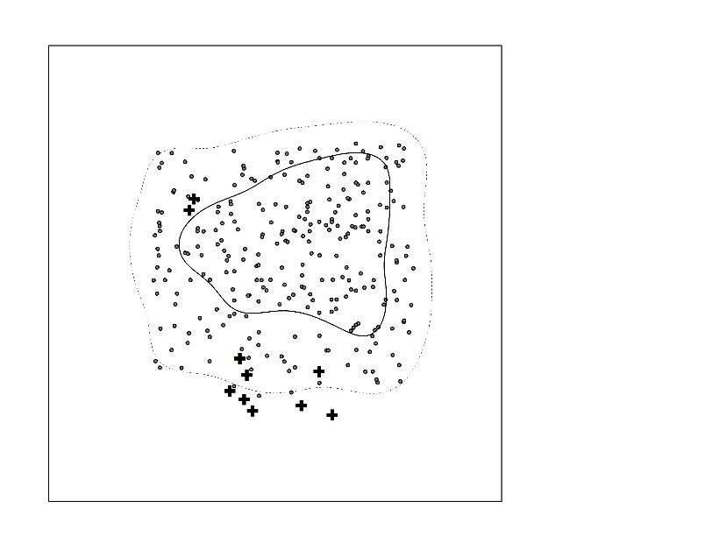
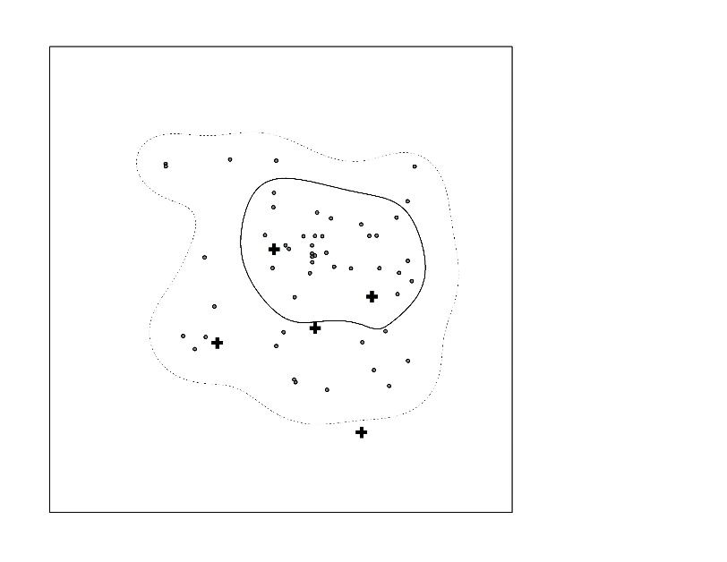
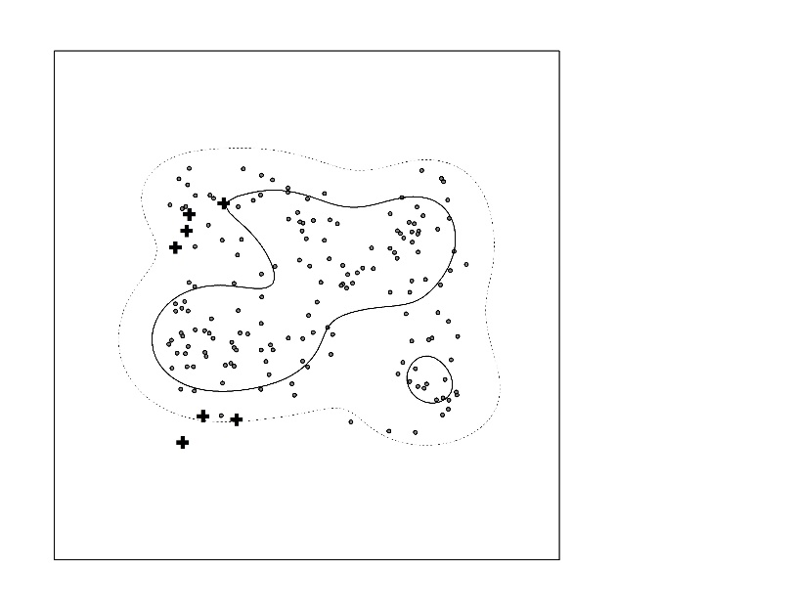
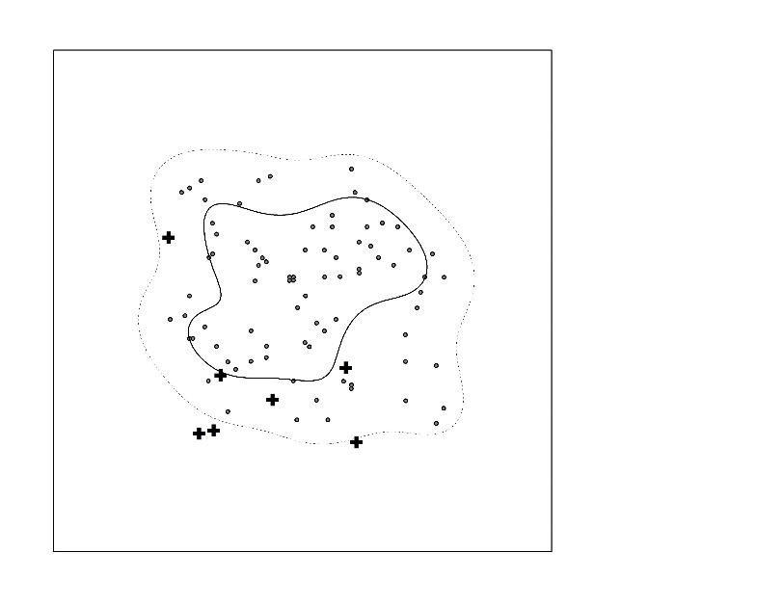
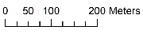
Plot A
2012
2013
2014
2015

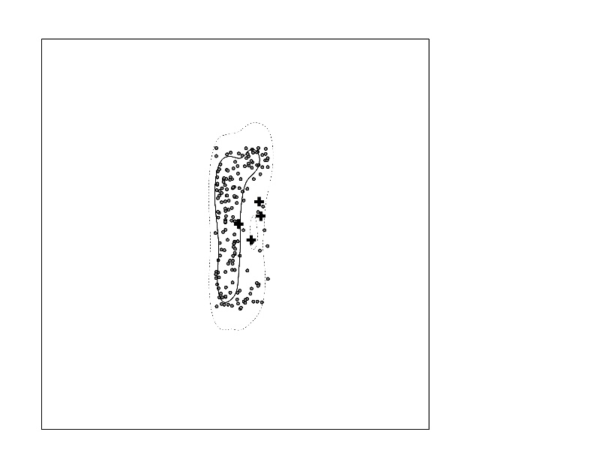
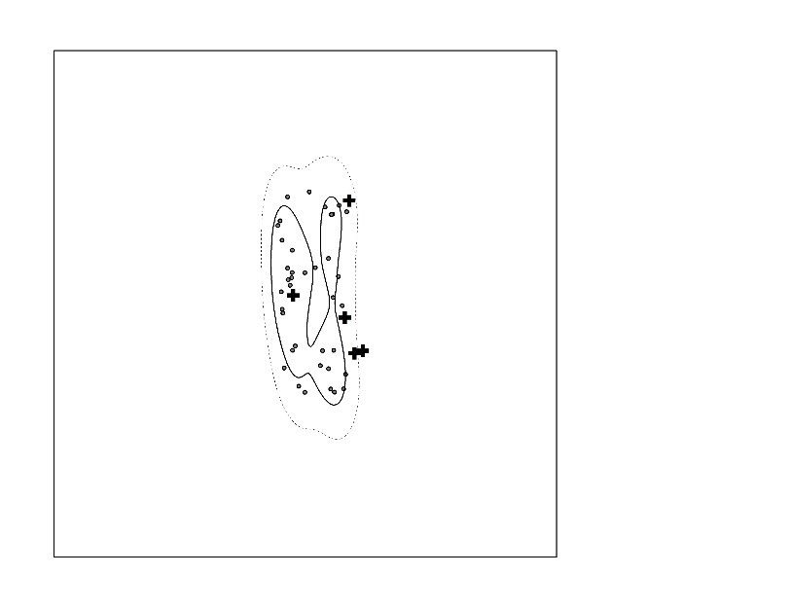
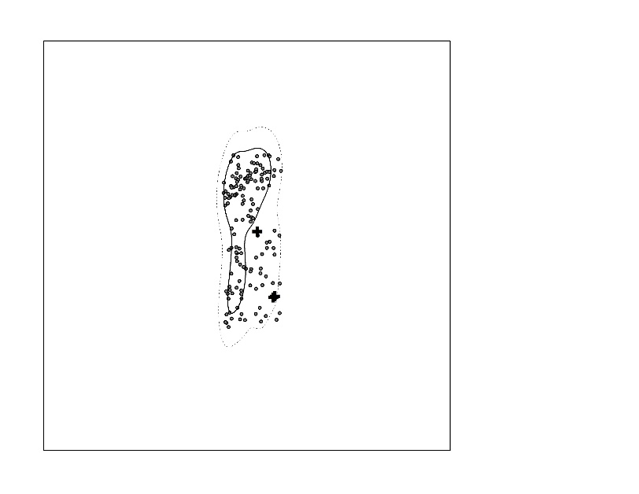
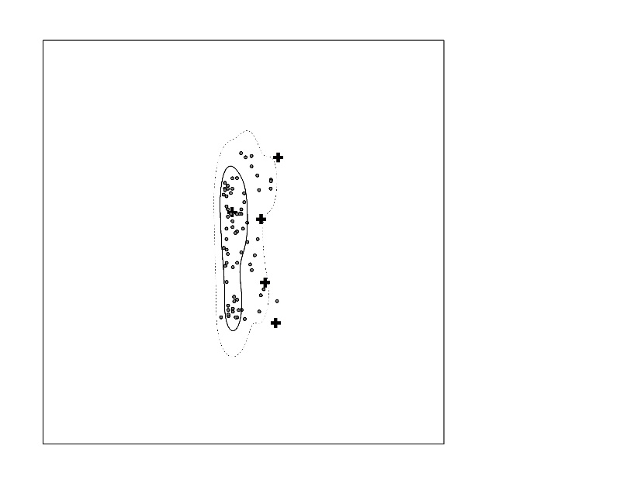
Plot B
2012
2013
2014
2015

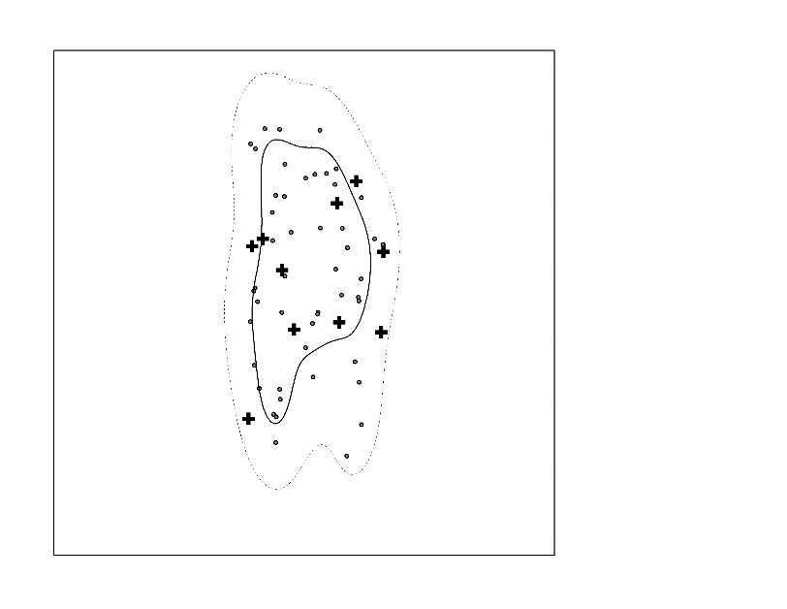
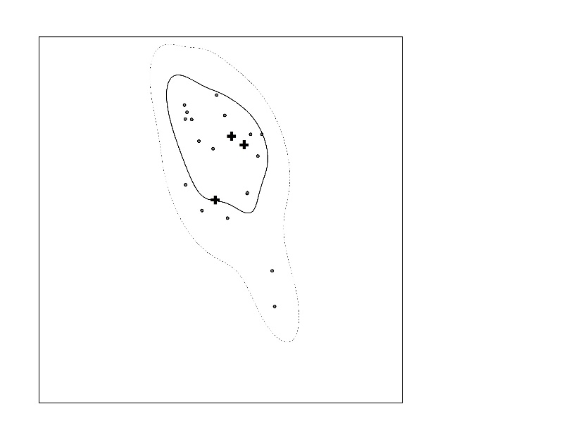
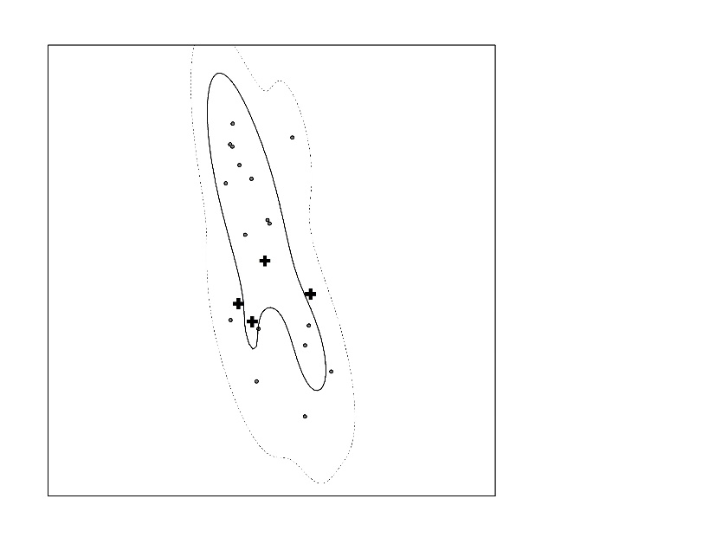
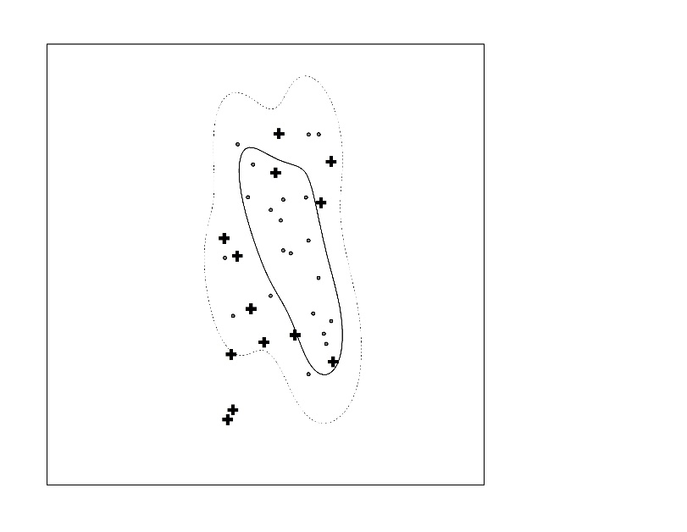
Plot C
2012
2013
2014
2015

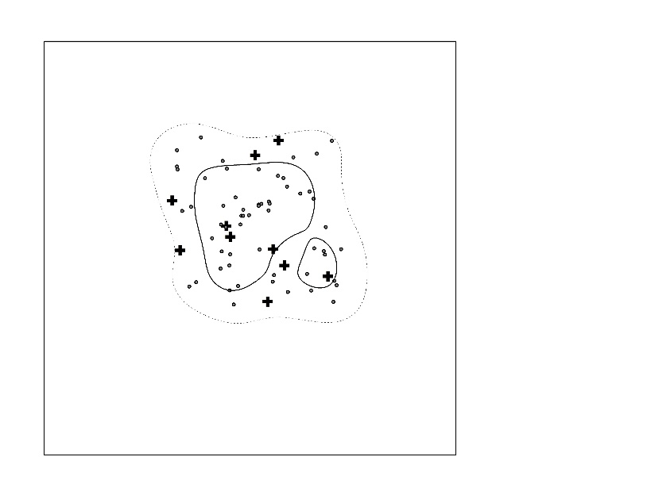
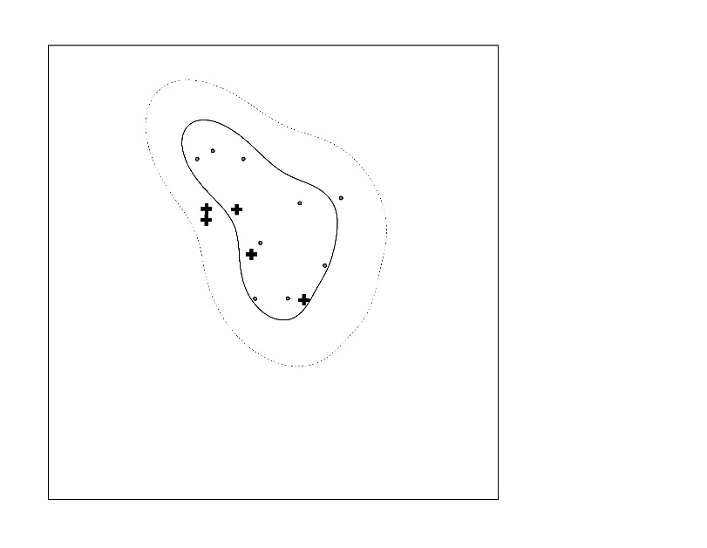
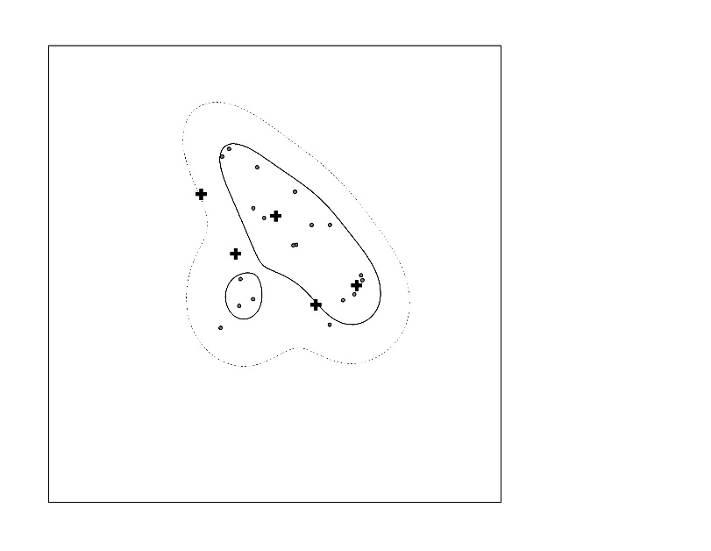
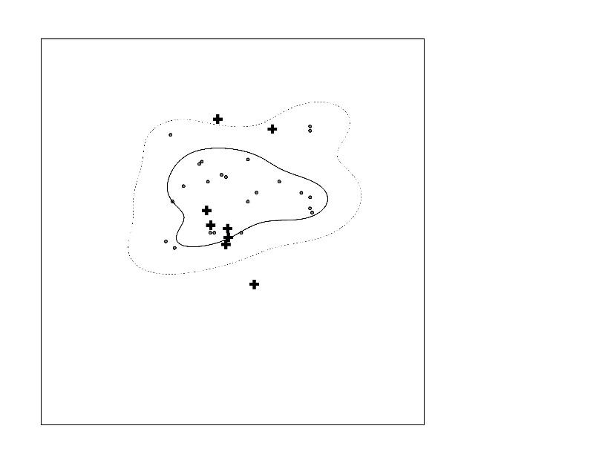
Plot D
2012
2014
2013
2015
Supplementary Figure 1. Eastern Chipmunk activity estimated using kernel density functions based on 50% isopleth (solid line) and 90% isopleth (dotted line) densities. Mapped detections of Eastern Chipmunks are also shown by dots (“.”) for each plot and year, as well as the locations of Hermit Thrush and Ovenbird nests (+).

Supplementary Figure 2. Map showing transects used to survey Eastern Chipmunks in study plot B. Observers walked slowly along dotted lines and recorded all visual and aural detections within a 25-m band on either side of the transect line. Starting points were alternated between visits.

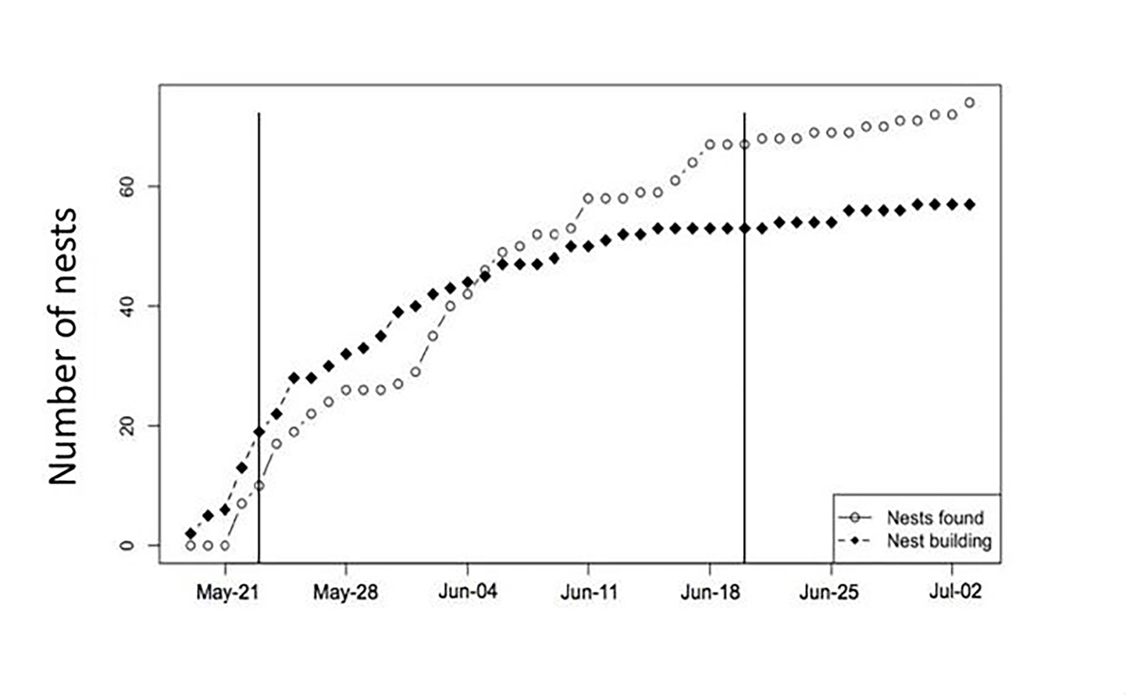

Supplementary Figure 3. Cumulative increase in the number of ovenbird nests found on (or backdated to) the first day of nest building (black diamonds; n=57), or at any stage (open symbols; n=86) in the summer of 2012 in New Brunswick, Canada. Solid vertical lines indicate the beginning and the end of the spot mapping of Eastern Chipmunks. Note that this data set was collected in a broader study area (see Haché and Villard 2010) encompassing the study plots analyzed here.

Supplementary Table 1. Mean number of nest predator detections per study plot and year, with corresponding standard errors.

Year | Plot | Eastern Chipmunk |  |  | Red Squirrel |  |  | Blue Jay
2012 | A | 46.2 | ± | 7.5 | 1.3 | ± | 0.4 | 2.3 | ± | 0.9
 | B | 28.3 | ± | 6.9 | 0.8 | ± | 0.3 | 0.8 | ± | 0.4
 | C | 7.7 | ± | 3.0 | 0.7 | ± | 0.3 | 0.2 | ± | 0.2
 | D | 9.5 | ± | 1.6 | 1.2 | ± | 0.4 | 0.5 | ± | 0.3
2013 | A | 10.2 | ± | 3.7 | 0.0 | ± | 0.0 | 0.2 | ± | 0.2
 | B | 6.6 | ± | 1.7 | 0.4 | ± | 0.2 | 0.0 | ± | 0.0
 | C | 3.2 | ± | 0.9 | 0.2 | ± | 0.2 | 0.2 | ± | 0.2
 | D | 1.8 | ± | 1.0 | 0.0 | ± | 0.0 | 0.0 | ± | 0.0
2014 | A | 27.8 | ± | 5.4 | 0.3 | ± | 0.2 | 1.5 | ± | 0.7
 | B | 22.5 | ± | 3.9 | 1.2 | ± | 0.5 | 1.0 | ± | 0.4
 | C | 2.8 | ± | 0.9 | 0.7 | ± | 0.3 | 0.0 | ± | 0.0
 | D | 3.2 | ± | 0.2 | 1.8 | ± | 1.1 | 0.3 | ± | 0.2
2015 | A | 20.0 | ± | 5.7 | 0.0 | ± | 0.0 | 0.0 | ± | 0.0
 | B | 13.5 | ± | 2.6 | 1.0 | ± | 0.5 | 0.2 | ± | 0.2
 | C | 3.8 | ± | 1.3 | 0.5 | ± | 0.2 | 0.0 | ± | 0.0
 | D | 3.0 | ± | 0.6 | 0.3 | ± | 0.3 | 0.0 | ± | 0.0

Supplementary Table 2. Effects of Eastern Chipmunk activity (as estimated using the kernel approach, “Chipmunk”), songbird species (“Species”), plot, and year on daily nest survival rate from 2012 to 2015. Results of generalized linear models with a binomial link function are shown. Bold indicates the best models according to ΔAIC. All other models did not converge.

Model | K | AIC | ΔAIC | Weight | Deviance
Chipmunk + Species | 3 | 108.69 | 0.00 | 0.30 | -51.16
Species | 2 | 108.89 | 0.19 | 0.27 | -52.35
Species + Plot | 5 | 109.24 | 0.55 | 0.23 | -49.15
Chipmunk + Species + Plot | 6 | 110.01 | 1.31 | 0.16 | -48.33
Null | 1 | 115.86 | 7.16 | 0.01 | -56.90
Chipmunk + Year | 5 | 115.96 | 7.26 | 0.01 | -52.50
Chipmunk | 2 | 116.83 | 8.13 | 0.01 | -56.32
Plot | 4 | 117.12 | 8.43 | 0.00 | -54.25
Plot + Year | 7 | 117.51 | 8.81 | 0.00 | -50.84
Chipmunk + Plot + Year | 8 | 118.56 | 9.86 | 0.00 | -50.08
Chipmunk + Plot | 5 | 118.70 | 10.00 | 0.00 | -53.87
Chipmunk*Plot | 5 | 118.98 | 10.29 | 0.00 | -54.02
Year | Did not converge
Chipmunk*Species | Did not converge
Chipmunk*Year | Did not converge
Year + Species | Did not converge
Year*Species | Did not converge
Plot*Year | Did not converge
Species + Plot +Year | Did not converge
Species + Chipmunk + Year | Did not converge
Species + Chipmunk + Year + Plot | Did not converge

Supplementary Table 3. Parameter estimates and standard errors (SE) from the best generalized linear model explaining daily nest survival rate of two songbird species (see Supplementary Table 2 for the different models we compared). Chipmunk: estimated Eastern Chipmunk activity at the nest.

Explanatory Variables | Estimate | SE | z | P
Intercept | 1.32 | 0.49 | 2.718 | 0.007
Chipmunk | 0.20 | 0.14 | 1.362 | 0.173
Species(Ovenbird) | 1.32 | 0.43 | 3.050 | 0.002

Supplementary Table 4. Parameter estimates and standard errors (SE) from the second best generalized linear model explaining daily nest survival rate of two songbird species (see Supplementary Table 2 for the different models we compared).

Explanatory Variables | Estimate | SE | z | P
Intercept | 1.89 | 0.34 | 5.527 | < 0.001
Species(Ovenbird) | 1.19 | 0.42 | 2.799 | 0.005

Supplementary Table 5. Parameter estimates and standard errors (SE) from the third best generalized linear model explaining daily nest survival rate of two songbird species (see Supplementary Table 2 for the different models we compared).

Explanatory Variables | Estimate | SE | z | P
Intercept | 1.97 | 0.51 | 3.880 | <0.001
Species(Ovenbird) | 1.34 | 0.44 | 3.024 | 0.002
Plot A | -1.07 | 0.58 | -1.860 | 0.063
Plot B | -0.10 | 0.65 | -0.161 | 0.872
Plot C | 0.21 | 0.56 | 0.378 | 0.706

Supplementary Table 6. Parameter estimates and standard errors (SE) from the fourth best generalized linear model explaining daily nest survival rate of two songbird species (see Supplementary Table 2 for the different models we compared). Chipmunk: estimated Eastern Chipmunk activity at the nest.

Explanatory Variables | Estimate | SE | z | P
Intercept | 1.36 | 0.66 | 2.078 | 0.038
Chipmunk | 0.17 | 0.15 | 1.165 | 0.244
Species(Ovenbird) | 1.43 | 0.45 | 3.183 | 0.001
Plot A | -0.87 | 0.59 | -1.465 | 0.143
Plot B | -0.05 | 0.67 | -0.070 | 0.944
Plot C | 0.40 | 0.57 | 0.694 | 0.488

Supplementary Table 7. Effects of Eastern Chipmunk activity (as estimated using kernel approach, “Chipmunk”), songbird species (“Species”), and year on daily nest survival rate during intermediary years (2014 to 2015). Results of generalized linear models with a binomial link function are shown. Bold indicates the best models according to ΔAIC. All other models did not converge.
Model | K | AIC | ΔAIC | Weight | Deviance
Chipmunk + Plot + Year | 6 | 60.81 | 0.00 | 0.67 | -23.17
Plot + Year | 5 | 62.82 | 2.02 | 0.24 | -25.55
Plot | 4 | 66.41 | 5.60 | 0.04 | -28.65
Chipmunk + Plot | 5 | 66.46 | 5.65 | 0.04 | -27.37
Chipmunk + Year | 3 | 70.86 | 10.05 | 0.00 | -32.10
Chipmunk + Species + Year | 4 | 72.15 | 11.34 | 0.00 | -31.52
Chipmunk + Species | 3 | 72.97 | 12.16 | 0.00 | -33.16
Chipmunk | 2 | 73.97 | 13.16 | 0.00 | -34.83
Null | 1 | 74.30 | 13.49 | 0.00 | -36.10
Species | 2 | 74.59 | 13.78 | 0.00 | -35.14
Chipmunk*Species | 3 | 76.04 | 15.24 | 0.00 | -34.70
Year | Did not converge
Chipmunk*Year | Did not converge
Chipmunk*Plot | Did not converge
Year + Species | Did not converge
Year*Species | Did not converge
Species + Plot | Did not converge
Species + Plot + Year | Did not converge
Species + Plot + Chipmunk | Did not converge
Chipmunk + Plot + Year | Did not converge
Chipmunk + Species + Plot + Year | Did not converge

Supplementary Table 8. Parameter estimates and standard errors (SE) from the best generalized linear model explaining daily nest survival rate of two songbird species for the years 2014-2015 (see Supplementary Table 7 for the different models compared). Chipmunk: estimated Eastern Chipmunk activity at the nest.

Explanatory Variables | Estimate | SE | z | P
Intercept | 0.64 | 1.24 | 0.514 | 0.607
Chipmunk | 0.66 | 0.35 | 1.910 | 0.056
Plot A | -1.97 | 1.00 | -1.973 | 0.049
Plot B | 0.50 | 1.15 | 0.432 | 0.666
Plot C | 1.43 | 1.06 | 1.357 | 0.175
Year 2015 | 2.24 | 0.87 | 2.562 | 0.010

