Supporting Information

CuGeO₃ nanoparticles: an efficient photothermal theragnosis agent for CT imaging-guided photothermal therapy of cancers
Jiawu Wang¹, Chengyao zhang²*
¹Department of Urology, the Second Affiliated Hospital of Chongqing Medical University, Chongqing 400010, China.
²Department of Head and Neck Cancer Center, Chongqing University Cancer Hospital & Chongqing Cancer Institute & Chongqing Cancer Hospital, Chongqing 400010, China.
*Email: CY. Zhang, cczhangcy@163.com.

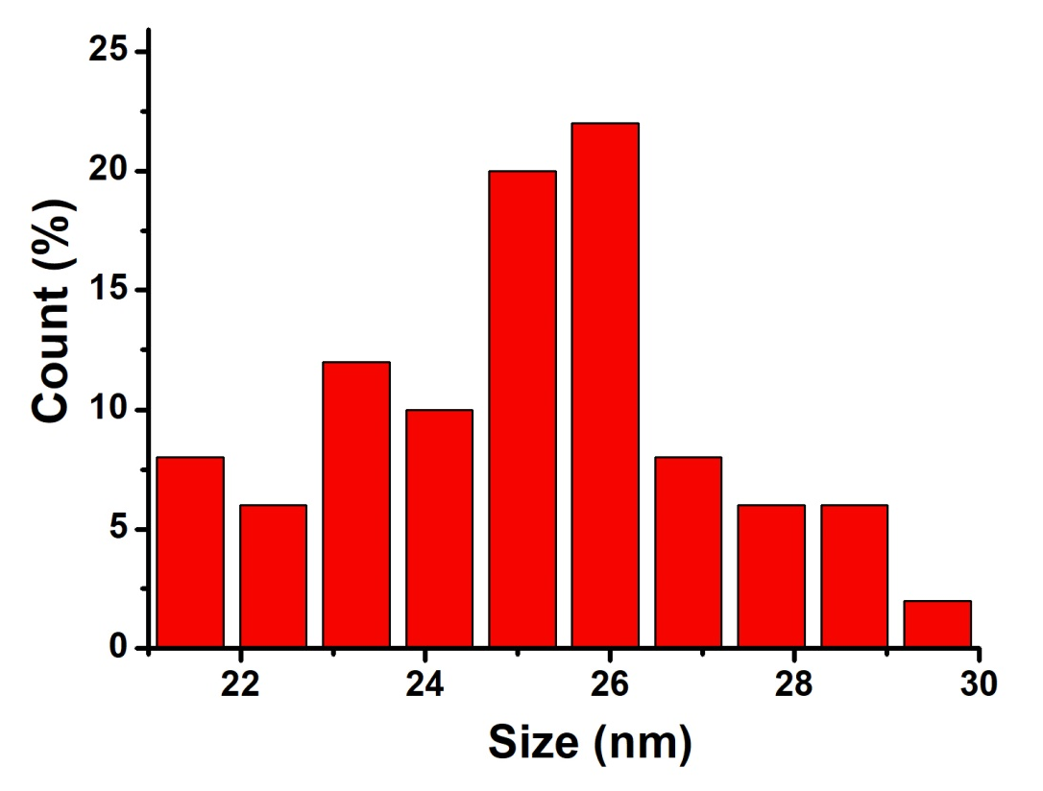
Figure S1. Size distribution of CGO nanoparticles.

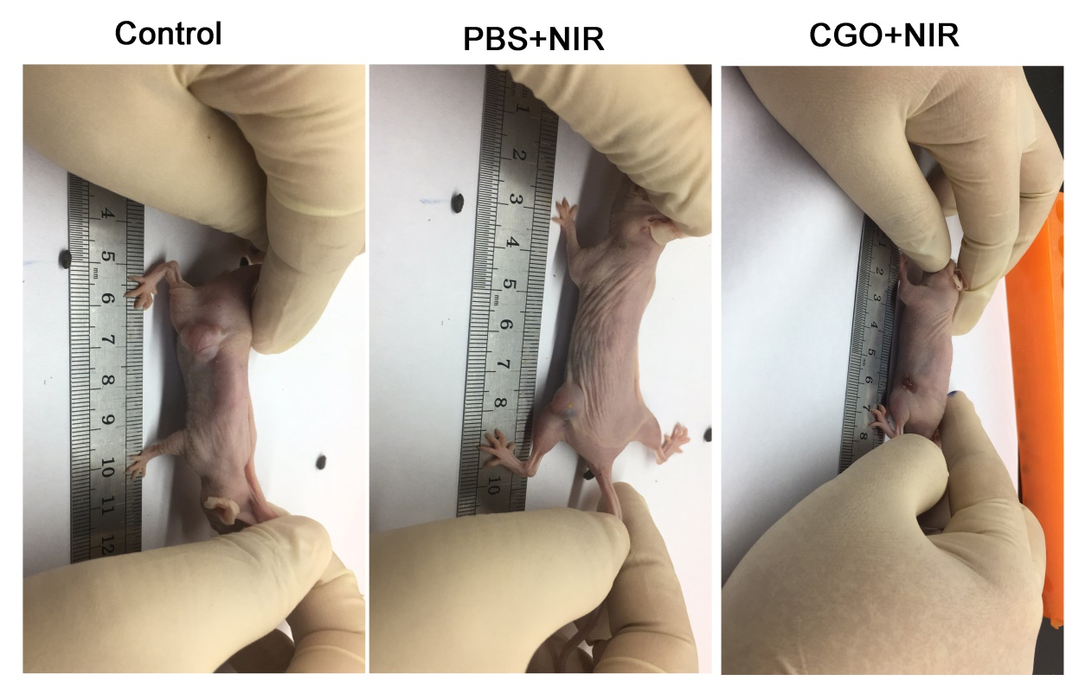
Figure S2. Pictures of mice in different groups after the indicated treatments at day 14th.

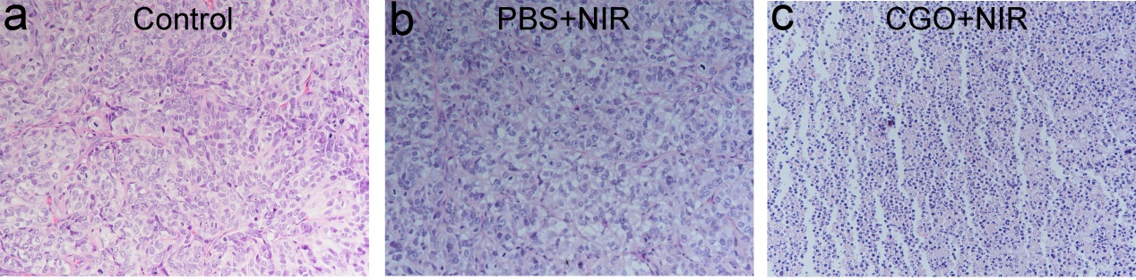
Figure S3. The representative hematoxylin and eosin (H&E) stained histological images of the corresponding ex vivo tumor sections: (a) control group, (b) PBS+NIR group, (c) CGO+NIR group. Magnification: 200 times.

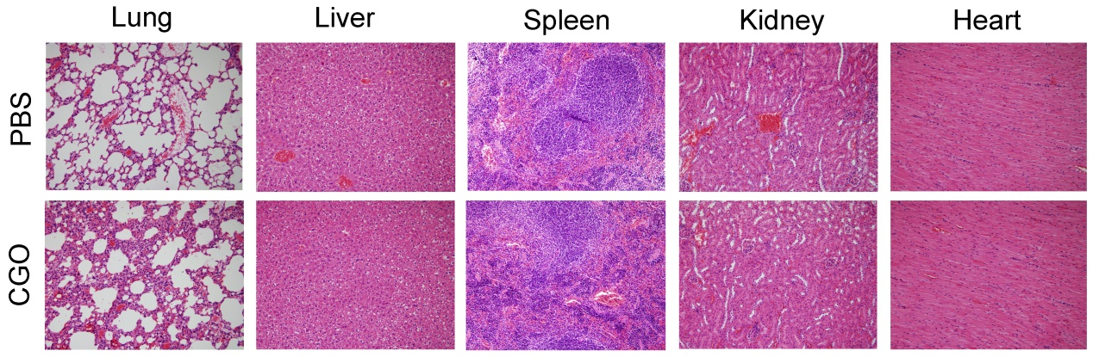
Figure S4. H&E stained slices of main organs. Magnification: 200 times.

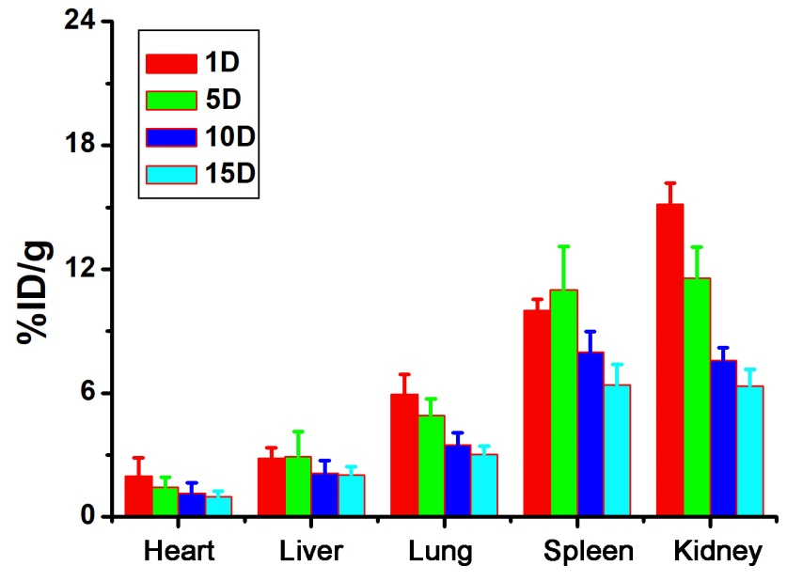
Figure S5. Biodistribution of CGO nanoparticles in major organs.

