Overexpression and purification of Gracilariopsis chorda carbonic anhydrase (GcCAα3) in Nicotiana benthamiana, and its immobilization and use in CO₂ hydration reactions

Md Abdur Razzak¹, Dong Wook Lee^{1,2}, Junho Lee¹ and Inhwan Hwang^{1,3}*

¹Division of Integrative Biosciences and Biotechnology, Pohang University of Science and Technology, Pohang, 37673, Korea.
²Department of Bioenergy Science and Technology, Chonnam National University, Gwangju, 61186, South Korea.
³Department of Life Sciences, Pohang University of Science and Technology, Pohang, 37673, Korea.

Highlights: α-Carbonic anhydrase GcCAα3 from the red alga Gracilariopsis chorda was overexpressed in Nicotiana benthamiana, and immobilization on cellulose beads enhanced its stability, facilitating reuse in CO₂ hydration reactions.

*Corresponding author: To whom correspondence should be addressed
E-mail: ihhwang@postech.ac.kr
Tel: 82-54-279-2128
Fax: 82-54-279-8159
ORCID ID: 0000-0002-1388-1367 (I.H.)

Supplementary Figures
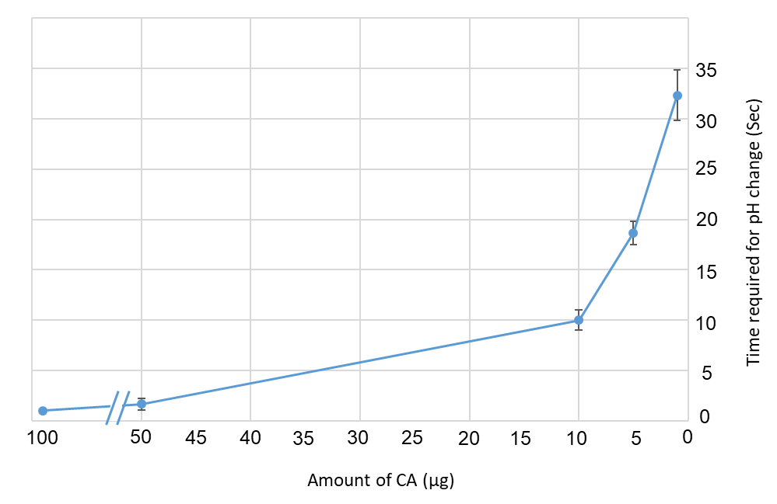
Supplementary Figure S1. The activity of MC-GcCAα3 based on pH change of TRIS buffer 8.3 to 6.3 with different amounts of MC-GcCAα3.

To optimize the CO₂ hydration reaction of MC-GcCAα3, we used 1, 5, 10, 50 and 100 μg of proteins to test the activity. As expected, we found the activity showed a linear range. The activity of 1, 5, 10 μg of enzyme showed a linear increase. In addition, to be more precise, the enzyme activity was saturated at 50 and 100 μg. The less time required for pH change indicates the faster reaction. Based on these observations, we used 10 μg of MC-GcCAα3 to test activity of MC-GcCAα3 in all other experiments.

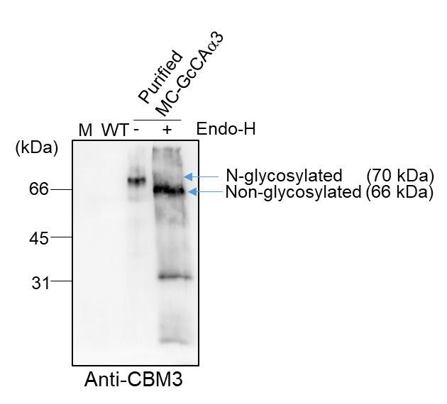
Supplementary Figure S2. GcCAα3 expressed in ER of N. benthamiana leaf cells and glycosylated.
GcCAα3 were purified from leaf tissues of N. benthamiana by MCC. Then the purified proteins were treated with Endoglycosidase-H (Endo-H) for 3 hours at 37°C. Endo-H can deglycosylates the ER protein. Therefore, after treated with Endo-H protein bands appears with reduced size. WT, protein extracts from non-transformed control wild type plants; M, molecular weight standard. (-), untreated and (+), treated protein with Endo-H.
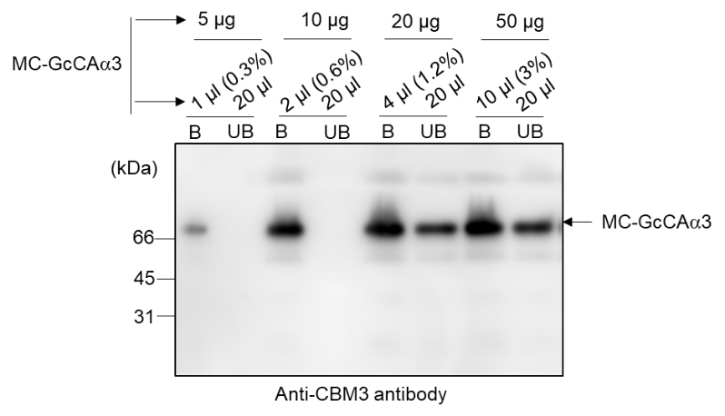
Supplementary Figure S3. Binding capacity of microcrystalline cellulose (MCC) beads for CBM3 fusion proteins.
To determine the binding capacity of MCC beads for MC-GcCAα3, different amounts (5–50 µg) of total protein extracts from leaf tissues of N. benthamiana harvested at 5 DPI after infiltration with a mixture (1:1 ratio) of Agrobacterium harboring MC-GcCAα3 and Agrobacterium harboring P38 were incubated with 10 mg MCC beads in 1 mL buffer. Total protein extracts were prepared at a ratio of 2 mL buffer to 1 g leaf tissue. After binding, MCC beads and supernatant (unbound fraction) were collected separately. MCC beads harboring bound proteins were washed four times with 40 mM TRIS-HCl, pH 7.5. Proteins bound to beads (B fraction) were released by boiling in 300 μL sample buffer (250 mM TRIS-HCl (pH 6.8), 10% SDS, 0.5% Bromophenol Blue, 50% glycerol v/v, 0.6 M DTT). Proteins in 10 µL (3% of the total volume) of the bound fraction or 20 µL (5% of the total volume) of the unbound (UB) fraction were separated by 10% SDS-PAGE and analyzed by western blotting with anti-CBM3 antibody.

Supplementary Figure S4. Expression and purification of Hisx6:GcCAα3 from E. coli.
(A) Schematic diagram of the Hisx6:GcCAα3 construct for expression in E. coli.
(B, C) Expression of His₆-tagged GcCAα3 in E. coli. The construct was introduced into E. coli strain BL21 (DE3). E. coli cells were cultured in LB medium and expression of Hisx6:GcCAα3 was induced with IPTG for 3 h at 37°C. Cell extracts were prepared from E. coli cultures and Hisx6:GcCAα3 was purified using Ni⁺-NTA affinity column chromatography. Purified Hisx6:GcCAα3, total extracts, flow-through, and wash fractions were separated by SDS-PAGE and stained with Coomassie Brilliant Blue (B) or analyzed by western blotting using anti-His antibody (C). M, molecular weight markers; T, total soluble proteins extracted from E. coli after induction with IPTG; NT, total extracts from non-transformed E. coli; NI, total extracts from non-induced E. coli; FT, flow-through fraction; W, wash fraction; E, eluted fraction. The amount of purified Hisx₆:GcCAα3 was measured by the Bradford method.
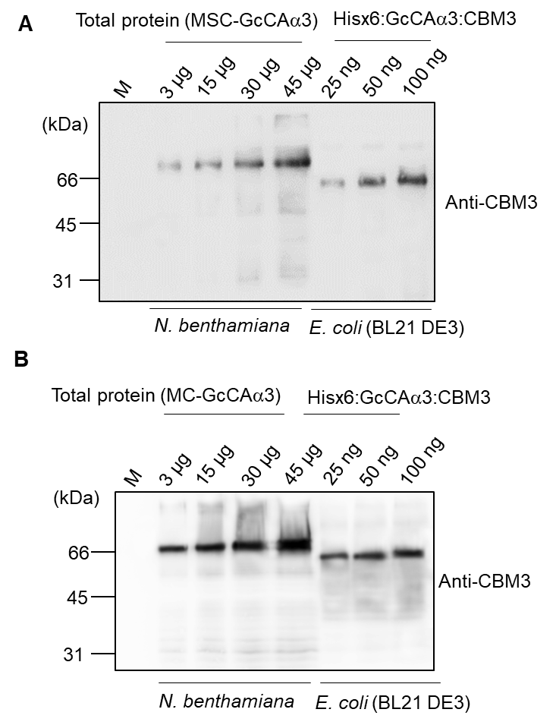

Supplementary Figure S5. Quantification of MSC-GcCAα3 and MC-GcCAα3 produced in N. benthamiana.
(A) Quantification of MSC-GcCAα3 in total protein extracts. To prepare total protein extracts, 1 g leaf tissue from N. benthamiana infiltrated with a mixture of Agrobacterium harboring MSC-GcCAα3 and Agrobacterium harboring P38 was harvested at 5 DPI. After grinding in liquid nitrogen, it was homogenized in 5 mL extraction buffer. Total proteins contained in the indicated amounts (3–45 μg) were separated by SDS-PAGE and analyzed by western blotting using anti-CBM3 antibody. As control for quantification, the indicated amounts (25–100 ng) of Hisx6:GcCAα3:CBM3 purified from E. coli were loaded on the same gel. The amount of MSC-GcCAα3 in total protein extracts was quantified by comparing band intensity in the western blot image. The signal intensity of the protein bands was measured using Multi Gauge V2.2 densitometric software (Fujifilm). The quantity of MSC-GcCAα3 was represented in arbitrary units (A.U.) at a 10 log scale (Log₁₀). MSC-GcCAα3 in 3 μg total protein extracts appears to be equal to 25 ng Hisx6:GcCAα3:CBM3. Quantification indicates that the yield of MSC-GcCAα3 in N. benthamiana was approximately 100 μg/g FW.
(B) Quantification of MC-GcCAα3 abundance in total protein extracts. To quantify the expression level of MC-GcCAα3, total protein extracts were prepared from leaf tissues of N. benthamiana at 5 DPI after infiltration of a mixture of Agrobacterium harboring MC-GcCAα3 and Agrobacterium harboring P38. 1 g sample of leaf tissue was ground in liquid nitrogen and homogenized in 10 mL extraction buffer. Due to high expression of MC-GcCAα3, the weight of fresh leaf tissues to extraction buffer ratio was 1:10 (1 g leaf tissue: 10 mL extraction buffer). Finally, the indicated amounts (3–45 μg) of total protein extracts were separated by SDS-PAGE. As control for quantification, the indicated amounts (25–100 ng) of purified Hisx6:GcCAα3:CBM3 from E. coli were loaded on the same gel. After western blot analysis using anti-CBM3 antibody, the band intensity of MC-GcCAα3 was quantified by Multi Gauge V2.2 densitometric software supplied with LAS4000, and the amount of protein was estimated by comparing with that of Hisx6:GcCAα3:CBM3. MC-GcCAα3 in 3 μg total protein extracts appears to be equal to 100 ng Hisx6:GcCAα3:CBM3. The amount of MC-GcCAα3 was estimated to be 1.0 mg/g FW. M, molecular weight standards.
Supplementary Figure S6. MC-GcCAα3 binds tightly to MCC beads under various conditions and different pH values.
To test the binding stability of MC-GcCAα3 to MCC beads, MC-GcCAα3-bound MCC beads were incubated in the indicated solutions for 24 h, after which proteins spontaneously released from MCC beads during incubation were collected from the incubation solution (RE), and proteins still bound to MCC beads (B) were eluted by boiling. These fractions were analyzed by western blotting using anti-CBM3 antibody.

Supplementary Table S1. Primer sequences used to generate the constructs in this study.

Primer names | Sequences
BamHI-M domain-F | CG GGATCC CG ATGGCAAACATCACTGTGG
M domain-SpeI-SUMO-F | CTGCTCCTGATGGTGGAGGAGGTTCTGGTGGTGGATCAACTAGT CATATTAATTTGAAAGTGAA
M domain-SpeI-SUMO-R | TTCACTTTCAAATTAATATGACTAGTTGATCCACCACCAGAACCTCCTCCACCATCAGGAGCAG
SUMO-MSC-CBM3-F | CAGACTGGTGCCGGCGGT CCCGGGGGTGGAGGAGGTTCA  GGTGGTACC GTATCAGGTAACCTTAAGG
SUMO-MSC-CBM3-R | CCTTAAGGTTACCTGATACGGTACCACCTGAACCTCCTCCACCCCCGGGACCGCCGGCACCAGTCTG
XhoI-CBM3_HDEL-R | CCGCTCGAGTTAAAGCTCGTCATGACCAGGTTCCTTTCCCCA
XmaI_GcCAα3-F | TCCC CCCGGG AACGAGGAAATCGAGGTC
KpnI_GcCAα3-R | CGG GGTACC GGACACGTAGCAAGTGAC
SpeI_GcCAα3-F | GGACTAGTATGAACTTCTTCGCTACC
BamHI_GcCAα3-F | CGGGATCCGAGGAAATCGAGGTCGAC
XhoI_GcCAα3-R | CCGCTCGAGTTAGGACACGTAGCAAGT
KpnI-M domain-F | CGG GGTACC ATGGCAAACATCACTGTGG
XhoI-CBM3_HDEL-R | CCG CTCGAG TTAAAGCTCGTCATGACCAGGTTCCTTTC  CCCA

