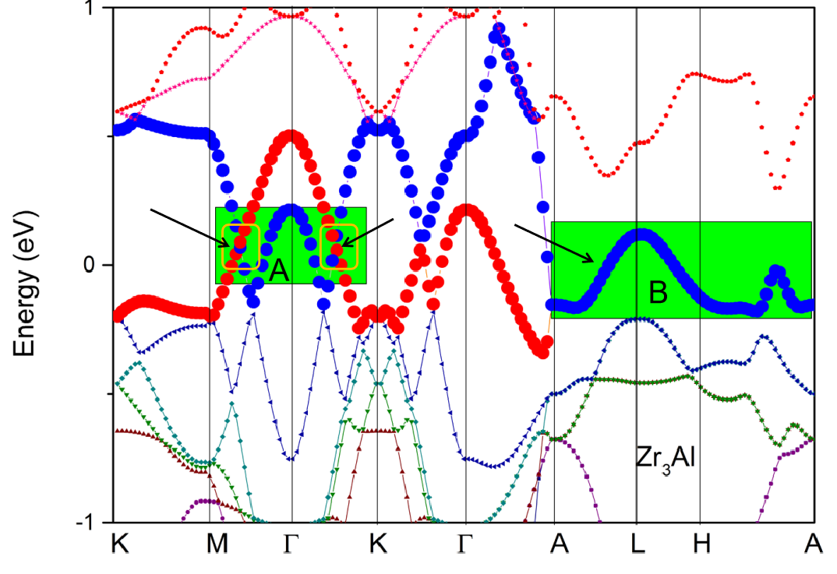
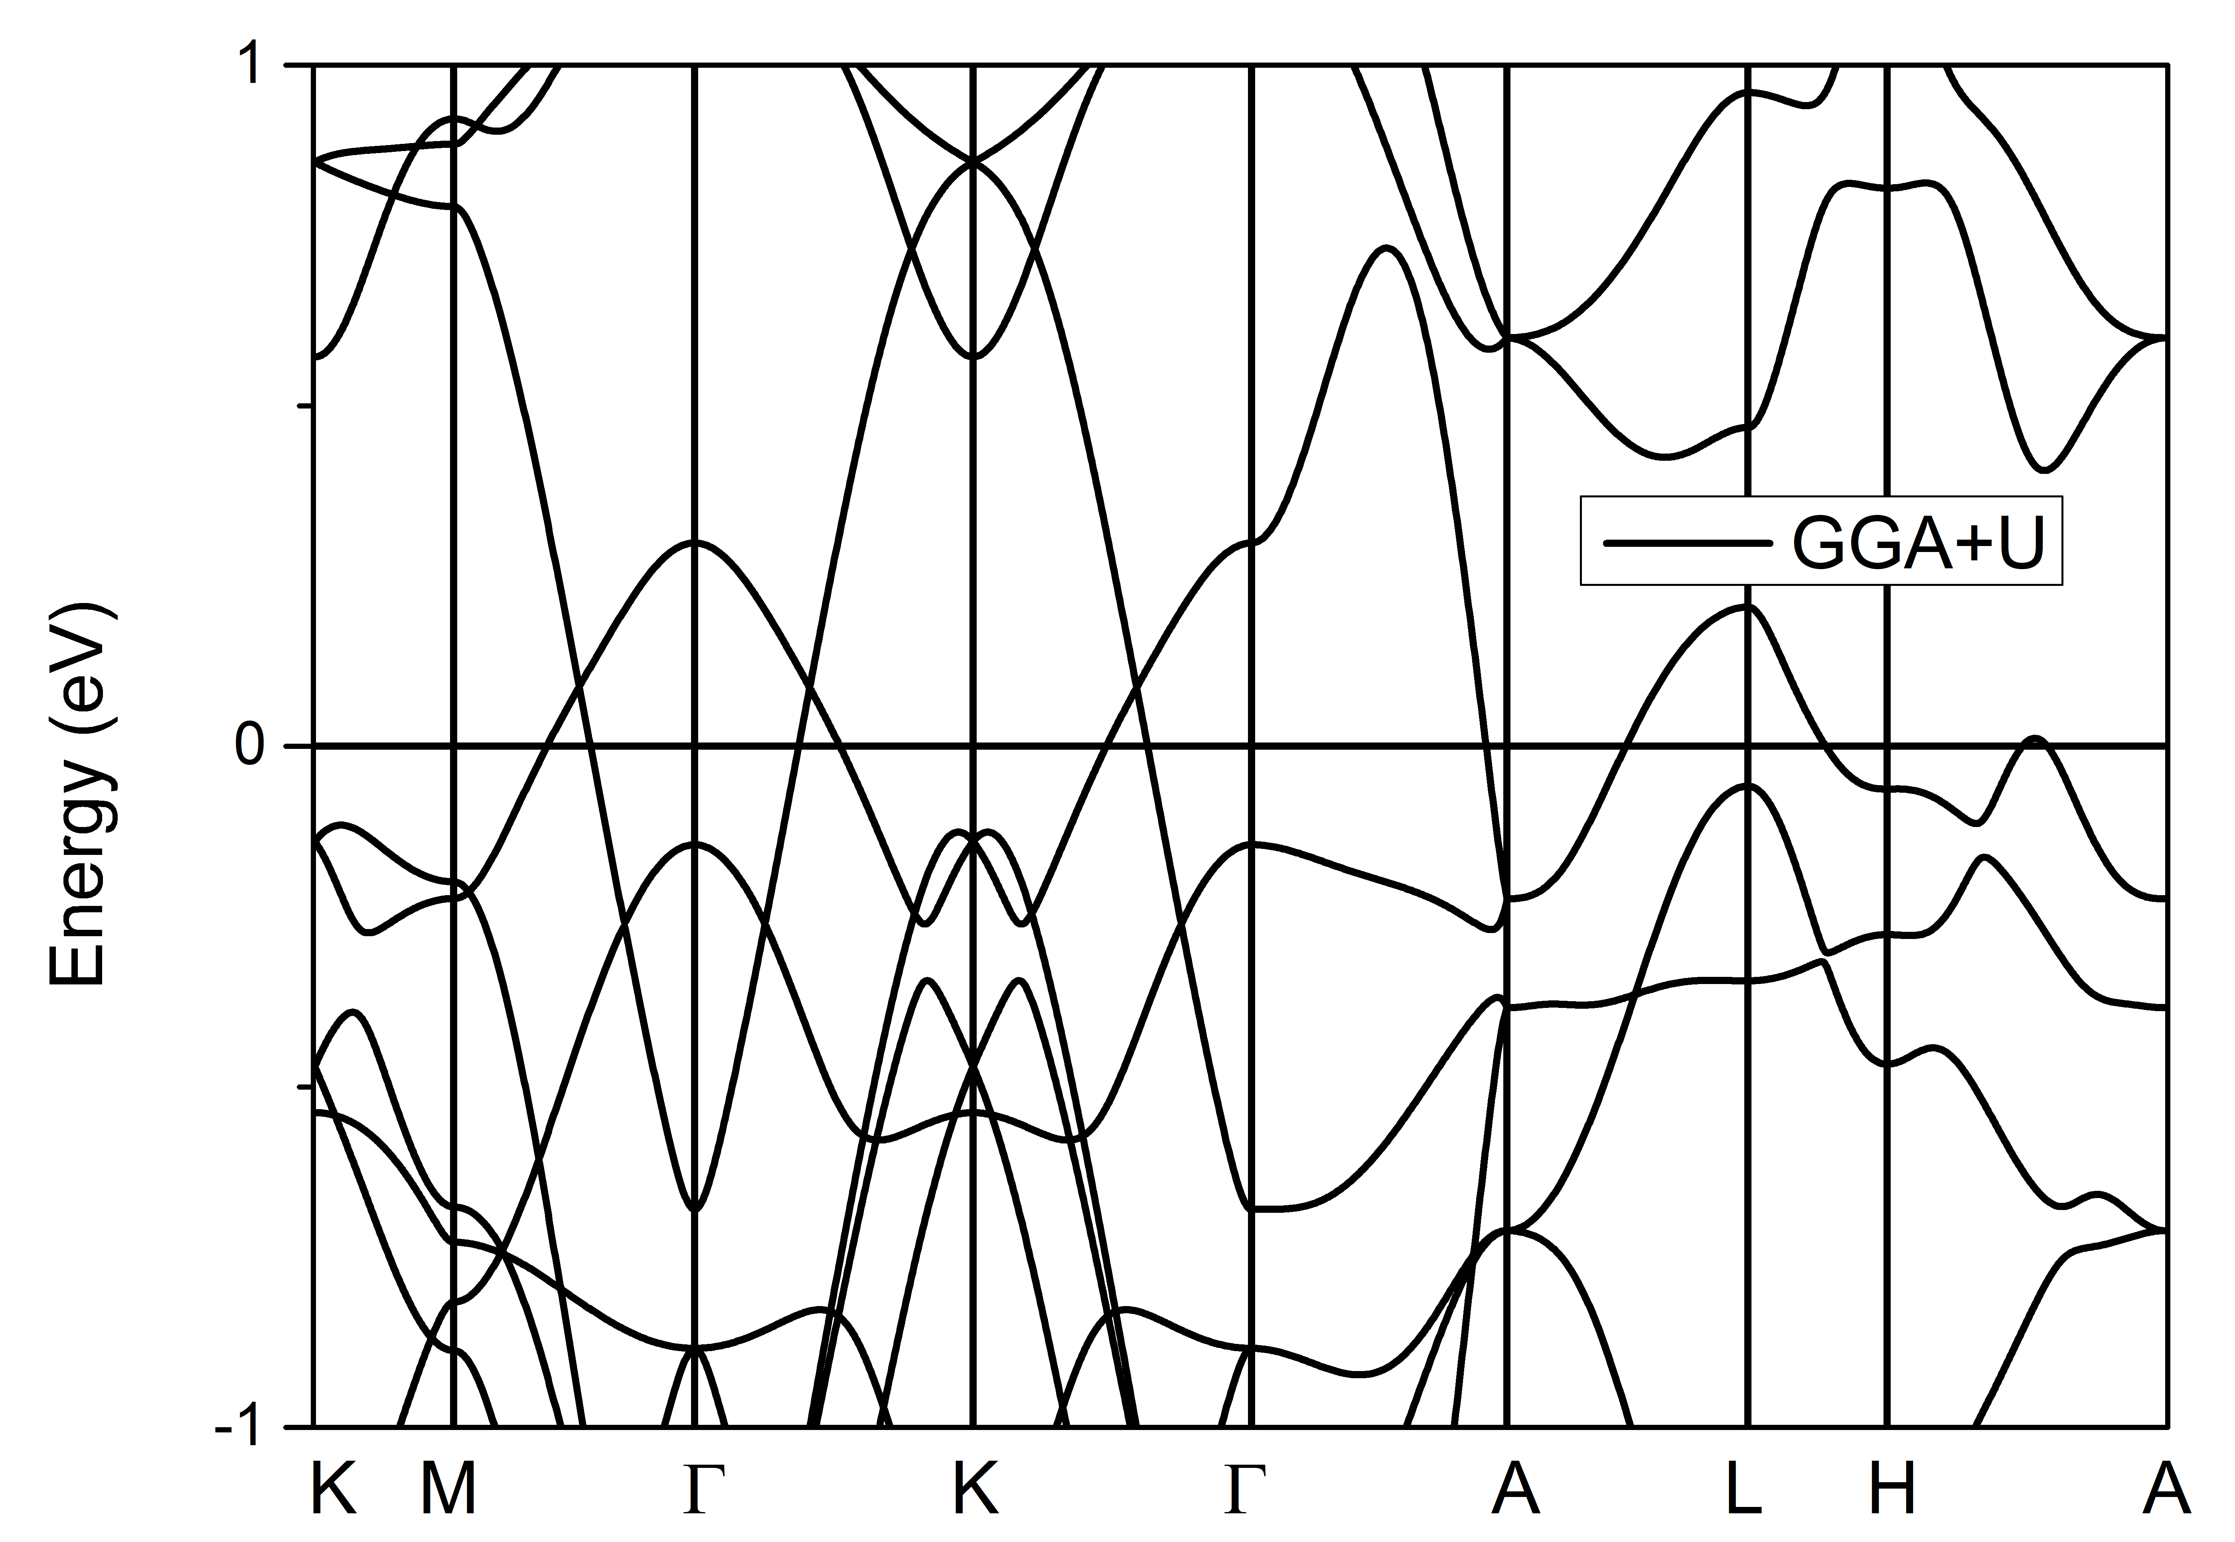
Figure S1: (upper) Band structure of Zr₃Al with lines in colors; (bottom) Band structure of Zr₃Al via GGA+U (U = 4 eV for Zr -d orbitals).

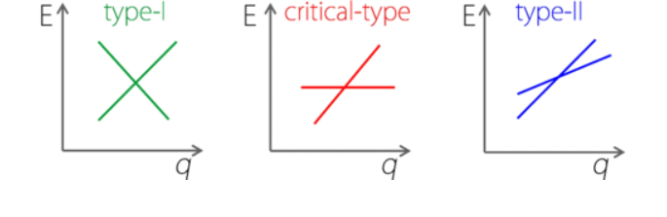
Figure S2: Schematic figure of type-I, critical-type, and type-II band dispersions in the momentum-energy space. For type-I band crossing points, the bands manifest conventional conical dispersions, with electron and hole regions well separated by the energy; For type II band crossing point, the spectrum is completely tipped over, which can give rise to the coexistence of electron and hole states at a given energy; For critical-type band crossing point, it is composed of a flat band and a dispersive band.

