Supported Pt Nanoparticles on Mesoporous Titania for Selective Hydrogenation of Phenylacetylene

Mingzhen Hu,^{1,2} Lei Jin,² Yanliu Dang,³ Steven L. Suib,^{2,3} Jie He^{2,3} and Ben Liu^{1,*}

¹Jiangsu Key Laboratory of New Power Batteries, Collaborative Innovation Center of Biomedical Functional Materials, School of Chemistry and Materials Science, Nanjing Normal University, Nanjing 210023, China; ²Department of Chemistry, and ³Institute of Materials Science, University of Connecticut, Storrs, Connecticut 06269, United States.

*Email: ben.liu@njnu.edu.cn

Figure Contents
Figure S1. SEM image of the mTiO₂ at low magnification.
Figure S2. EDS elementary loading measurement of the Pt@mTiO₂.
Figure S3. TEM images of the commercial Pt/C catalyst.
Figure S4. Phenylacetylene conversion over the mTiO₂ from 7 h to 26 h.
Figure S5. Phenylacetylene conversion and styrene selectivity of commercial Pt/C as a function of reaction time from 7 h to 26 h.
Figure S6. Catalytic stability test of the commercial Pt/C.
Figure S7. HAADF-STEM image of the postreaction and Pt@mTiO₂ after five catalytic recycling measurement.
Figure S8. HAADF-STEM images and size distributions of the 3.6 nm Pt NPs on mTiO₂.
Figure S9. Phenylacetylene conversion and styrene selectivity of the 3.6 nm Pt NPs on mTiO₂ as a function of reaction time.
Figure S10. Schematic model of 2.5 nm Pt NPs and 3.6 nm Pt NPs.

Table Comments
Table S1. Comparisons of initial Pt loadings and that from EDS measurements of the Pt@mTiO₂.
Table S2. Cell parameters of the Pt@TiO₂ and mTiO₂.
Table S3. Styrene selectivity at full phenylacetylene conversion of Pt@mTiO₂ and previous results.

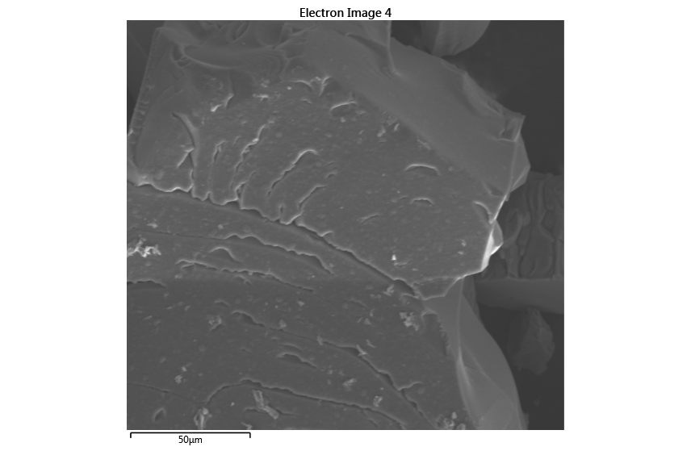
Figure S1. SEM image of the mTiO₂ at low magnification.

Figure S2. (a-c) SEM EDS elemental mappings of the Pt@mTiO₂.

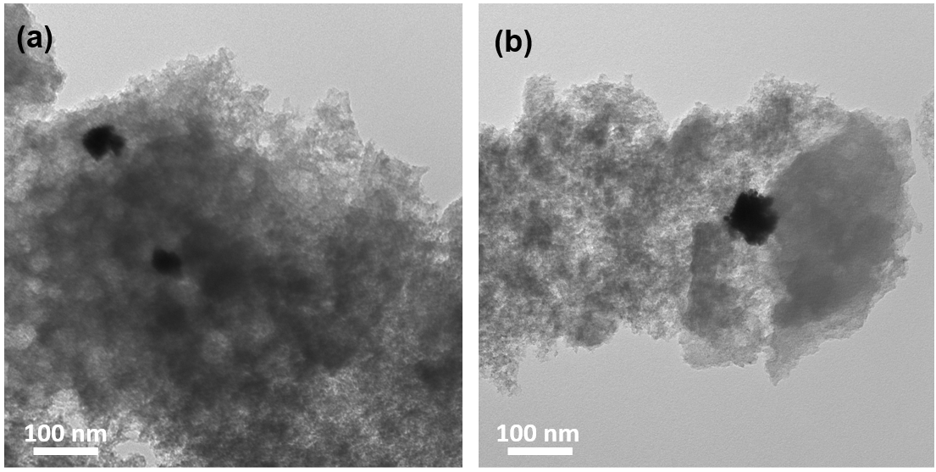
Figure S3. (a,b) TEM images of the commercial Pt/C catalyst.

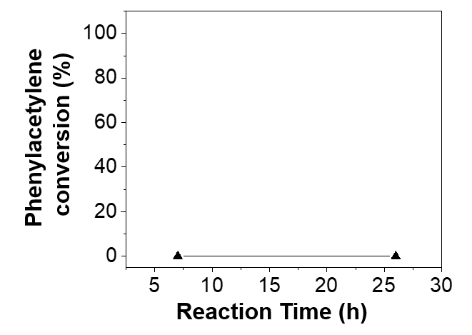
Figure S4. Phenylacetylene conversion over the mTiO₂ from 7 h to 26 h.
Reaction conditions: 10 mg of mTiO₂ was dispersed in 3 mL of 1,4-dioxane with 0.1 g of phenylacetylene at 50 °C and 50 psi of hydrogen for different reaction times.

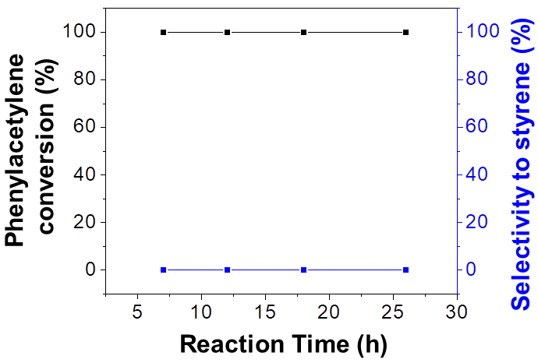
Figure S5. Phenylacetylene conversion over the commercial Pt/C from 7 h to 26 h.
Reaction conditions: 10 mg of mTiO₂ was dispersed in 3 mL of 1,4-dioxane with 0.1 g of phenylacetylene at 50 °C and 50 psi of hydrogen for different reaction times.

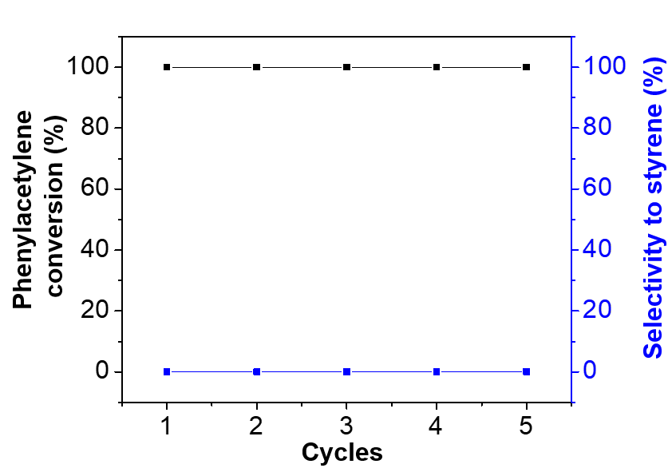
Figure S6. Phenylacetylene conversion and styrene selectivity of the commercial Pt/C after five catalytic cycling measurement.
Reaction conditions: 10 mg of commercial Pt/C was dispersed in 3 mL of 1,4-dioxane with 0.1 g of phenylacetylene at 50 °C and 50 psi of hydrogen for 26 hours.

Figure S7. HAADF-STEM images of the postreaction and Pt@mTiO₂ after five catalytic recycling measurement.

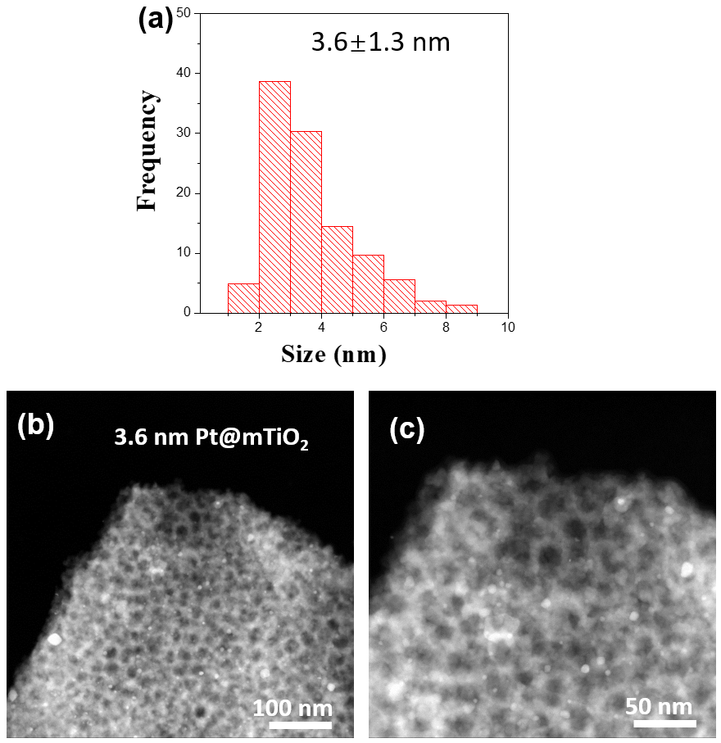
Figure S8. (a) The histogram of Pt particle-size distributions, (b,c) HAADF-STEM images of the 3.6 nm Pt on mTiO₂ prepared after 650 ºC thermal calcination.

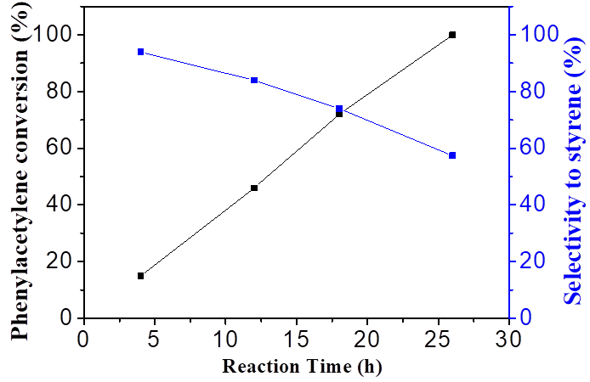
Figure S9. Phenylacetylene conversion and styrene selectivity of the 3.6 nm Pt NPs on mTiO₂ as a function of reaction time.

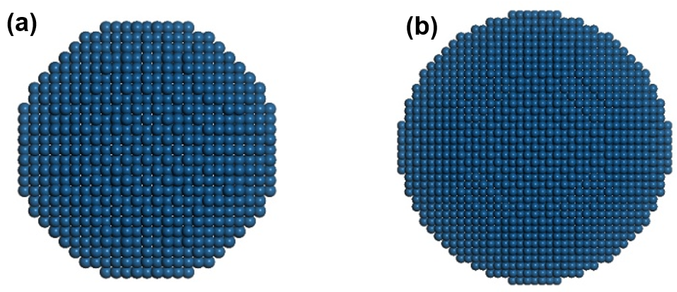
Figure S10. (a) Schematic model of the Pt NPs with a diameter of 2.5 nm. (b) Schematic model of the Pt NPs with a diameter of 3.6 nm.

Table S1. Comparison of initial Pt loading and that from EDS measurements in 2.5 nm Pt@mTiO₂.
Catalyst | Pt loading from EDS | Initial Pt loading
2.5 nm Pt@mTiO₂ | 1% | 1%

Table S2. The average cell parameters of the 2.5 nm Pt@TiO₂ and mTiO₂ calculated by three small-angle X-ray scattering (SAXS) reflections.
Crystal plane | q (nm⁻¹) | a (nm)
(111) | 0.29 | 37
(311) | 0.53 | 40
(500) | 0.84 | 37
The calculations are according to the following equation, in which d is the d spacing, q is the scattering vector, (hkl) are the Miller indices and a is the cell parameter. The average cell parameter is calculated to be 38 nm by three small-angle X-ray scattering (SAXS) reflections.
$$d= \frac{2π}{q}$$
$$a^{2}=d^{2}(h^{2}+k^{2}+ l^{2})$$

Table S3. Comparisons of styrene selectivity at full phenylacetylene conversion of Pt@mTiO₂ and previous results.
Catalysts | Pd loading/% |  | Phenylacetylene conversion/% |  | Styrene  Selectivity/% | Reference
Pt@mTiO₂ |  | 1 |  | 100 | 80.3 | This paper
Pt/CNTs |  | 0.79 |  | 100 | 0 | Catal. Today. 2012, 186, 69
Pt/γ-Al₂O₃ |  | 0.5 |  | 100 | 0 | Ind. Eng. Chem. Res. 2002, 41, 3345
Lindlar Catalyst |  | -- |  | >99 | 60 | Adv. Mater. 2016, 28, 4747
Pd/Al₂O₃ |  | 5 |  | >99 | 35 | Adv. Mater. 2016, 28, 4747
PdHHDMA/TiS |  | -- |  | >99 | 50 | Adv. Mater. 2016, 28, 4747
Pd NPs |  | -- |  | >99 | 0 | ACS Catal. 2019, 9, 4632
Pd/CuS |  | 2 |  | 100 | 0 | Nano Res. 2016, 9. 1209
Pd/MDPC |  | -- |  | 97 | 62 | ChemCatChem, 2016, 8,1111

