Supplementary Material

Supplementary data

Supplementary Video 1. Singapore Healthcare Datathon 2018 event video.

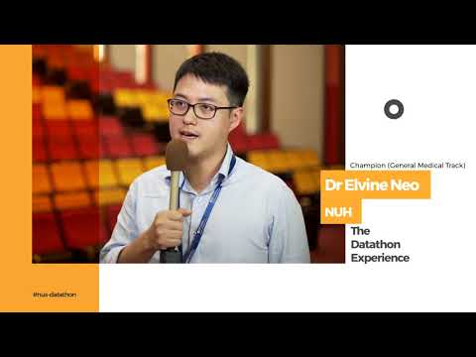

Supplementary Video 2. Singapore Healthcare Datathon 2018 participants interview Part I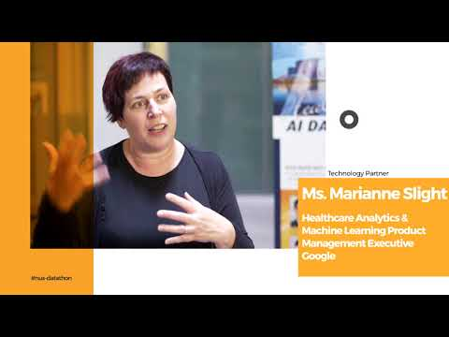
Supplementary Video 3. Singapore Healthcare Datathon 2018 participants interview Part II
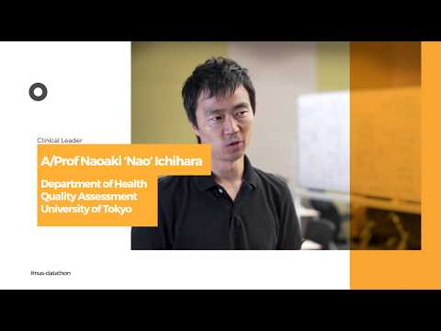

Supplementary Video 4. Singapore Healthcare Datathon 2019 event video.
