Supplementary Material

Supplementary Figures and Tables

Supplementary Figures

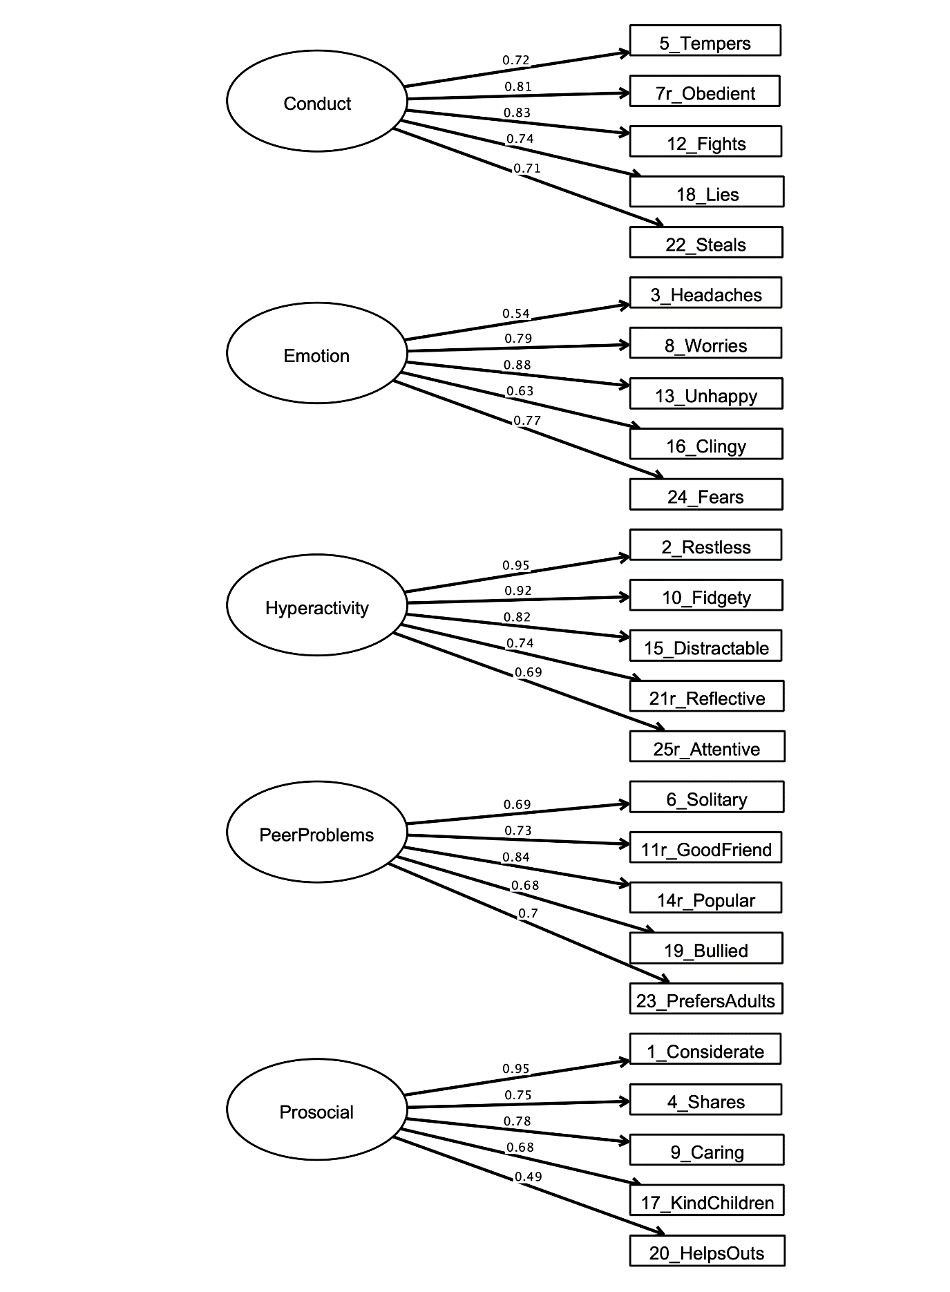Supplementary Figure 1. Five factor structure of the SDQ. Latent variables representing Conduct Problems (Conduct), Emotional Symptoms (Emotion), Hyperactivity-Inattention (Hyperactivity), Peer Problems and Pro-Social Behaviour (ProSocial) are represented in ovals. Specific items are shown as observed variables in squares with item numbers and a brief description. Items 7, 11, 14, 21, 25 were reverse coded for ease of interpretation. Parameter estimates are fully standardized. Factor covariances are omitted for simplicity.
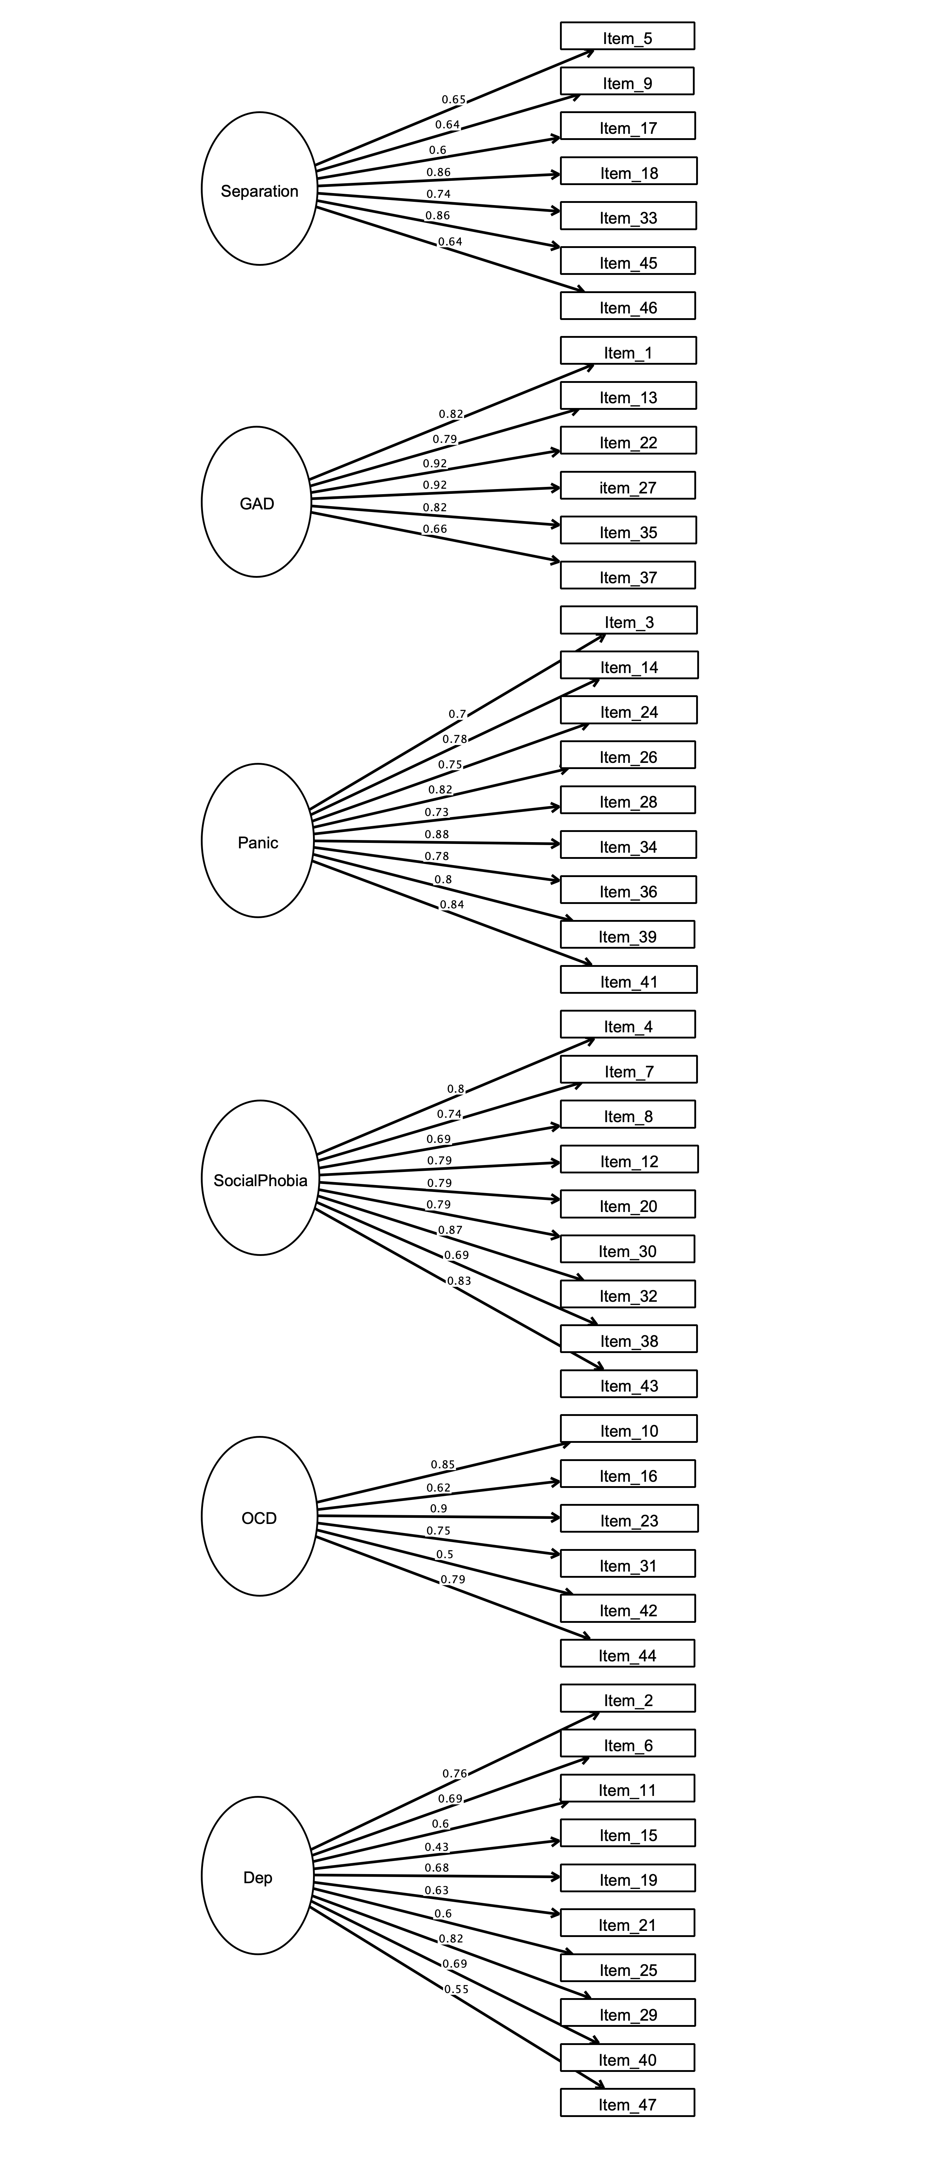

Supplementary Figure 2. Six factor structure of the RCADS. Latent variables representing Separation Anxiety (Separation), Generalized Anxiety Disorder (GAD), Panic Disorder (Panic), Social Phobia (SocialPhobia), Obsessive Compulsive Disorder (OCD) and Depression (Dep) are represented in ovals. Specific items are shown as observed variables in squares with item numbers. Parameter estimates are fully standardized. Factor covariances are omitted for simplicity.

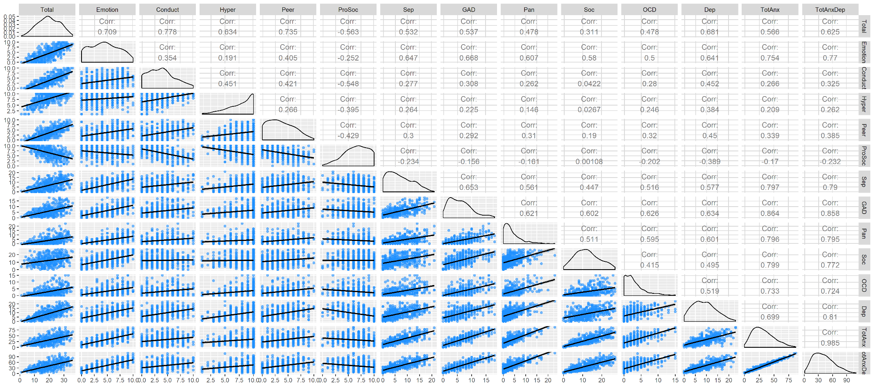Supplementary Figure 3. Correlations between scores on SDQ and RCADS-P scales. All correlations were significant, p <.01, uncorrected. Peer = SDQ Peer Problems; ProSoc = SDQ Prosocial; Sep = RCADS- P Separation Anxiety ; GAD = RCADS- P Generalized Anxiety Disorder; Pan = RCADS- P Panic Disorder; Soc = RCADS- P Social Anxiety; OCD = RCADS- P Obsessive Compulsive Disorder; Dep = RCADS- P Depression; TotAnx = RCADS- P Total Anxiety; TotAnxDep = RCADS- P Total Anxiety and Depression.

Supplementary Tables
Supplementary Table 1. Linear regressions predicting RCADS-P residual scores from SDQ residual scores

 | Total Anxiety |  |  |  | Depression |  |  |  | Total Anxiety & Depression
SDQ Subscale | B | SE | B | p | B | SE | B | p | B | SE | B | p
Total | 1.37 | 0.10 | 0.56 | <.0001*** | 0.47 | 0.03 | 0.68 | <.0001*** | 1.84 | 0.12 | 0.62 | <.0001***
R² | 0.32 |  |  |  | 0.47 |  |  |  | 0.39
Emotion | 4.68 | 0.24 | 0.74 | <.0001*** | 0.91 | 0.07 | 0.51 | <.0001*** | 5.59 | 0.28 | 0.73 | <.0001***
Conduct | -0.17 | 0.30 | -0.03 | .56 | 0.20 | 0.09 | 0.10 | .02* | 0.03 | 0.35 | 0.003 | 0.94
Hyperactivity | 0.69 | 0.30 | 0.09 | .02* | 0.44 | 0.09 | 0.20 | <.0001*** | 1.13 | 0.36 | 0.12 | 0.002**
Peer problems | 0.38 | 0.28 | 0.05 | .18 | 0.18 | 0.08 | 0.09 | .04* | 0.56 | 0.33 | 0.06 | 0.09
Prosocial | -0.44 | 0.31 | -0.06 | .16 | 0.18 | 0.09 | 0.09 | .05 | -0.26 | 0.37 | -0.03 | 0.48
R² | 0.58 |  |  |  | 0.53
Note: N=389. *p<.05, **p<.01, ***p<.001

Supplementary Table 2. Model comparisons for SDQ subscales identified as significant predictors of RCADS-P residual scores in simultaneous linear regressions

RCADS-P measure | Model | SDQ measure | B | p | F | Adjusted R² | Difference
Total Anxiety | A1 | Emotion | 0.74 | <.001*** | 502 | .569
 | A2 | Hyperactivity | 0.07 | .05 | 254.73 | .573 | ΔR² = .004
 |  |  |  |  |  |  | ΔF = 3.79
Depression | B1 | Emotion | 0.64 | <.001*** | 268.62 | .41
 | B2 | Emotion | 0.59 | <.001***
 |  | Hyperactivity | 0.29 | <.001*** | 185.97 | .49 | ΔR² = .081**
 |  |  |  |  |  |  | ΔF = 61.00***
 | B3 | Emotion | 0.54 | <.001***
 |  | Hyperactivity | 0.22 | <.001***
 |  | Conduct | 0.17 | <.001*** | 134.23 | .51 | ΔR² = .021**
 |  |  |  |  |  |  | ΔF = 16.04***
 | B4 | Emotion | 0.51 | <.001***
 |  | Hyperactivity | 0.21 | <.001***
 |  | Conduct | 0.14 | .002*
 |  | Peer problems | 0.11 | .01* | 103.89 | .52 | ΔR² = .009**
 |  |  |  |  |  |  | ΔF = 6.75**
 | B5 | Emotion | 0.51 | <.001***
 |  | Hyperactivity | 0.20 | <.001***
 |  | Conduct | 0.11 | .03*
 |  | Peer problems | 0.09 | .04*
 |  | Prosocial | 0.09 | .05 | 84.52 | .52 | ΔR² = .005*
 |  |  |  |  |  |  | ΔF = 3.88*
Total Anxiety & Depression | C1 | Emotion | 0.77 | <.001*** | 551.78 | .59
 | C2 | Emotion | 0.75 | <.001***
 |  | Hyperactivity | 0.12 | <.001*** | 292.05 | .60 | ΔR² = .014**
 |  |  |  |  |  |  | ΔF = 13.78***
Note: N=389. *p<.05, **p<.01, ***p<.001

Supplementary Table 3. Logistic regressions predicting clinical RCADS scores from SDQ residual scores

 | Total Anxiety |  |  |  | Depression |  |  |  | Total Anxiety & Depression
SDQ measure | B | Wald χ² | p | OR | B | Wald χ² | p | OR | B | Wald χ² | p | OR
Total | 0.19 | 8.36 | <.0001*** | 1.21 | 0.21 | 9.39 | <.0001*** | 1.24 | 0.18 | 8.56 | <.0001*** | 1.20
Nagelkerke's R² | 0.33 |  |  |  | 0.41 |  |  |  | 0.33
Emotion | 0.66 | 8.49 | <.0001*** | 1.93 | 0.46 | 7.64 | <.0001*** | 1.58 | 0.65 | 8.82 | <.0001*** | 1.92
Conduct | 0.02 | 0.22 | .824 | 1.02 | 0.16 | 2.4 | .02* | 1.17 | -0.02 | -0.29 | .770 | 0.98
Hyperactivity | 0.25 | 2.83 | .005** | 1.28 | 0.24 | 3.19 | .001** | 1.27 | 0.19 | 2.39 | .017* | 1.21
Peer problems | -0.01 | -0.18 | .860 | 0.99 | -0.02 | -0.35 | .72 | 0.98 | 0.03 | 0.41 | .679 | 1.03
Prosocial | -0.02 | -0.22 | .828 | 0.98 | 0.11 | 1.72 | .09 | 1.12 | -0.003 | -0.04 | .965 | 1.00
Nagelkerke's R² | 0.50 |  |  |  | 0.47 |  |  |  | 0.51
Note: N=389. *p<.05, **p<.01, ***p<.001

