SUPPLEMENTAL FIGURES
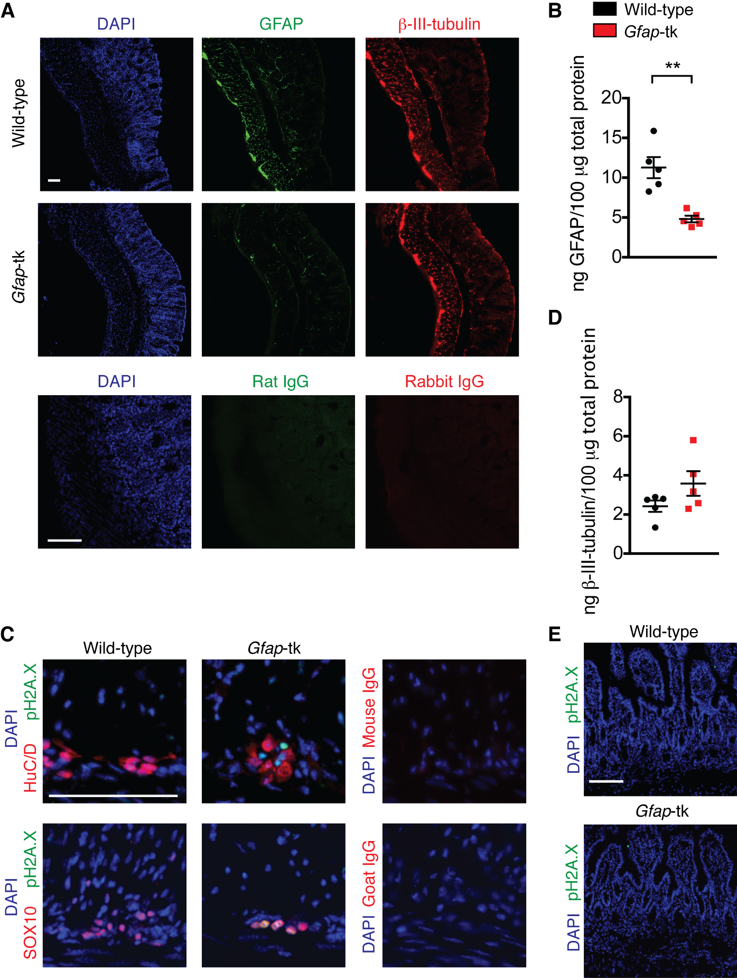
Figure S1. Enteric glia depletion in Gfap-tk mice. (A) Representative immunofluorescence images of DAPI (blue), GFAP (green), and β-III-tubulin (red) in colons from wild-type and Gfap-tk mice induced with AOM/DSS and treated with ganciclovir. Isotype controls are shown in the bottom panels. (B) GFAP ELISA of distal colonic lysates from wild-type and Gfap-tk mice induced with AOM/DSS and treated with ganciclovir (n = 5 mice per group). (C) Immunofluorescence images of DAPI (blue), pH2A.X (green), and SOX10 or HuC/D (red) in colons from wild-type and Gfap-tk mice induced with AOM/DSS and treated with ganciclovir. Isotype controls are shown in the panels to the right. (D) β-III-tubulin ELISA of distal colonic lysates from wild-type and Gfap-tk mice induced with AOM/DSS and treated with ganciclovir (n = 5 mice per group). (E) Immunofluorescence images of DAPI (blue) and pH2A.X (green) in small intestines from wild-type and Gfap-tk mice induced with AOM/DSS and treated with ganciclovir. Scale bars are 100 μm. Data are presented as mean±SEM. P<0.05 = *; P<0.01 = **; P<0.001 = ***; P<0.0001 = ****, Mann-Whitney U test.
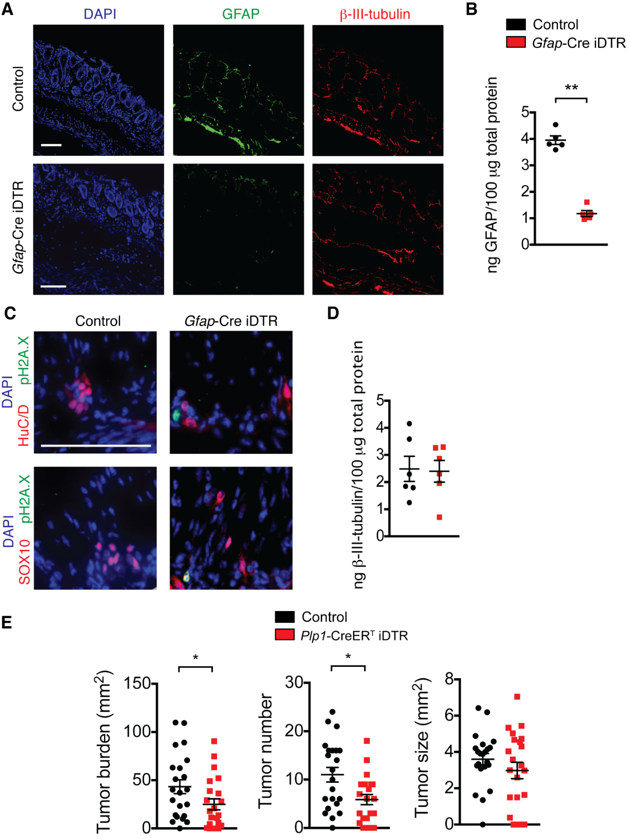
Figure S2. Enteric glia depletion in Gfap-Cre iDTR mice and tumor burden analyses in Plp1-CreER^{T} iDTR mice. (A) Representative immunofluorescence images of DAPI (blue), GFAP (green), and β-III-tubulin (red) in colons from non-depleted control mice and enteric-glia-depleted Gfap-Cre iDTR mice. (B) GFAP ELISA of distal colonic lysates from non-depleted control AOM/DSS mice and enteric-glia-depleted Gfap-Cre iDTR AOM/DSS mice (n = 5 mice per group). (C) Immunofluorescence images of DAPI (blue), pH2A.X (green), and SOX10 or HuC/D (red) in colons from non-depleted control AOM/DSS mice and enteric-glia-depleted Gfap-Cre iDTR AOM/DSS mice. (D) β-III-tubulin ELISA of distal colonic lysates from non-depleted control AOM/DSS mice and enteric-glia-depleted Gfap-Cre iDTR AOM/DSS mice (n = 6 mice per group). (E) Analysis of tumors in non-depleted control AOM/DSS mice and enteric-glia-depleted Plp1-CreER^{T} iDTR AOM/DSS mice (n = 22 mice per group; pooled from two independent experiments). Scale bars are 100 μm. Data are presented as mean±SEM. P<0.05 = *; P<0.01 = **; P<0.001 = ***; P<0.0001 = ****, Mann-Whitney U test.

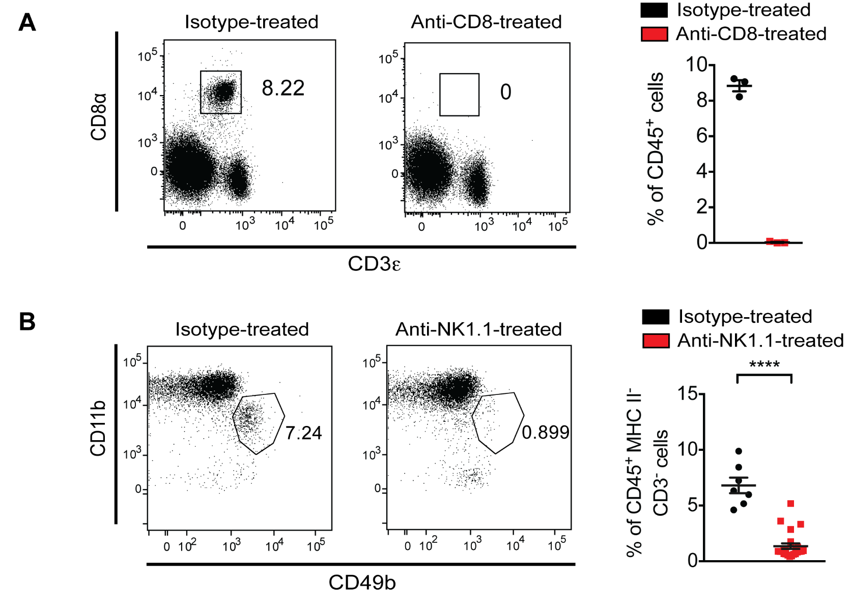
Figure S3. Depletion of CD8⁺ T cells and NK cells in antibody-treated mice. (A) Representative flow cytometry plots of cells from the blood of isotype-treated and anti-CD8α-treated mice (n = 3 mice per group). Quantification of percent of CD8⁺ T cells of total CD45⁺ cells is shown on the right. (B) Representative flow cytometry plots of cells from the blood of isotype-treated and anti-NK1.1-treated mice (n = 7-23 mice per group). Quantification of percent of NK cells of CD45⁺ MHC II⁻ CD3⁻ cells is shown on the right. Data are presented as mean±SEM. P<0.05 = *; P<0.01 = **; P<0.001 = ***; P<0.0001 = ****, Mann-Whitney U test.

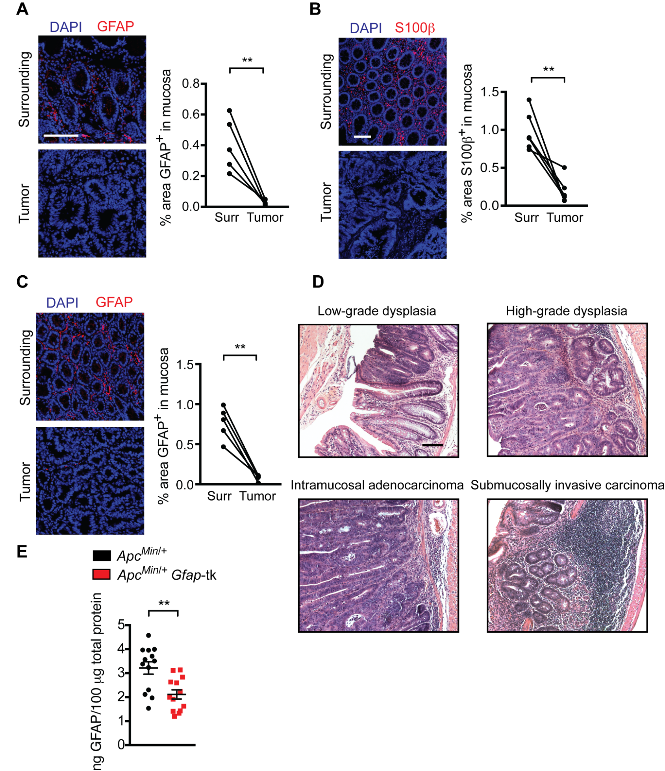
Figure S4. Images of enteric glia in tumors and depletion of enteric glia in Apc^{Min/+} Gfap-tk mice. (A-C) Representative immunofluorescence images of S100β (red) and DAPI (blue) in surrounding tissue (top) and matched tumor tissue (bottom) from CRC patients (n = 6 patients) (B) and of GFAP (red) and DAPI (blue) in surrounding tissue (top) and tumor tissue (bottom) from AOM/DSS mice (n = 5 mice) (A) and Apc^{Min/+} mice (n = 5 mice) (C). Quantifications are shown on the right. (D) Representative hematoxylin and eosin images of neoplastic lesions in the distal colons of AOM/DSS mice. (E) GFAP ELISA of small intestinal lysates from Apc^{Min/+} and Apc^{Min/+} Gfap-tk mice treated with ganciclovir (n = 13 mice per group). Scale bars are 100 μm. Data are presented as mean±SEM. P<0.05 = *; P<0.01 = **; P<0.001 = ***; P<0.0001 = ****, paired t-test (A-C), Mann-Whitney U test (E).

