Supplementary material
Therapeutic targeting of retinal immune microenvironment with CSF-1 Receptor antibody promotes visual function recovery after ischemic optic neuropathy

Yizhen Tang^{1,2,3,4}, Zebin Xiao⁵, Pan Li^{2,6}, Dongli Zhuang^{1,3,4}, Kin-Sang Cho², Kyle Robert², Xiaoxiao Chen^{1,3,4}, Lian Shu^{1,3,4}, Guangxian Tang⁷, Jihong Wu^{1,3,4}, Xinghuai Sun^{1,3,4*} and Dong F. Chen^{2*}
¹Eye Institute and Department of Ophthalmology, Eye & ENT Hospital, Fudan University, Shanghai, 200031, China
²Schepens Eye Research Institute of Massachusetts Eye and Ear, Department of Ophthalmology, Harvard Medical School, Boston, Massachusetts, USA
³NHC Key Laboratory of Myopia (Fudan University); Key Laboratory of Myopia, Chinese Academy of Medical Sciences, Shanghai, 200031, China
⁴Shanghai Key Laboratory of Visual Impairment and Restoration, Shanghai, 200031, China
⁵Department of Radiology, Eye & ENT Hospital, Fudan University, Shanghai, 200031, China
⁶School of Optometry, the Hong Kong Polytechnic University, Hong Kong, China
⁷Department of Ophthalmology, Shijiazhuang No. 1 Hospital, Hebei, China

*Correspondence:
Co-corresponding author, email: dongfeng_chen@meei.harvard.edu (D.F. Chen), xhsun@shmu.edu.cn (X. Sun).

Supplementary Caption:
- Table S1. Sequences of primers used for qPCR.
- Figure S1. Retinal ischemia/reperfusion injury induced retinal inflammation.
- Figure S2. CSF-1RAb alleviated the expressions of inflammatory cytokines in primary mouse microglia.
- Figure S3. Selective expression of CSF-1R in microglia and the effect of CSF-1RAb in purified microglial cultures.
Table S1. Sequences of primers used for qPCR

Species | Genes | Forward 5’-3’ | Reverse 5’-3’
Rat | Gapdh | TTCAACGGCACAGTCAAGG | CACCAGTGGATGCAGGGAT
 | CD16 | AACGGCACTGCTACTTACGG | CGAGATGAGGCTTTTGTTATGG
 | CD86 | TAGGGATAACCAGGCTCTAC | CGTGGGTGTCTTTTGCTGTA
 | CD206 | CTCTAAGCGCCATCTCCGTT | ATGATCTGCGACTCCGACAC
 | TNF-α | CGTCGTAGCAAACCACCAAGC | CCAGTCGCCTCACAGAGCAAT
 | IL-1β | AATGACCTGTTCTTTGAGGCTGAC | CGAGATGCTGCTGTGAGATTTGAAG
 | TGF-β | CCGCAACAACGCAATCTATG | AGCCCTGTATTCCGTCTCCTT
Mouse | Β-actin | GGCTGTATTCCCCTCCATCG | CCAGTTGGTAACAATGCCATGT
 | TNF-α | CAAAGGGATGAGAAGTTC | AGATGATCTGAGTGTGAG
 | IL-1β | CCTCAATGGACAGAATATC | TTACACAGGACAGGTATAG
 | IL-6 | ACCTGTCTATACCACTTCA | GCATCATCGTTGTTCATAC
 | IFN-γ | ACACCTGATTACTACCTTCTTC | GACCTCAAACTTGGCAATAC
Human | Gapdh | GTCTCCTCTGACTTCAACAGCG | ACCACCCTGTTGCTGTAGCCAA
 | TNF-α | CTCTTCTGCCTGCTGCACTTTG | ATGGGCTACAGGCTTGTCACTC
 | IL-1β | CCACAGACCTTCCAGGAGAATG | GTGCAGTTCAGTGATCGTACAGG
 | IL-6 | TTCTGCCAGTGCCTCTTTGCTG | AGACAGCCACTCACCTCTTCAG
 | IFN-γ | GAGTGTGGAGACCATCAAGGAAG | TGCTTTGCGTTGGACATTCAAGTC

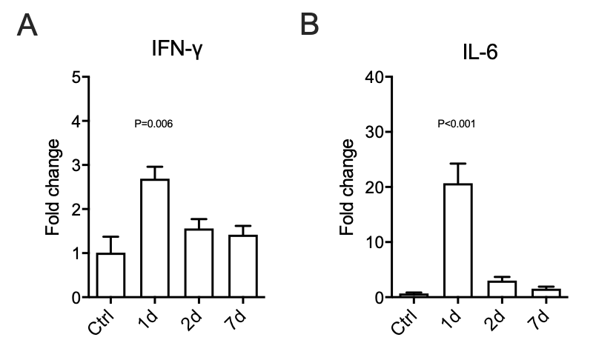

Figure S1. Retinal ischemia/reperfusion injury induced IFN-γ and IL-6 upregulation. Results of qPCR showing fold changes of IFN-γ (A) and IL-6 (B) mRNA levels in retinas of control mice (Ctrl) and mice at 1 – 7 days (d) post RI. One-way ANOVA compared to control (n = 3/group).

Figure S2. CSF-1RAb administration alleviated the expression of inflammatory cytokines in primary microglial cultures of mice. (A-B) Representative images of cytokine array membrane (A) and quantification (B) of inflammatory cytokines using proteome profiler cytokine array in primary mouse microglial cultures treated with LPS + ATP or LPS + ATP + CSF-1RAb (10 μg/ml). One-way ANOVA comparing between LPS + ATP and CSF-1RAb treatment groups (n = 6/group).

Figure S3. Selective expression of CSF-1R in microglia and the effect of CSF-1RAb in purified microglial cultures. (A) Results of qPCR showing no significant fold changes (of TNF-a, IL-1β, IFN-γ, and IL-6 mRNA levels in primary mouse microglia treated with CSF-1RAb at 1, 5 and 10 μg/ml, respectively (One-way ANOVA, n = 3/group). (B) Epifluorescence photomicrographs of retinal sections of adult mice that were immunolabeled for CSF-1R (green) and counter-stained with a nuclear marker DAPI (blue). (C) Photomicrograph of retinal flat-mount that were double-immunolabeled for CSF-1R (green) and microglial marker Iba-1 (red). Note that CSF-1R signal was strongly colocalized with Iba-1 immunolabeling, but was scarce in other retinal layers or areas. Scale bar: 50 μm.

