Table S1. Pearson’s correlation index between maternal behavior, anxiety-like behavior Z-score and Corticosterone.

 | Arched-back nursing |  | Passive nursing |  | Licking/  Grooming |  | Nest building |  | Maternal behavior |  | Nest exits |  | Non-maternal behavior
 | r | p | r | p | r | p | r | p | r | p | r | p | r | p
Anxiety-like behavior  Z-score | - 0.535 | 0.015* | 0.269 | 0.250 | 0.740 | <0.001* | 0.651 | 0.001* | 0.447 | 0.047* | 0.776 | <0.001* | - 0.244 | 0.298
Corticosterone | 0.680 | 0.001* | - 0.428 | 0.076 | - 0.593 | 0.009* | - 0.624 | 0.005* | - 0.481 | 0.042* | - 0.717 | <0.001* | 0.316 | 0.200

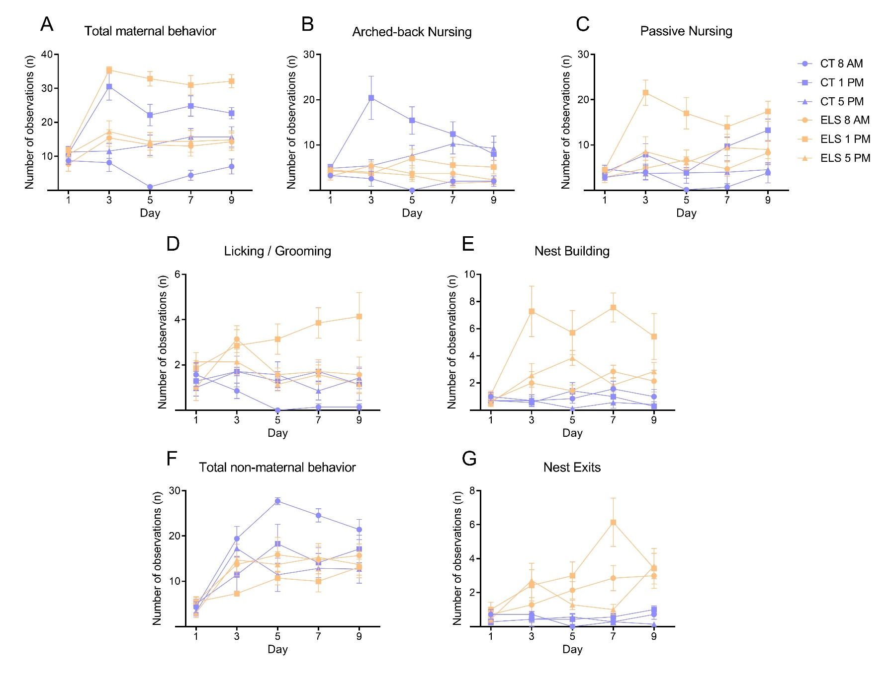

Figure S1. Analysis of maternal and non-maternal behaviors throughout each day and specific time points. A) Total maternal behavior during PND 1, PND 3, PND 5, PND 7, and PND 9 at 8 a.m., 1 p.m., and 5 p.m.; B) Arched-back nursing during PND 1, PND 3, PND 5, PND 7, and PND 9 at 8 a.m., 1 p.m., and 5 p.m.; C) Passive nursing during PND 1, PND 3, PND 5, PND 7, and PND 9 at 8 a.m., 1 p.m., and 5 p.m.; D) Licking/grooming during PND 1, PND 3, PND 5, PND 7, and PND 9 at 8 a.m., 1 p.m., and 5 p.m.; E) Nest building during PND 1, PND 3, PND 5, PND 7, and PND 9 at 8 a.m., 1 p.m., and 5 p.m.; F) Total non-maternal behavior during PND 1, PND 3, PND 5, PND 7, and PND 9 at 8 a.m., 1 p.m., and 5 p.m.; G) Exits from the nest during PND 1, PND 3, PND 5, PND 7, and PND 9 at 8 a.m., 1 p.m., and 5 p.m.. Results are expressed as mean ± SEM; n = 7 litters per group. (Repeated Measures ANOVA followed by Tukey’s post-hoc when necessary).

