Supplementary material 1. Number of dolphin sightings, surveys and effort (km) between 2015 and 2018, for each year and for the whole period (2015-2018)
Year | N° Surveys | km | Sightings
2015 | 98 | 2.664 | 59
2016 | 88 | 2.608 | 64
2017 | 102 | 2.819 | 97
2018 | 103 | 2.767 | 87
2015-2018 | 391 | 10.858 | 307

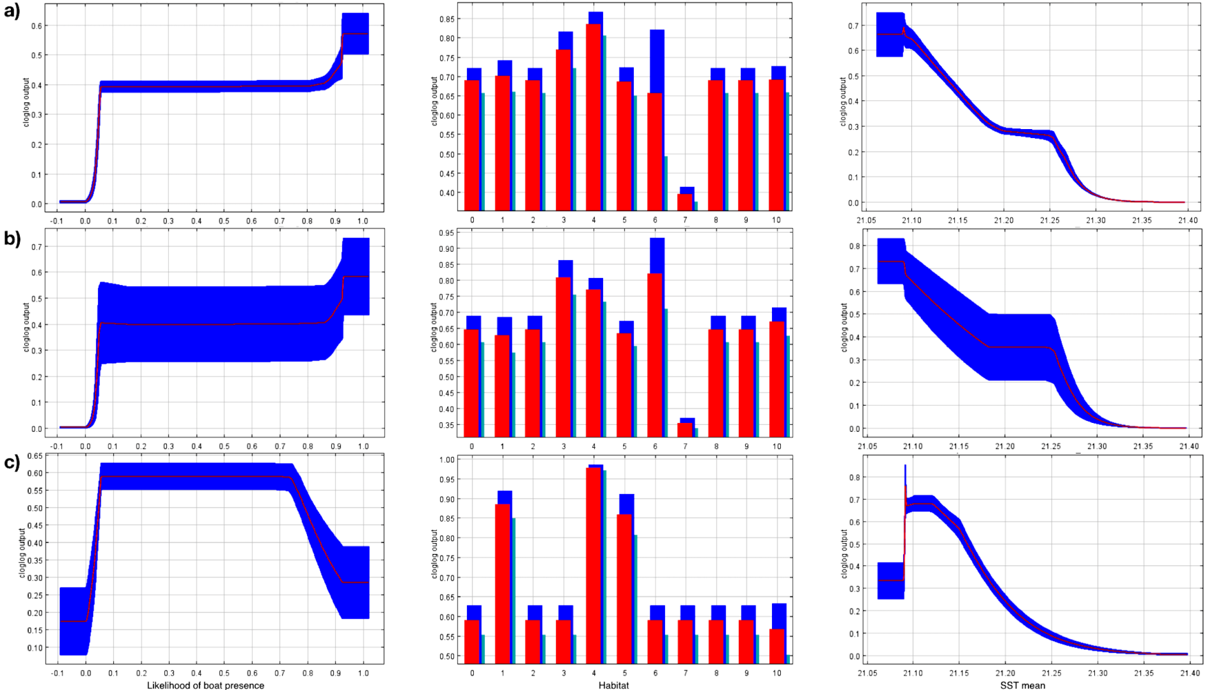
Supplementary material 2. Likelihood of boat presence, SST mean and Habitat effect on likelihood of dolphin presence (cloglog output) for a) all groups; b) groups without calves; c) groups with calves.

