 | Summer |  |  |  |  | Winter
Variable | Year | A-n | N-n | N-a | N-o | Year | A-n | N-n | N-a | N-o
T (°C) | 2014 | 10.51 | 8.32 | 8.28 | 9.59 | 2013/14 | -0.09 | 0.08 | -0.10 | -0.14
Length (days) |  | 157 | 122 | 122 | 122 |  | 219 | 254 | 254 | 254
Dd (° C) |  | 1650 | 1014 | 1009 | 1170 |  | -19 | 19 | -35 | -35
SWP (MPa) |  | -0.02 | -0.03 | -0.02 | -0.02 |  | -0.09 | -0.04 | -0.03 | -0.03
T (°C) | 2015 | 11.89 | 10.36 | 10.45 | 11.71 | 2014/15 | 0.09 | 0.05 | -0.14 | -0.14
Length (days) |  | 162 | 115 | 115 | 115 |  | 196 | 242 | 242 | 242
Dd (° C) |  | 1925 | 1191 | 1201 | 1346 |  | 17 | 11 | -33 | -35
SWP (MPa) |  | -0.01 | -0.04 | -0.04 | -0.08 |  | -0.03 | -0.03 | -0.06 | -0.05
T (°C) | 2016 | 11.99 | 10.94 | 10.86 | 12.73 | 2015/16 | -1.51 | -1.75 | -1.70 | -1.71
Length (days) |  | 153 | 108 | 108 | 108 |  | 208 | 253 | 253 | 253
Dd (° C) |  | 1834 | 1181 | 1173 | 1375 |  | -314 | -444 | -431 | -433
SWP (MPa) |  | -0.03 | -0.02 | -0.02 | -0.03 |  | -0.64 | -0.57 | -0.58 | -0.55
T (°C) | 2017 | 12.65 | 10.48 | 10.48 | 12.06 | 2016/17 | 0.06 | -0.37 | -0.34 | -0.30
Length (days) |  | 151 | 130 | 130 | 130 |  | 218 | 238 | 238 | 238
Dd (° C) |  | 1911 | 1362 | 1362 | 1568 |  | 12 | -89 | -82 | -82
SWP (MPa) |  | -0.08 | -0.03 | -0.06 | -0.07 |  | -0.42 | -0.49 | -0.49 | -0.49
T (°C) | Average | 11.76 | 10.03 | 10.02 | 11.52 | Average | -0.36 | -0.50 | -0.57 | -0.57
Length (days) |  | 156 | 119 | 119 | 119 |  | 210 | 247 | 247 | 247
Dd (° C) |  | 1830 | 1188 | 1187 | 1366 |  | -76 | -125 | -146 | -146
SWP (MPa) |  | -0.04 | -0.03 | -0.04 | -0.05 |  | -0.30 | -0.28 | -0.29 | -0.28

Supporting information Table S1
Mean soil temperature (T), mean season length (length), mean degree days (dd. °C) and mean soil water potential (SWP) in summer and winter in the four years, at the alpine vegetation belt (A site) on its natural soil (A-n) and at the nival vegetation belt (site N) on its natural soil (N-n), on soil originating from site A (N-a) and under the OTC (N-o). The first snow-free day and the length of the growing season (daily mean soil temperature >2 °C) were derived from the data of soil T.

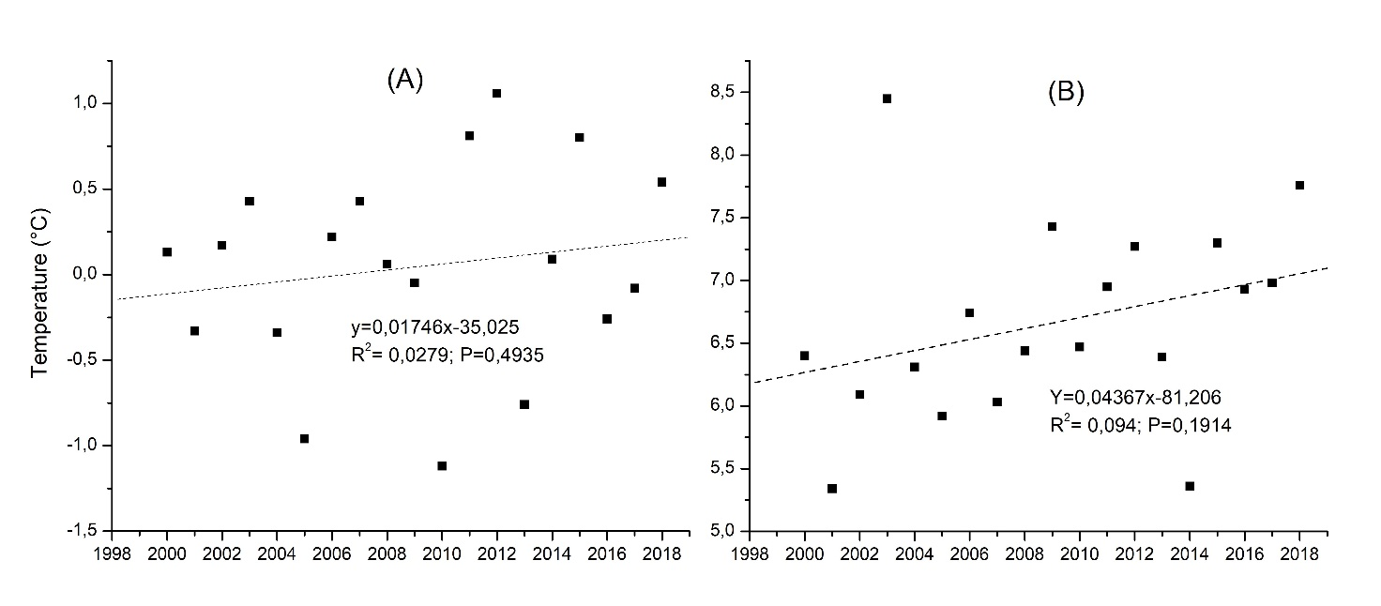
Supporting information Figure S1
Mean annual (A) and summer (Jun-Sep; B) temperatures in the last 18 years before the end of the experiment at the weather station of Livigno La Vallaccia (46°28'40.9"N 10°12'22.0"E; 2660 m a.s.l.), located approx. 7 km far the study area (data available at https://www.arpalombardia.it).

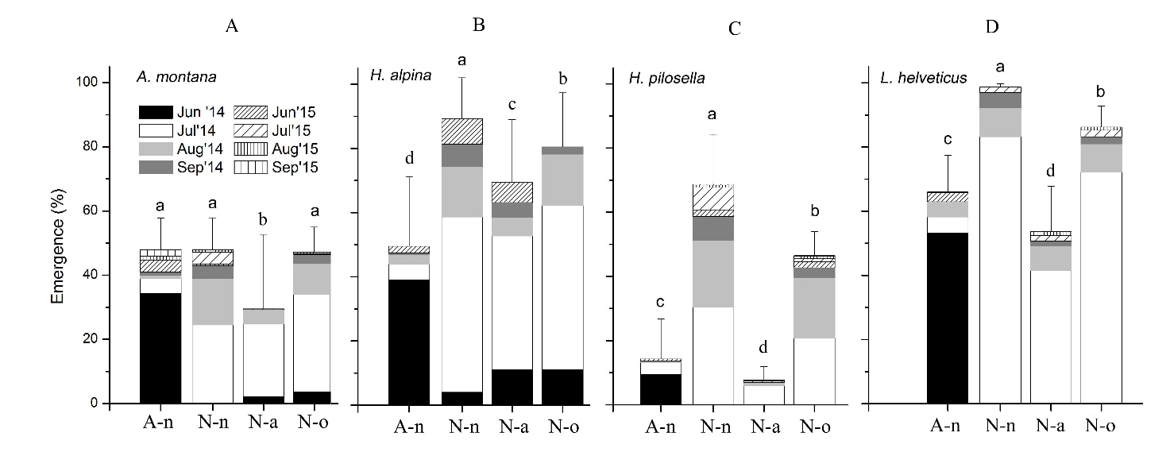
Supporting information Figure S1
Cumulative monthly seedling emergence (means ± c.i.) of the four species at the alpine vegetation belt (site A) on its natural soil (A-n) and at the nival vegetation belt (site N) on its natural soil (N-n), on soil originating from site A (N-a) and under the OTC (N-o). Data are shown for the growing seasons 2014-2015 (no further germination occurred during the growing seasons 2016-2018). In each panel different letters represent significant differences at P < 0.05.

