SUPPLEMENTARY DATA

Supplementary Figure S1 - A. hypochondriacus Plainsman PI558499. Image from https://www.southernexposure.com/products/amaranth-plainsman/

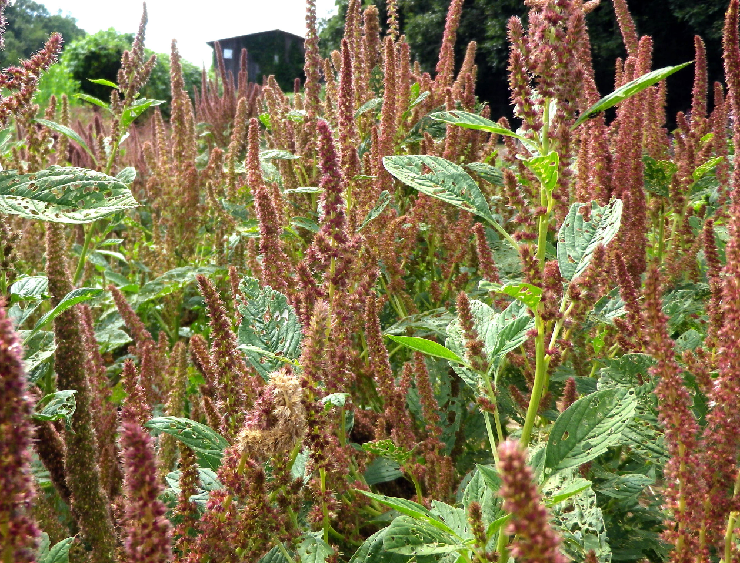

Supplementary Figure S2 - C₀t analysis of A.hyp_K_white and A.hyp_K_red
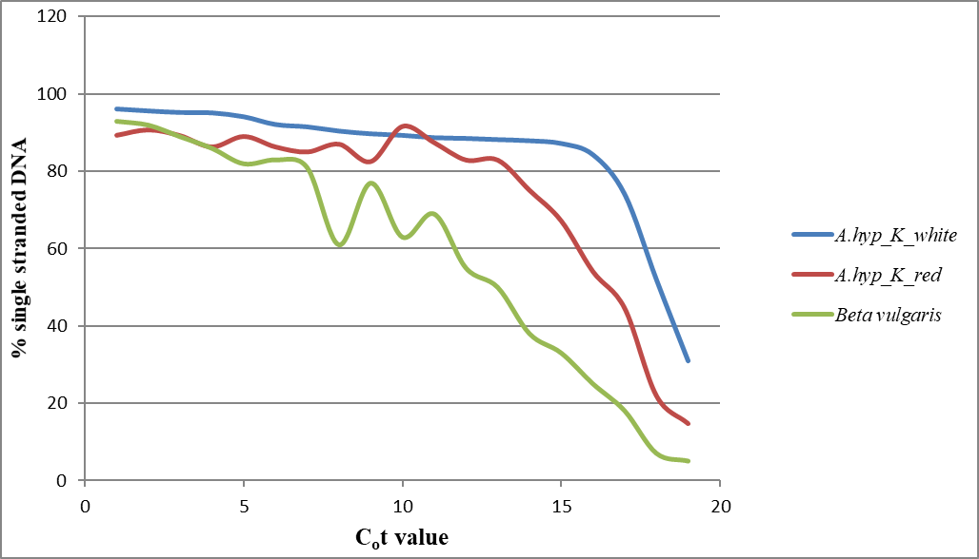
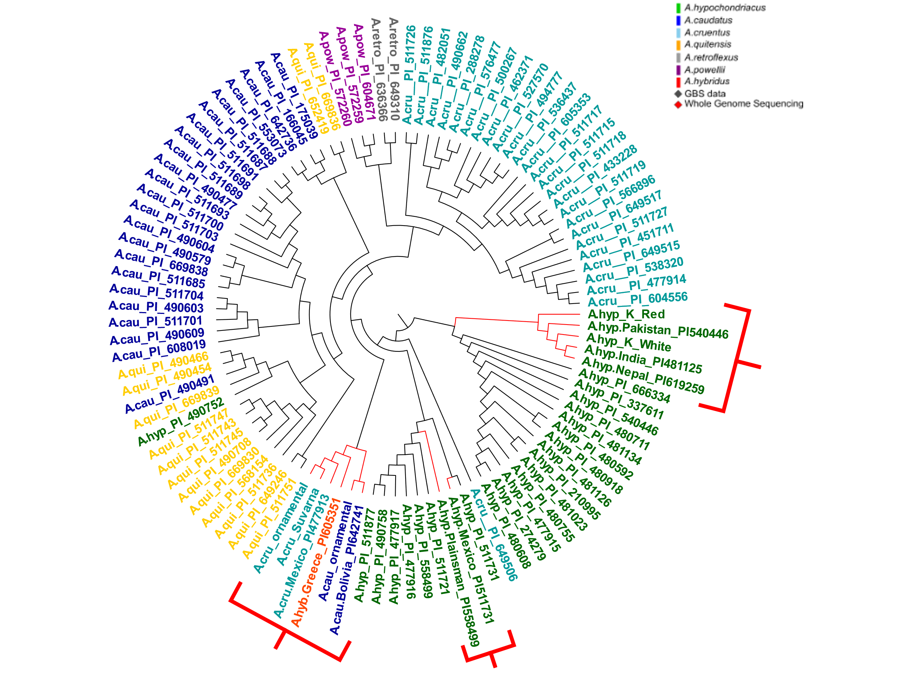
Supplementary Figure S3- Tree generated using non-normalized WGS-GBS data.
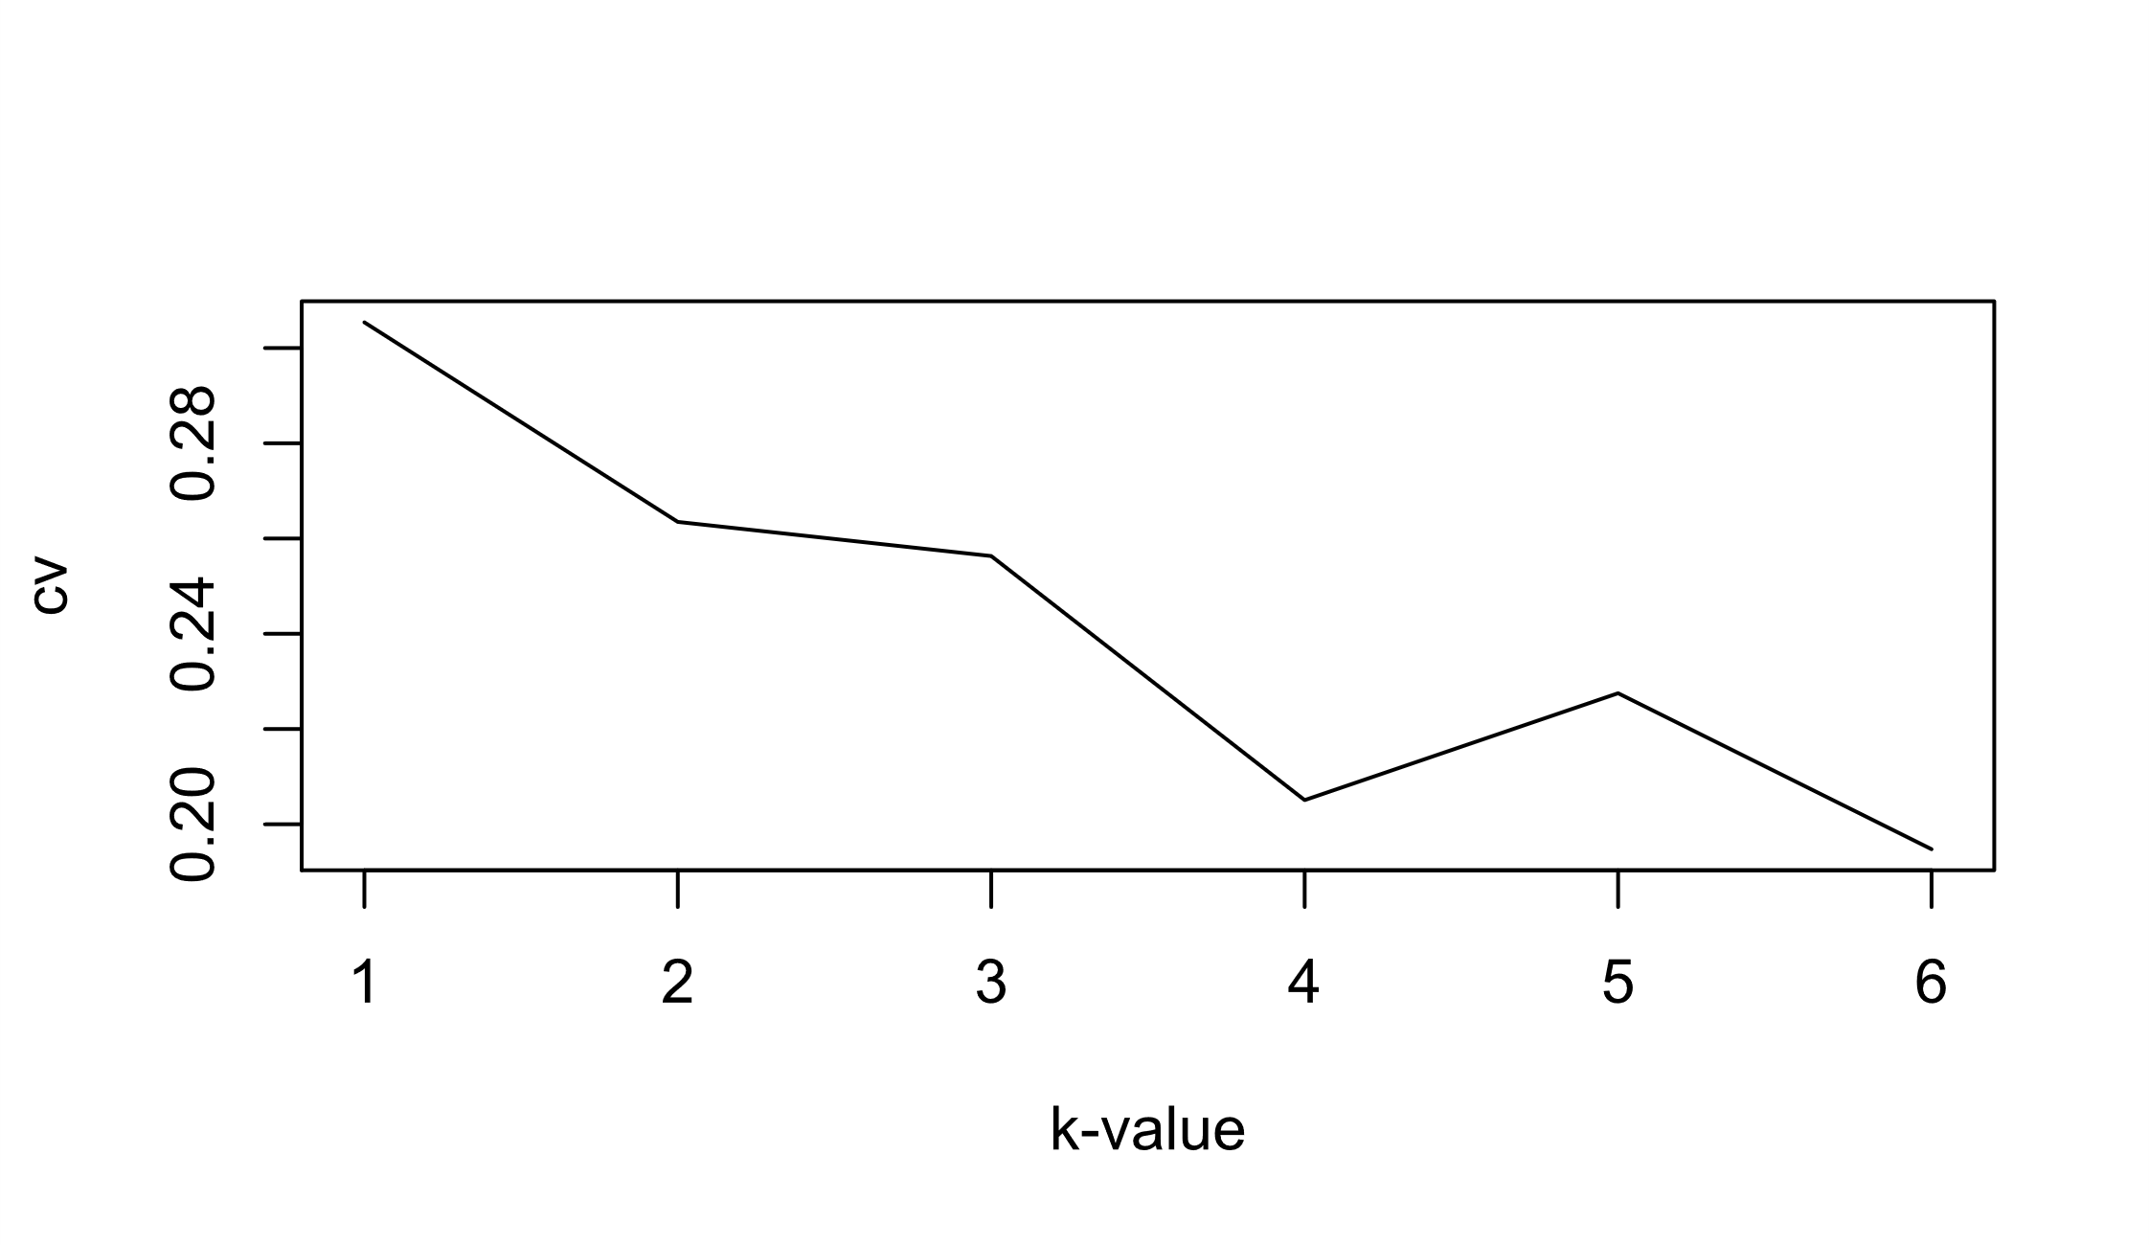
Supplementary Figure S4- Cross validation error value plot for different K values of admixture analysis.
Supplementary Table S1- Details of in-house sequenced plants
 | Total no of reads | Coverage
A.hyp_K_white | 469749648 | 87.3357055
A.cau_ornamental | 266702040 | 53.1278964
A.cru_ornamental | 353363298 | 69.2869212
A.hyp_K_red | 447933760 | 111.03960
A.cru_Suvarna | 501687774 | 147.555228

Supplementary Table S2- SNP count of all whole genome samples on both references
Name | Alias | On A.hyp.V.2.1 | On AhKP
A. caudatus (Bolivia) PI 642741 | A.cau_PI642741 | 2846014 | 2424857
A. cruentus (Mexico) PI 477913 | A.cru_PI477913 | 3263942 | 2773417
A. hypochondriacus (India) PI481125 | A.hyp_PI481125 | 886235 | 117514
A. hypochondriacus K white (India) | A.hyp_K_white | 901042 | 110024
A. hypochondriacus Plainsman PI558499 | A.hyp_PI558499 | 78926 | 765147
A. hypochondriacus (Nepal) PI619259 | A.hyp_PI619259 | 881424 | 112943
A. hypochondriacus (Pakistan)PI540446 | A.hyp_PI540446 | 937366 | 196203
A. hypochondriacus K red (India) | A.hyp_K_red | 1006061 | 193013
A. hypochondriacus (Mexico) PI511731 | A.hyp_PI511731 | 1248769 | 738991
Suvarna (India) | A.cru_Suvarna | 3267631 | 2796817
A. hybridus (Greece) PI605351 | A.hyb_PI605351 | 3280993 | 2783846
A. caudatus (Love-Lies-Bleeding) | A.cau_ornamental | 2954432 | 2138832
A. cruentus (Autumn Touch) | A.cru_ornamental | 3428292 | 2920539

Supplementary Table S3- Agronomic trait comparison between A.hyp_K_white and A.hyp_Plainsman_PI558499

 | A.hyp_K_white ~PI619259 | Plainsman PI558499 (Baltensperger 1999)
Seed color | Light | Light
Inflorescence | White | White/Red
Height | 5-6 feet | 4 feet
Seed length/width | ~450/450 µm (See Figure 2.f) | NA
Yeild | 3-4g per plant | 2-3g per plant

