Supplementary Materials

Table 1. Search strategies
Databases | Search items | Result
PubMed | #1 (((("Neoplasms"[Title/Abstract] OR "Neoplasia"[Title/Abstract]) OR "Tumor"[Title/Abstract]) OR "Cancer"[Title/Abstract]) OR "Malignancy"[Title/Abstract]) OR (((("neoplasm s"[All Fields] OR "Neoplasms"[MeSH Terms]) OR "Neoplasms"[All Fields]) OR "neoplasm"[All Fields]) AND "Malignancy"[Title/Abstract])  #2 "CD163"[Title/Abstract] OR "sCD163"[Title/Abstract] OR "soluble cd163"[Title/Abstract] OR "soluble scavenger receptor"[Title/Abstract]  #3 (#1) AND (#2) | 1209
the Web of Science | TS= (Neoplasms OR Neoplasia OR Tumor OR Cancer OR Malignancy OR Neoplasms Malignancy) AND TS= (CD163 OR sCD163 OR soluble CD163 OR soluble scavenger receptor) | 1380
Embase | #1 (Neoplasms OR Neoplasia OR Tumor OR Cancer OR Malignancy OR Neoplasms Malignancy):ab ti  #2 (CD163 OR sCD163 OR soluble CD163 OR soluble scavenger receptor):ab ti  #3 #1 AND #2 | 7
CBM | ("癌"[常用字段:智能] OR "肿瘤"[常用字段:智能]) AND ( "CD163"[常用字段:智能] OR "可溶性清道夫受体"[常用字段:智能]) OR "sCD163"[常用字段:智能] | 332
Scopus | TITLE-ABS-KEY (neoplasms OR neoplasia OR tumor OR cancer OR malignancy OR neoplasms AND malignancy) AND TITLE-ABS-KEY (cd163 OR scdgf OR soluble AND cd163 OR soluble AND scavenger AND receptor ) | 13
Cochrane | Neoplasms OR Neoplasia OR Tumor OR Cancer OR Malignancy OR Neoplasms Malignancy in Title Abstract Keyword AND CD163 OR sCD163 OR soluble CD163 OR soluble scavenger receptor in Title Abstract Keyword | 67

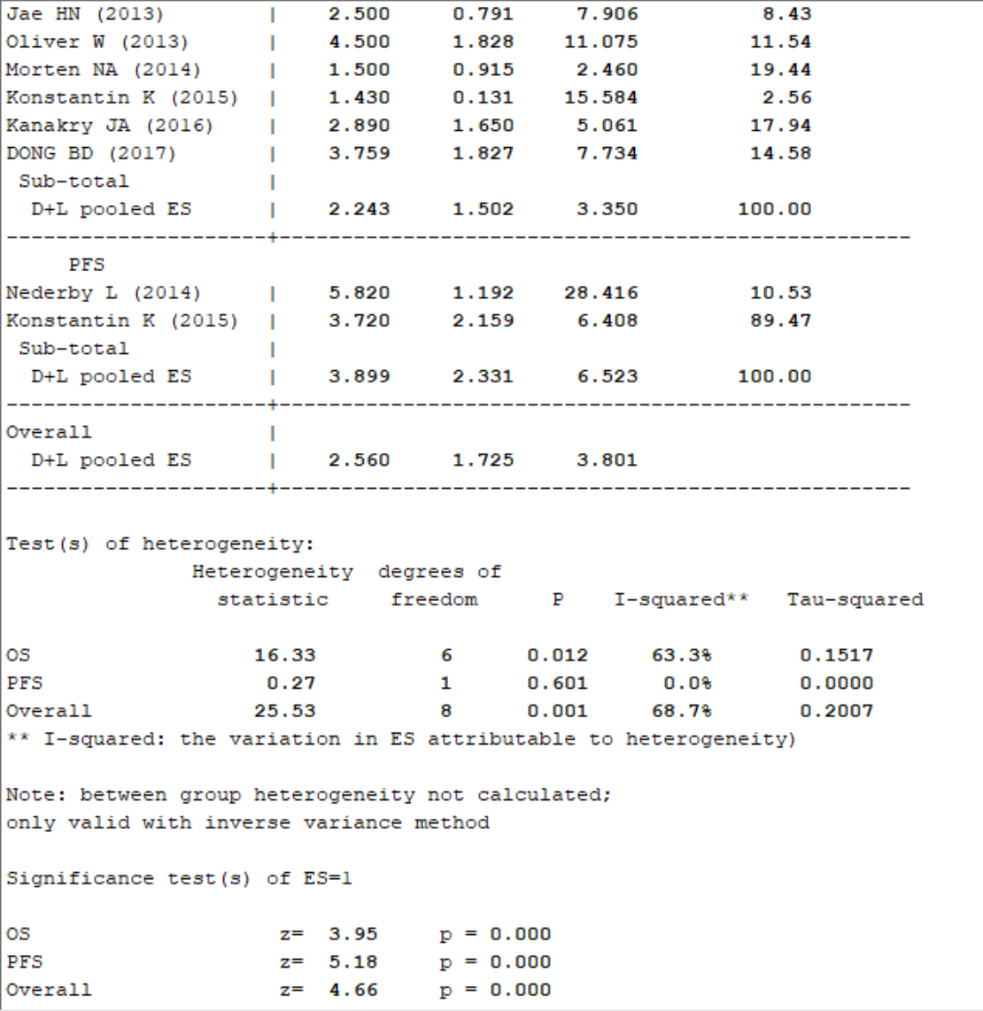
Supplementary Figure 1. Meta-analysis result of subgroup analysis of survival outcome
Supplementary Figure 2. Meta-analysis result of subgroup analysis of sample size using random-effects model
Supplementary Figure 3. Meta-analysis result of subgroup analysis of analysis method using random-effects model
Supplementary Figure 4. Meta-analysis result of subgroup analysis of cancer type using random-effects model
Supplementary Figure 5. Meta-analysis result of subgroup analysis of age at diagnosis using random-effects model
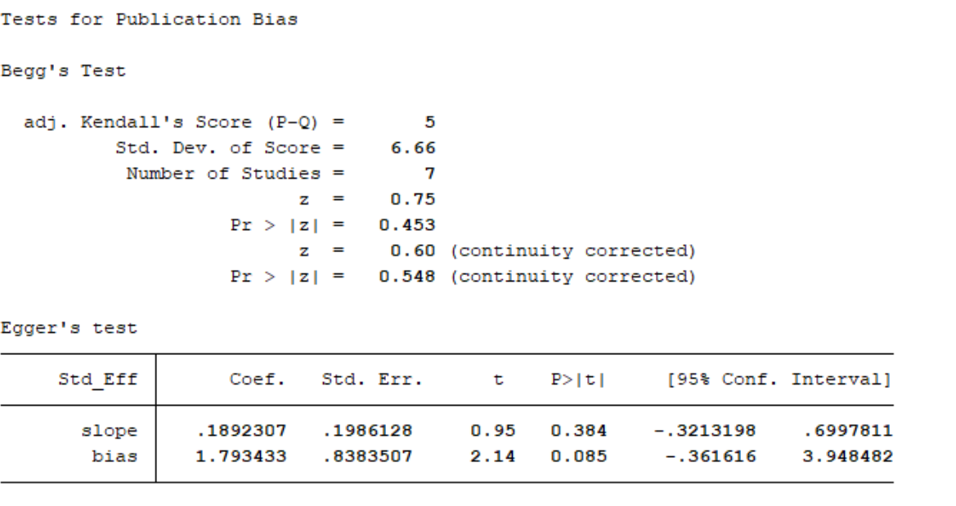
Supplementary Figure 6. Begg’s test for publication bias of results of survival
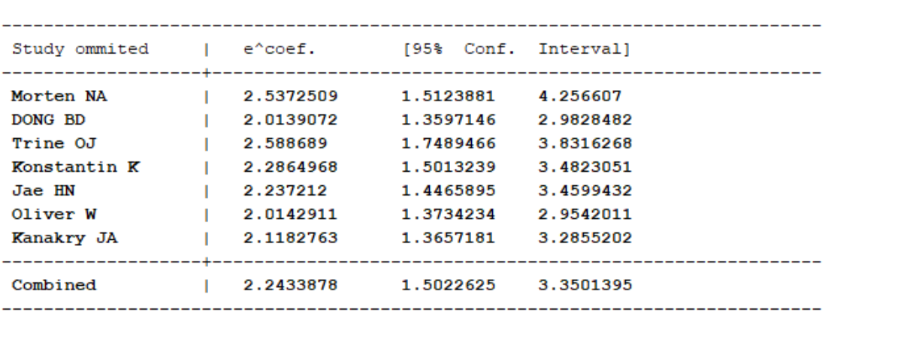
Supplementary Figure 7. Sensitivity analysis for studies about OS by omitting each study sequential
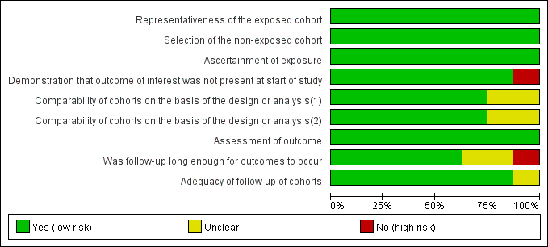
Supplementary Figure 8. Assessment analysis for studies by the Newcastle-Ottawa Scale (NOS)

