Supplementary Material

Supplementary Figures and Tables

Supplementary Figures
Supplementary Figure 1. (A) CK of Zhefujing83; (B) CK of AD516; (C) BYK of Zhefujing83; (D) BYK of AD516; (E) DWB of Zhefujing83; (F) DWB of AD516; (G) WKB of Zhefujing83; (H) WKB of AD516.

Supplementary Figure 2. The architecture of autoencoder. For HSI, the data dimensionalities from beginning to the end could be simply recorded as 390-64-32-64-390. For MIR, the change of dimensionalities could be simply recorded as 7468-64-16-64-7468. For LIBS, the change of dimensionalities could be simply recorded as 22036-256-64-256-22036.
Supplementary Figure 3. The relationship between epoch and training performances.

Supplementary Figure 4. The CNN architecture of Full-HSI of Zhefujing83 and AD516.
Supplementary Figure 5. The CNN architecture of Full-MIR of Zhefujing83 and AD516.
Supplementary Figure 6. The CNN architecture of Full-LIBS of Zhefujing83 and AD516.

(A) | (B)
Supplementary Figure 7. (A) The CNN architecture of PCA-HSI of Zhefujing83; (B) The CNN architecture of PCA-HSI of AD516.
(A) | (B)
Supplementary Figure 8. (A) The CNN architecture of PCA-MIR of Zhefujing83; (B) The CNN architecture of PCA-MIR of AD516.

(A) | (B)
Supplementary Figure 9. (A) The CNN architecture of PCA-LIBS of Zhefujing83; (B) the CNN architecture of PCA-LIBS of AD516.
Supplementary Figure 10. The CNN architecture of AE-HSI of Zhefujing83 and AD516.
Supplementary Figure 11. The CNN architecture of AE-MIR of Zhefujing83 and AD516.
(A) | (B)
Supplementary Figure 12. (A) The CNN architecture of AE-LIBS of Zhefujing83; (B) The CNN architecture of AE-LIBS of AD516.
Supplementary Figure 13. The CNN architecture of Full-HSI-MIR of Zhefujing83 and AD516.

Supplementary Figure 14. The CNN architecture of Full-HSI-LIBS (Batch size=20), Full-MIR-LIBS (Batch size=20) and Full-HSI-MIR-LIBS (Batch size=10) of Zhefujing83 and AD516.
Supplementary Figure 15. The CNN architecture of AE-PCA-HSI-MIR, AE-PCA-HSI-LIBS, AE-PCA-MIR-LIBS and AE-PCA-HSI-MIR-LIBS of Zhefujing83 and AD516.

(A) | (B)
Supplementary Figure 16. (A) The CNN architecture of PCA-HSI-MIR of Zhefujing83; (B) The CNN architecture of PCA-HSI-MIR of AD516.
(A) | (B)
Supplementary Figure 17. (A) The CNN architecture of PCA-HSI-LIBS of Zhefujing83; (B) The CNN architecture of PCA-HSI-LIBS of AD516.
(A) | (B)
Supplementary Figure 18. (A) The CNN architecture of PCA-MIR-LIBS of Zhefujing83; (B) The CNN architecture of PCA-MIR-LIBS of AD516.

Supplementary Figure 19. The CNN architecture of PCA-HSI-MIR-LIBS of Zhefujing83 and AD516.

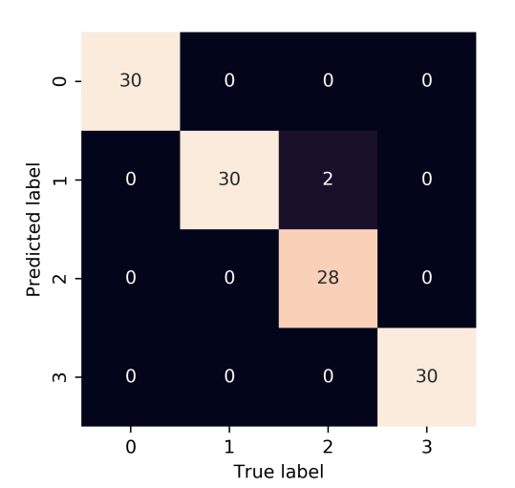  (A) | 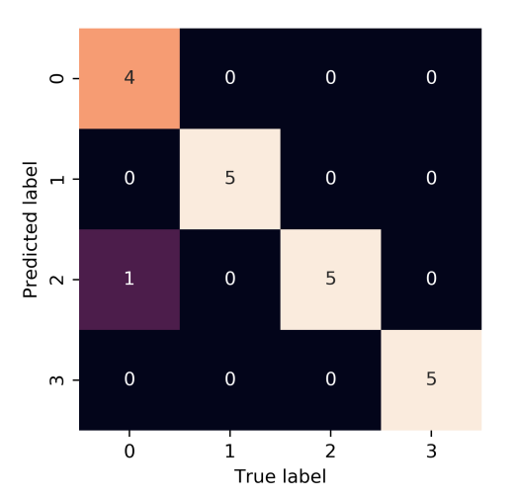  (B)
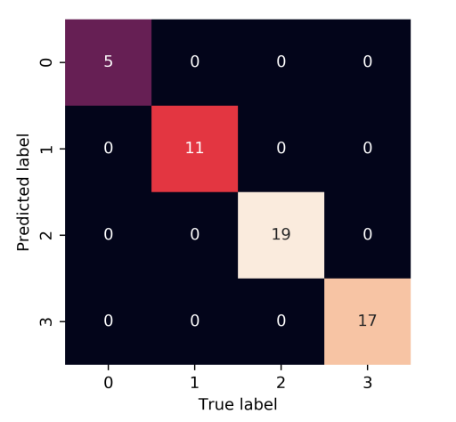
(C)
Supplementary Figure 20. The confusion matrix of the training set (A), the validation set (B) and the test set (C) of Full-HSI of Zhefujing83.

Supplementary Table 1. ANOVA analysis of results of the training set of CNN for Full spectra, PCA features and AE features.
Sig. | 0ª | 1^{b} | 2^{c}
0 | - | 0.648 | 0.294
1 | 0.648 | - | 0.544
2 | 0.294 | 0.544 | -
ª accuracy of training set of Full spectra; ^{b} accuracy of training set of PCA features; ^{c} accuracy of training set of AE features; Sig. means significance.

Supplementary Table 2. ANOVA analysis of results of the validation set of CNN Full spectra, PCA features and AE features.
Sig. | 0ª | 1^{b} | 2^{c}
0 | - | 0.801 | 0.093
1 | 0.801 | - | 0.145
2 | 0.093 | 0.145 | -
ª accuracy of validation set of Full spectra; ^{b} accuracy of validation set of PCA features; ^{c} accuracy of validation set of AE features; Sig. means significance.

Supplementary Table 3. ANOVA analysis of results of the test set of CNN for Full spectra, PCA features and AE features.
Sig. | 0ª | 1^{b} | 2^{c}
0 | - | 0.709 | 0.008
1 | 0.709 | - | 0.017
2 | 0.008 | 0.017 | -
ª accuracy of test set of Full spectra; ^{b} accuracy of test set of PCA features; ^{c} accuracy of test set of AE features; Sig. means significance.

Supplementary Table 4. ANOVA analysis of results of the training set of CNN for Full individual spectra, low-level fusion, mid-level fusion and high-level fusion.
Sig. | 0ª | 1^{b} | 2^{c} | 3^{d}
0 | - | 0.163 | 0.232 | 0.191
1 | 0.163 | - | 0.615 | 1.0
2 | 0.232 | 0.615 | - | 0.652
3 | 0.191 | 1.0 | 0.652 | -
ª accuracy of training set of Full individual spectra; ^{b} accuracy of training set of low-level fusion; ^{c} accuracy of training set of mid-level fusion; ^{d} accuracy of training set of high-level fusion; Sig. means significance.

Supplementary Table 5. ANOVA analysis of results of the validation set of CNN for Full individual spectra, low-level fusion, mid-level fusion and high-level fusion.
Sig. | 0ª | 1^{b} | 2^{c} | 3^{d}
0 | - | 0.338 | 0.512 | 0.472
1 | 0.338 | - | 0.052 | 0.847
2 | 0.512 | 0.052 | - | 0.124
3 | 0.472 | 0.847 | 0.124 | -
ª accuracy of validation set of Full individual spectra; ^{b} accuracy of validation set of low-level fusion; ^{c} accuracy of validation set of mid-level fusion; ^{d} accuracy of validation set of high-level fusion; Sig. means significance.

Supplementary Table 6. ANOVA analysis of results of the test set of CNN for Full individual spectra, low-level fusion, mid-level fusion and high-level fusion.
Sig. | 0ª | 1^{b} | 2^{c} | 3^{d}
0 | - | 0.628 | 0.063 | 0.960
1 | 0.628 | - | 0.141 | 0.591
2 | 0.063 | 0.141 | - | 0.055
3 | 0.960 | 0.591 | 0.055 | -
ª accuracy of test set of Full individual spectra; ^{b} accuracy of test set of low-level fusion; ^{c} accuracy of test set of mid-level fusion; ^{d} accuracy of test set of high-level fusion; Sig. means significance.

