Supplementary Material

Supplementary Tables
Supplementary Table S1. A) Results of the linear regression between air temperature (T) and metabolic traits of C. incanus leaves and B) Results of the linear regression between the leaf thickness (LT) and the other morphological leaf traits (UE = upper epidermis, PM = palisade mesophyll, SM = spongy mesophyll, LE = lower epidermis) or physiological parameters of photosynthesis (P_{n}) and stomatal conductance (g_{s}) of C. incanus leaves. R²: determination coefficient, P: significance level, (+): significant positive relationship, (-): significant negative relationship and (ns) variable not significant.

A | Parameter | T (°C) | Slope | Intercept | R² | p
 | P_{n} | ns | -0.03 | 2.38 | 0.01 | ˃0.05
 | g_{s} | + | 2.70 | -31.13 | 0.14 | <0.01
 | Fv/Fm | - | -0.01 | 1.07 | 0.46 | <0.001
 | Φ_{PSII} | ns | -0.003 | 0.21 | 0.01 | ˃0.05
 | RWC | - | -2.37 | 122.43 | 0.66 | <0.001
 | Ψ_{W} | - | -0.26 | 3.97 | 0.64 | <0.001
 | Pol_{Tot} | + | 3.47 | -22.85 | 0.52 | <0.01
 | BVOCs | + | 16.42 | -441.60 | 0.94 | <0.001
B | Parameter | LT (µm) | Slope | Intercept | R² | p
 | UE | + | 0.11 | 2.05 | 0.46 | <0.01
 | PM | + | 0.55 | -13.66 | 0.66 | <0.001
 | SM | + | 0.28 | 7.30 | 0.35 | <0.05
 | LE | ns | 0.07 | -1.77 | 0.63 | ˃0.05
 | P_{n} | + | 0.01 | -0.62 | 0.35 | <0.01
 | g_{s} | + | 0.41 | -37.85 | 0.59 | <0.001

Supplementary Figures
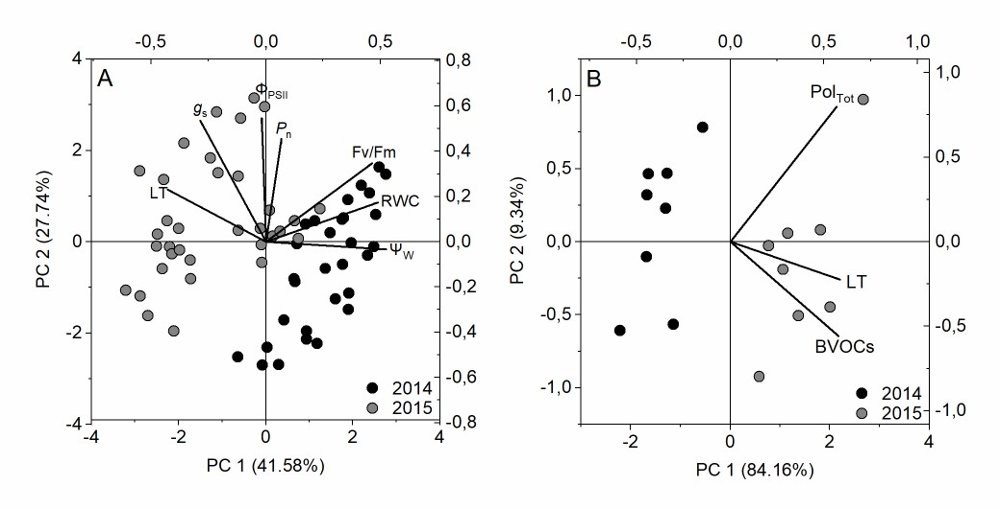

Supplementary Figure S1. Bi-plot of the principal component analysis on metabolic traits of C. incanus: Leaf thickness (LT), photosynthesis (P_{n}) and stomatal conductance (g_{s}), Fv/Fm, photosystem II maximum efficiency (Φ_{PSII}), water potential (Ψ_{w}) and relative water content (RWC) (A). Total polyphenols content (Pol_{Tot}), biogenic organic compounds (BVOCs) and leaf thickness (LT) (B).

Supplementary Figure S2. C. incanus naturally growing in the costal dunes of Southern Tuscany (GR). The Mediterranean shrub showed larger leaf size and a lower degree of leaf rolling in July 2014 (A) than July 2015 (B).

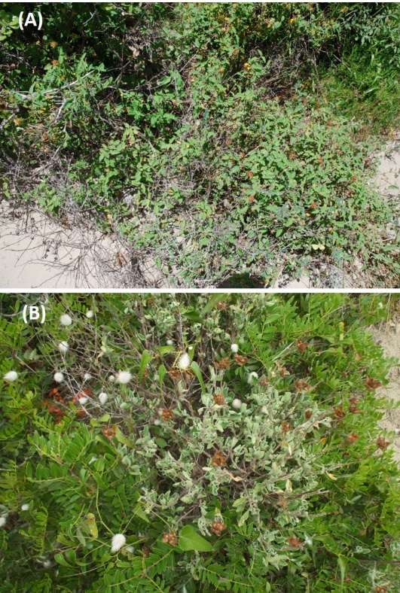

Supplementary Figure S3. Daily leaf temperatures (T_{leaf}) of C. incanus in July 2014 and 2015. Two way ANOVA followed by Tukey's pairwise comparison was performed to compare data (means ± SD; n = 8). Letters indicate significant differences (p ≤ 0.05) among sampling hours for each years, whereas asterisks represent significant differences among yeas for each sampling hour, * (p ≤ 0.05), ** (p ≤ 0.01), *** (p ≤ 0.001).

