Supplementary Information
Table S1. Summary statistics of body morphometric variables for neonates in 2016 and 2018, separated by treatment (incubator, hatchery) and including overall statistics for each year.
Variable |  |  | 2016 |  |  | 2018
 |  | Incubator | Hatchery | Overall | Incubator | Hatchery | Overall
Mass (g)
 | Mean | 42.7 | 42.4 | 42.5 | 45.9 | 49.9 | 48.3
 | Std.Dev | 3.8 | 3.3 | 3.5 | 2.5 | 3.8 | 3.9
 | Range | 33.0-48.0 | 37.0-50.0 | 33.0-50.0 | 43.2-52.7 | 42.3-56.0 | 42.3-56.0
Standard Carapace Length (mm)
 | Mean | 60.3 | 60.5 | 60.4 | 61.8 | 62.4 | 62.1
 | Std.Dev | 3.3 | 2.2 | 2.6 | 1.9 | 3.5 | 2.9
 | Range | 51.5-64.8 | 55.1-64.6 | 51.5-64.8 | 58.0-64.0 | 53.0-69.0 | 53.0-69.0
Standard Carapace Width (mm)
 | Mean | 41.6 | 42.0 | 41.8 | 40.8 | 41.0 | 40.9
 | Std.Dev | 1.6 | 1.6 | 1.6 | 1.2 | 2.9 | 2.3
 | Range | 36.8-43.9 | 38.6-45.1 | 36.8-45.1 | 38.0-43.0 | 37.0-52.0 | 37.0-52.0
Head Width (mm)
 | Mean | 17.5 | 17.9 | 17.8 | 15.6 | 16.3 | 16.0
 | Std.Dev | 0.6 | 0.5 | 0.6 | 1.2 | 0.9 | 1.1
 | Range | 15.8-18.3 | 17.0-18.9 | 15.8-18.9 | 14.0-18.0 | 15.0-18.0 | 14.0-18.0
Flipper Length (mm)
 | Mean | NA | NA | NA | 55.2 | 57.6 | 56.6
 | Std.Dev | NA | NA | NA | 3.1 | 3.3 | 3.4
 | Range | NA | NA | NA | 52.0-64.0 | 51.0-65.0 | 51.0-65.0

Table S2. Results of a linear mixed effects model predicting the variance in neonate swimming speed (residuals from final neonate GAMM model, see Table 3 in text) as a function of time along the track (move number). Individual neonates were included as random effects.
Fixed Effect |  | Estimate | Estimate Error | p-value
Intercept | 0.001 |  | 0.011 | 0.924
Time Along Track  (Move Number) | -0.000 |  | 0.001 | 0.619
Current Speed | 0.008 |  | 0.014 | 0.569

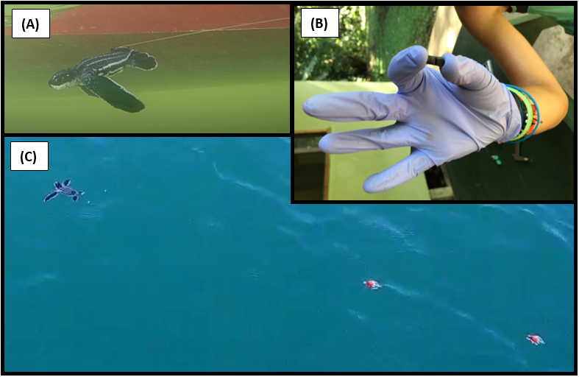
Figure S1. (A) Illustration of the Velcro attachment to neonate carapace dorsal-ventrally. (B) Picture of Vemco V5 acoustic tag. Tag design from Hoover et al. (2017). (C) Tag design attached to neonate, with 2 m of monofilament line with orange floats and acoustic tag.
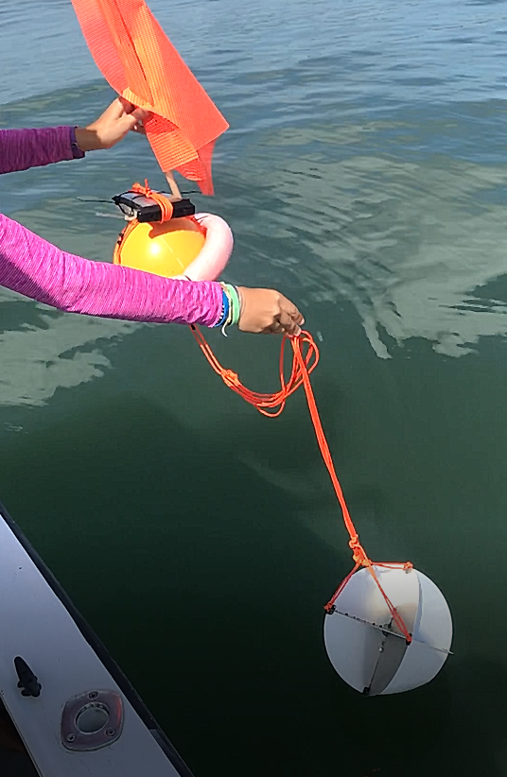
Figure S2. Surface drifter design, with orange floats, GPS-enabled phone in a waterproof phone case, orange flag, and metal drogue, tethered together with orange Paracord®. Drifter design from Hoover et al. 2020.
Figure S3. Map of first passage time values (hours) for all neonate tracks (n=94) within the study region in Pacuare, Costa Rica, with each point representing an observation. Warmer colors correspond with higher first passage time values.
Figure S4. Generalized additive mixed model (GAMM) smoothing curve for neonate in-water speeds (in-water movements, m s⁻¹) as a function of first passage time (FPT, hours) for 2016 and 2018. A higher first passage time value indicates that neonates spent more time in a given spatial radius of 59 m.

Figure S5. Boxplots of the current speeds (m s⁻¹) for 2016 (red) versus 2018 (blue).

Figure S6. Monthly mean time series for daily rainfall data (resolution 0.5° x 0.5°) for July-September 2014 to 2019, in the region of 83-84°W and 9-11°N. The monthly mean daily rainfall (mm day⁻¹) for July-September for the study period (2016, 2018) are highlighted with red boxes (11.96 mm day⁻¹ for 2016 and 15.57 mm day⁻¹ for 2018). The time series average for July to September for 1948-2019 was 12.53 mm day⁻¹. Plots were created using the data visualization tool from the online IRI/LDEO Climate Data Library for the NOAA National Centers for Environmental Prediction (NCEP) Climate Prediction Center (CPC) dataset for daily rainfall.

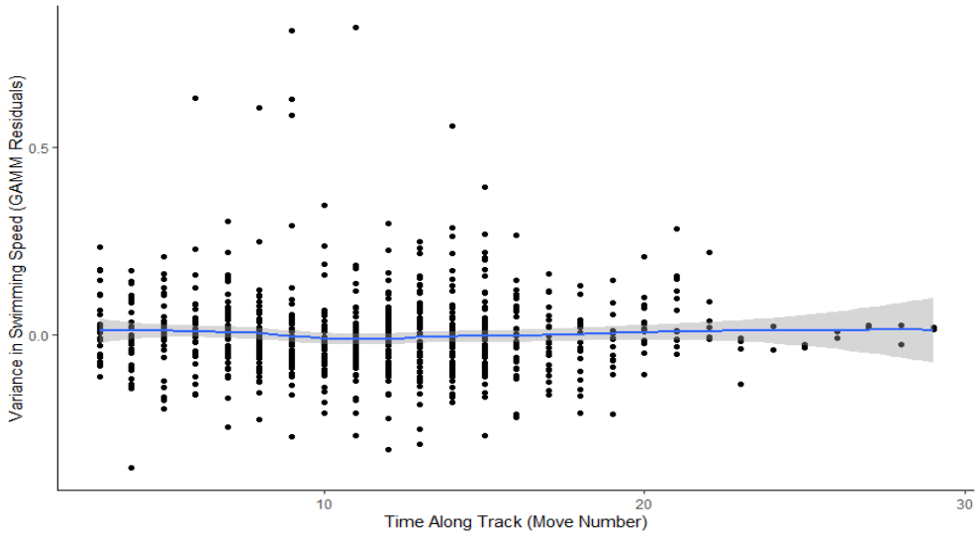
Figure S7. Scatter plot of the variance in swimming speed (extracted residuals from final neonate GAMM model, see Table 3 in text) as a function of the time along the track (move number). A loess smoother was applied to show any relationship present.

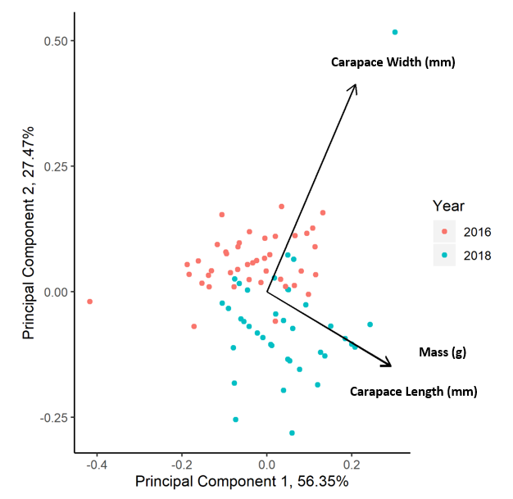
Figure S8. Biplot of the results of the principal component analysis, using body morphometric variables carapace length (mm), carapace width (mm), and body mass (g) and with observations colored by year (2016, 2018). The first component explained 56% of the total variance, with mass and carapace length having the largest correlations with the first principal component.

