Table S1
Table S1. Primers used in qPCR
Primer | Sequence
Col1α1 forward | CCCTGGTCCCTCTGGAAATG
Col1α1 reverse | GGACCTTTGCCCCCTTCTTT
Runx2 forward | ATACCCCCTCGCTCTCTGTT
Runx2 reverse | ACATAGGTCCCCATCTGCCT
ALP forward | TTCATAAGCAGGCGGGGGA
ALP reverse | GGTGTACCCTGAGATTCGTCC
OCN forward | CCCAGACCTAGCAGACACCA
OCN reverse | GCCGGAGTCTGTTCACTACC
OPN forward | TGGAGAGGTAGAAAAGGCACA
OPN reverse | CAAACACACTCTTGGCACCAC
GAPDH forward | ACCCAGAAGACTGTGGATGG
GAPDH reverse | CACATTGGGGGTAGGAACAC

Table S2
Table S2. Different operation procedure of Each group
Group | calvarial defects |  | Harvesting time
 | Left | Right
I | Blank | 3D-pPES  3D-pPES  3D-pPES  3D-pPES | 4 weeks
II | PEGDA hydrogel |  | 4 weeks
III | Blank |  | 8 weeks
IV | PEGDA hydrogel |  | 8 weeks

Supplemental Fig. S1
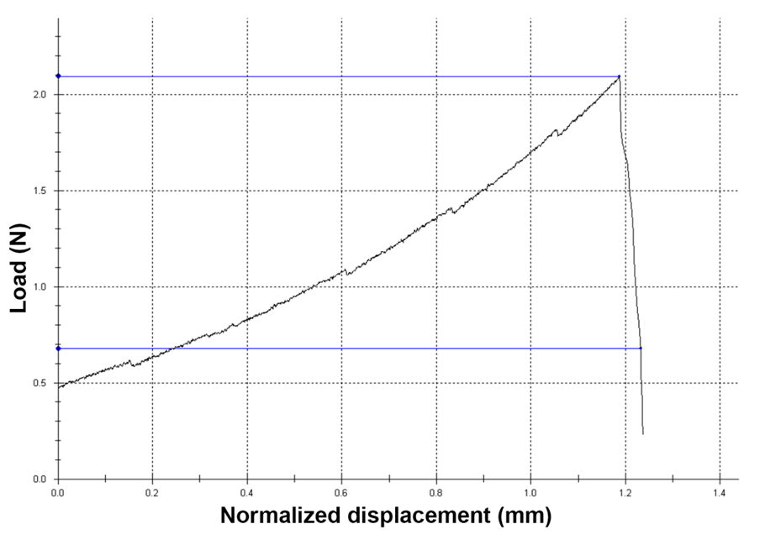
Supplemental Fig. S1 Representative stress–strain curve of the 3D-pPES. The initial linear portion of the stress–strain data showed the process of elastic deformation of a hydrogel. Room temperature: 25℃, Relative humidity: 50%.

Supplemental Fig. S2
Supplemental Fig. S2 The structural formula of PEGDA (A) and LAP (B).

Supplemental Fig. S3
Supplemental Fig. S3 Time-temperature curve of the entire printing process. Room temperature: 25℃.

Supplemental Fig. S4
Supplemental Fig. S4 Qualitative analysis of the 3D-pPES leaching solution Cytotoxicity. *P < 0.05, compares to control group at the same time. #P < 0.05, ##P < 0.01 compares to the same group on day 1.

Supplemental Fig. S5
Supplemental Fig. S5 The degradation curve of the PEGDA and 3D-pPES in vitro. *P < 0.05. **P < 0.01.

