Supplementary information
A Risk Prediction Model for Evaluating the disease progression of COVID-19 pneumonia
Guodong Cao^{1,2,#}, Pengping Li^{3,#}, Yuanyuan Chen⁴, Kun Fang⁵, Bo Chen¹, Shuyue Wang², Xudong Feng², Zhenyu Wang³, Maoming Xiong^{1,*}, Ruiying Zheng^{6,*}, Mengzhe Guo^{7,*}, Qiang Sun^{7,*}

Supplementary Text S1 detailed methods
Meta-analyses
Search strategy
Relevant articles were searched by two investigators independently in the PubMed, Web of Science, and CNKI databases, from inception to Mar 18, 2020. The search terms included ("COVID-19" OR "SARS-CoV-2" OR "2019 novel coronavirus ") AND ("Clinical data" OR "Clinical features" OR "Clinical characteristics"). Full texts were reviewed to assess whether the papers met the inclusion criteria.
The inclusive and exclusive criteria
Studies were considered to be relevant if they met the following criteria: (1) provided the clinical features of COVID-19 patients; (2) the hazard ratio (HR) of risk factors were showed; (3) English and Chinese as publication language. Exclusion criteria were: (1) data repetition; (2) reviews; (3) case reports; (4) erroneous data.
Data extraction and quality evolution
According to selection criteria, all relevant data were extracted from each eligible study independently by two investigators (Guodong Cao and Pengping Li). Disagreement was resolved by team discussion until consensus was reached. The extracted data included first author’s name, year of publication, total number of patients, clinicopathological parameters, HR values and clinical outcomes. Two investigators independently evaluated the quality of eligible studies by the Newcastle- Ottawa scale.
Meta-analysis statistics
Statistical analyses were performed with the STATA software (version 12.0, StataCorp LP, College Station, TX, USA). Crude odds ratios (ORs) and 95% conﬁdence intervals (CIs) were used to estimate the strength of the association between clinical features and COVID-19. ORs/risk ratios (RRs) and 95%CIs were used to estimate the relationship of complications/death and severe COVID-19. Standardized mean difference (SMD) and 95%CIs were used to estimate the relationship between lab findings and severe COVID-19 when data were expressed as mean±SD. The I² index, which indicates the percentage of the total variation across studies, was used to assess statistical heterogeneity. A random-effects model was used in case of significant heterogeneity (I² > 50% or P < 0.1); otherwise, a fixed-effects model was employed. To assess potential publication bias, the Begg's rank correlation test and Egger's weighted regression method was used, with P < 0.05 indicating statistically significant publication bias.

Supplementary Text S2 PRISMA Checklist: Preferred Reporting Items for Systematic Reviews and Meta-Analyses
Section/topic | # | Checklist item | Reported on page #
TITLE
Title | 1 | Identify the report as a systematic review, meta-analysis, or both. | Page 1
ABSTRACT
Structured summary | 2 | Provide a structured summary including, as applicable: background; objectives; data sources; study eligibility criteria, participants, and interventions; study appraisal and synthesis methods; results; limitations; conclusions and implications of key findings; systematic review registration number. | Page 4
INTRODUCTION
Rationale | 3 | Describe the rationale for the review in the context of what is already known. | Page 5-6
Objectives | 4 | Provide an explicit statement of questions being addressed with reference to participants, interventions, comparisons, outcomes, and study design (PICOS). | Page 6
METHODS
Protocol and registration | 5 | Indicate if a review protocol exists, if and where it can be accessed (e.g., Web address), and, if available, provide registration information including registration number. | Appendix page 2
Eligibility criteria | 6 | Specify study characteristics (e.g., PICOS, length of follow-up) and report characteristics (e.g., years considered, language, publication status) used as criteria for eligibility, giving rationale. | Appendix page 2
Information sources | 7 | Describe all information sources (e.g., databases with dates of coverage, contact with study authors to identify additional studies) in the search and date last searched. | Appendix page 2
Search | 8 | Present full electronic search strategy for at least one database, including any limits used, such that it could be repeated. | Appendix page 2
Study selection | 9 | State the process for selecting studies (i.e., screening, eligibility, included in systematic review, and, if applicable, included in the meta-analysis). | Appendix page 2
Data collection process | 10 | Describe method of data extraction from reports (e.g., piloted forms, independently, in duplicate) and any processes for obtaining and confirming data from investigators. | Appendix page 2
Data items | 11 | List and define all variables for which data were sought (e.g., PICOS, funding sources) and any assumptions and simplifications made.
Risk of bias in individual studies | 12 | Describe methods used for assessing risk of bias of individual studies (including specification of whether this was done at the study or outcome level), and how this information is to be used in any data synthesis. | Appendix page 2
Summary measures | 13 | State the principal summary measures (e.g., risk ratio, difference in means).
Synthesis of results | 14 | Describe the methods of handling data and combining results of studies, if done, including measures of consistency (e.g., I²) for each meta-analysis. | Appendix page 2

Section/topic | # | Checklist item | Reported on page #
Risk of bias across studies | 15 | Specify any assessment of risk of bias that may affect the cumulative evidence (e.g., publication bias, selective reporting within studies).
Additional analyses | 16 | Describe methods of additional analyses (e.g., sensitivity or subgroup analyses, meta-regression), if done, indicating which were pre-specified.
RESULTS
Study selection | 17 | Give numbers of studies screened, assessed for eligibility, and included in the review, with reasons for exclusions at each stage, ideally with a flow diagram. | Page 6
Study characteristics | 18 | For each study, present characteristics for which data were extracted (e.g., study size, PICOS, follow-up period) and provide the citations.
Risk of bias within studies | 19 | Present data on risk of bias of each study and, if available, any outcome level assessment (see item 12). | Page 8
Results of individual studies | 20 | For all outcomes considered (benefits or harms), present, for each study: (a) simple summary data for each intervention group (b) effect estimates and confidence intervals, ideally with a forest plot. | Page8-10,  appendix  page 5-7
Synthesis of results | 21 | Present results of each meta-analysis done, including confidence intervals and measures of consistency.
Risk of bias across studies | 22 | Present results of any assessment of risk of bias across studies (see Item 15).
Additional analysis | 23 | Give results of additional analyses, if done (e.g., sensitivity or subgroup analyses, meta-regression [see Item 16]).
DISCUSSION
Summary of evidence | 24 | Summarize the main findings including the strength of evidence for each main outcome; consider their relevance to key groups (e.g., healthcare providers, users, and policy makers). | Page  11-12
Limitations | 25 | Discuss limitations at study and outcome level (e.g., risk of bias), and at review-level (e.g., incomplete retrieval of identified research, reporting bias). | Page 14
Conclusions | 26 | Provide a general interpretation of the results in the context of other evidence, and implications for future research. | Page 15
FUNDING
Funding | 27 | Describe sources of funding for the systematic review and other support (e.g., supply of data); role of funders for the systematic review.

Supplementary TABLE S1 analysis of association between complications/death and disease progression of patients with COVID-19 pneumonia
Complications and death | Studies | Total cases | I²(%) | Model | OR/RR | 95%CI | P value
ARDS | 10 | 2246 | 69.3 | RE | 49.03 | 20.14-119.35 | <0.001
Shock | 9 | 2135 | 46.8 | FE | 45.48 | 19.85-104.18 | <0.001
Acute kidney injury | 7 | 1787 | 8.9 | FE | 24.82 | 11.40-54.02 | <0.001
Acute cardiac injury | 8 | 1015 | 34.7 | FE | 37.93 | 17.92-80.28 | <0.001
Arrhythmia | 2 | 359 | 68.7 | RE | 20.82 | 9.34-46.41 | <0.001
Secondary infection | 4 | 317 | 36.5 | FE | 32.69 | 12.69-84.27 | <0.001
DIC | 3 | 1446 | 0 | FE | 14.53 | 1.50-140.94 | 0.021
Rhabdomyolysis | 2 | 1179 | 0 | FE | 1.07 | 0.05-22.29 | 0.967
Heart failure | 2 | 165 | 0 | FE | 9.59 | 1.01-91.12 | 0.049
Liver dysfunction | 2 | 98 | 0 | FE | 7.59 | 2.46-23.39 | <0.001
Death | 5 | 1918 | 26.2 | FE | 30.09 | 11.46-79.01 | <0.001
Supplementary TABLE S2 Meta-analysis of association between clinical characteristics and disease progression of patients with COVID-19 pneumonia
Categories | Parameters | Studies | Total cases | I²(%) | Model | OR | 95%CI | P value
Basic information | Gender | 29 | 4966 | 26.6 | FE | 1.57 | 1.36-1.80 | <0.001
 | Exposure history | 14 | 1853 | 41.1 | FE | 0.99 | 0.78-1.30 | 0.958
 | Smoking | 12 | 2621 | 73.4 | RE | 2.10 | 1.04-4.24 | 0.039
 | Alcohol | 2 | 353 | 0 | FE | 0.76 | 0.18-3.19 | 0.709
Comorbidities | Hypertension | 26 | 4912 | 57.6 | RE | 2.53 | 1.89-3.37 | <0.001
 | Diabetes | 28 | 5047 | 34.6 | FE | 2.43 | 1.98-2.97 | <0.001
 | Cancer | 15 | 2987 | 20.4 | FE | 1.73 | 1.07-2.78 | 0.025
 | Heart diseases | 21 | 4430 | 46.2 | FE | 4.11 | 3.15-5.35 | <0.001
 | Pulmonary diseases | 18 | 3979 | 0 | FE | 4.17 | 2.86-6.08 | <0.001
 | Kidney diseases | 11 | 2746 | 0 | FE | 5.44 | 2.81-10.54 | <0.001
 | Cerebrovascular disease | 10 | 3004 | 0 | FE | 4.02 | 2.41-6.60 | <0.001
 | Liver diseases | 14 | 2502 | 0 | FE | 1.47 | 0.92-2.35 | 0.104
 | Stomach diseases | 2 | 293 | 28.9 | FE | 0.86 | 0.22-3.39 | 0.832
 | Thyroid diseases | 4 | 531 | 0 | FE | 2.13 | 0.72-6.29 | 0.17
 | Immunosuppression | 5 | 1660 | 0 | FE | 1.19 | 0.36-3.89 | 0.778
Clinical symptoms | Fever | 23 | 4513 | 42.6 | FE | 1.22 | 1.01-1.47 | 0.043
 | Cough | 26 | 4723 | 26.2 | FE | 1.13 | 0.97-1.32 | 0.117
 | Chest soreness | 7 | 2213 | 28.7 | FE | 0.94 | 0.63-1.40 | 0.75
 | Expectoration | 14 | 2611 | 38.6 | FE | 1.31 | 1.05-1.63 | 0.016
 | Fatigue | 20 | 4320 | 53.7 | RE | 1.47 | 1.11-1.93 | 0.007
 | Muscular soreness | 17 | 2425 | 43.4 | FE | 1.44 | 1.13-1.85 | 0.004
 | Breath problem | 20 | 3844 | 56.1 | RE | 4.27 | 3.07-5.95 | <0.001
 | Abdominal pain, diarrhea | 20 | 4115 | 22.8 | FE | 1.22 | 0.88-1.69 | 0.236
 | Headache or dizziness | 17 | 3415 | 0 | FE | 1.22 | 0.92-1.61 | 0.17
 | Chest congestion | 10 | 1476 | 24.7 | FE | 1.92 | 1.40-2.63 | <0.001
 | Anorexia | 7 | 1426 | 67.7 | RE | 1.76 | 1.00-3.09 | 0.050
 | Pharyngalgia | 10 | 2031 | 53.0 | RE | 0.93 | 0.48-1.80 | 0.837
 | Rhinorrhea | 6 | 1298 | 0 | FE | 0.80 | 0.33-1.93 | 0.617
 | Nausea or vomiting | 8 | 2540 | 53.3 | RE | 2.00 | 0.98-4.09 | 0.057
 | Hemoptysis | 4 | 1685 | 75.5 | RE | 0.62 | 0.07 | 0.659

Supplementary TABLE S3 Meta-analysis of association between laboratory findings and disease progression of patients with COVID-19 pneumonia
Categories | Parameters | Studies | Total cases | SMD | 95%CI | P value
Basic information | Age | 24 | 4097 | 2.04 | 1.45~2.63 | <0.001
Blood routine | Hb | 12 | 2357 | -0.74 | -1.34~-0.13 | 0.018
 | Lymphocyte | 23 | 4125 | -2.35 | -2.85~-1.86 | <0.001
 | WBC | 22 | 3800 | 1.35 | 0.49~2.22 | 0.002
 | Neutrophil | 18 | 2472 | 2.21 | 1.70~2.73 | <0.001
 | Monocyte | 5 | 594 | 1.46 | -0.39~3.31 | 0.122
 | PLT | 18 | 3257 | -0.88 | -1.42~-0.34 | 0.001
Immunocyte | CD3 lymphocyte | 2 | 351 | -9.84 | -19.94~0.27 | 0.056
 | CD4 lymphocyte | 6 | 690 | -5.08 | -7.34~-2.82 | <0.001
 | CD8 lymphocyte | 5 | 690 | -4.79 | -7.16~-2.43 | <0.001
Blood biochemistry | K⁺ | 7 | 1979 | -0.31 | -1.10~0.48 | 0.445
 | Na⁺ | 7 | 1979 | -1.85 | -3.09~-0.62 | 0.003
 | Ca⁺ | 2 | 489 | -2.32 | -6.90~2.25 | 0.319
 | ALT | 20 | 2968 | 1.29 | 0.84~1.74 | <0.001
 | AST | 17 | 2139 | 2.01 | 1.20~2.81 | <0.001
 | CREA | 21 | 3068 | 1.20 | 0.72~1.68 | <0.001
 | BUN | 13 | 1755 | 2.44 | 1.52~3.36 | <0.001
 | Total bilirubin | 12 | 2171 | 0.88 | 0.06~1.70 | 0.036
 | Albumin | 11 | 1650 | -3.18 | -3.98~-2.38 | <0.001
 | Serum lactate | 4 | 799 | 0.27 | -0.76~1.31 | 0.604
Coagulation function | D-dimer | 15 | 2571 | 2.05 | 1.53~2.57 | <0.001
 | Prothrombin time | 11 | 1866 | 1.86 | 1.01~2.70 | <0.001
 | Partial thromboplastin time | 9 | 1237 | 0.36 | -0.92~1.63 | 0.252
 | Fibrinogen | 4 | 804 | 1.89 | -0.33~4.11 | 0.095
Infection-related parameters | CRP | 19 | 2656 | 4.8 | 3.23~5.33 | <0.001
 | Procalcitonin | 9 | 1042 | 1.85 | 0.76~2.93 | <0.001
 | ESR | 5 | 897 | 0.96 | 0.63~1.30 | <0.001
 | Ferritin | 5 | 533 | 2.73 | 1.21~4.25 | <0.001
Myocardial enzyme | LDH | 16 | 2258 | 4.04 | 2.73~5.36 | <0.001
 | cTnI | 5 | 856 | 1.84 | 0.77~2.91 | 0.001
 | Myoglobin | 2 | 463 | 6.50 | 4.32~8.69 | <0.001
 | CK | 14 | 1793 | 1.64 | 0.71~2.56 | 0.001
 | CK-MB | 5 | 963 | 1.80 | 1.55~2.05 | <0.001

Supplementary TABLE S4 Meta-analysis of the pool Hazard Ratios between potential risk factors and disease progression of patients with COVID-19 pneumonia
Parameters | Studies | HR | 95% CI | P value
Age | 11 | 1.31 | 1.17-1.47 | <0.001
Sex | 9 | 1.26 | 0.83-1.91 | 0.271
Hypertension | 6 | 2.11 | 1.60-2.79 | <0.001
Diabetes | 8 | 1.71 | 1.16-2.54 | 0.007
Smoking | 2 | 2.19 | 0.55-8.69 | 0.265
Pulmonary diseases | 3 | 3.60 | 1.91-6.78 | 0.006
Heart diseases | 5 | 5.02 | 1.47-17.10 | 0.010
Fever | 3 | 1.73 | 1.06-2.84 | 0.029
Cough | 2 | 2.78 | 0.32-24.39 | 0.355
Respiratory rate | 4 | 3.85 | 0.84-17.61 | 0.082
CT scores | 2 | 8.69 | 1.53-49.50 | 0.015
Blood oxygen saturation | 2 | 0.94 | 0.89-0.99 | 0.025
Hb | 3 | 1.00 | 0.96-1.05 | 0.873
ALT | 5 | 1.43 | 0.98-2.08 | 0.065
AST | 4 | 1.02 | 0.98-1.05 | 0.409
Total bilirubin | 2 | 2.19 | 0.81-5.91 | 0.121
Albumin | 4 | 1.75 | 0.80-3.80 | 0.162
Creatinine | 8 | 1.08 | 1.02-1.15 | 0.007
BUN | 5 | 1.54 | 1.28-1.87 | <0.001
CRP | 7 | 1.02 | 0.99-1.04 | 0.165
Lymphocyte | 7 | 0.73 | 0.16-3.36 | 0.688
ESR | 2 | 1.19 | 0.59-2.40 | 0.632
WBC | 4 | 2.59 | 0.93-7.19 | 0.068
Neutrophils | 5 | 1.17 | 1.00-1.38 | 0.050
Procalcitonin | 4 | 4.07 | 1.05-15.73 | 0.042
IL-6 | 2 | 1.06 | 0.97-1.16 | 0.22
Serum ferritin | 2 | 4.59 | 2.00-10.55 | <0.001
Platelets | 2 | 1.00 | 0.99-1.00 | 0.241
D-dimer | 3 | 3.25 | 0.44-23.79 | 0.246
Prothrombin time | 2 | 2.22 | 0.82-6.00 | 0.117
CK | 2 | 2.13 | 1.44-3.15 | <0.001
CK-MB | 2 | 1.12 | 0.90-1.38 | 0.319
LDH | 4 | 2.15 | 1.32-3.51 | 0.002
cTnI | 5 | 4.87 | 1.48-16.01 | 0.009
NT-proBNP | 2 | 4.00 | 0.43-36.99 | 0.222

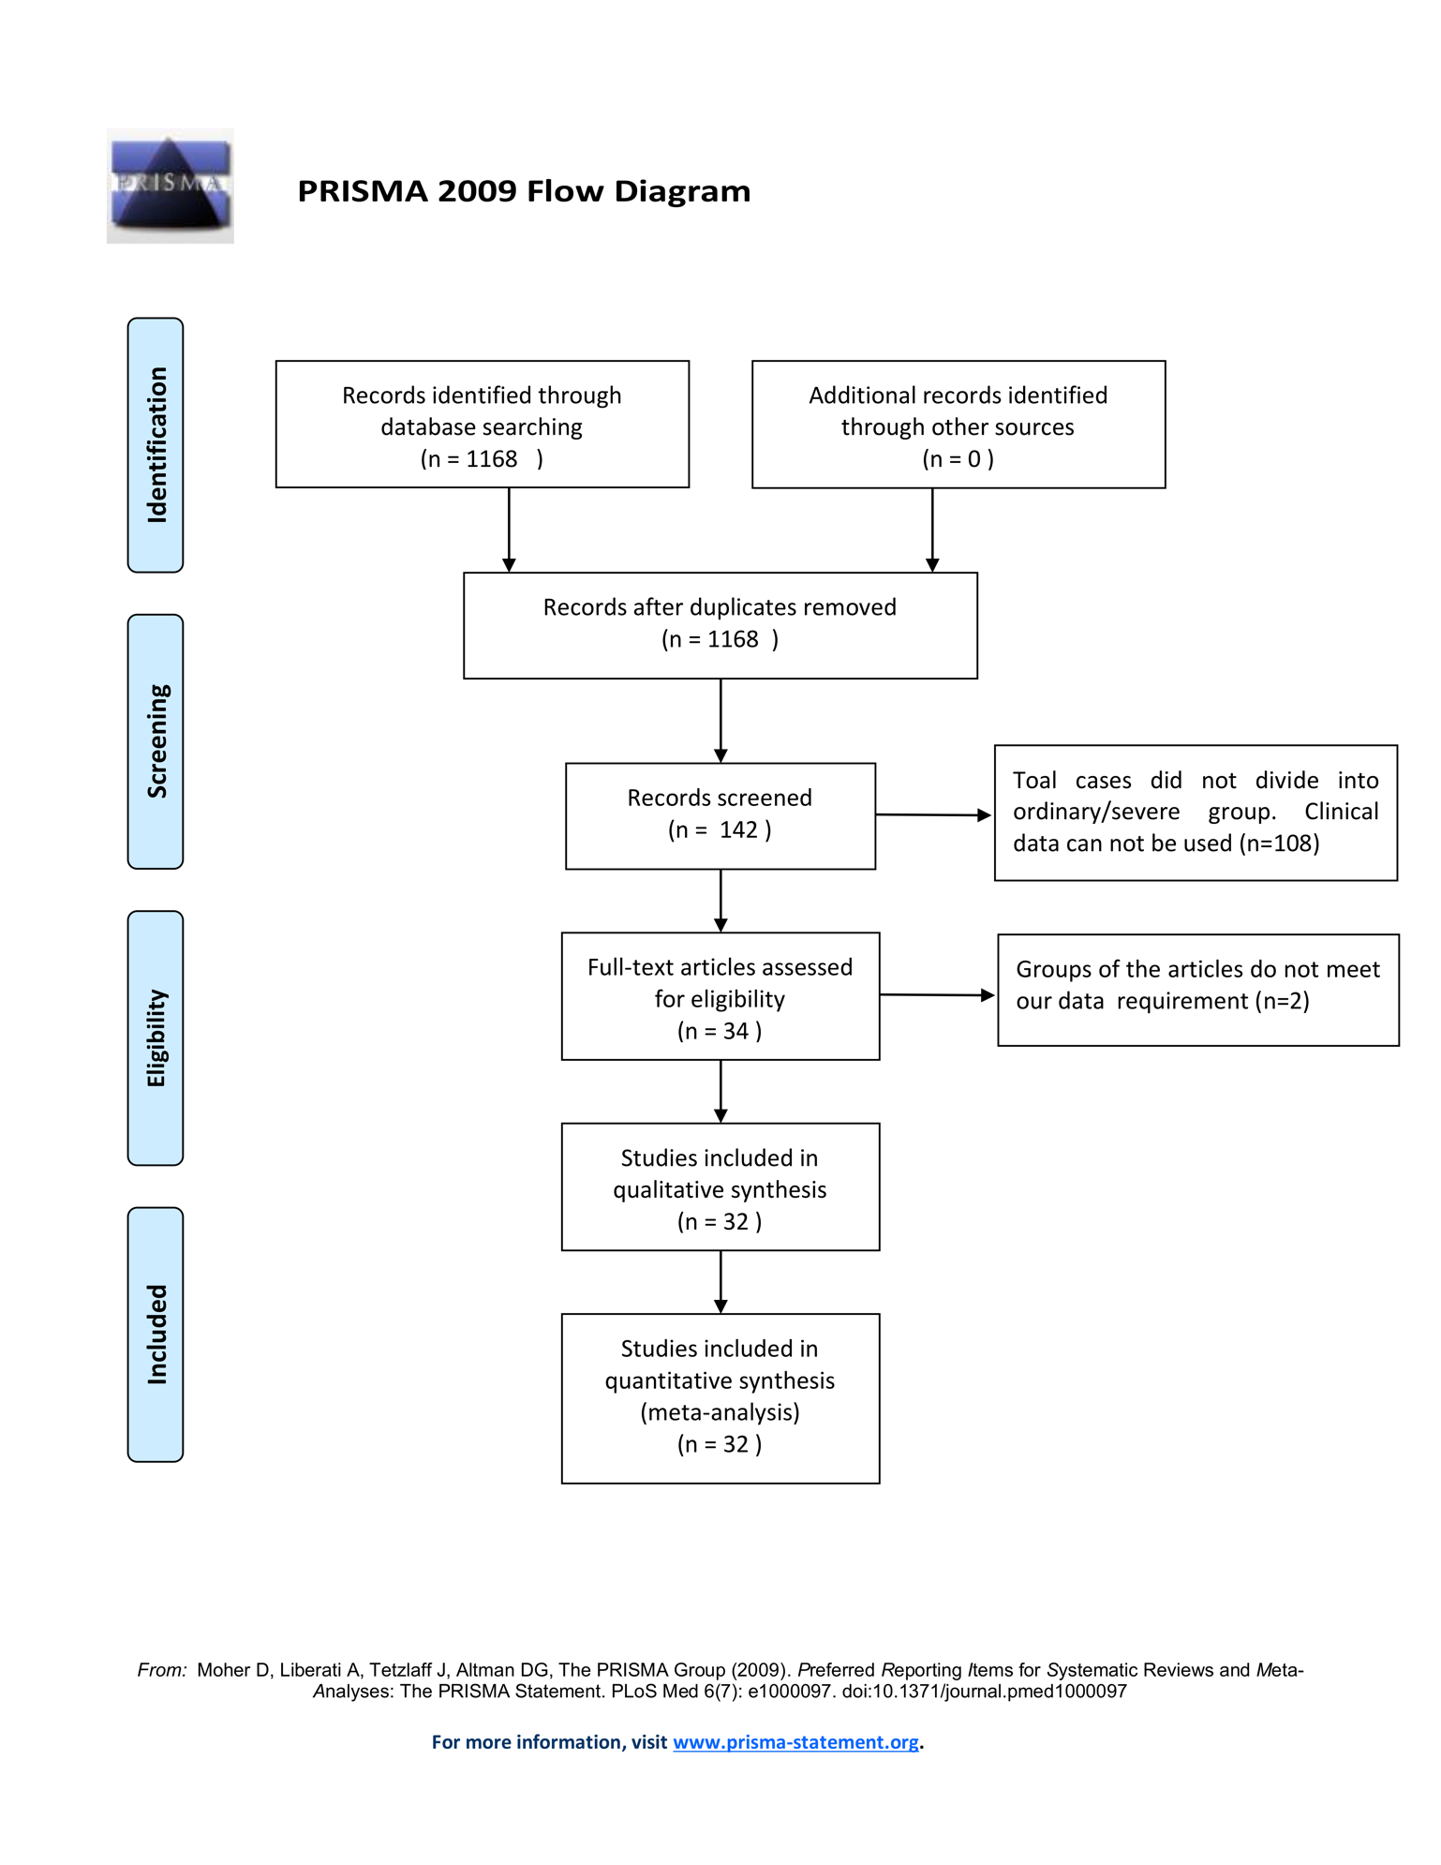
Supplementary Figure S1 FlowDiagram of the study selection procedure of the meta-analysis

Supplementary Figure S2 Publication bias: Begg’s (A) (P > 0.05) and Egger’s (B) (P > 0.05) funnel plots for possible publication bias in the current study. No publication bias was found, indicating credible results.
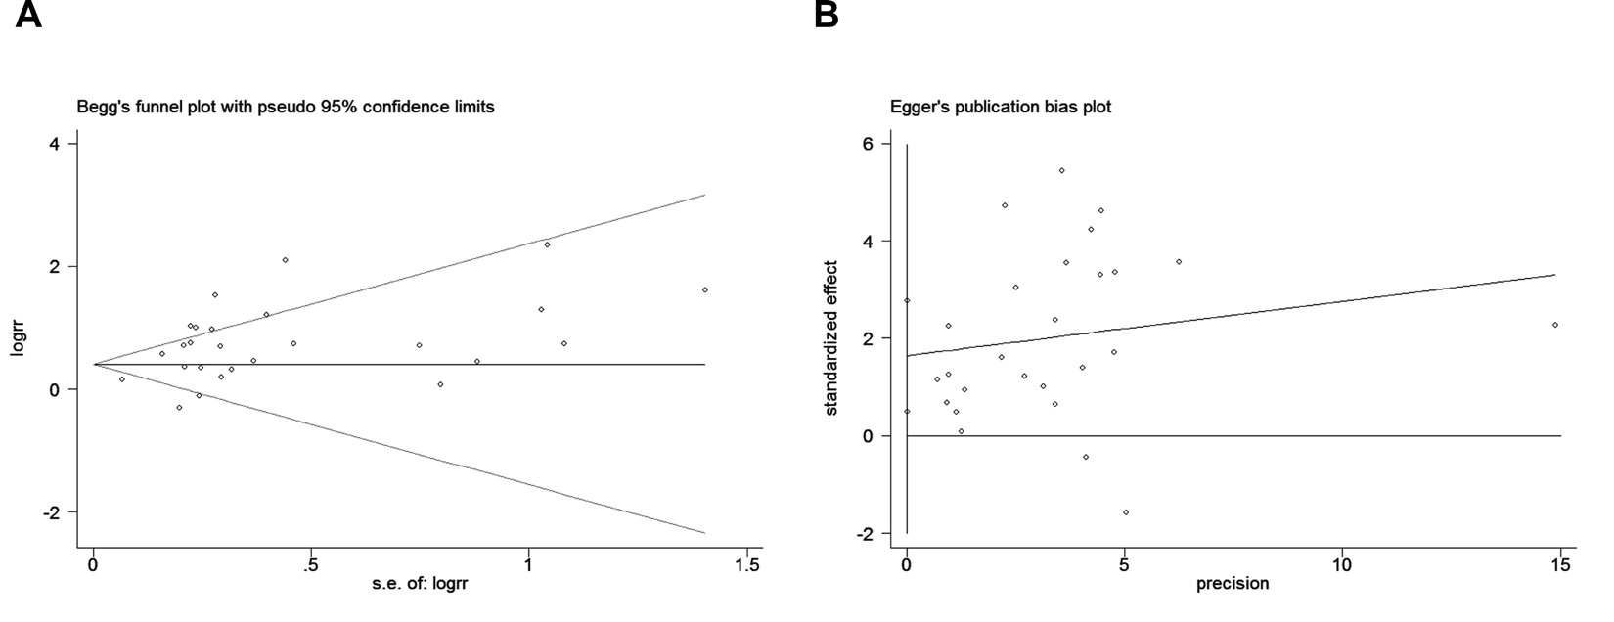

Supplementary Figure S3 Forest plots of standardized mean differences showed the associations between immune cell counts (A-C) or inflammation-related index (D) and disease progression of COVID-19 pneumonia.
Supplementary Figure S4 Forest plots of standardized mean differences showed the associations between liver function indexes (A-B), renal function indexes (C-D) as well as heart function indexes (E-F) and disease progression of COVID-19 pneumonia.

Supplementary Figure S5 Venn diagram represented the overlapped risk factors identified by both meta-analysis and univariate logistic regression analysis

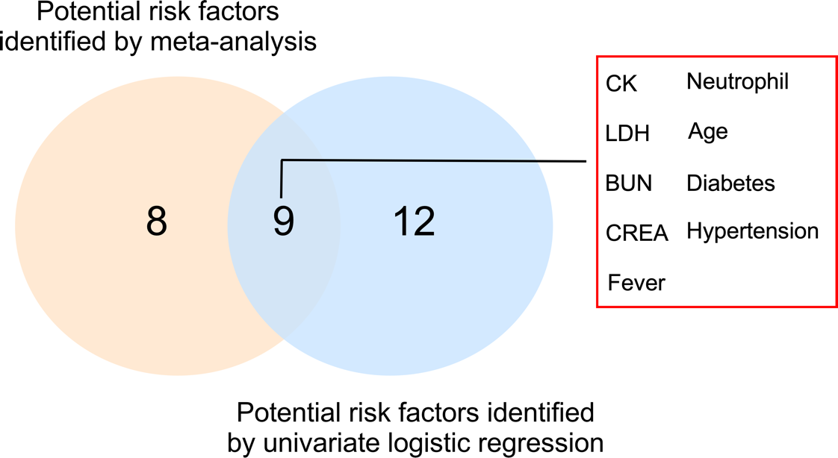

Supplementary Figure S6 (A) Correlation between the laboratory test parameters. (B-D) Receiver operating characteristic curves of sensitivity and specificity of the nomogram for predicting severe COVID-19 pneumonia in development (D), Hangzhou validation (E), and Yinchuan validation cohorts (F).

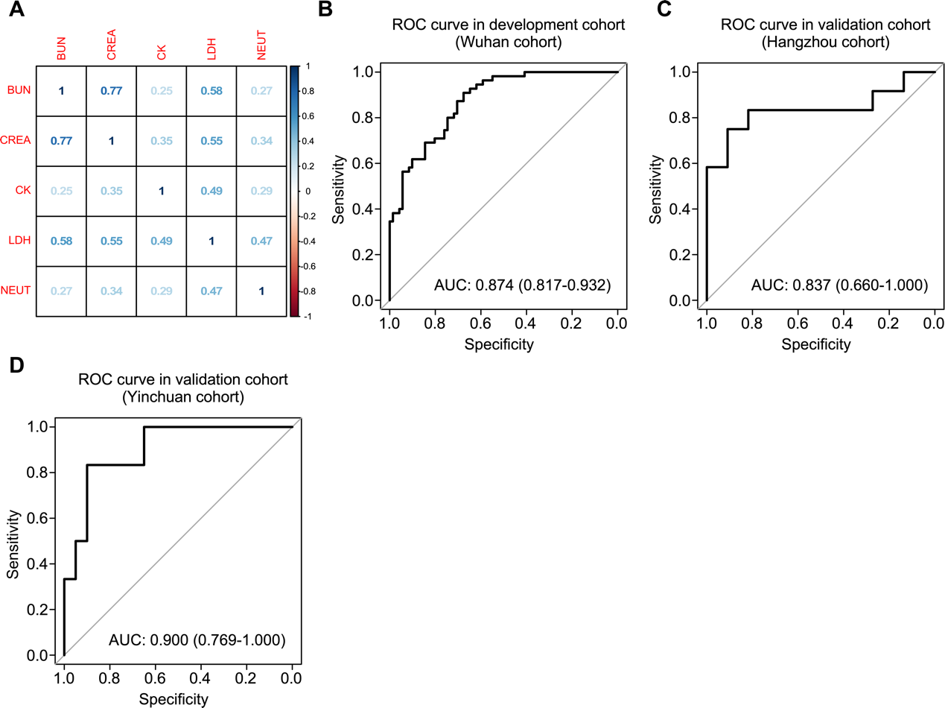

References(1-32)
1. Liu, W., Tao, Z. W., Lei, W., Ming-Li, Y., Kui, L., Ling, Z., et al. (2020) Analysis of factors associated with disease outcomes in hospitalized patients with 2019 novel coronavirus disease. Chin Med J (Engl) doi:10.1097/CM9.0000000000000775
2. Li, K., Wu, J., Wu, F., Guo, D., Chen, L., Fang, Z., et al. (2020) The Clinical and Chest CT Features Associated with Severe and Critical COVID-19 Pneumonia. Invest Radiol doi:10.1097/RLI.0000000000000672
3. Zhang, J. J., Dong, X., Cao, Y. Y., Yuan, Y. D., Yang, Y. B., Yan, Y. Q., et al. (2020) Clinical characteristics of 140 patients infected with SARS-CoV-2 in Wuhan, China. Allergy doi:10.1111/all.14238
4. Wang, D., Hu, B., Hu, C., Zhu, F., Liu, X., Zhang, J., et al. (2020) Clinical Characteristics of 138 Hospitalized Patients With 2019 Novel Coronavirus-Infected Pneumonia in Wuhan, China. JAMA doi:10.1001/jama.2020.1585
5. Huang, C., Wang, Y., Li, X., Ren, L., Zhao, J., Hu, Y., et al. (2020) Clinical features of patients infected with 2019 novel coronavirus in Wuhan, China. Lancet 395 (10223), 497-506. doi:10.1016/S0140-6736(20)30183-5
6. Mo, P., Xing, Y., Xiao, Y., Deng, L., Zhao, Q., Wang, H., et al. (2020) Clinical characteristics of refractory COVID-19 pneumonia in Wuhan, China. Clin Infect Dis doi:10.1093/cid/ciaa270
7. Guan, W. J., Ni, Z. Y., Hu, Y., Liang, W. H., Ou, C. Q., He, J. X., et al. (2020) Clinical Characteristics of Coronavirus Disease 2019 in China. N Engl J Med doi:10.1056/NEJMoa2002032
8. Peng, Y. D., Meng, K., Guan, H. Q., Leng, L., Zhu, R. R., Wang, B. Y., et al. (2020) Clinical characteristics and outcomes of 112 cardiovascular disease patients infected by 2019-nCoV. Zhonghua Xin Xue Guan Bing Za Zhi 48 (0), E004. doi:10.3760/cma.j.cn112148-20200220-00105
9. Lu, Z., He, R., Jiang, W., Fan, T., and Geng, Q. (2020) Clinical characteristics and immune function analysis of COVID‐19. Medical Journal of Wuhan University doi:10.14188/j.1671‐8852.2020.0126
10. Chen, C., Chen, C., Yan, J. T., Zhou, N., Zhao, J. P., and Wang, D. W. (2020) Analysis of myocardial injury in patients with COVID-19 and association between concomitant cardiovascular diseases and severity of COVID-19. Zhonghua Xin Xue Guan Bing Za Zhi 48 (0), E008. doi:10.3760/cma.j.cn112148-20200225-00123
11. Wan, Q., Shi, A., He, T., and tang, L. (2020) Analysis of clinical features of 153 patients with novel coronavirus pneumonia in Chongqing. Chinese Journal of Clinical Infectious Diseases doi:10.3760/cma.j.cn 115673-20200212-00030
12. Zhou, F., Yu, T., Du, R., Fan, G., Liu, Y., Liu, Z., et al. (2020) Clinical course and risk factors for mortality of adult inpatients with COVID-19 in Wuhan, China: a retrospective cohort study. The Lancet 395 (10229), 1054-1062. doi:10.1016/s0140-6736(20)30566-3
13. Wu, C., Chen, X., Cai, Y., Xia, J., Zhou, X., Xu, S., et al. (2020) Risk Factors Associated With Acute Respiratory Distress Syndrome and Death in Patients With Coronavirus Disease 2019 Pneumonia in Wuhan, China. JAMA Intern Med doi:10.1001/jamainternmed.2020.0994
14. Cao, W., Shi, L., Chen, L., Xu, X., and Wu, Z. (2020) Clinical features and laboratory inspection of novel coronavirus pneumonia (COVID-19) in Xiangyang, Hubei. medRxiv doi:10.1101/2020.02.23.20026963
15. Cao, M., Zhang, D., Wang, Y., Lu, Y., Zhu, X., Li, Y., et al. (2020) Clinical Features of Patients Infected with the 2019 Novel Coronavirus (COVID-19) in Shanghai, China. medRxiv doi:10.1101/2020.03.04.20030395
16. Zhang, G., Hu, C., Luo, L., Fang, F., Chen, Y., Li, J., et al. (2020) Clinical features and outcomes of 221 patients with COVID-19 in Wuhan, China. medRxiv doi:10.1101/2020.03.02.20030452
17. Feng, Z., Yu, Q., Yao, S., Luo, L., Duan, J., Yan, Z., et al. (2020) Prediction of Disease Progression in 2019 Novel Coronavirus Pneumonia Patients Outside Wuhan with CT and Clinical Characteristics. medRxiv doi:10.1101/2020.02.19.20025296
18. Liu, J., Li, S., Liu, J., Liang, B., Wang, X., Wang, H., et al. (2020) Longitudinal characteristics of lymphocyte responses and cytokine profiles in the peripheral blood of SARS-CoV-2 infected patients. medRxiv doi:10.1101/2020.02.16.20023671
19. Chen, X., Zheng, F., Qing, Y., Ding, S., Yang, D., Lei, C., et al. (2020) Epidemiological and clinical features of 291 cases with coronavirus disease 2019 in areas adjacent to Hubei, China: a double-center observational study. medRxiv doi:10.1101/2020.03.03.20030353
20. Lu, H., Ai, J., Shen, Y., Li, Y., Li, T., Zhou, X., et al. (2020) A descriptive study of the impact of diseases control and prevention on the epidemics dynamics and clinical features of SARS-CoV-2 outbreak in Shanghai, lessons learned for metropolis epidemics prevention. medRxiv doi:10.1101/2020.02.19.20025031
21. Liu, T., Zhang, J., Yang, Y., Ma, H., Li, Z., Zhang, J., et al. (2020) The potential role of IL-6 in monitoring severe case of coronavirus disease 2019. medRxiv doi:10.1101/2020.03.01.20029769
22. Yang, Y., Shen, C., Li, J., Yuan, J., Yang, M., Wang, F., et al. (2020) Exuberant elevation of IP-10, MCP-3 and IL-1ra during SARS-CoV-2 infection is associated with disease severity and fatal outcome. medRxiv doi:10.1101/2020.03.02.20029975
23. Liu, L., Gao, J., Hu, W., Zhang, X., Guo, L., Liu, C., et al. (2020) Clinical characteristics of 51 patients discharged from hospital with COVID-19 in Chongqing, China. medRxiv doi:10.1101/2020.02.20.20025536
24. Xu, Y., Xu, Z., Liu, X., Cai, L., Zheng, H., Huang, Y., et al. (2020) Clinical findings in critically ill patients infected with SARS-CoV-2 in Guangdong Province, China: a multi-center, retrospective, observational study. medRxiv doi:10.1101/2020.03.03.20030668
25. Qi, D., Yan, X., Tang, X., Peng, J., Yu, Q., Feng, L., et al. (2020) Epidemiological and clinical features of 2019-nCoV acute respiratory disease cases in Chongqing municipality, China: a retrospective, descriptive, multiple-center study. medRxiv doi:10.1101/2020.03.01.20029397
26. Wang, L., Li, X., Chen, H., Yan, S., Li, Y., Li, D., et al. (2020) SARS-CoV-2 infection does not significantly cause acute renal injury: an analysis of 116 hospitalized patients with COVID-19 in a single hospital, Wuhan, China. medRxiv doi:10.1101/2020.02.19.20025288
27. Chen, G., Wu, D., Guo, W., Cao, Y., Huang, D., Wang, H., et al. (2020) Clinical and immunologic features in severe and moderate forms of Coronavirus Disease 2019. medRxiv doi:10.1101/2020.02.16.20023903
28. Lu, J., Hu, S., Fan, R., Liu, Z., Yin, X., Wang, Q., et al. (2020) ACP risk grade: a simple mortality index for patients with confirmed or suspected severe acute respiratory syndrome coronavirus 2 disease (COVID-19) during the early stage of outbreak in Wuhan, China. medRxiv doi:10.1101/2020.02.20.20025510
29. Shi, Q., Zhao, K., Yu, J., Feng, J., Zhao, K., Zhang, X., et al. (2020) Clinical characteristics of 101 non-surviving hospitalized patients with COVID-19—A single center, retrospective study. medRxiv doi:10.1101/2020.03.04.20031039
30. Fu, L., Fei, J., Xiang, H.-X., Xiang, Y., Tan, Z.-X., Li, M.-D., et al. (2020) Influence factors of death risk among COVID-19 patients in Wuhan, China: a hospital-based case-cohort study. medRxiv doi:10.1101/2020.03.13.20035329
31. Cheng, Y., Luo, R., Wang, K., Zhang, M., Wang, Z., Dong, L., et al. (2020) Kidney impairment is associated with in-hospital death of COVID-19 patients. medRxiv doi:10.1101/2020.02.18.20023242
32. Gao, L., Jiang, D., Wen, X., Cheng, X., Sun, M., He, B., et al. (2020) Prognostic value of NT-proBNP in patients with severe COVID-19. medRxiv doi:10.1101/2020.03.07.20031575

