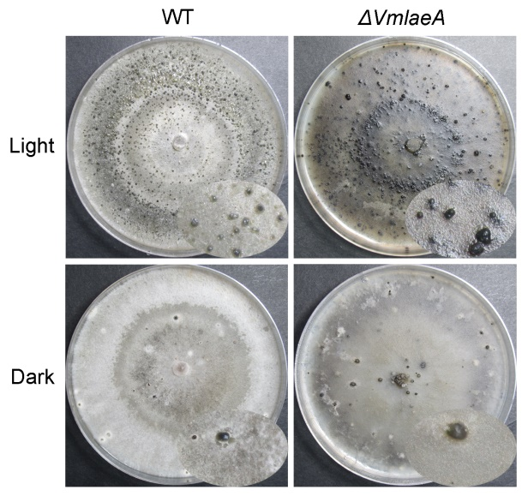
Supplementary Figure 1. Conidiation of Valsa mali WT and ΔVmlaeA under light and dark conditions. WT and ΔVmlaeA strain were cultivated on PDA medium for 30 days under light and dark conditions, respectively.

Supplementary Figure 2. Verification of 20 differentially expressed genes (DEGs) from transcriptomic analysis by RT-qPCR. The bars showed the fold changes of the 20 DEGs from transcriptomic analysis. Scatters with error bars presented the fold changes of the 20 DEGs verified by RT-qPCR. Minus fold change represent the gene was down-regulated in ΔVmlaeA for corresponding multiple. The RT-qPCR experiments were repeated three times.

Supplementary Figure 3. Gene ontology (GO) classification of differentially expressed genes (DEGs) and proteins (DEPs) at level 2 GO terms. (A) GO classification of transcriptomic DEGs at level 2 GO terms. (B) GO classification of proteomic DEPs at level 2 GO terms.

Supplementary Figure 4. Confirmation of deletion and overexpression mutants of cluster PKS11, NRPS14, PKS16, PKS23, PKS31 and PKS39. (A) Southern blots of genomic DNA of WT and the core enzyme gene deletion mutants of cluster PKS11, NRPS14, PKS16, PKS23, PKS31 and PKS39 hybridized with neo gene probe. (B) Relative expression levels of the transcription factor gene of cluster PKS11, NRPS14, PKS16, PKS23, PKS31 and PKS39 in WT and their overexpression mutants. Asterisks represent significant difference in expression levels (P-value < 0.05).
Supplementary Figure 5. Vegetative growth of WT, deletion and overexpression mutants of cluster PKS11, NRPS14, PKS16, PKS23, PKS31 and PKS39. All stains were inoculated on PDA and cultured for 48 h.

Supplementary Figure 6. Pigment accumulation in Vmpks11OE, Vmpks16OE, Vmpks23OE and Vmpks31OE. WT and mutant strains were cultured on PDA medium for five days. The left side of each plate is the front of colony and the right side is the back of colony.

Supplementary Figure 7. Pathogenicity tests of deletion and overexpression mutants of cluster PKS11, PKS16, PKS23, PKS31 and PKS39. WT and mutant strains of cluster PKS11, PKS16, PKS23, PKS31 and PKS39 were inoculated on detached leaves of Malus domestica borkh. cv. ‘Fuji’ and were cultured for three days. In bar graphs, means ± standard deviation (SD) of at least three biological replicates are shown. Significant differences would indicate with asterisks (P-value < 0.05).

Supplementary Figure 8. The schematic representation of targeted gene replacement. 1F, 2R, 3F, 4R, 5F, 6R, 7F, 8R, CF and CR are gene specific primers. Primer G855R, G856F, G852F and G850R are used for detecting fused DNA fragments and screening the knockout mutant of targeted genes.

