Supplementary Material for
Two-Dimensional Metal-Organic Framework Nanosheets as Bifunctional Catalyst for Electrochemical and Photoelectrochemical Water Oxidation
- Chang Liu^{1, #}, Xiaochen Shen^{2, #}, Grayson Johnson¹, Yulu Zhang¹, Changlin Zhang², Jiafu Chen², Lingyan Li², Colton Sheehan¹, Zhenmeng Peng^{2, *}, Sen Zhang^{1, *}
¹Department of Chemistry, University of Virginia, Charlottesville, Virginia 22904, United States
²Department of Chemical and Biomolecular Engineering, University of Akron, Akron, Ohio, 44325, United States.

* Correspondence:
Zhenmeng Peng, Sen Zhang
zpeng@uakron.edu, sz3t@virginia.edu
# These authors contributed equally to this work.

Figure S1 (A, B) TEM images of Co-MOF nanosheets, and (C) digital photograph of the Tyndall effect for Co-MOF nanosheets colloid suspension in isopropanol.

Figure S2 TEM images of bulk MOF-71.
Figure S3 FTIR spectrum of terephthalic acid powder.
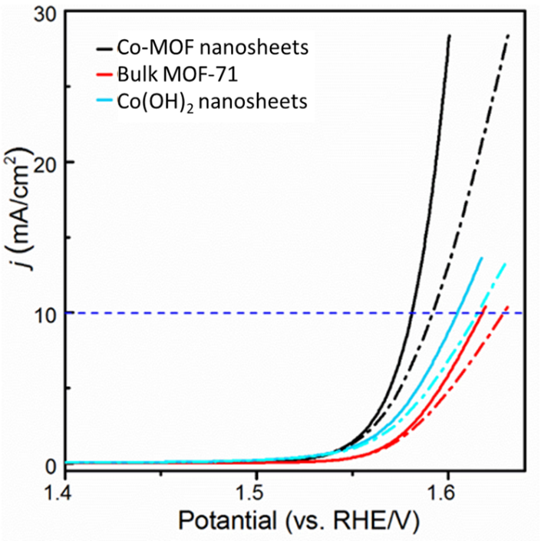
Figure S4 Electrochemical measurements of Co-MOF nanosheets, bulk MOF-71 and Co(OH)₂ nanosheets, with (solid line) and without (dashed line) iR-correction.

Figure S5 TEM images of the prepared Co(OH)₂ nanosheets.

Figure S6 XRD of the prepared Co(OH)₂ nanosheets.
Figure S7 FTIR spectrum of the as-synthesized Co(OH)₂ nanosheets.

Figure S8 Electrochemical measurements of the Co-MOF nanosheets: iR-corrected (Red) and uncorrected (Black) LSV plots.
Figure S9 Electrochemical measurements of the bulk MOF-71: iR-corrected (Red) and uncorrected (Black) LSV plots.

Figure S10 Electrochemical measurements of the Co(OH)₂ nanosheets: iR-corrected (Red) and uncorrected (Black) LSV plots.

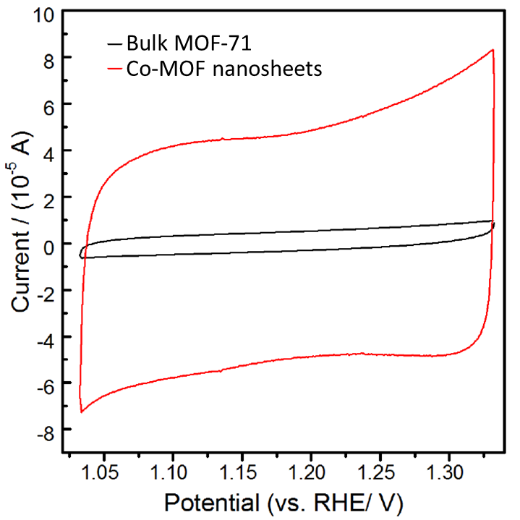

Figure S11 Cyclic voltammetry (CV) measurements of Co-MOF nanosheets (Red) and bulk MOF-71 (Black).
Figure S12 Electrochemical measurements of the Co-MOF nanosheets: iR-corrected LSV plots with and without light illumination.

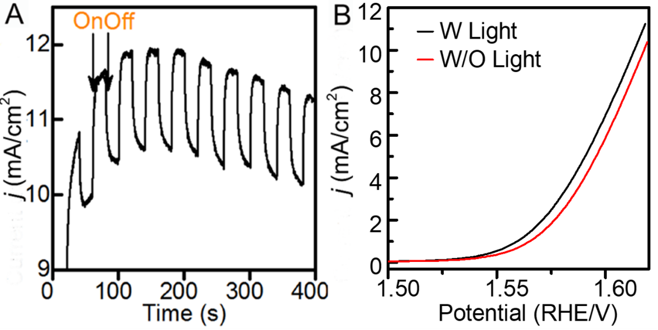
Figure S13 Electrochemical measurements of the bulk MOF-71: (A) potentiostatic current response at E= 1.532 V and (B) iR-corrected LSV plots with and without light illumination.

Figure S14 Characterization of bulk MOF-71, UV-Vis absorption (A), Mott-Schottky plot (B), and Energy band alignment (C).

Figure S15 Durability test of the Co-MOF nanosheets at 352 mV overpotential: current density and current density retention as function of time.
Figure S16 Electrochemical measurements of the Co-MOF nanosheets: Nyquist plot before and after durability test at 352 mV overpotential.
Figure S17 Characterizations of the tested Co-MOF nanosheets: (A, B) TEM of the Co-MOF nanosheets after at 302 mV overpotential for 8,000 seconds, and (C, D) TEM of the Co-MOF nanosheets after at 352 mV overpotential for 8,000 seconds.
Figure S18 Durability test of the Co-MOF nanosheets at 302 mV overpotential: current density and current density retention as function of time.

Figure S19 Electrochemical measurements of the Co-MOF nanosheets: (A) iR-corrected LSV plots and (B) Nyquist plots before and after durability test at overpotential 302 mV.

Figure S20 Electrochemical measurements of the Co-MOF nanosheeets after stability test: potentiostatic current response at E= 1.532 V with and without light illumination.

Table S1 Summary of OER electrocatalytic activity from recently reported 2D MOF nanosheets and MOF-derived materials.
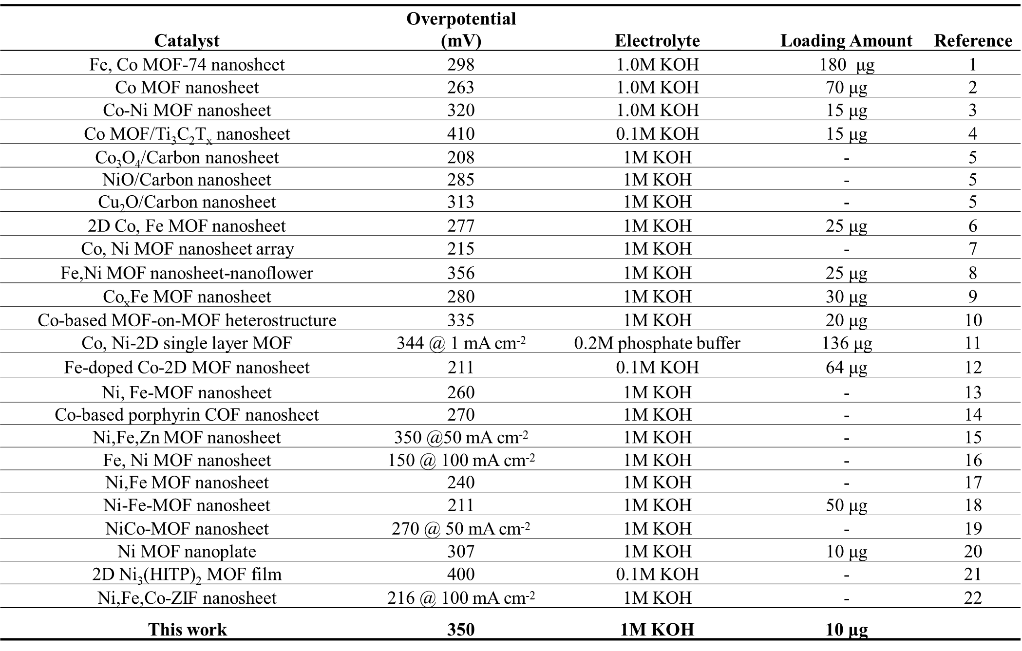
Supplementary References:
- Zhuang, L., Ge, L., Liu, H., Jiang, Z., Jia, Y., Li, Z., et al. (2019) A surfactant-free and scalable general strategy for synthesizing ultrathin two-dimensional metal–organic framework nanosheets for the oxygen evolution reaction. Angew. Chem. Int. Ed. 58, 13565–13572. doi: 10.1002/anie.201907600
- Xu, Y., Li, B., Zheng, S., Wu, P., Zhan, J., Xue, H., et al. (2018) Ultrathin two-dimensional cobalt–organic framework nanosheets for high-performance electrocatalytic oxygen evolution. J. Mater. Chem. A 6, 22070–22076. doi: 10.1039/c8ta03128b
- Lu, M., Li, Y., He, P., Cong, J., Chen, D., Wang, J., et al. (2019) Bimetallic metal-organic framework nanosheets as efficient electrocatalysts for oxygen evolution reaction. J. Solid State Chem. 272, 32–37. doi: 10.1016/j.jssc.2019.01.023
- Zhao, L., Dong, B., Li, S., Zhou, L., Lai, L., Wang, Z., et al. (2017) Interdiffusion reaction-assisted hybridization of two-dimensional metal−organic frameworks and Ti₃C₂T_{x} nanosheets for electrocatalytic oxygen evolution. ACS Nano 11, 5800−5807. doi: 10.1021/acsnano.7b01409
- Zhou, J., Dou, Y., Zhou, A., Shu, L., Chen, Y. and Li, J. R. (2018) Layered metal−organic framework-derived metal oxide/carbon nanosheet arrays for catalyzing the oxygen evolution reaction. ACS Energy Lett. 3, 1655−1661 doi: 10.1021/acsenergylett.8b00809
- Xu, J., Zhu, X. and Jia X. (2019) From low- to high-crystallinity bimetal−organic framework nanosheet with highly exposed boundaries: an efficient and stable electrocatalyst for oxygen evolution reaction. ACS Sustainable Chem. Eng. 7, 16629−16639. doi: 10.1021/acssuschemeng.9b03952
- Huang, L., Gao, G., Zhang, H., Chen, J., Fang, Y., and Dong, S. (2020) Self-dissociation-assembly of ultrathin metal-organic framework nanosheet arrays for effcient oxygen evolution. Nano Energy 68, 104296. doi:10.1016/j.nanoen.2019.104296
- Li, Y., Lu, M., He, P., Wu, Y., Wang, J., Chen, D., et al. (2019) Bimetallic metal-organic framework-derived nanosheet assembled nanoflower electrocatalysts for efficient oxygen
evolution reaction. Chem. Asian J. 14, 1590 – 1594. doi: 10.1002/asia.201900328
- Li, W., Fang, W., Wu, C., Dinh, K. N., Ren, H., Zhao, L., et al. (2020) Bimetal–MOF nanosheets as efficient bifunctional electrocatalysts for oxygen evolution and nitrogen reduction reaction. J. Mater. Chem. A 8, 3658–3666. doi: 10.1039/c9ta13473e
- Zha, Q., Yuan, F., Qin, G. and Ni, Y. (2020) Cobalt-based MOF-on-MOF two-dimensional heterojunction nanostructures for enhanced oxygen evolution reaction electrocatalytic activity. Inorg. Chem. 59, 1295−1305. doi: 10.1021/acs.inorgchem.9b03011
- Pang, W., Shao, B., Tan, X. Q., Tang, Cong, Zhang, Z. and Huang J. Exfoliation of metal–organic frameworks into efficient single-layer metal–organic nanosheet electrocatalysts by the synergistic action of host–guest interactions and sonication. Nanoscale 12, 3623–3629. doi: 10.1039/c9nr09742b
- Huang, J., Li, Y., Huang, R. K., He, C. T., Gong, L., Hu, Q., et al. (2018) Electrochemical exfoliation of pillared-layer metal–organic framework to boost the oxygen evolution reaction. Angew. Chem. 130, 4722 –4726. doi: 10.1002/anie.201801029
- Hai, G., Jia, X., Zhang, K., Liu, X., Wu, Z., and Wang, G. (2017) High-performance oxygen evolution catalyst using two-dimensional ultrathin metal-organic frameworks nanosheets. Nano Energy 44, 345–352. doi: 10.1016/j.nanoen.2017.11.071
- Huang, H., Li, F., Zhang, Y. and Chen, Y. (2019) Two-dimensional graphdiyne analogue Cocoordinated porphyrin covalent organic framework nanosheets as a stable electrocatalyst for the oxygen evolution reaction. J. Mater. Chem. A 7, 5575–5582. doi: 10.1039/c9ta00040b
- Wei, X., Li, N. and Liu, N. (2019) Ultrathin NiFeZn-MOF nanosheets containing few metal oxide nanoparticles grown on nickel foam for efficient oxygen evolution reaction of electrocatalytic water splitting. Electrochimica Acta 318, 957-965. doi: 10.1016/j.electacta.2019.06.141
- Luo, S., Gu, R., Shi, P., Fan, J., Xu, Q., Min, Y. (2020) π-π interaction boosts catalytic oxygen evolution by self-supporting metal-organic frameworks. J. of Power Sources 448 227406. doi: 10.1016/j.jpowsour.2019.227406
- Duan, J., Chen, S., and Zhao, C. (2017) Ultrathin metal-organic framework array for efficient electrocatalytic water splitting. Nat Commun 8, 15341. doi: 10.1038/ncomms15341
- Li, F. L., Wang, P., Huang, X., Young, D. J., Wang, H. F., Braunstein, P., et al. (2019) Large-scale, bottom-up synthesis of binary metal–organic framework nanosheets for efficient water oxidation. Angew. Chem. 131, 7125 –7130. doi: 10.1002/anie.201902588
- Thangasamy, P., Shanmuganathan S. and Subramanian V. (2020) A NiCo-MOF nanosheet array based electrocatalyst for the oxygen evolution reaction. Nanoscale Adv. 2, 2073–2079. doi: 10.1039/d0na00112k
- Lin, Y., Wan, H., Wu, D., Chen, G., Zhang, N., Liu, X., et al. (2020) Metal−organic framework hexagonal nanoplates: bottom-up synthesis, topotactic transformation, and efficient oxygen evolution reaction J. Am. Chem. Soc. 142, 7317−7321. doi:10.1021/jacs.0c01916
- Liu, X. H., Yang, Y. W., Liu, X. M., Hao, Q., Wang, L. M., Sun, B., et al. (2020) Confined synthesis of oriented two-dimensional Ni₃(hexaiminotriphenylene)₂ films for electrocatalytic oxygen evolution reaction. Langmuir 36, 7528−7532. doi: 10.1021/acs.langmuir.0c01128
- Ding, M., Chen, J., Jiang, M., Zhang, X. and Wang, G. (2019) Ultrathin trimetallic metal–organic framework nanosheets for highly efficient oxygen evolution reaction. J. Mater. Chem. A, 7, 14163-14168. doi: 10.1039/C9TA00708C

