Supplementary Material

Supplementary Tables
Supplementary Table 1. Sensitivity analysis of binsize on 50 simulation samples. 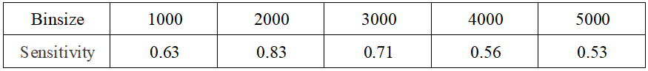
Supplementary Table 2. Sensitivity analysis of parameter k on 50 simulation samples. 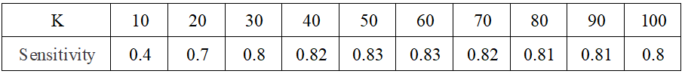
Supplementary Table 3. Sensitivity analysis of threshold (θ) on 50 simulation samples. 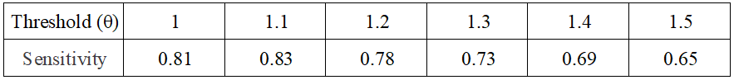
Supplementary Table 4. Sensitivity analysis of depth of exploration (m) on 50 simulation samples.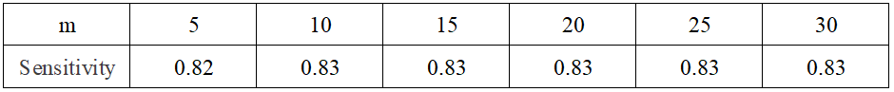
Supplementary Table 5. Summary of F1-scores of five methods based on simulation data. 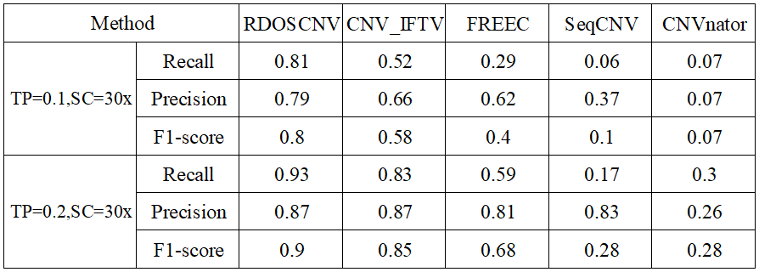
The equations on the left and right sides of the comma represent the tumor purity (TP) and sequencing coverage (SC), respectively. Here, each method only uses RD information to predict CNVs.

