Supplementary Material

# Supplementary Figures and Tables

## Supplementary Figures

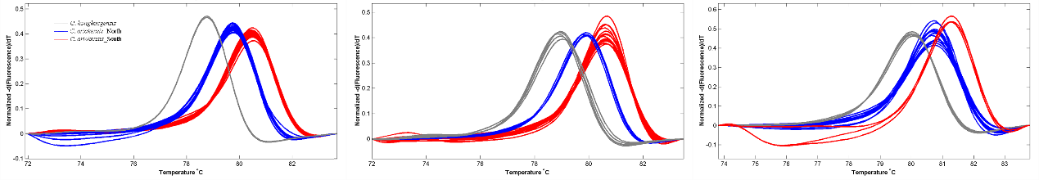

**Supplementary Figure 1.** Normalized melting curves of the amplicons from the *COI* gene segment for the northern (blue) and southern (red) *Crassostrea ariakensis* and *Crassostrea hongkongensis* (grey) oysters.



**Supplementary Figure 2.** Growth parameters, including **(a)** shell length, **(b)** shell width, and **(c)** wet weight, of the northern and southern estuarine oyster populations at each of their native habitats using reciprocal transplant experiments for three months post attachment. Asterisks indicate significant differences (\*\**p* < 0.01), and error bars represent s.d. values.



**Supplementary Figure 3.** Preliminary **(a)** heat shock and **(b)** high salinity exposures indicate the survival temperature and salinity ranges for the northern (BZ) and southern (TS) oysters.

## Supplementary Tables

**Supplementary Table 1.** Sampling locations and the number of oysters used for the sequence variation analysis of the *COI* gene segment.

|  |  |  |  |  |
| --- | --- | --- | --- | --- |
| **Location** | **Group** | **Longitude (°E)** | **Latitude (°N)** | **N** |
| DD (Dandong) | N | 123.74 | 39.76 | 7 |
| YK (Yingkou) | N | 122.15 | 40.69 | 28 |
| BZ (Binzhou) | N | 118.05 | 38.18 | 33 |
| DY (Dongying) | N | 119.24 | 37.83 | 35 |
| QD (Qingdao) | N | 120.95 | 36.57 | 11 |
| NT (Nantong) | N | 121.52 | 32.11 | 26 |
| SH (Shanghai) | N | 121.41 | 30.75 | 31 |
| XM-JLJ (Xiamen-Jiulongjiang) | S | 117.84 | 24.43 | 14 |
| XM-ZJ (Xiamen-Zhangjiang) | S | 118.19 | 24.66 | 28 |
| TS (Taishan) | S | 112.83 | 21.95 | 36 |
| QZ (Qingzhou) | S | 108.58 | 21.74 | 29 |

**Supplementary Table 2. Two-way ANOVA results tables in this study. (a)** survival and **(b)** growth of larvae crossed from male and female oyster derived from northern and southern habitats; **(c)** metabolic rate and **(d)** growth of southern and northern oysters cultured at northern and southern sampling sites.

**a**

|  |  |  |  |  |  |
| --- | --- | --- | --- | --- | --- |
| **Survival of larvae** | **SS** | **DF** | **MS** | **F** | **P value** |
| Interaction | 0.01044 | 1 | 0.01044 | F (1, 8) = 0.9745 | 0.3525 |
| Sex | 0.0008135 | 1 | 0.0008135 | F (1, 8) = 0.07591 | 0.7899 |
| Sampling site | 0.03093 | 1 | 0.03093 | F (1, 8) = 2.887 | 0.1277 |
| Residual | 0.08573 | 8 | 0.01072 |  |  |
| **b** |  |  |  |  |  |
| **Growth of larvae** | **SS** | **DF** | **MS** | **F** | **P value** |
| Interaction | 24.39 | 1 | 24.39 | F (1, 8) = 346.1 | 0.0001 |
| Sex | 0.06643 | 1 | 0.06643 | F (1, 8) = 0.9427 | 0.36 |
| Sampling site | 12.22 | 1 | 12.22 | F (1, 8) = 173.3 | 0.0001 |
| Residual | 0.5638 | 8 | 0.07047 |  |  |
| **c** |  |  |  |  |  |
| **Metabolic rate** | **SS** | **DF** | **MS** | **F** | **P value** |
| Interaction | 0.00001938 | 1 | 1.938E-05 | F (1, 19) = 104.5 | 0.0001 |
| Sampling site | 0.000001089 | 1 | 1.089E-06 | F (1, 19) = 5.871 | 0.0256 |
| Origin | 0.000001219 | 1 | 1.219E-06 | F (1, 19) = 6.572 | 0.019 |
| Residual | 0.000003524 | 19 | 1.855E-07 |  |  |
| **d** |  |  |  |  |  |
| **Growth** | **SS** | **DF** | **MS** | **F** | **P value** |
| Interaction | 717406762 | 1 | 717406762 | F (1, 396) = 1041 | 0.0001 |
| Sampling site | 56823705 | 1 | 56823705 | F (1, 396) = 82.47 | 0.0001 |
| Origin | 783129442 | 1 | 783129442 | F (1, 396) = 1137 | 0.0001 |
| Residual | 272840086 | 396 | 688990 |  |  |