Supplementary Material
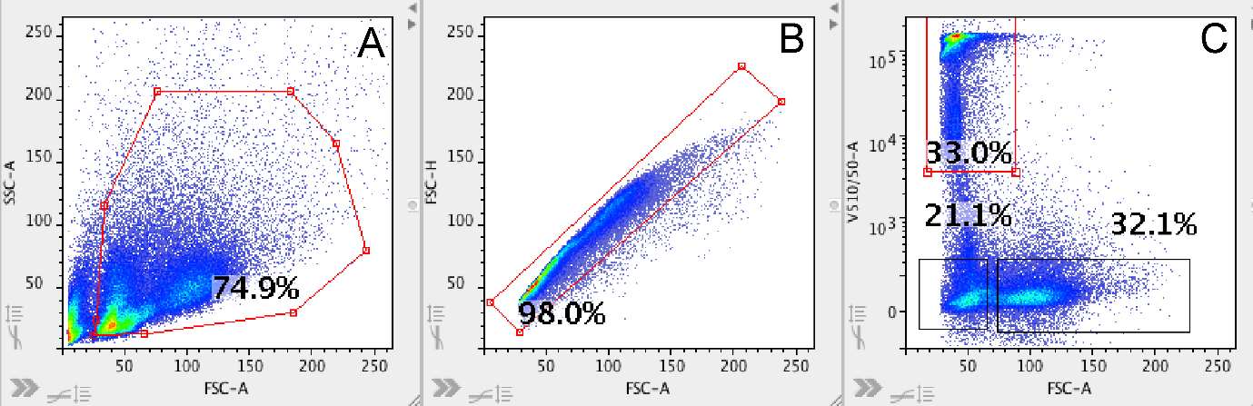
Supplementary Figure S3. Gating strategy for distinguishing different retinal cell populations, based on size and viability at time of isolation. For flow cytometry analysis, an initial gate was set on forward scatter (FSC) and side scatter (SSC) to eliminate debris (A) and find single cell events for each sample (B). Using physical parameters (FSC) and viability staining (DAPI), three distinct subpopulations of cells were consistently detectable in all samples: small dead cells, small live and large live cells (C).

