Supplementary Material

## Supplementary Figures



**Supplementary Figure 1** Lead-lag correlations of the NH and SH HC strength derived from the (a) NCEP data set from 1948 to 2013 and the (b) ERA20C data set from 1900 to 2010. The long-term linear trends were removed. The correlation applied to the raw data is represented by the red line, while the blue line represents the correlation based on the decadal component of the data. Dashed lines indicate the 95% confidence level for the correlations of decadally filtered data using the effective degree of freedom.

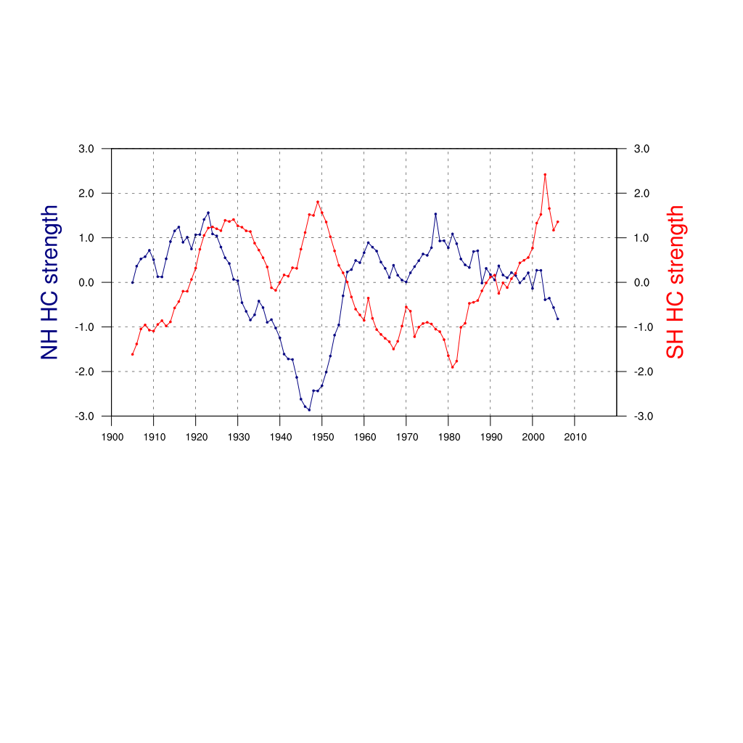**Supplementary Figure 2** Time series of the normalized 11-year running averages (decadal component) of the HC strength indices in the NH (blue lines) and SH (red lines) derived from the 20CR data set for 1900-2010.

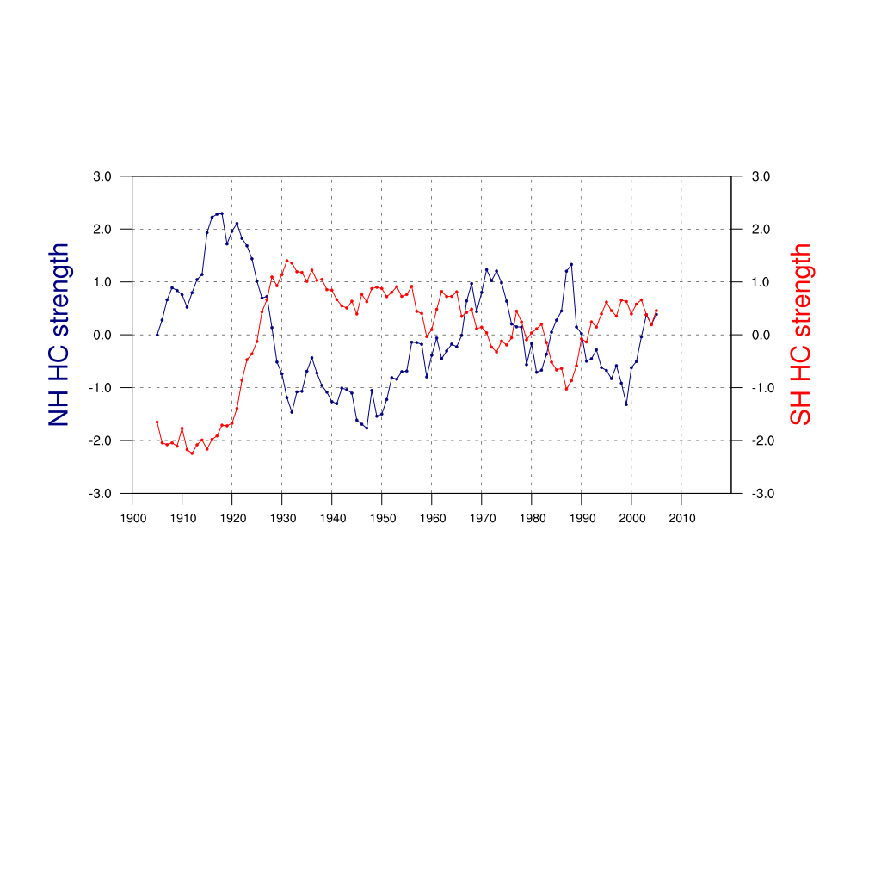

**Supplementary Figure 3** Time series of the normalized 11-year running averages (decadal component) of the HC strength indices in the NH (blue lines) and SH (red lines) derived from the ERA20C data set for 1900-2010.

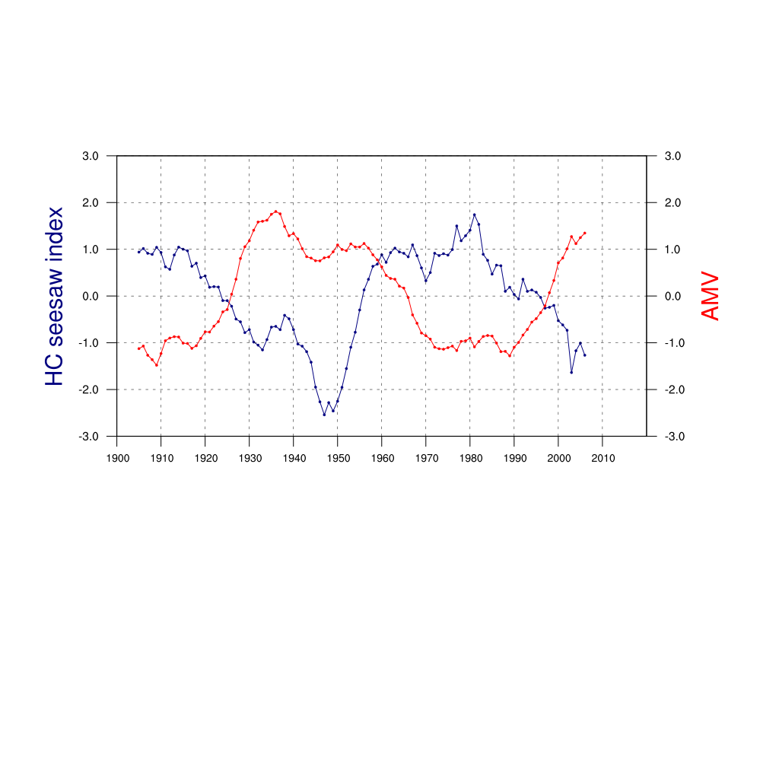

**Supplementary Figure 4** Time series of the normalized 11-year running averages (decadal component) of the 20CR-based HC seesaw index (blue line) and the AMV index (red line) for the period 1900-2010.



**Supplementary Figure 5** Correlation map between the decadal component of the HC seesaw index and tropical precipitation (30°S-30°N). The precipitation data is derived from GPCC data from 1901 to 2010. The long-term linear trends were removed before the analysis. Dotted shading indicates the correlation coefficients significant at the 95% confidence level.



**Supplementary Figure 6** The anomalous SST (K) regressed on the AMV index derived from the HadSST3 data set. Dotted shading indicates the regression coefficients significant at the 95% confidence level.



**Supplementary Figure 7** The anomalous SST (K) regressed on the AMV index derived from the COBE SST data set. Dotted shading indicates the regression coefficients significant at the 95% confidence level.

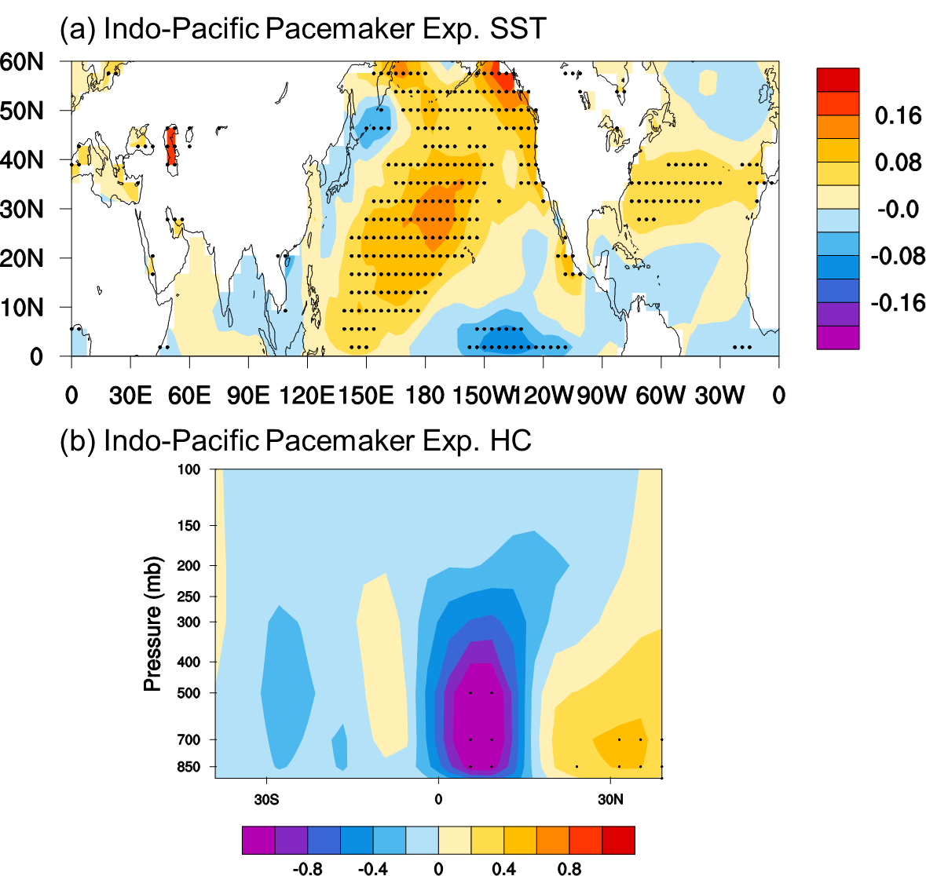

**Supplementary Figure 8** (a) The anomalous SST (K) in northern ocean basins regressed on the AMV index (K) derived from the Indo-Pacific pacemaker experiment. The SSTs over the northern Indo-Pacific basin are prescribed with monthly-varying SSTs from the HadISST data, while in the Atlantic the SST is coupled to the atmosphere. (b) The Hadley circulation mass stream function (108 kg s-1) regressed on the AMV index (K) in the Indo-Pacific pacemaker experiment. Dotted shading in (a) and (b) indicates the correlation coefficients significant at the 95% confidence level.

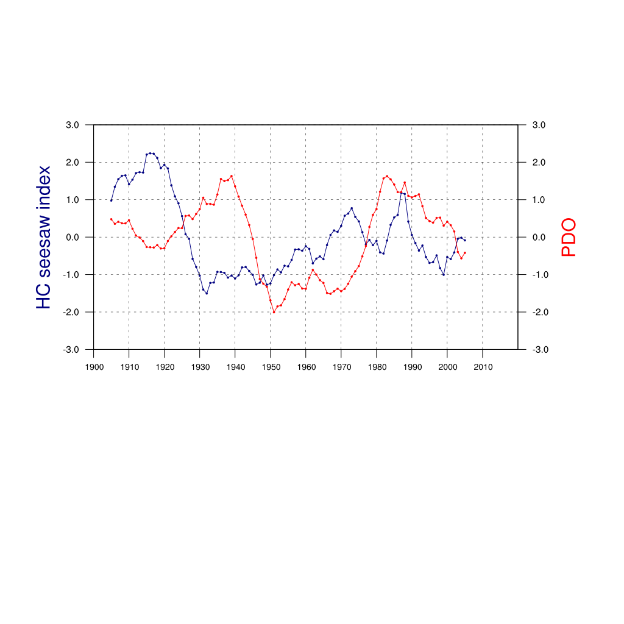

**Supplementary Figure 9** Time series of the normalized 11-year running averages (decadal component) of the ERA20C-based HC seesaw index (blue line) defined by the NH HC strength minus the SH HC strength and the PDO index (red line) from the Japan Meteorological Agency which is defined as the projections of monthly mean SST anomalies which subtracts globally averaged monthly mean SST anomalies onto their first EOF vectors in the North Pacific (north of 20° N) for the period 1900-2010.

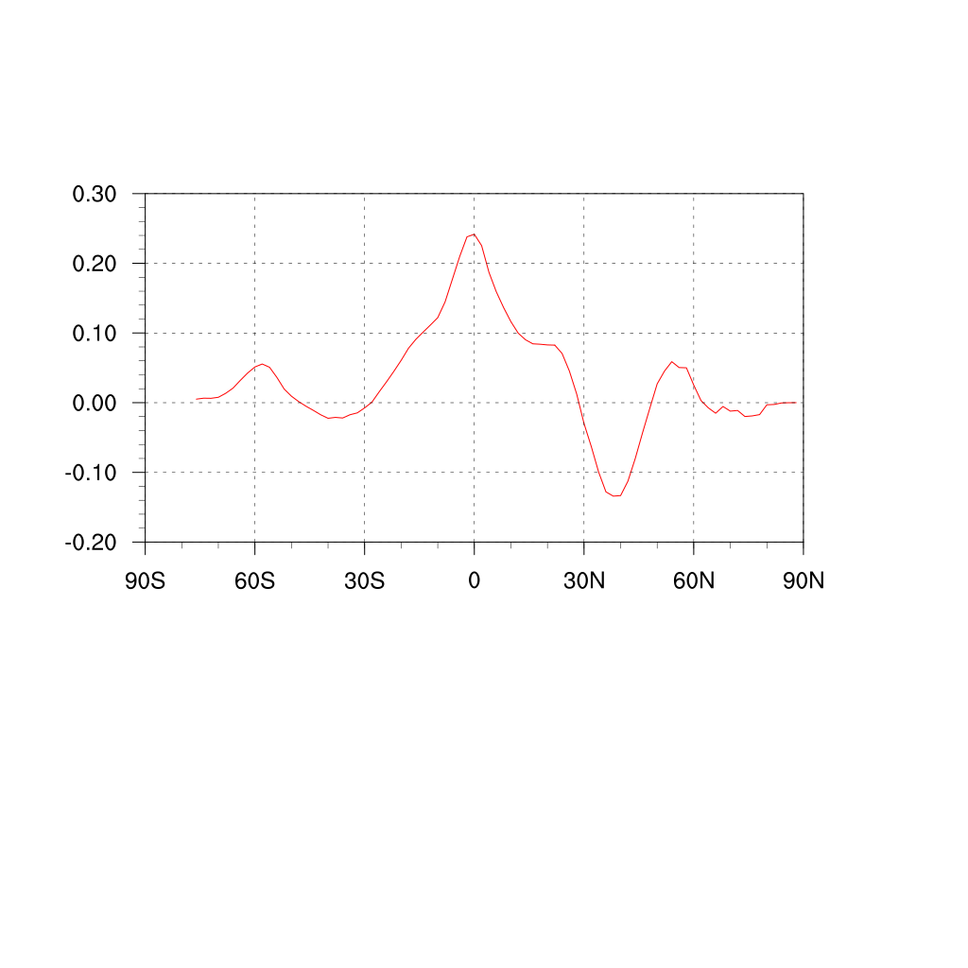

**Supplementary Figure 10** The zonally mean SST anomalies (K) of the PDO (red line) from the Japan Meteorological Agency.