Supplementary Material

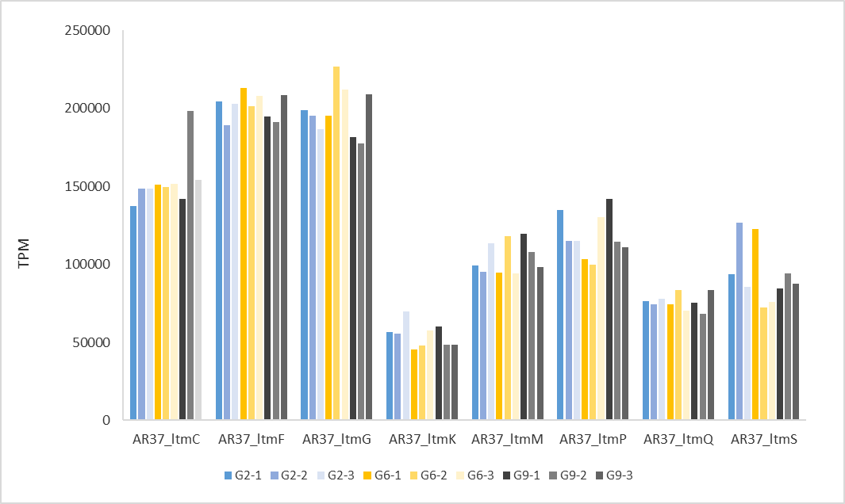
Supplementary Figure 1. Expression of eight AR37 janthitrem biosynthesis genes (in TPM based on reads mapping to the endophyte genome), identified as homologues lolitrem pathway genes (Razzaq, 2019; Johnson, personal communication). Shown are expression levels for each of three biological replicates in each generation.

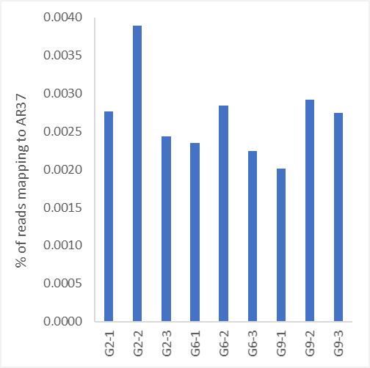
Supplementary Figure 2. Percentage of all reads mapping to AR37 in each biological replicate of three generations of the seed maintenance program. Labels refer to the Generation, followed by the number of the biological replicate.

Supplementary Figure 3. Plant growth curves in G2 (A, B), G6 (C, D) and G9 (E, F). Single tillers of endophyte-infected and endophyte-free plant genotypes in three biological replicates were placed into root trainers and grown under controlled conditions in a growth cabinet. Plant growth was measured by tiller counting every other day. (A, B) Graphs displaying nine endophyte-infected (E+) (individual plants for one of the genotypes died) and three endophyte-free (E-) plant genotypes for G2. (C, D) Eight E+ (individual plants for two of the genotypes died) and three E- plant genotypes for G6. (E, F) Eleven E+ and two E- genotypes for G9. Weighted average log phases (appearance of the first daughter tiller) were 7 days for both G6 and G9, and for both E+ and E-. For G2, the weighted average log phase was 6 days for both E+ and E-. Error bars represent Standard Errors of the three biological replicates.

