Supplementary Material

SERPINA12 and SLURP1 coding status assessment
We applied PseudoChecker (Alves et al., 2020) to assess the coding status of SERPINA12 and SLURP1 genes in 29 cetaceans (10 Mysticeti and 19 Odontoceti) and H. amphibius, the latter representing the closest relative to extant cetaceans, working as a pivotal species for estimating the time of gene loss events (Supplementary Tables 1 and 2, see below). PseudoChecker is an integrated online pipeline capable of detecting cross-species conserved and non-conserved ORF-disruptive mutations (frameshift mutations, in-frame premature stop codons), greater levels of gene erosion (exon loss and full gene loss), only requiring, per analysis (per gene being tested), a single reference CDS plus the respective exon nucleotide sequence(s) and, for each target species, a corresponding orthologous genomic sequence against which the reference coding exons will be aligned, predicting the in-study gene CDS, further screened for inactivating evidence (Alves et al., 2020).
To this effect, for the two executed analyses, one regarding SERPINA12 and the other concerning SLURP1, we used the B. taurus gene orthologs as a reference, and as target species corresponding genomic sequences, we extracted previously (annotated and unannotated) sequences from different biological databases (Supplementary Tables 1 and 2). In detail, (i) for species with annotated genome and annotated gene of interest at NCBI (i.e. Balaenoptera acutorostrata scammoni), we directly imported the corresponding genomic sequence into PseudoChecker; (ii) for species with annotated genome but without annotation for the gene of interest at NCBI (i.e. Tursiops truncatus, Delphinapterus leucas), we submitted the respective genomic sequence flanked by the two gene of interest’s neighbouring genes in cetaceans, previously inferred while analysing the cases in (i) (SERPINA4 and SERPINA11 for SERPINA12; LY6D and THEM6 for SLURP1); (iii) finally, for Balaena mysticetus (www.bowhead-whale.org), for species without annotated genome at NCBI (i.e. Megaptera novaengliae, Phocoena phocoena), and for species with available genome at DNA Zoo (www.dnazoo.org) (i.e. Balaenoptera edeni), blast searches were conducted against their genomes using, as a query, a set of three sequences including the Bos taurus CDS of the gene of interest, as well as the CDS’s of the neighbouring genes of it in the same species (SERPINA4 and SERPINA11 for SERPINA12; LYPD2 and THEM6 for SLURP1), further downloading the genomic sequence corresponding to the consensus blast hit across the hits obtained per each query sequence. Finally, through each PseudoChecker’s analysis results, per species, identified disruptive mutations (when existing) were recovered. The visual demonstration of the detected ORF-disrupting mutations is represented through the Supplementary Figures 1 – 5 (see below Supplementary Tables 1 and 2).

Supplementary Table 1: Analyzed genomic sequences regarding the PseudoChecker’s coding status assessment of SERPINA12 in cetaceans and Hippopotamus amphibius.
# | Species | Family | Database | Genomic Sequence ID
1 | Tursiops aduncus | Delphinidae | NCBI | NCQN01000009.1
2 | Tursiops truncatus |  | NCBI | NC_047035.1
3 | Sousa chinensis |  | NCBI | RWJT01021752.1
4 | Globicephala melas |  | NCBI | NW_022134922.1
5 | Peponocephala electra |  | DNA ZOO | HiC_scaffold_6
6 | Cephalorhynchus commersonii |  | DNA ZOO | HiC_scaffold_5
7 | Lagenorhynchus obliquidens |  | NCBI | NW_020837965.1
8 | Orcinus orca |  | NCBI | NW_004438415.1
9 | Neophocaena asiaeorientalis asiaeorientalis | Phocoenidae | NCBI | NW_020172178.1
10 | Phocoena phocoena |  | NCBI | PKGA01135346.1
11 | Monodon monoceros | Monodontidae | NCBI | NW_021703778.1
12 | Delphinapterus leucas |  | NCBI | NW_022098016.1
13 | Pontoporia blainvillei | Pontoporiidae | NCBI | PGGH01071410.1
14 | Inia geoffrensis | Iniidae | NCBI | RJWO010011616.1
15 | Lipotes vexillifer | Lipotidae | NCBI | NW_006772141.1
16 | Mesoplodon bidens | Ziphiidae | NCBI | PVJJ010000221.1
17 | Ziphius cavirostris |  | NCBI | RJWS010151175.1
18 | Kogia breviceps | Kogiidae | NCBI | RJWL010050176.1
19 | Physeter macrocephalus | Physeteridae | NCBI | NC_041224.1
20 | Balaenoptera edeni | Balaenopteridae | DNA ZOO | HiC_scaffold_20
21 | Balaenoptera musculus |  | NCBI | CM020942.1
22 | Balaenoptera physalus |  | NCBI | SGJD01002715.1
23 | Megaptera novaeangliae |  | NCBI | RYZJ01000659.1
24 | Eschrichtius robustus | Eschrichtiidae | NCBI | NIPP01005531.1
25 | Balaenoptera acutorostrata scammoni | Balaenopteridae | NCBI | NW_006726576.1
26 | Balaenoptera bonaerensis |  | NCBI | DF437389.1
27 | Eubalaena japonica | Balaenidae | DNA ZOO | RJWP010000613.1
28 | Eubalaena glacialis |  | DNA ZOO | HiC_scaffold_13
29 | Balaena mysticetus |  | bowhead-whale.org | scaffold_1635
30 | Hippopotamus amphibius | Hippopotamidae | NCBI | PVJP02000056.1

Supplementary Table 2: Analyzed genomic sequences regarding the PseudoChecker’s coding status assessment of SLURP1 in cetaceans and Hippopotamus amphibius.
# | Species | Family | Database | Genomic Sequence ID
1 | Tursiops aduncus | Delphinidae | NCBI | NCQN01016125.1
2 | Tursiops truncatus |  | NCBI | NC_047050.1
3 | Sousa chinensis |  | NCBI | RWJT01019188.1
4 | Globicephala melas |  | NCBI | NW_022134900.1
5 | Peponocephala electra |  | DNA ZOO | HiC_scaffold_12
6 | Cephalorhynchus commersonii |  | DNA ZOO | HiC_scaffold_20
7 | Lagenorhynchus obliquidens |  | NCBI | NW_020837985.1
8 | Orcinus orca |  | NCBI | NW_004438426.1
9 | Neophocaena asiaeorientalis asiaeorientalis | Phocoenidae | NCBI | NW_020172779.1
10 | Phocoena phocoena |  | NCBI | PKGA01139387.1
11 | Monodon monoceros | Monodontidae | NCBI | NW_021703782.1
12 | Delphinapterus leucas |  | NCBI | NW_022098049.1
13 | Pontoporia blainvillei | Pontoporiidae | NCBI | PGGH01252053.1
14 | Inia geoffrensis | Iniidae | NCBI | RJWO010003874.1
15 | Lipotes vexillifer | Lipotidae | NCBI | NW_006791731.1
16 | Mesoplodon bidens | Ziphiidae | NCBI | PVJJ010033365.1
17 | Ziphius cavirostris |  | NCBI | RJWS010002737.1
18 | Kogia breviceps | Kogiidae | NCBI | --
19 | Physeter macrocephalus | Physeteridae | NCBI | NW_021146804.1
20 | Balaenoptera edeni | Balaenopteridae | DNA ZOO | HiC_scaffold_10
21 | Balaenoptera musculus |  | NCBI | CM020957.1
22 | Balaenoptera physalus |  | NCBI | SGJD01005450.1
23 | Megaptera novaeangliae |  | NCBI | RYZJ01000962.1
24 | Eschrichtius robustus | Eschrichtiidae | NCBI | NIPP01000017.1
25 | Balaenoptera acutorostrata scammoni | Balaenopteridae | NCBI | NW_006725399.1
26 | Balaenoptera bonaerensis |  | NCBI | DF402240.1
27 | Eubalaena japonica | Balaenidae | DNA ZOO | RJWP010039703.1
28 | Eubalaena glacialis |  | DNA ZOO | HiC_scaffold_18
29 | Balaena mysticetus |  | bowhead-whale.org | scaffold_2155
30 | Hippopotamus amphibius | Hippopotamidae | NCBI | PVJP02910145.1

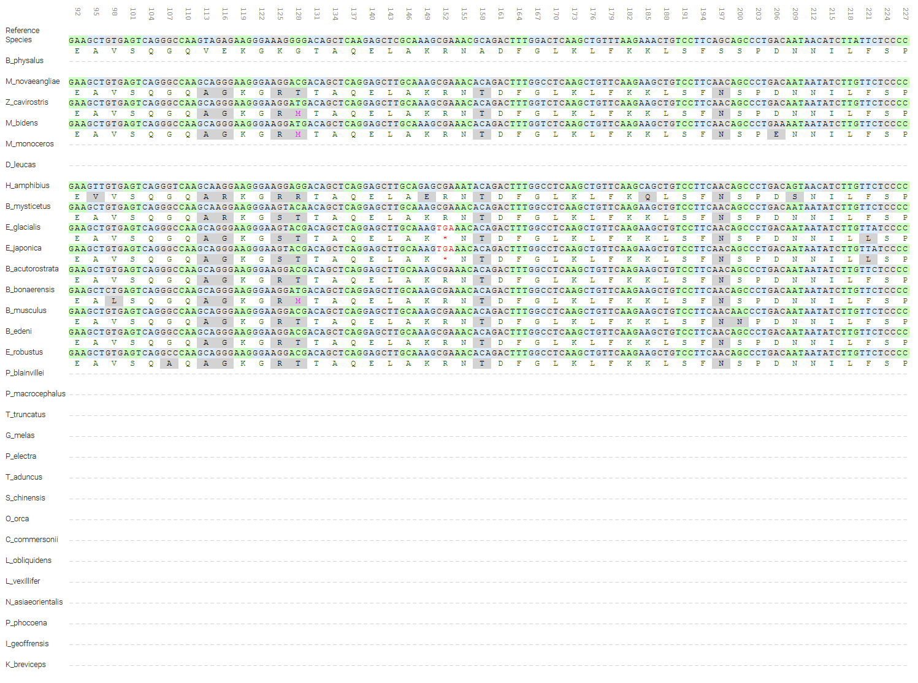
Supplementary Figure 1: PseudoChecker’s analysis screenshot: demonstration of a premature in-frame stop codon (alignment pos. 151) arising in exon 1 of E. glacialis and E. japonica’s SERPINA12 gene.

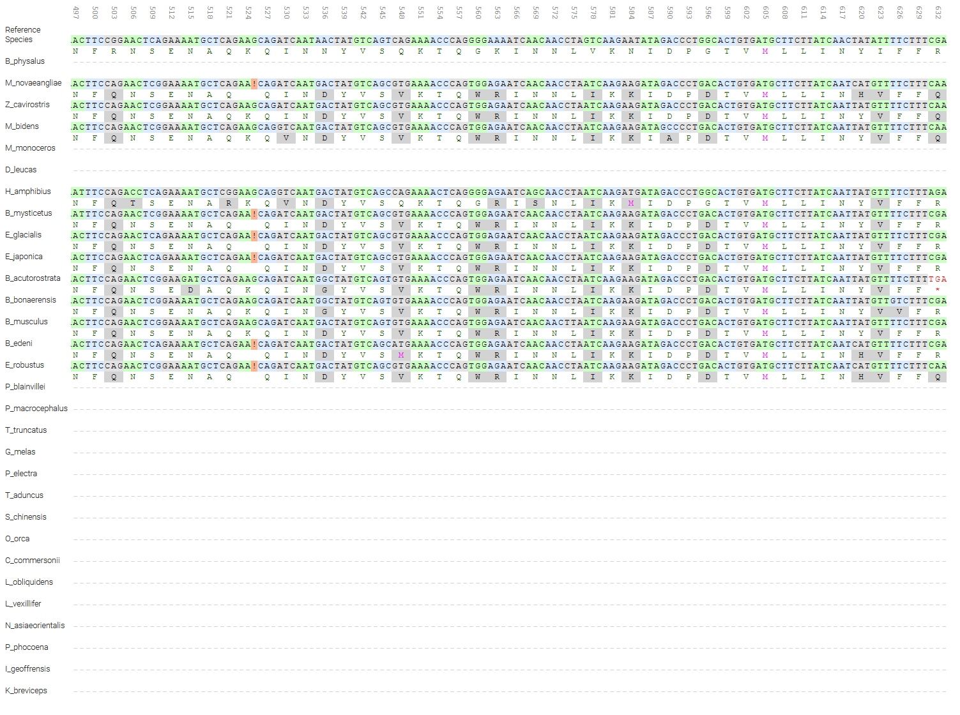
Supplementary Figure 2: PseudoChecker’s analysis screenshot: Demonstration of a single-nucleotide deletion (alignment pos. 525) in exon 1 of M. novaengliae, B. mysticetus, E. glacialis, E. japonica, B. edeni and E. robustus SERPINA12 gene, also including the demonstration of an in-frame premature stop codon (alignment pos. 631) arising in the same exon and gene of B. acutorostrata scammoni.
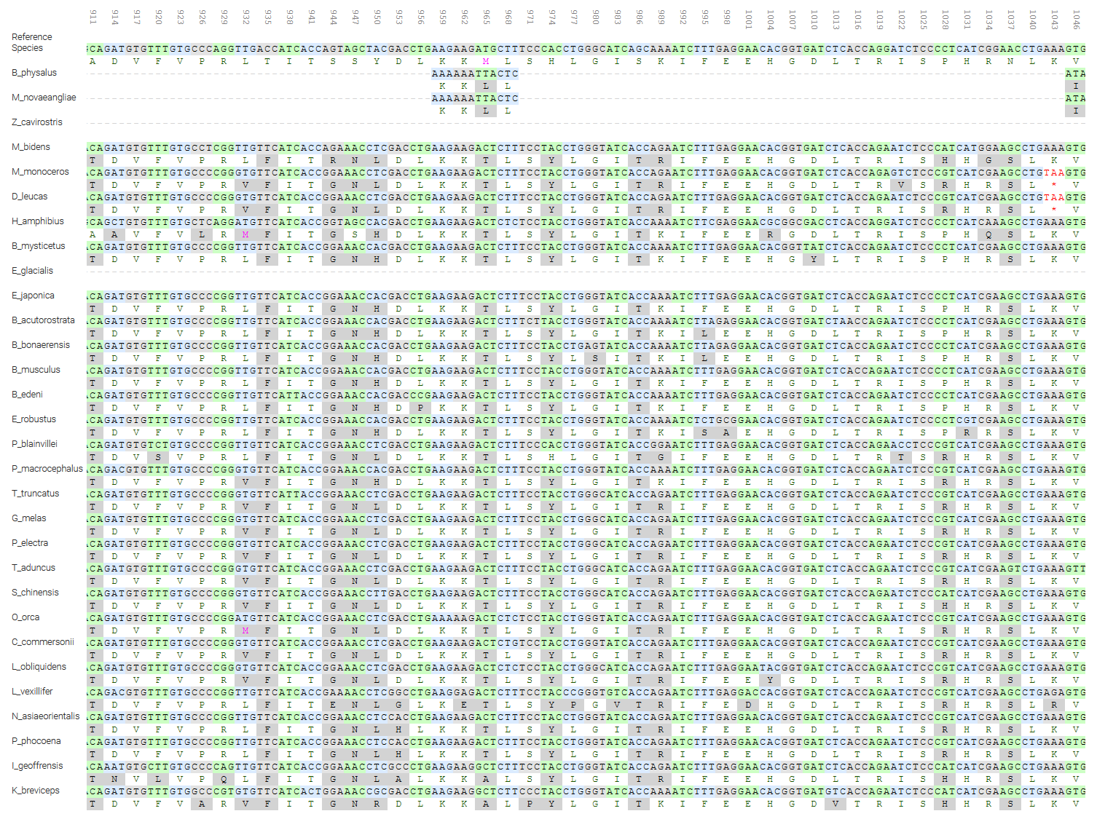
Supplementary Figure 3: PseudoChecker’s analysis screenshot: Demonstration of a premature in-frame stop codon (alignment pos. 1042) arising in exon 3 of M. monoceros and D. leucas’s SERPINA12 gene.
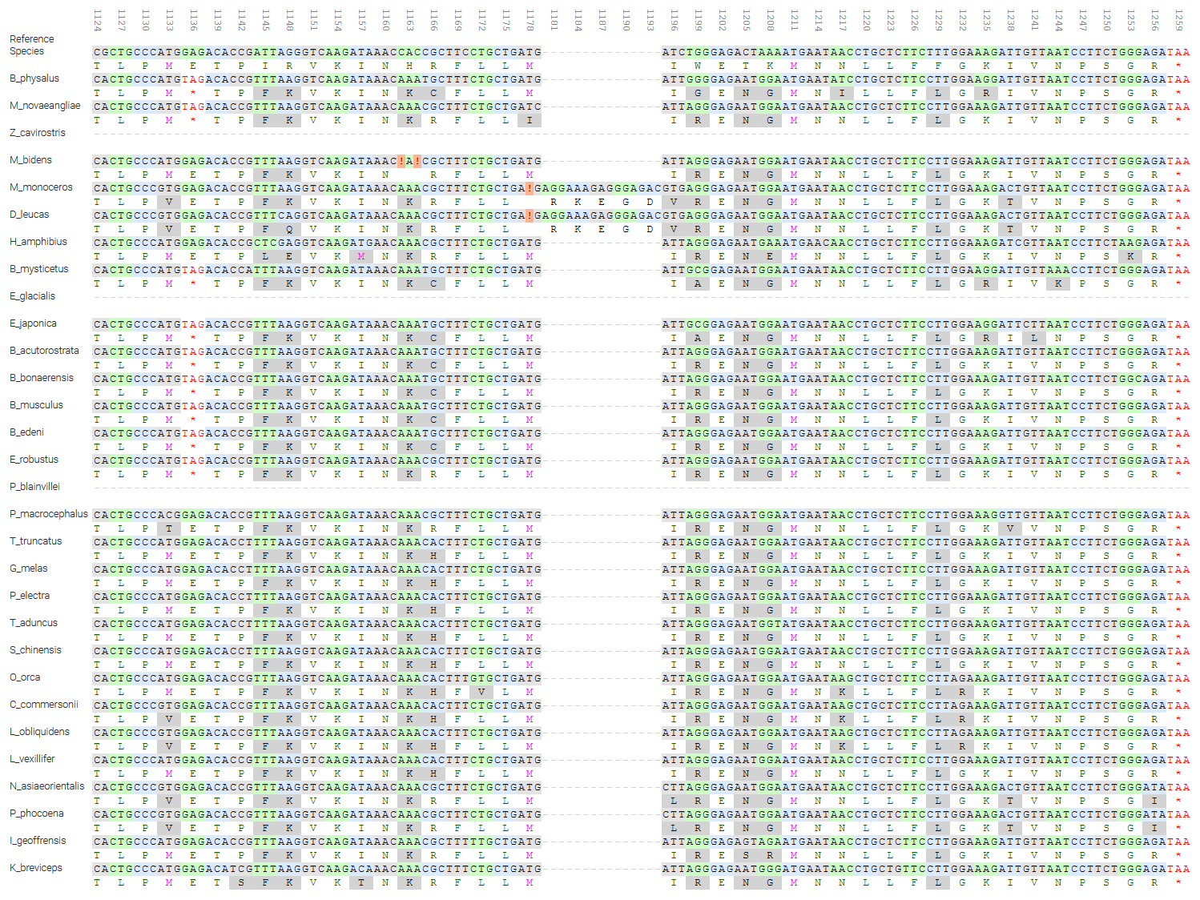
Supplementary Figure 4: PseudoChecker’s analysis screenshot: Demonstration of (a): an in-frame premature stop codon arising (alignment pos. 1135) in exon 4 of B. physalus, M. novaeangliae, B. mysticetus, E. japonica, B. acutorostrata scammoni, B. bonaerensis, B. musculus, B. edeni and E. robustus’s SERPINA12 gene; (b) two single-nucleotide deletions (alignment pos. 1162 and 1164) in exon 4 of M. bidens’s SERPINA12 gene; (c) a single-nucleotide deletion (alignment pos. 1170) in exon 4 of M. monoceros and D. leucas’s SERPINA12 gene.

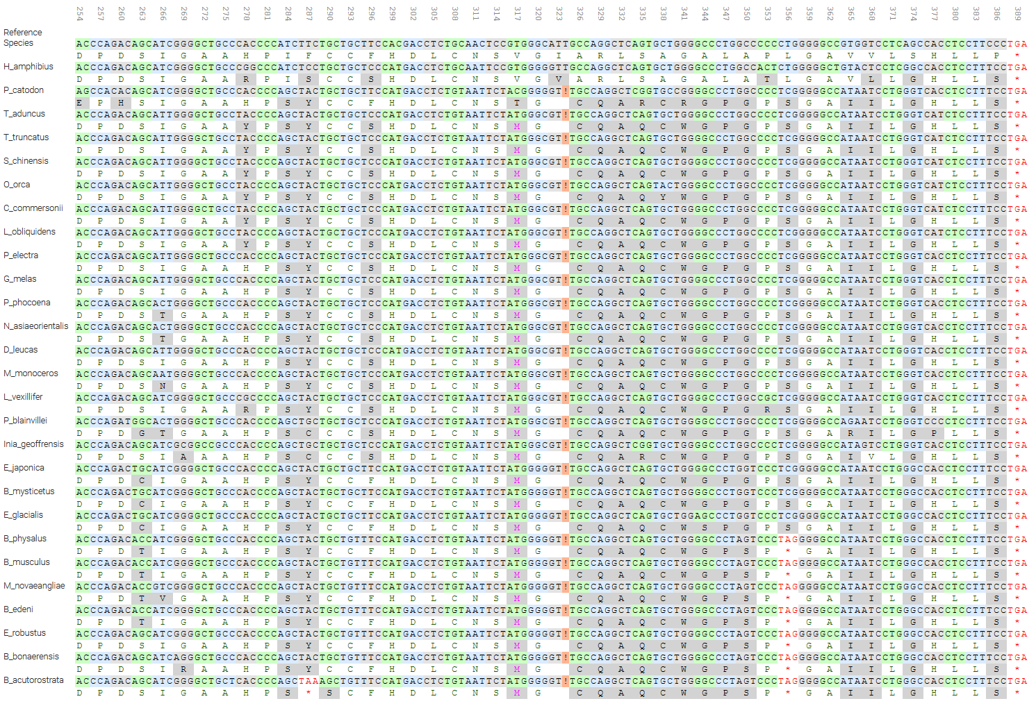
Supplementary Figure 5: PseudoChecker’s analysis screenshot: Demonstration of (a): an in-frame premature stop codon arising (alignment pos. 206) in exon 3 of B. acutorostrata scammoni’s SLURP1 gene; (b) one single-nucleotide deletion (alignment pos. 324) in exon 3 of all represented species’ SLURP1 gene, except for H. amphibius; (c) an in-frame premature stop codon arising (alignment pos. 355) in exon 3 of B. physalus, B. musculus, M. novaengliae, B. edeni, E. robustus, B. bonaerensis and B. acutorostrata scammoni’s SLURP1 gene.

