Supplementary Material

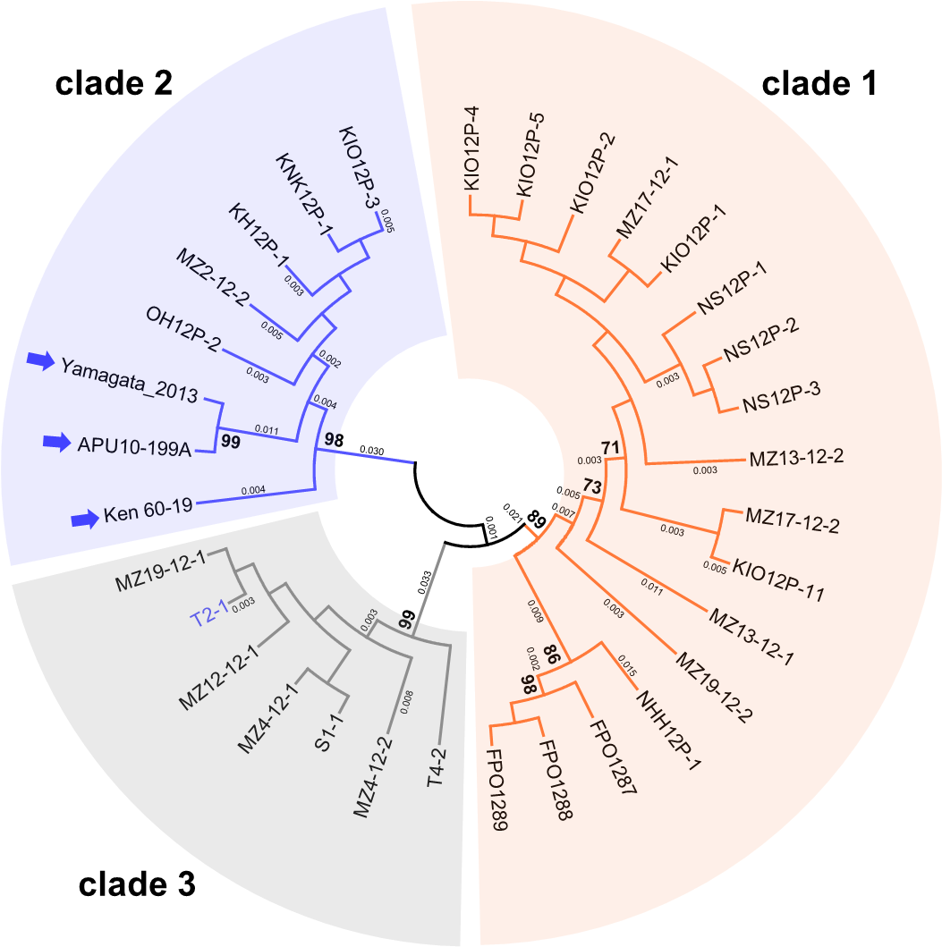

Supplementary Figure S1. An unrooted phylogenetic tree, inferred by the Maximum Likelihood method based on the Kimura 2-parameter model (Kimura, 1980), was constructed using partial nucleotide sequences (394 bp) of the CP coding domain in 32 MoV2 isolates from Japan. Numbers at nodes represent bootstrap values calculated from 1000 replicates, and smaller numbers indicate genetic distances. Bootstrap values less than 70% are not shown. Each MoV2 isolate is indicated by the name of its host M. oryzae strain. MoV2 isolates from outside the Kyusyu region are indicated by arrows. The blue text indicates the MoV2 isolate whose belonging with different clade in RdRp based phylogenetic tree.

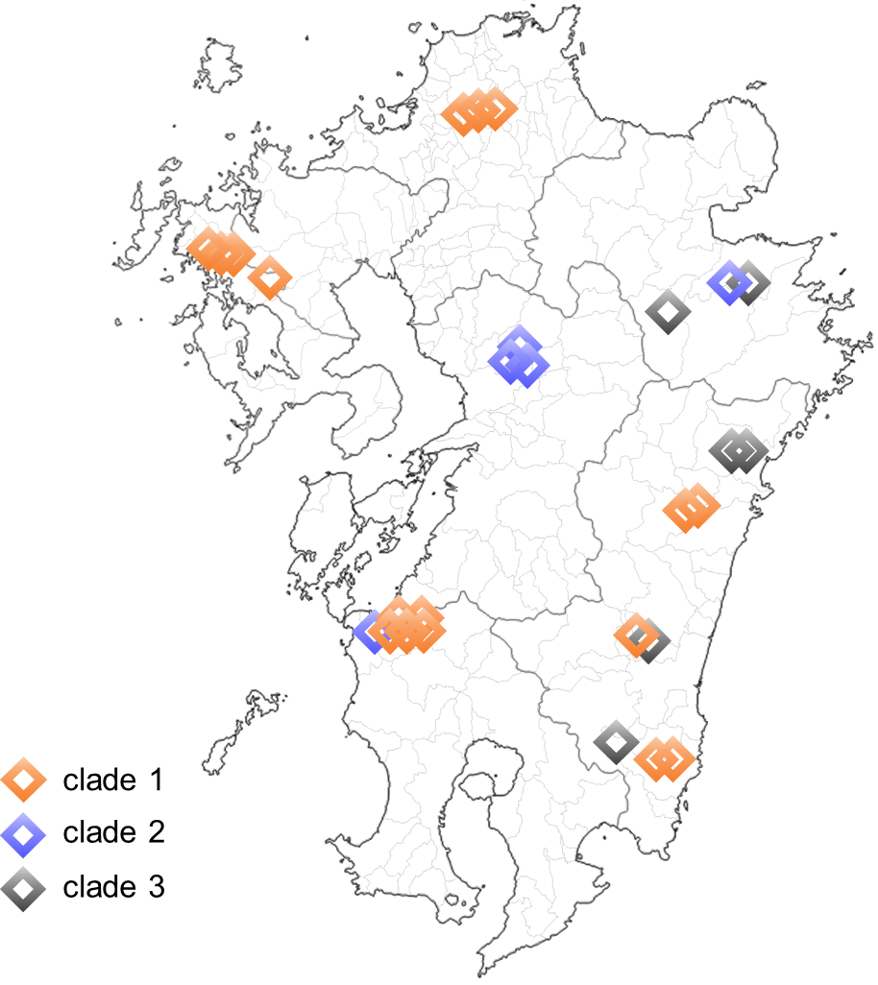

Supplementary Figure S2. Distribution of MoV2 in the Kyushu region. Each figure indicates location of MoV2 detected and each color indicates the clade of MoV2 based on Phylogenetic tree of partial RdRp region in Fig. 3. The overlap of figures indicates MoV2 from same location.

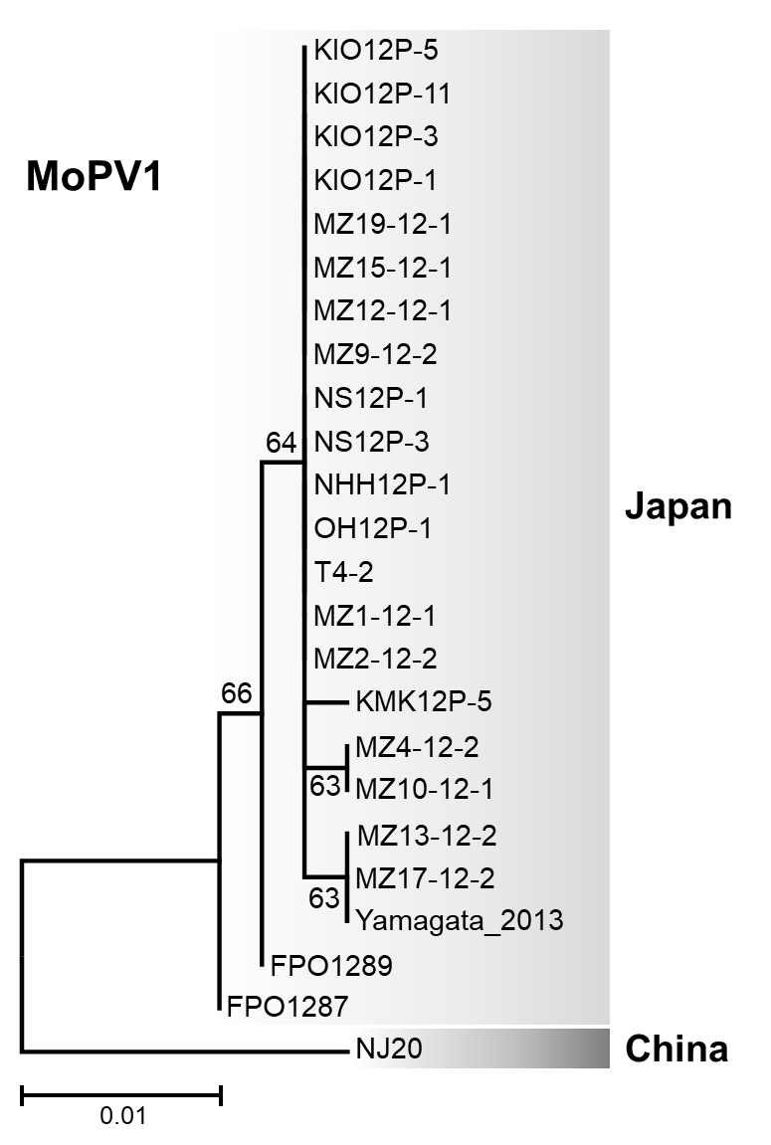
Supplementary Figure S3. An unrooted phylogenetic tree, inferred by the Maximum Likelihood method based on the Kimura 2-parameter model (Kimura, 1980), was constructed using partial nucleotide sequences (466 bp) of the RdRp coding domain in 23 MoPV1 isolates from Japan, and one sequence from China isolate. Numbers at nodes represent bootstrap values calculated from 1000 replicates. Each MoPV1 isolate is indicated by the name of its host M. oryzae strain.

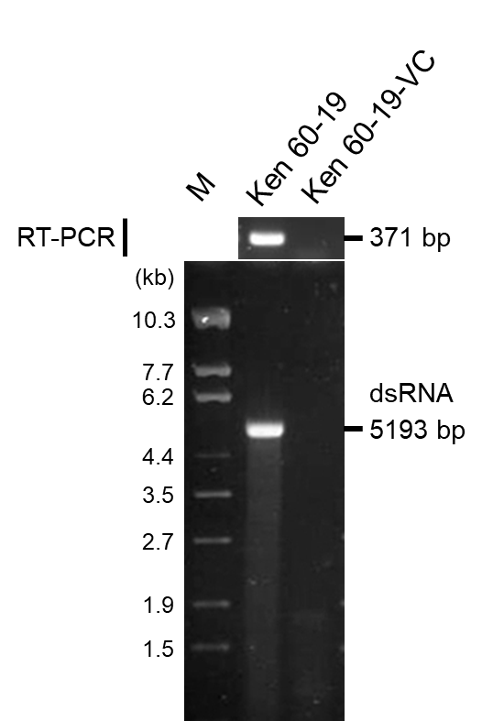

Supplementary Figure S4. Detections of MoV2 in M. oryzae strains Ken 60-19 and Ken 60-19-VC. Upper panel shows RT-PCR amplification using MoV2-specific primers. Lower panel shows pattern of agarose gel electrophoresis of dsRNA purified from each strain. Lane M, DNA size markers (λDNA digested with EcoT14 I).

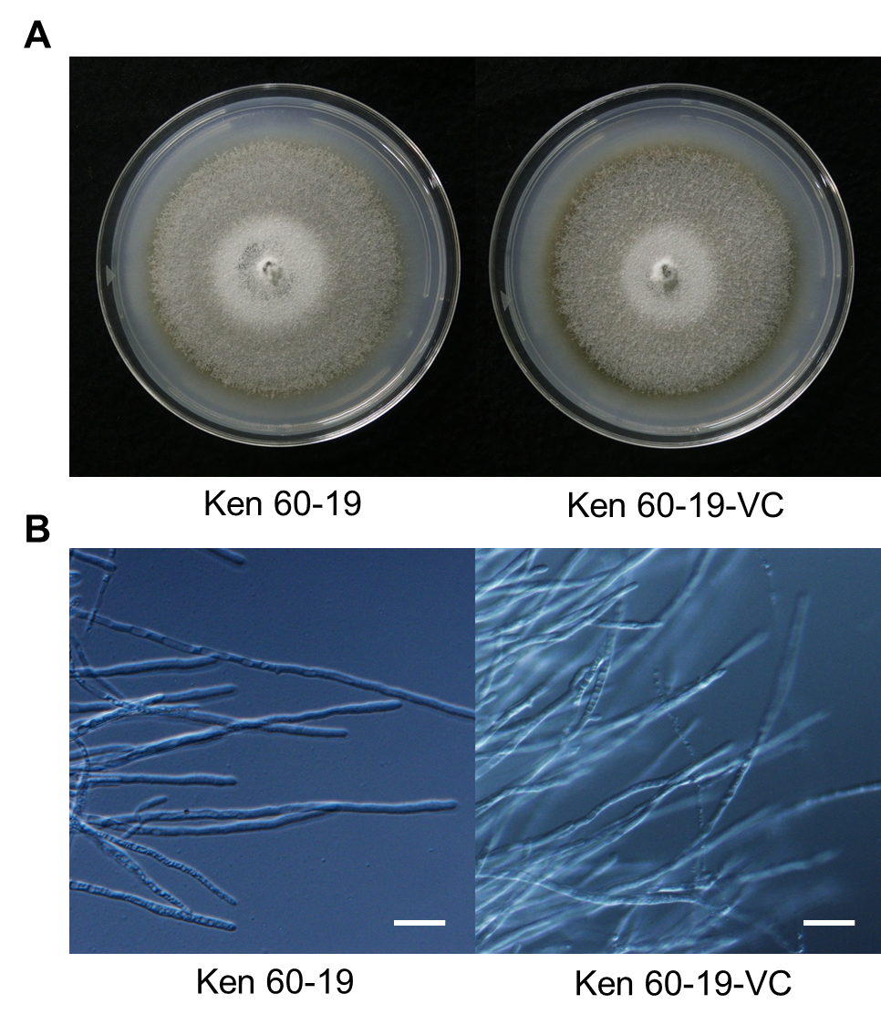

Supplementary Figure S5. Morphological characteristics of M. oryzae strains Ken 60-19 and Ken 60-19-VC. (A) Colony on PDA culture at 25°C for 10 days. (B) Aerial mycelia in YG liquid culture at 25°C for 1 week. Bars show 20 μm.

Supplementary Table S1. Oligonucleotide primers used in this study.
Primer name | Oligonucleotide sequence (5'-3') | Template (target position) ª | Purpose ^{b}
MoV1-detect F | AAGACGCGTGCGATCTTTGCTT | MoV1 (3877–3899) | Det.
MoV1-detect R | GGTGCCCGGACATGAGCGTAC | MoV1 (4226–4246) | Det.
MoV2-detect F 3703–3725 | AAGACCAGAGCAATCTTTGCCT | MoV2 (3703–3725) | Det., Seq., PCR
MoV2-detect R 4052–4073 | CGGTGGCCACTCATCAGAGTAC | MoV2 (4052–4073) | Det., Seq., PCR, cDNA synthesis
MoV3-3709F | CACTCAGTTACCTAGCTTTCG | MoV3 (3709–3729) | Det.
MoV3-4049R | ATGGCCGCTCATTAAGGTCC | MoV3 (4030–4049) | Det.
MoCV1C-ID9-F3 | CGGTGTGATGCTGGACTAC | MoCV1-D segment 1 (2080–2098) | Det.
MoCV1C-ID9-B3 | GCAACTCACCGTCGTACTC | MoCV1-D segment 1 (2246–2264) | Det.
MoPV-RdRp-F | ATCTTACCACCGTGCATTGC | MoPV1 segment1 (425–444) | Det., Seq.
MoPV-RdRp-R | ACTCCAGTCCATGGTTAGCTC | MoPV1 segment1 (870–890) | Det., Seq.
Hind-T7-MoV2F | TAATACGACTCACTATAG GATAGAAAACGAAGAATCGAAAGTTTCCC | MoV2 (1–29) | cDNA synthesis, PCR
MoV2-2697R | CAGGTATTGGCCCAAGGAG | MoV2 (2679–2697) | PCR
MoV2-2657F | CCACAAGAGCTAAAGCAAC | MoV2 (2657–2675) | PCR
Bam-MoV2R-re | GTAAAACGACGGCCAGTGAATTCGGATCCGCATTATGGGCCCCGTG | MoV2 (5177–5193) | cDNA synthesis, PCR
MoV2-1887F | TCTCGTCGTATCTGTGGCG | MoV2 (1887–1905) | Seq.
MoV2-1140R | AAGGCACGGAGGGATTGGTT | MoV2 (1121–1140) | Seq.
MoV2-2008R | CGCGTTGAAATCGTTATCCCA | MoV2 (1988–2008) | Seq.
MoV2-3155F | TCTACGGCTACGGATTGAGT | MoV2 (3155–3174) | Seq.
MoV2-3358R | CCTCCTCGCGCAAGTCGATT | MoV2 (3339–3358) | Seq.
MoV2-4076F | GCACAACCTACATCAACAGC | MoV2 (4076–4095) | Seq.
MoV2-229R | CGTTGGTATCAACGGAACCCTCCTCC | MoV2 (204–229) | RACE
MoV2-4939F | TGACAGGATCGCAGCTACGCCGC | MoV2 (4939–4961) | RACE
ª The reference sequences registered in GenBank (MoV1, AB176964; MoV2, AB300379; MoV3, KP893140; MoCV1-D, LC432338; MoPV1, KX119172) were used, respectively.
^{b} Det., mycovirus detection; Seq., sequencing.

Supplementary Table S2. Mycoviruses screening from M. oryzae strains in Japan by dsRNA electrophoresis assay.
 | Strain ª | Viruses ^{b} |  |  | Year ^{c} | Location, prefecture ^{d} | Accession no. ^{e}
 |  | MoV2 | MoCV1 | MoPV1 |  |  | MoV2 | MoPV1
Kyushu region
1 | FPO1229 | − | − | − | 2012 | Onga, Onga, Fukuoka | - | -
2 | FPO1233 | − | − | + | 2012 | Nakama, Fukuoka | - | -
3 | FPO1237 | − | − | + | 2012 | Yamakawa, Miyama, Fukuoka | - | -
4 | FPO1248 | − | − | − | 2012 | Kama, Fukuoka | - | -
5 | FPO1249 | − | − | + | 2012 | Kama, Fukuoka | - | -
6 | FPO1250 | − | − | − | 2012 | Kama, Fukuoka | - | -
7 | FPO1273 | − | − | − | 2012 | Uchikoshi, Itoda, Tagawa, Fukuoka | - | -
8 | FPO1274 | − | − | − | 2012 | Uchikoshi, Itoda, Tagawa, Fukuoka | - | -
9 | FPO1287 | + | − | + | 2012 | Iizuka, Fukuoka | LC573908 | LC573938
10 | FPO1288 | + | − | + | 2012 | Iizuka, Fukuoka | LC573909 | -
11 | FPO1289 | + | − | + | 2012 | Iizuka, Fukuoka | LC573910 | LC573939
12 | FPO1290 | − | − | − | 2012 | Nomachi, Chikuzen, Asakura, Fukuoka | - | -
13 | FPO1291 | − | − | − | 2012 | Nomachi, Chikuzen, Asakura, Fukuoka | - | -
14 | OS98L-1 | − | − | + | 1998 | Sari, Ouchi, Karatsu, Saga | - | -
15 | OS98L-2 | − | − | + | 1998 | Sari, Ouchi, Karatsu, Saga | - | -
16 | OS98L-3 | − | − | + | 1998 | Sari, Ouchi, Karatsu, Saga | - | -
17 | YM98L-1 | − | − | + | 1998 | Yamato, Saga, Saga | - | -
18 | YM98L-2 | − | − | + | 1998 | Yamato, Saga, Saga | - | -
19 | YM98L-3 | − | − | + | 1998 | Yamato, Saga, Saga | - | -
20 | FSK98L-1 | − | − | − | 1998 | Fuji, Saga, Saga | - | -
21 | FSK98L-2 | − | − | − | 1998 | Fuji, Saga, Saga | - | -
22 | FSK98L-3 | − | − | − | 1998 | Fuji, Saga, Saga | - | -
23 | MK98L-1 | − | − | − | 1998 | Mitsuse, Saga, Saga | - | -
24 | MK98L-2 | − | − | + | 1998 | Mitsuse, Saga, Saga | - | -
25 | MK98L-3 | − | − | + | 1998 | Mitsuse, Saga, Saga | - | -
26 | NS12P-1 | + | − | + | 2012 | Sasebo, Nagasaki | LC573911 | LC573940
27 | NS12P-2 | + | − | + | 2012 | Sasebo, Nagasaki | LC573912 | -
28 | NS12P-3 | + | − | + | 2012 | Sasebo, Nagasaki | LC573913 | LC573941
29 | NHH12P-1 | + | − | + | 2012 | Hiekoba, Hasami, Higashisonogi, Nagasaki | LC573905 | LC573942
30 | NHH12P-2 | + | − | + | 2012 | Hiekoba, Hasami, Higashisonogi, Nagasaki | - | -
31 | NHH12P-3 | − | − | + | 2012 | Hiekoba, Hasami, Higashisonogi, Nagasaki | - | -
32 | NHT12P-1 | − | − | + | 2012 | Takebeta, Hasami, Higashisonogi, Nagasaki | - | -
33 | NHT12P-2 | − | + | + | 2012 | Takebeta, Hasami, Higashisonogi, Nagasaki | - | -
34 | NHT12P-3 | − | + | + | 2012 | Takebeta, Hasami, Higashisonogi, Nagasaki | - | -
35 | NUA12P-1 | − | − | + | 2012 | Unzen, Azuma, Nagasaki | - | -
36 | NUA12P-2 | − | − | + | 2012 | Unzen, Azuma, Nagasaki | - | -
37 | NUA12P-3 | − | − | + | 2012 | Unzen, Azuma, Nagasaki | - | -
38 | KSH12P-1 | − | − | − | 2012 | Hayashibaru, Shichijo, Kikuchi, Kumamoto | - | -
39 | KSH12P-2 | − | − | − | 2012 | Hayashibaru, Shichijo, Kikuchi, Kumamoto | - | -
40 | YKO12P-1 | − | − | + | 2012 | Oda, Kikuka, Yamaga, Kumamoto | - | -
41 | YKO12P-2 | − | − | + | 2012 | Oda, Kikuka, Yamaga, Kumamoto | - | -
42 | YKS12P-1 | − | − | − | 2012 | Shiimochi, Kahoku, Yamaga, Kumamoto | - | -

 | Strain | Viruses |  |  | Year | Location, prefecture | Accession no.
 |  | MoV2 | MoCV1 | MoPV1 |  |  | MoV2 | MoPV1
43 | YKS12P-2 | − | − | + | 2012 | Shiimochi, Kahoku, Yamaga, Kumamoto | - | -
44 | YKY12P-1 | − | − | + | 2012 | Shicho, Kahoku, Yamaga, Kumamoto | - | -
45 | YKY12P-2 | − | − | + | 2012 | Shicho, Kahoku, Yamaga, Kumamoto | - | -
46 | KNK12P-1 | + | − | + | 2012 | Wabu, Koshi, Kumamoto | LC573914 | -
47 | KNK12P-2 | − | − | − | 2012 | Wabu, Koshi, Kumamoto | - | -
48 | OH12P-1 | − | − | + | 2012 | Haizuka, Ozu, Kikuchi, Kumamoto | - | LC573943
49 | OH12P-2 | + | − | + | 2012 | Haizuka, Ozu, Kikuchi, Kumamoto | LC573915 | -
50 | KH12P-1 | + | − | + | 2012 | Haramizu, Kikuyo, Kikuchi, Kumamoto | LC573916 | -
51 | KH12P-2 | − | − | − | 2012 | Haramizu, Kikuyo, Kikuchi, Kumamoto | - | -
52 | YH12P-1 | + | − | + | 2012 | Yatsushiro, Kumamoto | - | -
53 | YH12P-2 | − | − | − | 2012 | Yatsushiro, Kumamoto | - | -
54 | T2-1 | + | − | − | 2012 | Miyao, Oita, Oita | LC573917 | -
55 | T2-2 | − | − | + | 2012 | Miyao, Oita, Oita | - | -
56 | T4-1 | + | − | − | 2012 | Fukura, Oita, Oita | - | -
57 | T4-2 | + | − | + | 2012 | Fukura, Oita, Oita | LC573918 | LC573944
58 | T6-1 | − | − | − | 2012 | Kamihetsugi, Oita, Oita | - | -
59 | T6-2 | − | − | − | 2012 | Kamihetsugi, Oita, Oita | - | -
60 | T8-1 | − | − | − | 2012 | Nozu, Usuki, Oita | - | -
61 | T8-2 | − | − | − | 2012 | Nozu, Usuki, Oita | - | -
62 | H1-2 | − | − | + | 2012 | Shibayama, Chitose, Bungo-ono, Oita | - | -
63 | S1-1 | + | − | + | 2012 | Nagayu, Naoiri, Taketa, Oita | LC573919 | -
64 | S1-2 | − | − | − | 2012 | Nagayu, Naoiri, Taketa, Oita | - | -
65 | MZ1-12-1 | − | − | + | 2012 | Kamino, Takachiho, Nishiusuki, Miyazaki | - | LC573945
66 | MZ1-12-2 | − | − | − | 2012 | Kamino, Takachiho, Nishiusuki, Miyazaki | - | -
67 | MZ2-12-1 | − | − | − | 2012 | Hinokage, Nishiusuki, Miyazaki | - | -
68 | MZ2-12-2 | + | − | + | 2012 | Hinokage, Nishiusuki, Miyazaki | LC573920 | LC573946
69 | MZ3-12-1 | − | − | − | 2012 | Saigo, Misato, Higashiusuki, Miyazaki | - | -
70 | MZ3-12-2 | − | − | − | 2012 | Saigo, Misato, Higashiusuki, Miyazaki | - | -
71 | MZ4-12-1 | + | − | + | 2012 | Tsunoda, Kitakata, Nobeoka, Miyazaki | LC573921 | -
72 | MZ4-12-2 | + | − | + | 2012 | Tsunoda, Kitakata, Nobeoka, Miyazaki | LC573906 | LC573947
73 | MZ9-12-1 | − | − | − | 2012 | Yamada, Miyakonojo, Miyazaki | - | -
74 | MZ9-12-2 | + | − | + | 2012 | Yamada, Miyakonojo, Miyazaki | - | LC573948
75 | MZ10-12-1 | − | − | + | 2012 | Yamanokuchi, Miyakonojo, Miyazaki | - | LC573949
76 | MZ12-12-1 | + | − | + | 2012 | Mimata, Kitamorokata, Miyazaki | LC573922 | LC573950
77 | MZ12-12-2 | + | − | − | 2012 | Mimata, Kitamorokata, Miyazaki | - | -
78 | MZ13-12-1 | + | − | + | 2012 | Kitago, Nichinan, Miyazaki | LC573907 | -
79 | MZ13-12-2 | + | − | + | 2012 | Kitago, Nichinan, Miyazaki | LC573923 | LC573951
80 | MZ15-12-1 | + | − | + | 2012 | Nojiri, Kobayashi, Miyazaki | - | LC573952
81 | MZ15-12-2 | − | − | + | 2012 | Nojiri, Kobayashi, Miyazaki | - | -
82 | MZ17-12-1 | + | − | − | 2012 | Saigo, Misato, Higashiusuki, Miyazaki | LC573924 | -
83 | MZ17-12-2 | + | − | + | 2012 | Saigo, Misato, Higashiusuki, Miyazaki | LC573925 | LC573953
84 | MZ19-12-1 | + | − | + | 2012 | Kunitomi, Higashimorokata, Miyazaki | LC573926 | LC573954
85 | MZ19-12-2 | + | − | − | 2012 | Kunitomi, Higashimorokata, Miyazaki | LC573927 | -
86 | KMK12P-1 | − | − | + | 2012 | Ono, Kinpo, Mianamisatsuma, Kagoshima | - | -
87 | KMK12P-2 | − | − | + | 2012 | Ono, Kinpo, Mianamisatsuma, Kagoshima | - | -
88 | KMK12P-3 | − | − | + | 2012 | Ono, Kinpo, Mianamisatsuma, Kagoshima | - | -
 | Strain | Viruses |  |  | Year | Location, prefecture | Accession no.
 |  | MoV2 | MoCV1 | MoPV1 |  |  | MoV2 | MoPV1
89 | KMK12P-4 | − | − | + | 2012 | Ono, Kinpo, Mianamisatsuma, Kagoshima | - | -
90 | KMK12P-5 | − | − | + | 2012 | Ono, Kinpo, Mianamisatsuma, Kagoshima | LC573955 | -
91 | KMK12P-6 | − | − | + | 2012 | Ono, Kinpo, Mianamisatsuma, Kagoshima | - | -
92 | KIO12P-1 | + | − | + | 2012 | Okuchi, Isa, Kagoshima | LC573928 | LC573956
93 | KIO12P-2 | + | − | + | 2012 | Okuchi, Isa, Kagoshima | LC573929 | -
94 | KIO12P-3 | + | − | + | 2012 | Okuchi, Isa, Kagoshima | LC573930 | LC573957
95 | KIO12P-4 | + | − | + | 2012 | Okuchi, Isa, Kagoshima | LC573931 | -
96 | KIO12P-5 | + | − | + | 2012 | Okuchi, Isa, Kagoshima | LC573932 | LC573958
97 | KIO12P-11 | + | − | + | 2012 | Okuchi, Isa, Kagoshima | LC573933 | LC573959
98 | KIO12P-19 | − | − | − | 2012 | Okuchi, Isa, Kagoshima | - | -
99 | KIO12P-20 | − | − | − | 2012 | Okuchi, Isa, Kagoshima | - | -
100 | KIO12P-21 | − | − | − | 2012 | Okuchi, Isa, Kagoshima | - | -
Hokuriku region
1 | 01150-01 | − | − | − | unknown | Takada, Agano, Niigata | - | -
2 | 01150-02 | − | − | − | unknown | Norikiyo, Shibata, Niigata | - | -
3 | 01150-03 | − | − | − | unknown | Obiori, Sanjo, Niigata | - | -
4 | 01150-06 | − | − | + | unknown | Iida, Sanjo, Niigata | - | -
5 | 01150-12 | − | + | + | unknown | Warimachi-shinden, Kariwa, Kariwa, Niigata | - | -
6 | 01150-15 | − | − | + | unknown | Takada, Agano, Niigata | - | -
7 | 01150-18 | − | + | − | unknown | Yokaichi, Murakami, Niigata | - | -
8 | 01150-19 | − | − | − | unknown | Arasawa, Murakami, Niigata | - | -
9 | 01150-20 | − | − | + | unknown | Sambusho, Ojiya, Niigata | - | -
10 | 01150-21 | − | + | + | unknown | Shimojima, Uonuma, Niigata | - | -
11 | 01150-22 | − | − | − | unknown | Yoshimizu, Uonuma, Niigata | - | -
12 | 01150-25 | − | + | − | unknown | Nagamatsu, Minami-uonuma, Niigata | - | -
13 | 01150-27 | − | + | + | unknown | Urasa, Minami-uonuma, Niigata | - | -
14 | 01150-28 | − | + | + | unknown | Ikazuchi, Minami-uonuma, Niigata | - | -
15 | 01150-29 | − | − | + | unknown | Myogasawa, Minami-uonuma, Niigata | - | -
16 | 01150-30 | − | − | − | unknown | Amagashima-shinden, Minami-uonuma, Niigata | - | -
17 | 01150-31 | − | + | − | unknown | Izumi-shinden, Minami-uonuma, Niigata | - | -
18 | 01150-32 | − | − | − | unknown | Shitoka, Minami-uonuma, Niigata | - | -
19 | 01150-34 | − | + | + | unknown | Yamaguchi, Minami-uonuma, Niigata | - | -
20 | 01150-35 | − | − | − | unknown | Yamaguchi, Minami-uonuma, Niigata | - | -
21 | 01150-37 | − | + | + | unknown | Ozuki, Minami-uonuma, Niigata | - | -
22 | 01150-38 | − | − | − | unknown | Koguriyama, Minami-uonuma, Niigata | - | -
23 | 01150-39 | − | − | + | unknown | Kimizawa, Minami-uonuma, Niigata | - | -
24 | 01150-40 | − | − | − | unknown | Date, Tokamachi, Niigata | - | -
25 | 01150-41 | − | + | − | unknown | Komichiyama, Tokamachi, Niigata | - | -
26 | 01150-42 | − | − | − | unknown | Toriyama, Tokamachi, Niigata | - | -
27 | 01150-44 | − | − | − | unknown | Shimofunato, Tsunan, Naka-uonuma, Niigata | - | -
28 | 01150-45 | + | − | − | unknown | Shimofunato, Tsunan, Naka-uonuma, Niigata | - | -
29 | 01150-46 | − | − | − | unknown | Nakafukami, Tsunan, Naka-uonuma, Niigata | - | -
30 | 01150-47 | − | − | − | unknown | Shimofunato, Tsunan, Naka-uonuma, Niigata | - | -
31 | 01150-48 | − | − | − | unknown | Sambusho, Ojiya, Niigata | - | -
32 | 01150-49 | − | − | − | unknown | Kowada, Ojiya, Niigata | - | -

 | Strain | Viruses |  |  | Year | Location, prefecture | Accession no.
 |  | MoV2 | MoCV1 | MoPV1 |  |  | MoV2 | MoPV1
33 | 01150-50 | − | − | + | unknown | Shimojima, Uonuma, Niigata | - | -
34 | 01150-52 | − | + | + | unknown | Oura-Shinden, Uonuma, Niigata | - | -
35 | 01150-53 | − | − | + | unknown | Oura, Uonuma, Niigata | - | -
36 | 01150-55 | − | − | + | unknown | Itagi, Uonuma, Niigata | - | -
37 | 01150-56 | − | − | + | unknown | Nagamatsu, Uonuma, Niigata | - | -
38 | 01150-57 | − | − | + | unknown | Obiroo, Uonuma, Niigata | - | -
39 | 01150-58 | − | − | − | unknown | Obiroo, Uonuma, Niigata | - | -
40 | 01150-59 | − | − | − | unknown | Uonuma, Niigata | - | -
41 | 01150-60 | − | − | + | unknown | Myogasawa, Minami-uonuma, Niigata | - | -
42 | 01150-61 | − | − | − | unknown | Amagashima-shinden, Minami-uonuma, Niigata | - | -
43 | 01150-62 | − | − | − | unknown | Serida, Minami-uonuma, Niigata | - | -
44 | 01150-63 | − | − | − | unknown | Shitoka, Minami-uonuma, Niigata | - | -
45 | 01150-66 | − | − | + | unknown | Ubasawa-Shinden, Minami-uonuma, Niigata | - | -
46 | 01150-68 | − | − | + | unknown | Date, Tokamachi, Niigata | - | -
47 | 01150-70 | + | − | − | unknown | Komichiyama, Tokamachi, Niigata | - | -
48 | 01150-71 | − | − | − | unknown | Maibara, Tsunan, Naka-uonuma, Niigata | - | -
49 | 01150-74 | − | + | + | unknown | Kiyosato, Joetsu, Niigata | - | -
50 | 01150-75 | − | − | + | unknown | Minamigata, Joetsu, Niigata | - | -
51 | 01150-76 | − | − | − | unknown | Yamaya, Kakizaki, Joetsu, Niigata | - | -
52 | 01150-78 | − | − | + | unknown | Shinanozaka, yasuzuka, Joetsu, Niigata | - | -
53 | 01150-79-1 | − | + | + | unknown | Amamizukoshi, Matsunoyama, Tokamachi, Niigata | - | -
54 | 01150-87 | − | − | − | unknown | Ono, Itoigawa, Niigata | - | -
55 | 01150-92 | − | − | + | unknown | Fukuro, Sanjo, Niigata | - | -
56 | 01160-20 | − | − | + | unknown | Kume, Himi, Toyama | - | -
57 | 01160-22 | − | − | + | unknown | Nakano, Imizu, Toyama | - | -
58 | 01160-25 | + | − | + | unknown | Higashifuse, Kurobe, Toyama | - | -
59 | 01160-26 | − | − | + | unknown | Shitadan, Tateyama, Naka-niikawa, Toyama | - | -
60 | 01160-27 | − | − | + | unknown | Takano, Tateyama, Naka-niikawa, Toyama | - | -
61 | 01160-30 | − | + | + | unknown | Shimomura, Fuchu, Toyama, Toyama | - | -
62 | 01160-33 | − | − | + | unknown | Yasuchi, Yatsuo, Toyama, Toyama | - | -
63 | 01160-34 | − | − | + | unknown | Shimbo, Toyama, Toyama | - | -
64 | 01160-37 | − | − | + | unknown | Ofuse, Kurobe, Toyama | - | -
65 | 01170-01-1 | − | − | − | unknown | Nishiyachi, Nakajima, Nanao, Ishikawa | - | -
66 | 01170-02 | − | − | − | unknown | Sugimori, Nanao, Ishikawa | - | -
67 | 01170-05 | − | − | − | unknown | Nishiyachi, Nakajima, Nanao, Ishikawa | - | -
68 | 01170-06 | − | − | + | unknown | Shitsumi, Anamizu, Hosu, Ishikawa | - | -
69 | 01170-07 | − | − | + | unknown | Takigahara, Komatsu, Ishikawa | - | -
70 | 01170-09 | − | − | − | unknown | Nishiyachi, Nakajima, Nanao, Ishikawa | - | -
71 | 01170-10 | − | − | − | unknown | Jike, Hakui, Ishikawa | - | -
72 | 01170-11 | − | − | − | unknown | Takigahara, Komatsu, Ishikawa | - | -
73 | 01170-12 | − | − | + | unknown | Matsunagi, Suzu, Ishikawa | - | -
74 | 01170-13 | − | − | − | unknown | Shitsumi, Anamizu, Hosu, Ishikawa | - | -
75 | 01170-14 | − | − | + | unknown | Shitsumi, Anamizu, Hosu, Ishikawa | - | -
76 | 01180-09 | − | − | + | unknown | Kawai, Fukui, Fukui | - | -
77 | 01180-10 | − | − | + | unknown | Eihei, Yoshida, Fukui | - | -
78 | 01180-17 | − | + | + | unknown | Noune, Maruoka, Sakai, Fukui | - | -
 | Strain | Viruses |  |  | Year | Location, prefecture | Accession no.
 |  | MoV2 | MoCV1 | MoPV1 |  |  | MoV2 | MoPV1
79 | 01180-18 | − | − | − | unknown | Shinjo, Sakai, Sakai, Fukui | - | -
80 | 01180-19 | − | − | − | unknown | Yubinaka, Arawa, Fukui | - | -
81 | 01180-20 | − | − | + | unknown | Kunugi, Arawa, Fukui | - | -
82 | 01180-23 | − | − | − | unknown | Minami-yokoji, Maruoka, Sakai, Fukui | - | -
83 | 01180-25 | − | − | − | unknown | Kunugi, Arawa, Fukui | - | -
84 | 01180-26 | − | + | − | unknown | Yubinaka, Arawa, Fukui | - | -
85 | 01180-28 | − | − | − | unknown | Higashi-tanaka, Arawa, Fukui | - | -
86 | 01180-29 | − | − | + | unknown | Kawai, Fukui, Fukui | - | -
87 | 01180-30 | − | + | + | unknown | Okabo, Fukui, Fukui | - | -
88 | 01180-32 | − | − | − | unknown | Morida, Fukui, Fukui | - | -
Other region
1 | APU10-199A | + | + | + | 2010 | Akita | - | -
2 | Yamagata_2013 | + | + | + | 2013 | Yamagata | LC573937 | LC573960
3 | IB10 | + | − | + | unknown | Ibaraki | LC573934 | -
4 | IB11 | + | − | + | unknown | Ibaraki | LC573935 | -
5 | IB12 | + | − | + | unknown | Ibaraki | LC573936 | -
6 | Ken 60-19 | + | − | − | 1960 | Aichi | - | -
ª The name of host M. oryzae strain.
^{b} Mycovirus positive pattern detected by dsRNA electrophoresis assay indicates “+” and negative indicates “−”
^{c} Year when M. oryzae strain was collected.
^{d} Location where the M. oryzae strain was collected in Japan.
^{e} Accession number of complete or partial nucleotide sequence determined in this study.

Supplementary Table S3. Population genetic parameters for the full length of RdRp and CP sequences of five MoV2 isolates.
Virus ª | Gene | n | Net sites | S | h | π | Hd | d_{N} | d_{S} | d_{N}/d_{S}
MoV2 | RdRp | 5 | 2493 | 207 | 5 | 0.04420 | 1.000 | 0.00634 | 0.14010 | 0.04525
MoV2 | CP | 5 | 2366 | 233 | 5 | 0.05135 | 1.000 | 0.00443 | 0.17344 | 0.02554
ª Five isolates of MoV2 (Accession no.), Ken 60-19 (AB300379), APU10-199A (LC432343), NHH12P-1 (LC573905), MZ4-12-2 (LC573906), and MZ13-12-1 (LC573907) were used.
n, Number of isolates examined; Net sites, Length of sequence (excluding sites with gaps and missing data); S, Number of polymorphic sites; h, Number of haplotypes; π, Nucleotide diversity; Hd, Haplotype diversity; d_{N}, nonsynonymous rate; d_{S}, synonymous rate.

Supplementary Table S4. Property of the determined MoV2 complete genome.
MoV2 isolate ª  (Accession no.) |  |  | 5'UTR | ORF1 | ORF2 | 3'UTR | whole | overlapped sequence ^{b}
NHH12P-1  (LC573905) | nt  aa |  | 275 | 2367  788 | 2493  830 | 63 | 5194 | AUGA
MZ4-12-2  (LC573906) | nt  aa |  | 275 | 2367  788 | 2493  830 | 63 | 5194 | AUGA
MZ13-12-1  (LC573907) | nt  aa |  | 275 | 2367  788 | 2496  831 | 63 | 5197 | AUGA
ª Indicates host M. oryzae strain names.
^{b} Overlapped nucleotide sequence between start codon of ORF2 and terminal codon of ORF1.

