Snapshot of peptidomics of the red tide forming species Noctiluca scintillans
Shuwen Zhang^{1†}, Cheng LI^{2†}, Shunyan Cheung³, Mingming Sun², Shuqun Song⁴, Wang Guo², Cui Guo^{5,6}, Gongguo Wu², Hongbin Liu^{3,7}*
¹Guangdong Provincial Key Laboratory of Healthy and Safe Aquaculture, College of Life Science, South China Normal University, West 55 of Zhongshan Avenue, Guangzhou 510631, PR China
²Division of Life Science, The Hong Kong University of Science and Technology, Clear Water Bay, Kowloon, Hong Kong SAR, China
³Depeatment of Ocean Science, The Hong Kong University of Science and Technology, Clear Water Bay, Kowloon, Hong Kong SAR, China
⁴Key Lab of Marine Ecology and Environmental Sciences, Institute of Oceanology, Chinese Academy of Sciences, Qingdao 266003, PR China
⁵College of Marine Life Sciences, Ocean University of China, Qingdao 266003, China;
⁶Institute of Evolution and Marine Biodiversity, Ocean University of China, Qingdao 266003, China
⁷Hong Kong Branch of Southern Marine Science & Engineering Guangdong Laboratory, The Hong Kong University of Science and Technology, Hong Kong, China

*Corresponding author:
Hongbin Liu
Tel: +852-2358-7341; Fax: +852-2358-7323; E-mail: liuhb@ust.hk

Running title: Peptidomics of Noctiluca
Keywords: Noctiluca scintillans, peptidomics, mass spectrometry, protein, food digestion
Supplemetary Figure S1. SCX fraction profiles of Noctiluca scintillans extracts from initition and peak phase. A: 3 Kda cut-off filtration. Grey curve, initiation phase; Red curve, peak phase. B: 10 Kda cut-off filtration. Blue curve: initiation phase; Red curve: peak phase.
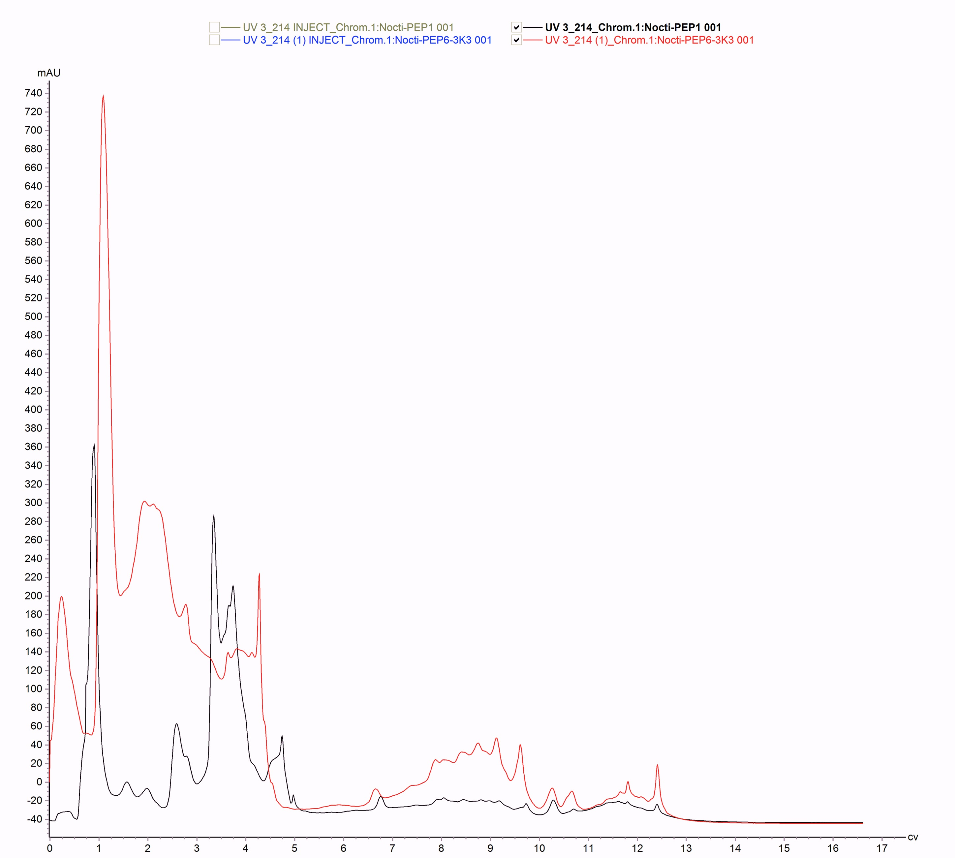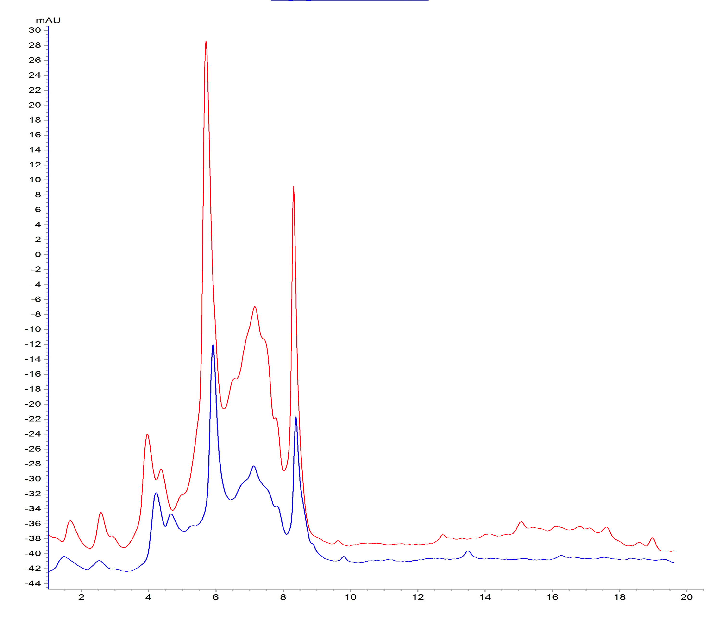
A
B

