pta
aor2
aor1
adhE1/2
L wt 2 wt 3 wt 4 wt 5 L

Figure S1. PCR amplifying internal fragments from Wild type(wt) and mutant strains, showing the presence of a gene in the wt, but loss in the deletion strain. L is the ladder. 2 is ∆pta, 3 is ∆pta ∆adhE1 ∆adhE2, 4 is ∆pta ∆aor2, 5 is ∆pta ∆aor2 ∆aor1. Primer sequences are in Table S1.

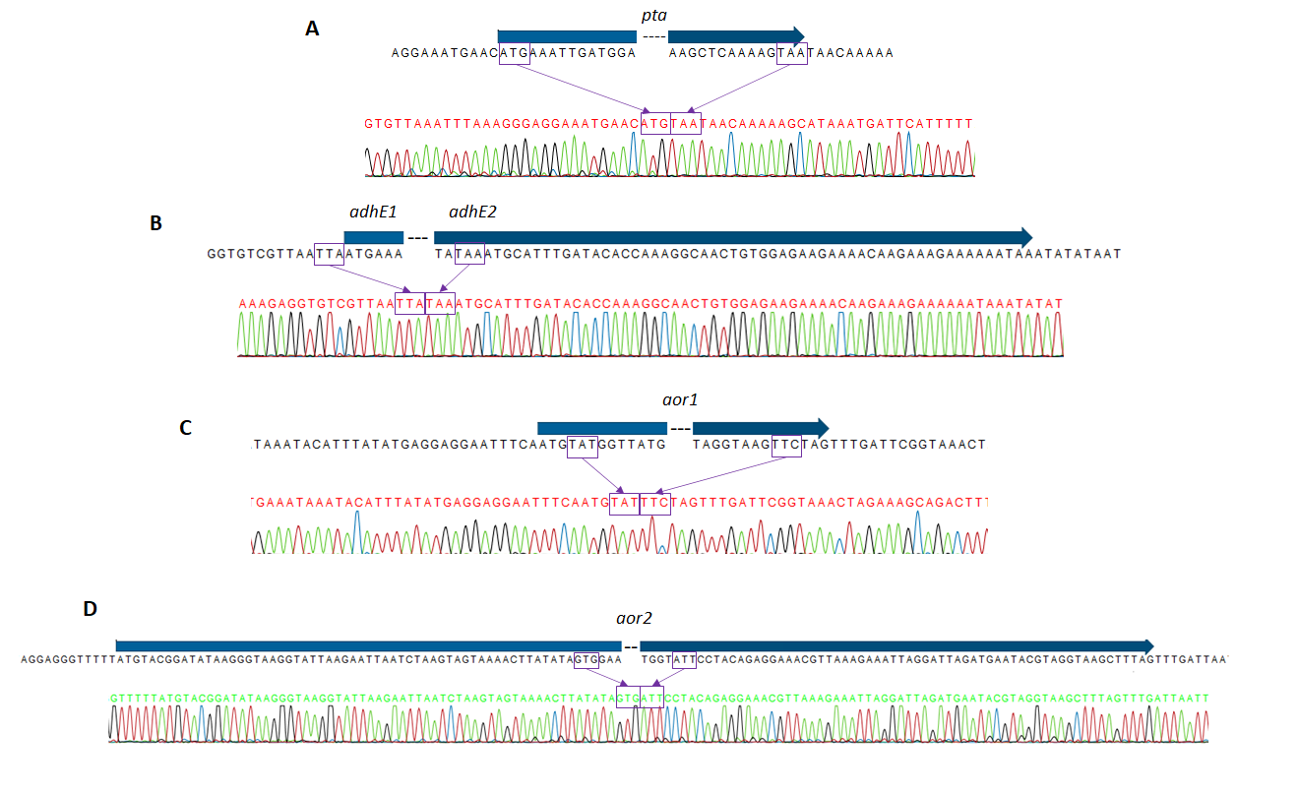
Figure S2. Sanger sequencing results of genomic regions showing deletions. Gene names are above blue arrows. Boxes outline where the deletions start and end in relation to the gene. The blue arrows indicate the location of the genes. A. pta deletion region. B. adhE1 and adhE2 deletion region. C. aor1 deletion region. D. aor2 deletion region.

Figure S3. Complementation of ∆pta ∆aor2 ∆aor1. Strains were grown on 5 g/L fructose for 144 hours and were measured for their fermentation products. pMTL83151 is the control plasmid. pta/ack is the plasmid expressing pta and ack under the native promoter. aor2 is the plasmid expressing aor2 under the native promoter. Both complementation strains show increased acetate, with pta/ack complementation showing double the acetate of ∆pta ∆aor2 ∆aor1, while aor2 complementation showed 50% more acetate. Error bars are standard deviation, n=3.

