Supplementary Material
Supplementary Table 1: Correlation matrix of NHEJ pathway genes based on Spearman’s correlations value in TCGA-COAD dataset.
 | XRCC6 | XRCC5 | PRKDC | XRCC4 | LIG4 | NHEJ1 | PAXX
XRCC6 | 1 | 0.4469757 | 0.1975668 | 0.2405135 | -0.07580873 | 0.1320411 | 0.03493542
XRCC5 | 0.4469757 | 1 | 0.3344423 | 0.4320771 | 0.3029311 | 0.11986 | -0.1243471
PRKDC | 0.1975668 | 0.3344423 | 1 | 0.24378 | 0.3130476 | 0.265947 | -0.2228298
XRCC4 | 0.2405135 | 0.4320771 | 0.24378 | 1 | 0.50295 | 0.0488774 | -0.1517053
LIG4 | -0.07580873 | 0.3029311 | 0.3130476 | 0.50295 | 1 | 0.05319917 | -0.2898128
NHEJ1 | 0.1320411 | 0.11986 | 0.265947 | 0.0488774 | 0.05319917 | 1 | -0.1648714
PAXX | 0.03493542 | -0.1243471 | -0.2228298 | -0.1517053 | -0.2898128 | -0.1648714 | 1

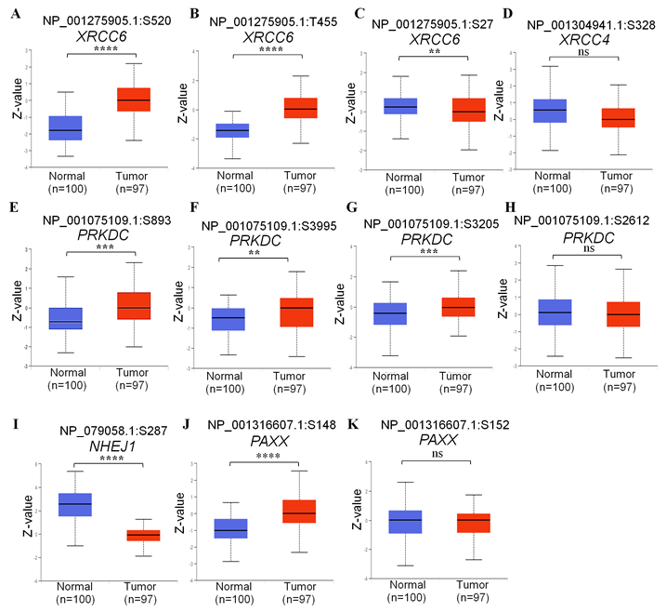
Supplementary figure S1: Comparison of phosphorylated protein levels of NHEJ pathway genes in normal and colon cancer tissues from CPTAC study, including (A) XRCC6 Ser520, (B) XRCC6 Thr455, (C) XRCC6 Ser27, (D) XRCC4 Ser328, (E) PRKDC Ser893, (F) PRKDC Ser3995, (G) PRKDC Ser3205, (H) PRKDC Ser2612, (I) XLF Ser287, (J) PAXX Ser148, and (K) PAXX Ser152. The peptides referenced for phosphoprotein detection have been depicted on top of each figure panel. *p<0.05, **p<0.01,***p<0.001,****p<0.0001.

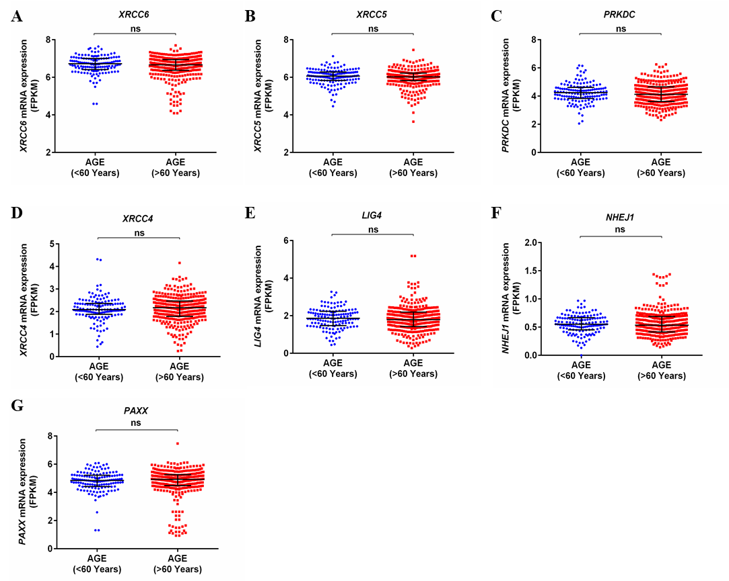

Supplementary Figure S2: Association of mRNA expression of NHEJ pathway genes from TCGA-COAD dataset with patient’s age. *p<0.05, **p<0.01,***p<0.001,****p<0.0001.

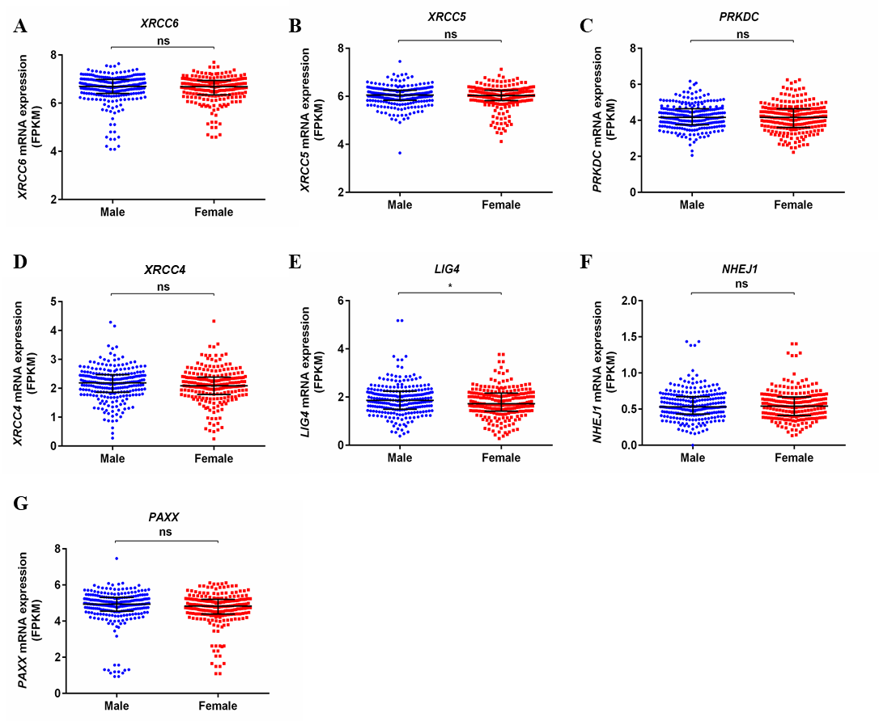Supplementary Figure S3: Association of mRNA expression of NHEJ pathway genes from TCGA-COAD dataset with gender. *p<0.05, **p<0.01,***p<0.001,****p<0.0001.
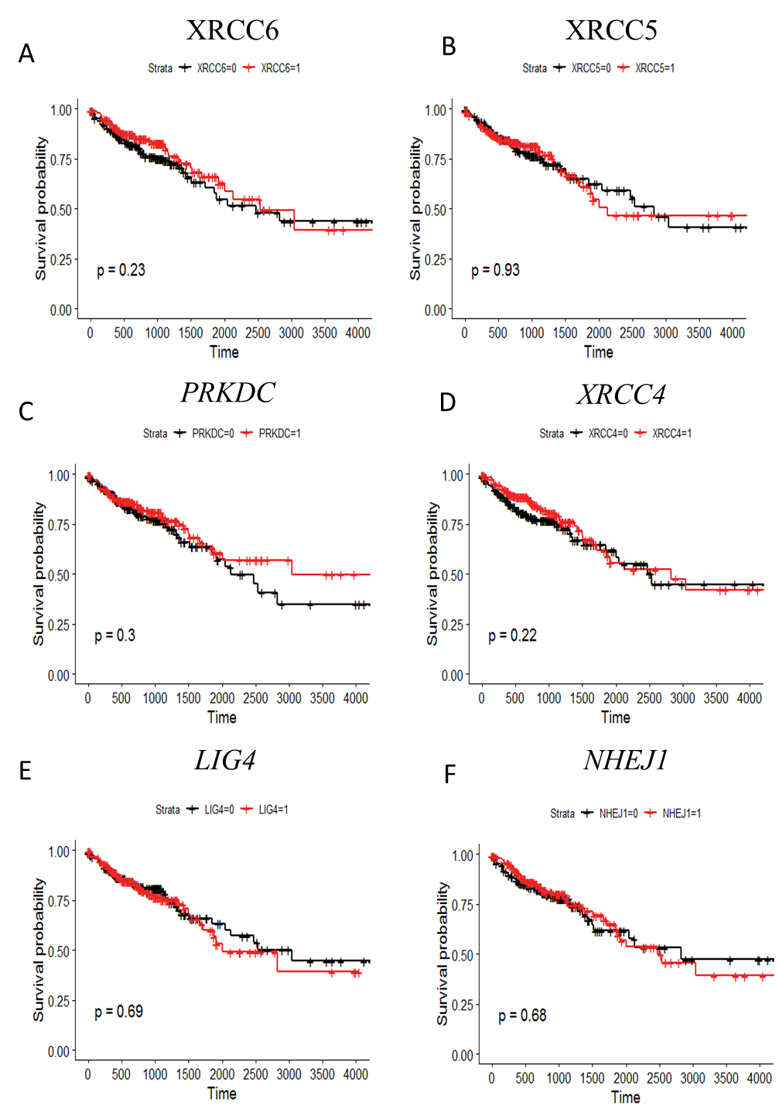
Supplementary Figure S4: Kaplan Meier survival curve for prognostic significance of NHEJ pathways genes for overall survival in colon cancer. (A) XRCC6, (B) XRCC5, (C) PRKDC, (D) XRCC4, (E) LIG4, and (F) NHEJ1. Patients were divided into two groups based on median expression value of respective genes from TCGA-COAD dataset. Survival probabilities are presented on the y-axis and time in days on the x-axis in all graphs. Log rank test p-values have been depicted in respective graphs.
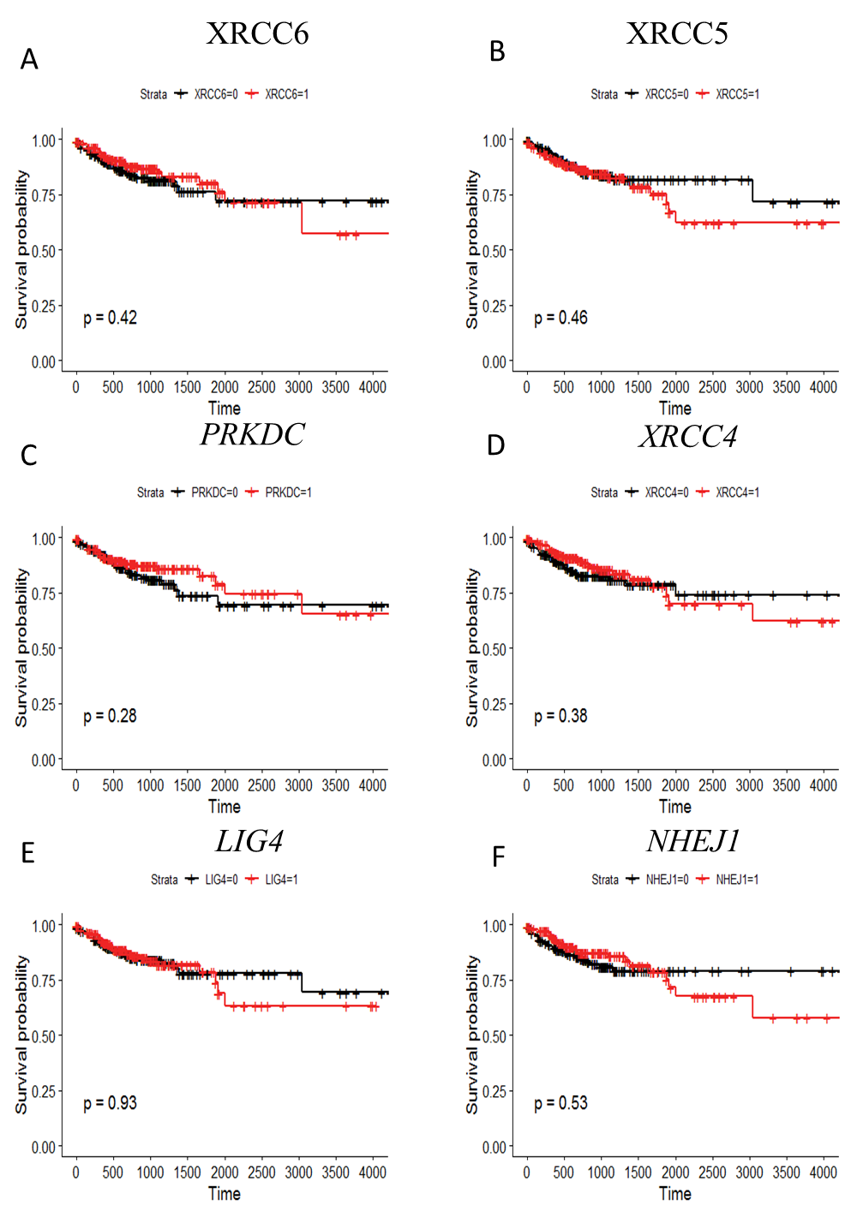
Supplementary Figure S5: Kaplan Meier survival curve for prognostic significance of NHEJ pathways genes for disease specific survival in colon cancer. (A) XRCC6, (B) XRCC5, (C) PRKDC, (D) XRCC4, (E) LIG4, and (F) NHEJ1. Patients were divided into two groups based on median expression value of respective genes from TCGA-COAD dataset. Survival probabilities are presented on the y-axis and time in days on the x-axis in all graphs. Log rank test p-values have been depicted in respective graphs.
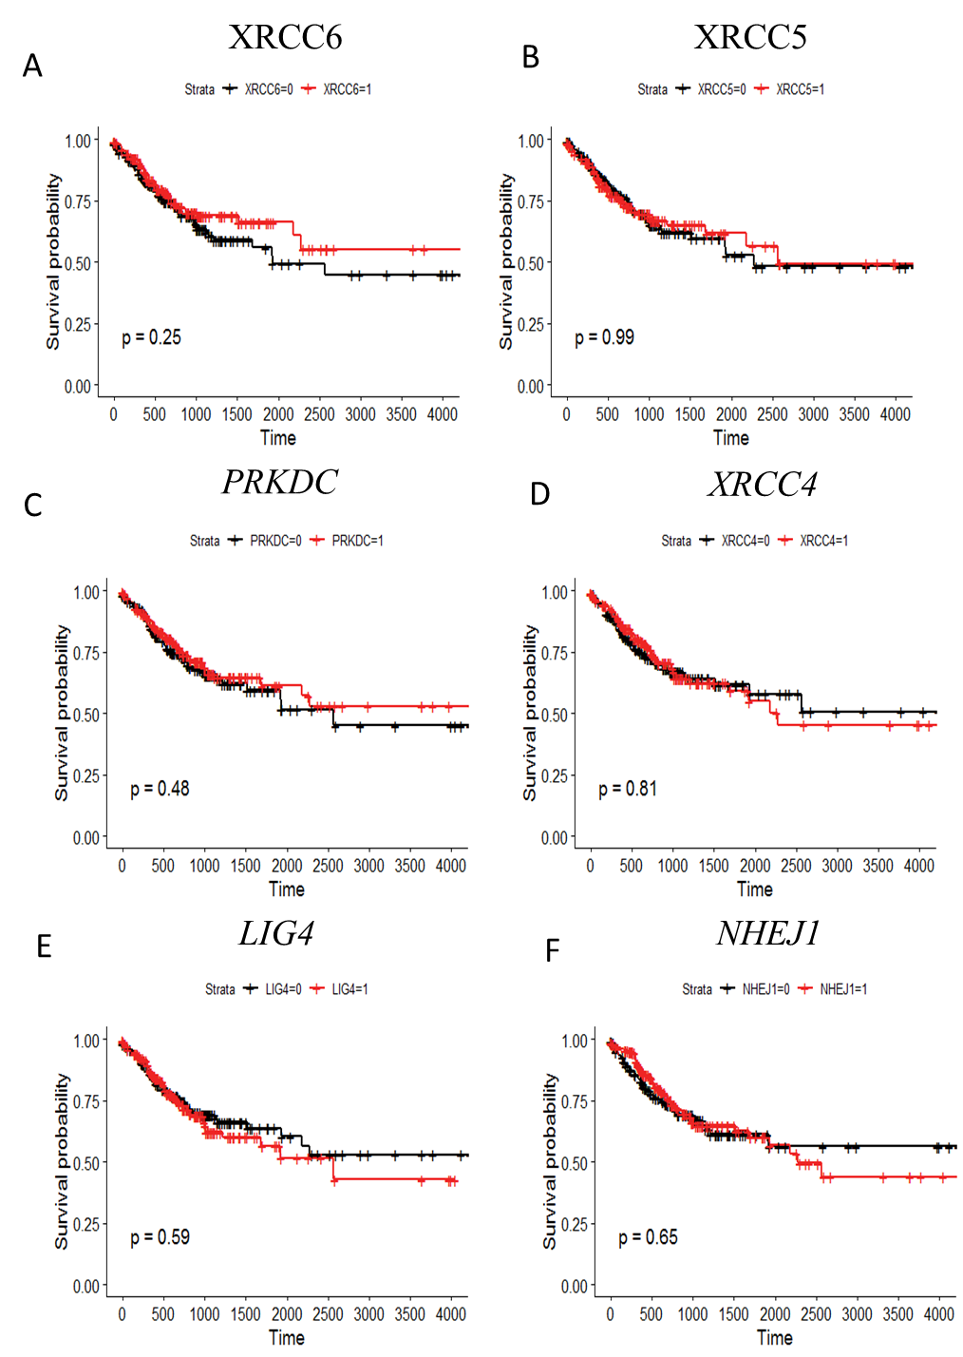
Supplementary Figure S6: Kaplan Meier survival curve for prognostic significance of NHEJ pathways genes for progression free interval in colon cancer. (A) XRCC6, (B) XRCC5, (C) PRKDC, (D) XRCC4, (E) LIG4, and (F) NHEJ1. Patients were divided into two groups based on median expression value of respective genes from TCGA-COAD dataset. Survival probabilities are presented on the y-axis and time in days on the x-axis in all graphs. Log rank test p-values have been depicted in respective graphs.
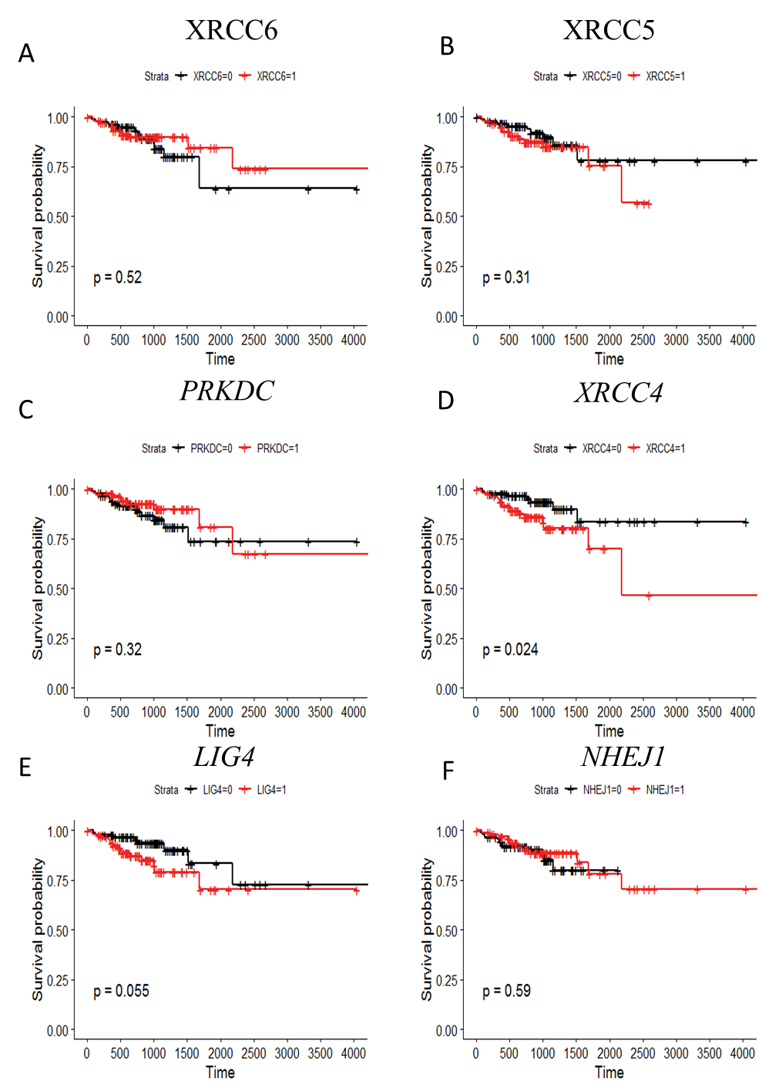
Supplementary Figure S7: Kaplan Meier survival curve for prognostic significance of NHEJ pathways genes for disease free interval in colon cancer. (A) XRCC6, (B) XRCC5, (C) PRKDC, (D) XRCC4, (E) LIG4, and (F) NHEJ1. Patients were divided into two groups based on median expression value of respective genes from TCGA-COAD dataset. Survival probabilities are presented on the y-axis and time in days on the x-axis in all graphs. Log rank test p-values have been depicted in respective graphs.
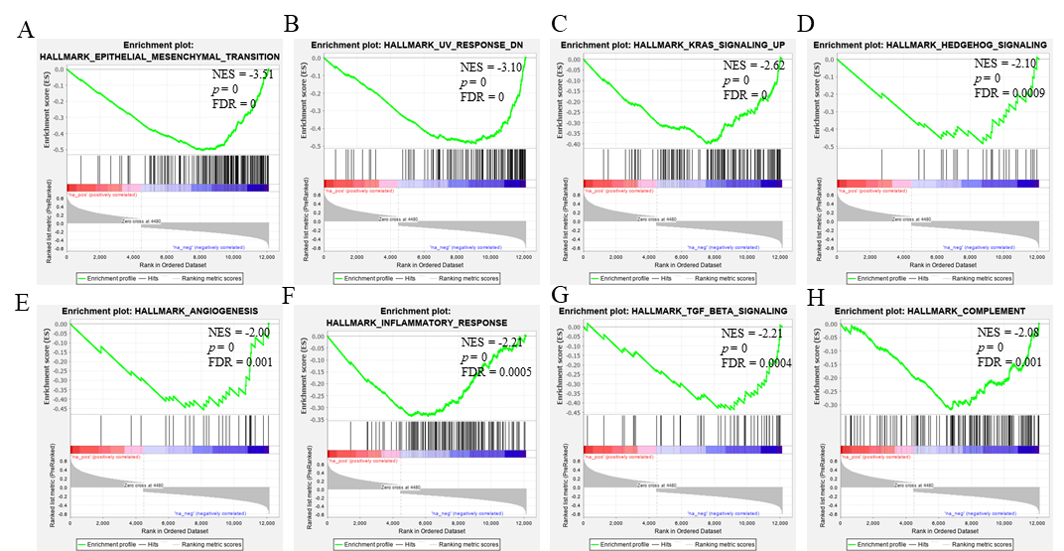
Supplementary Figure S8: Gene set enrichment analysis of PAXX correlated genes in the TCGA-COAD dataset. Each plot (A-H) depicts negatively enriched pathways of PAXX correlated genes with Normalized ES (NES), false discovery rate (FDR), and p-value depicted inside the respective pathway panel.

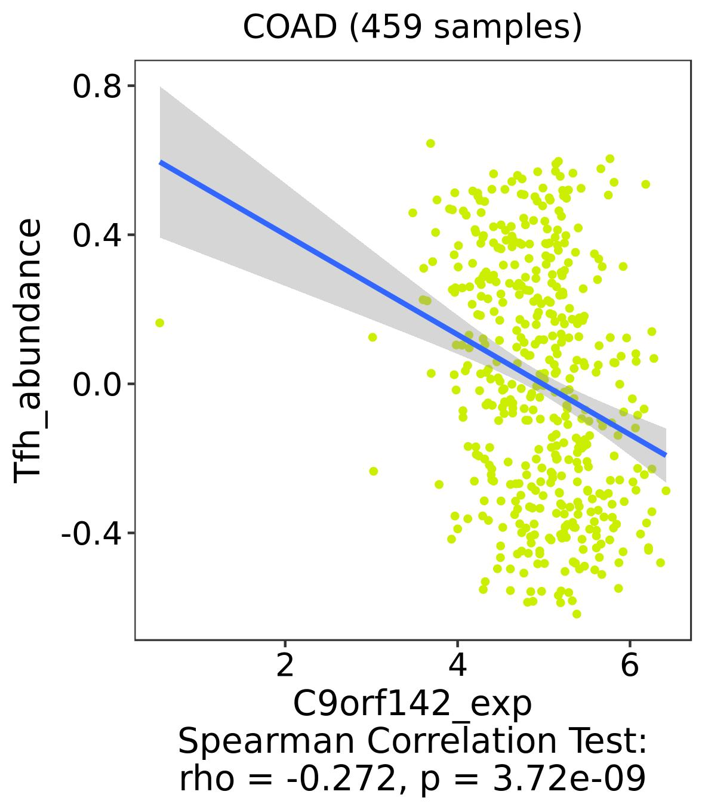
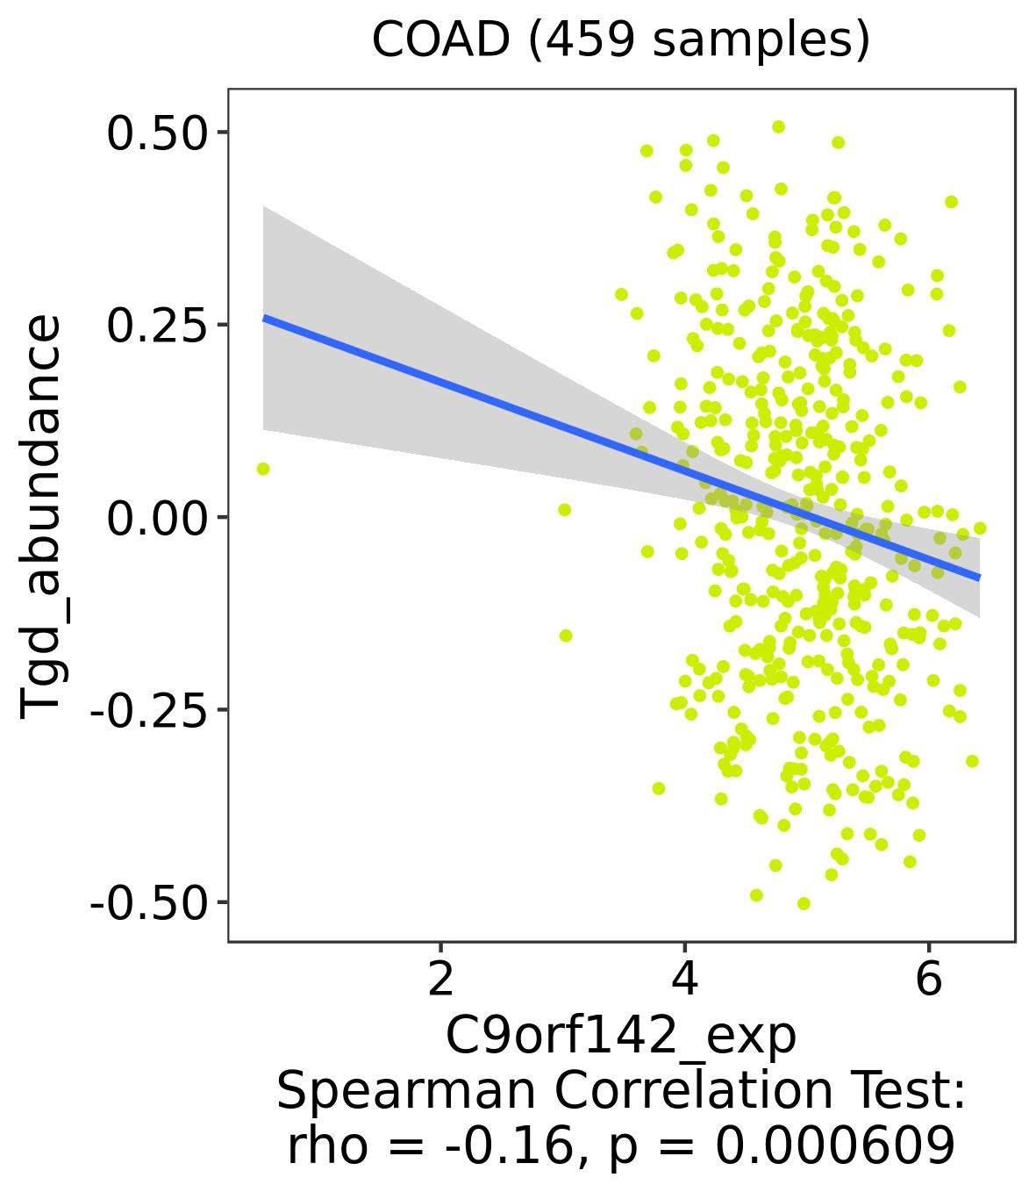
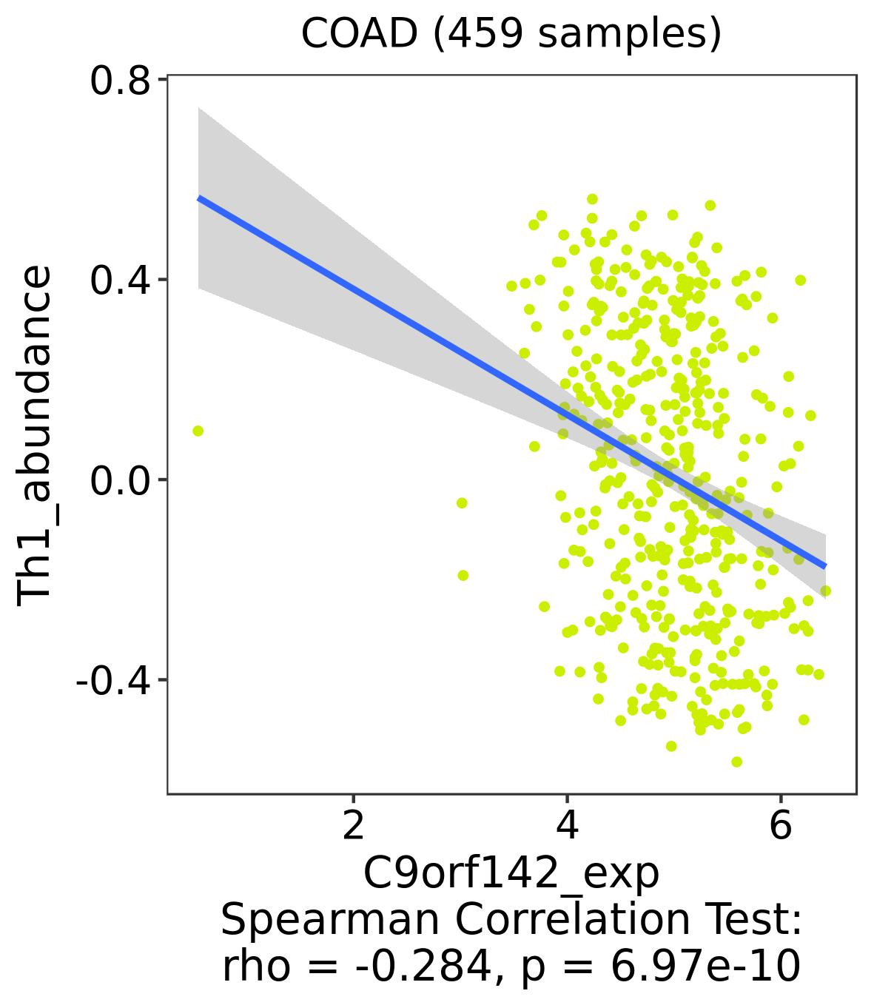
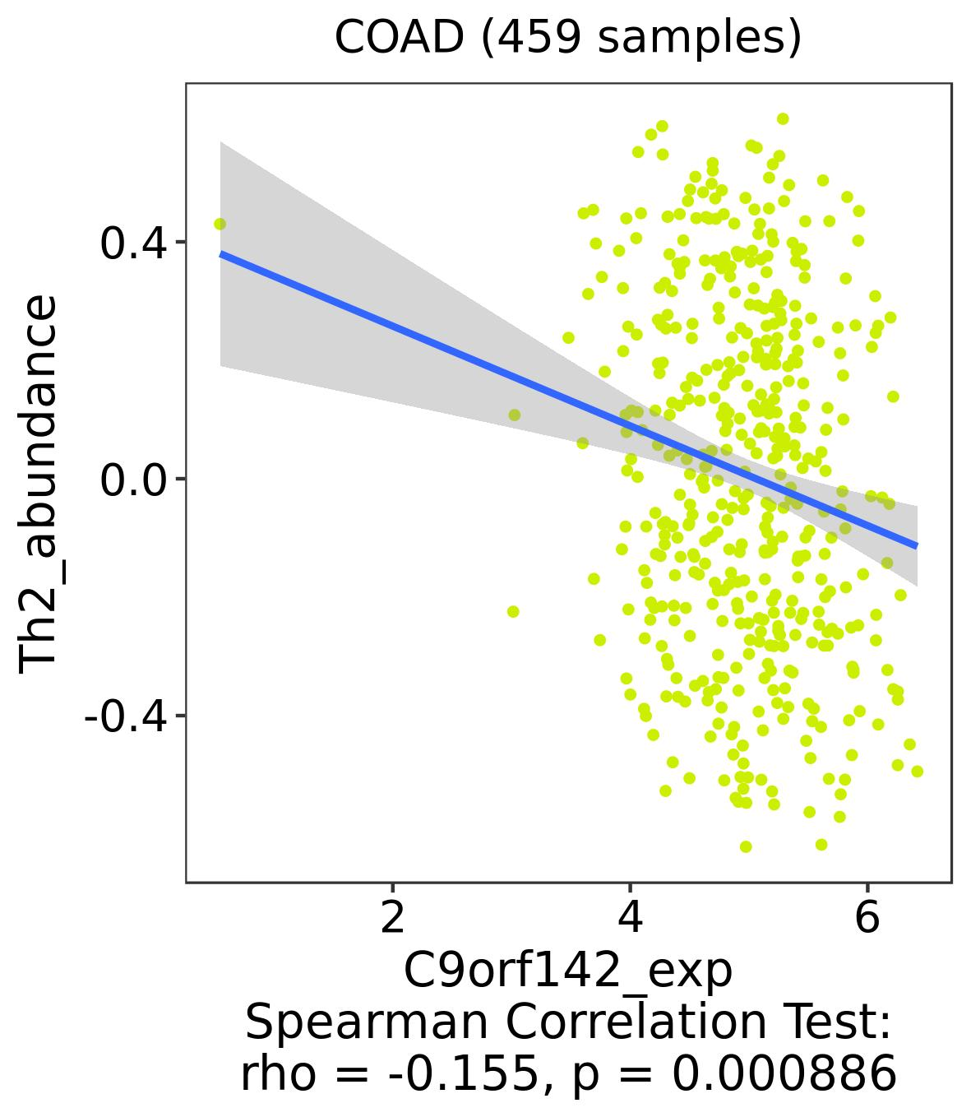
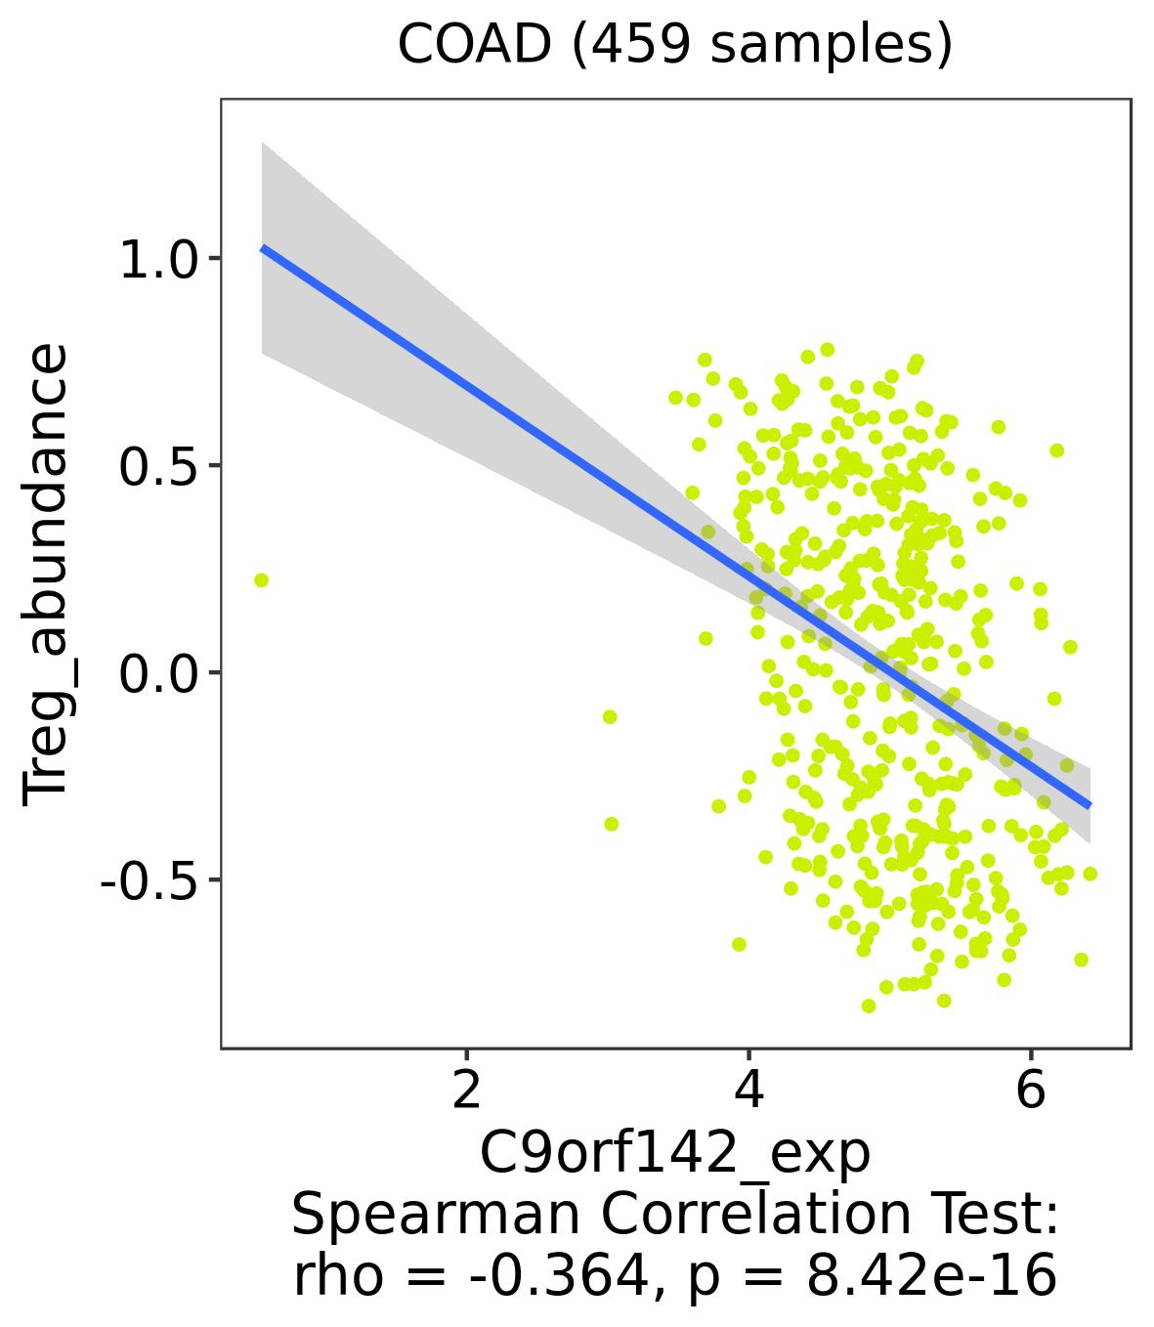
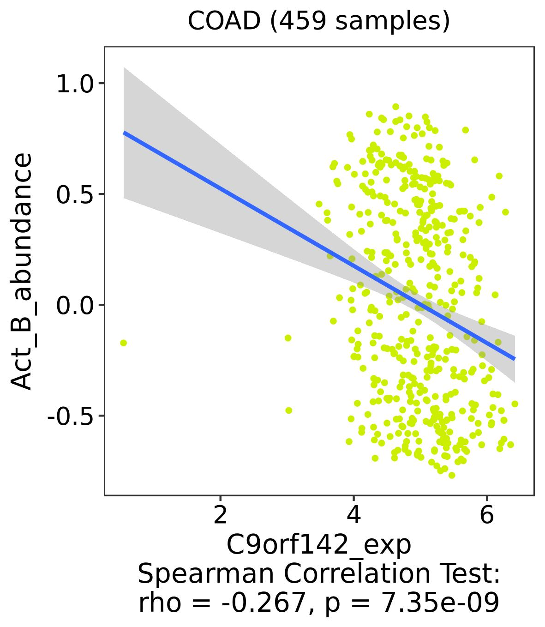
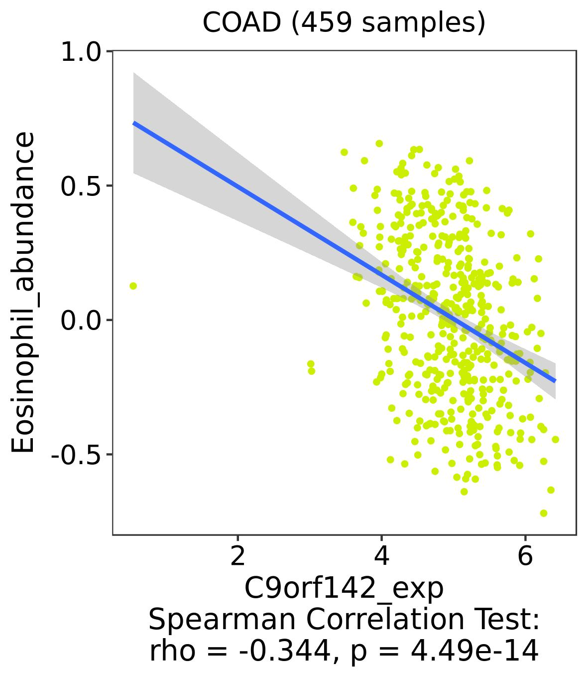
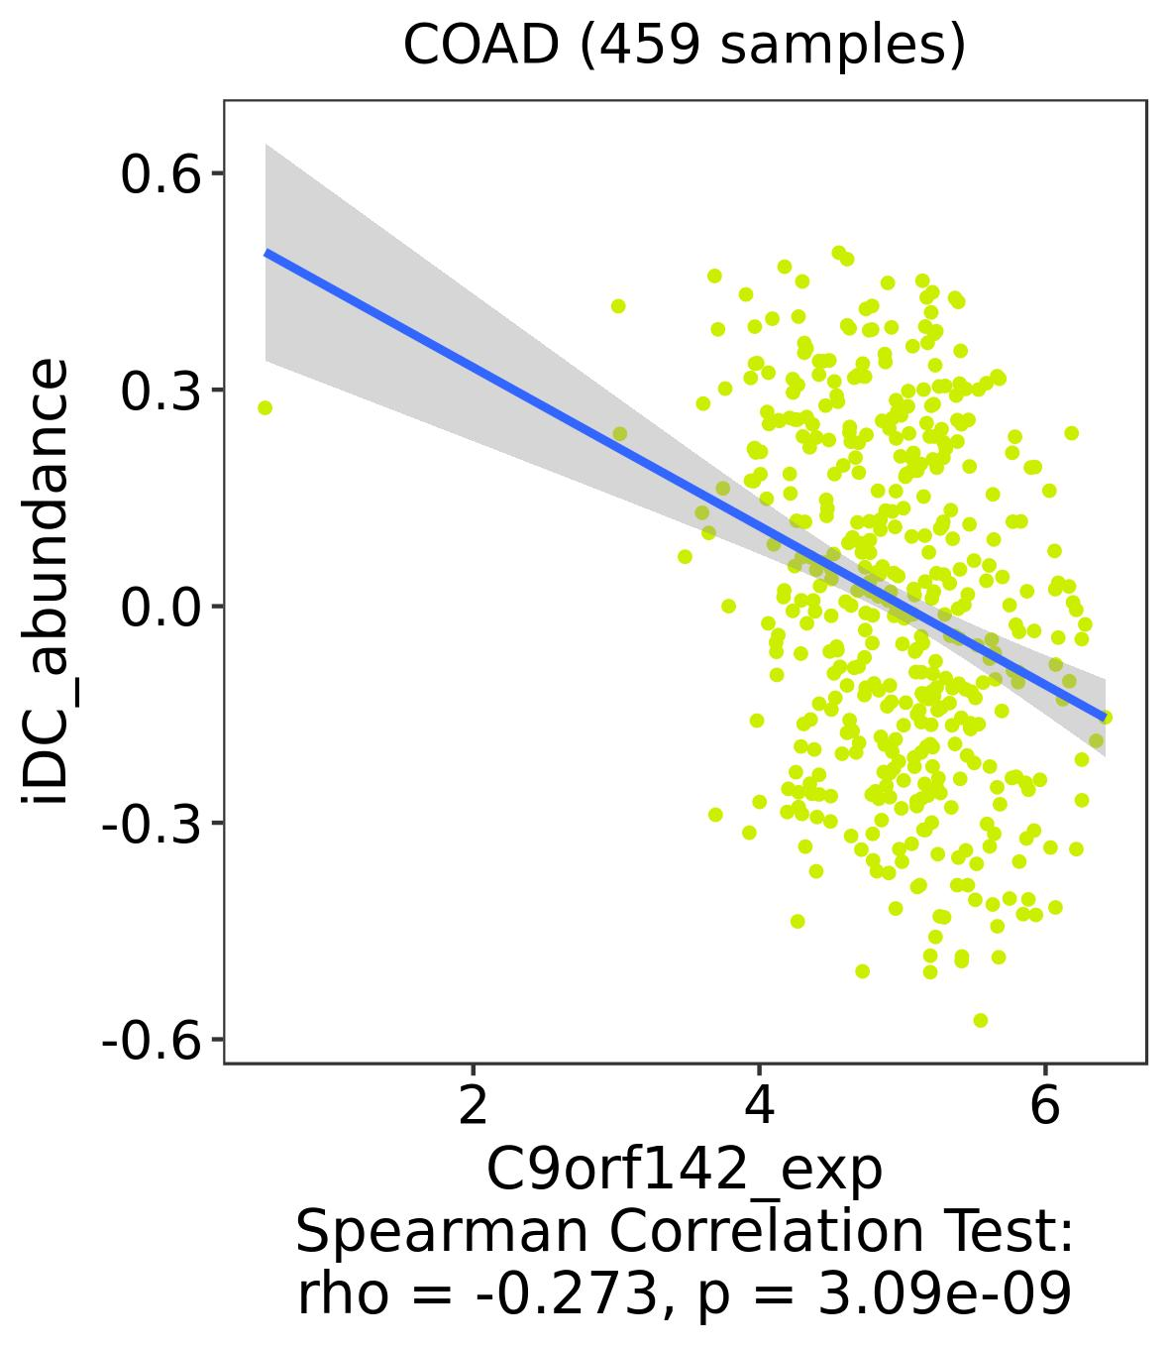
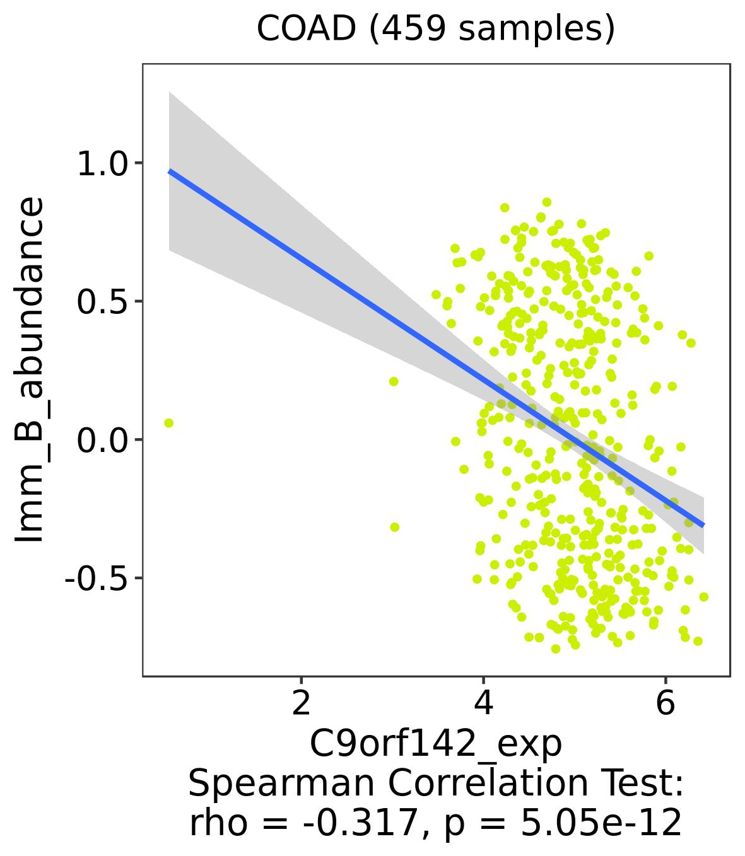
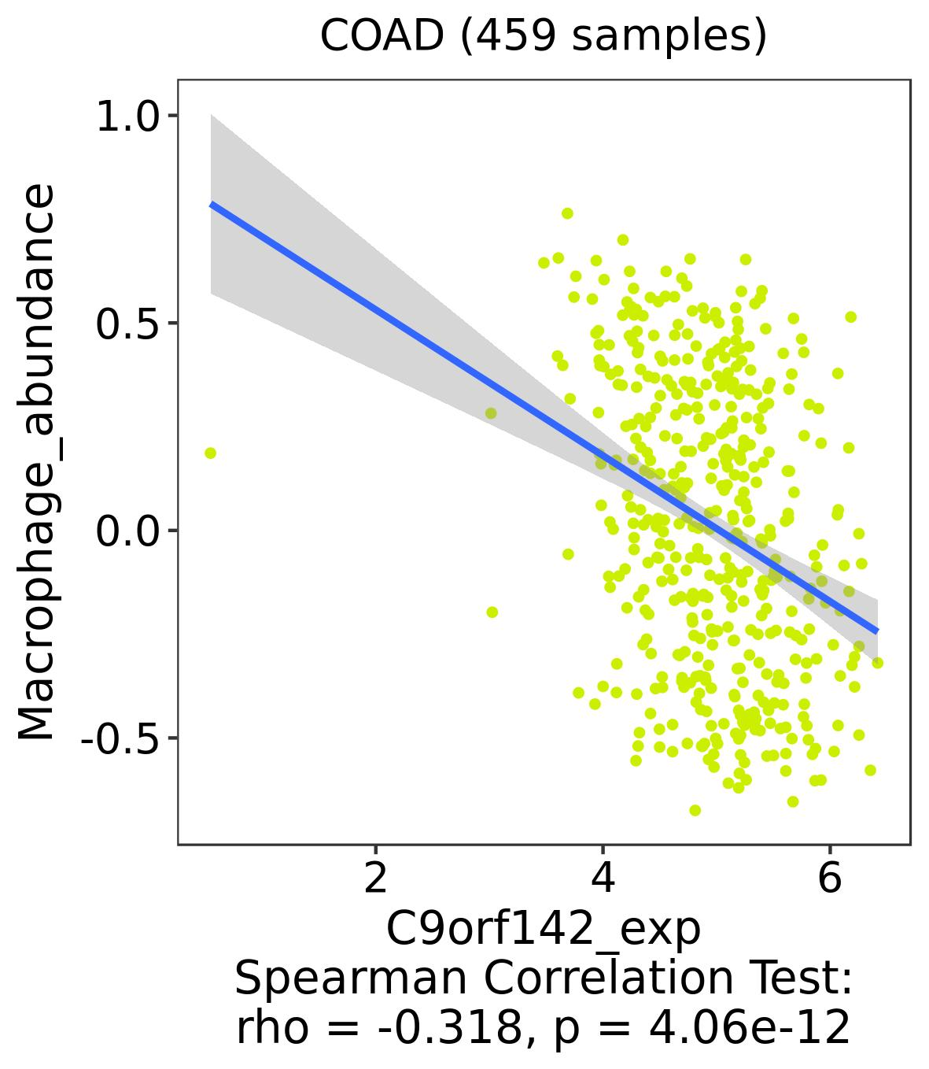
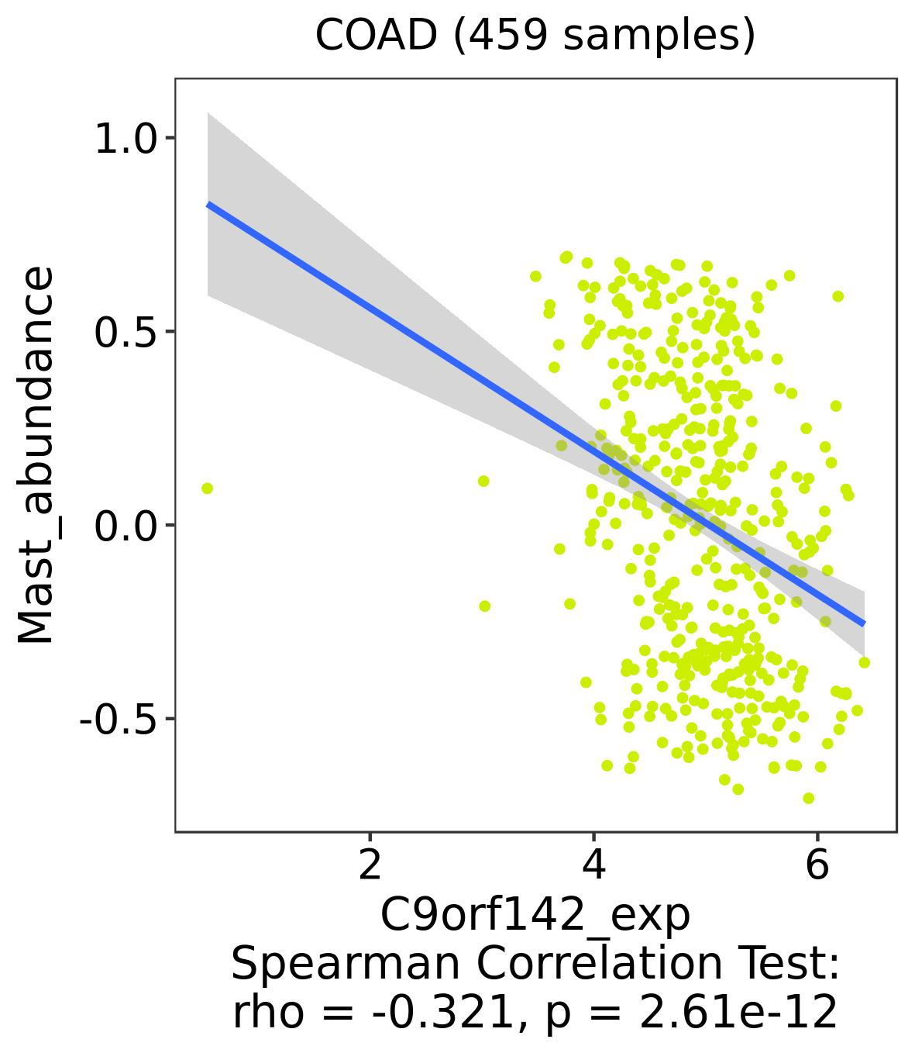
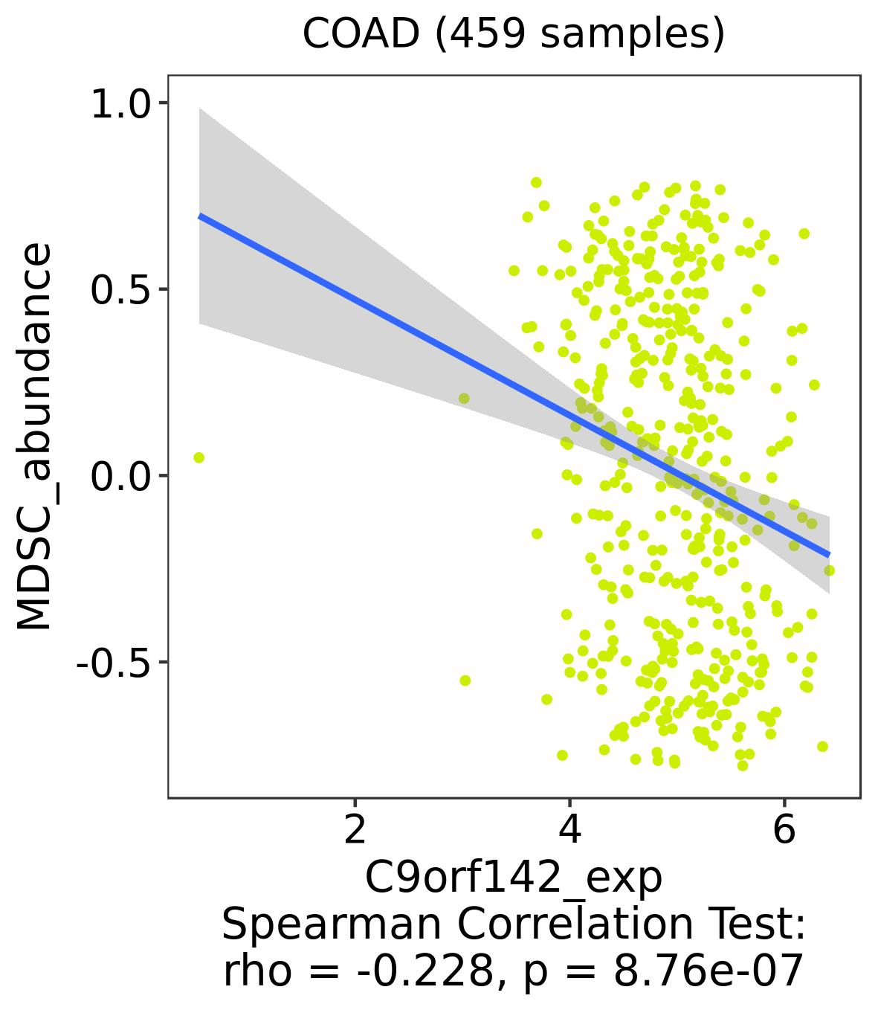
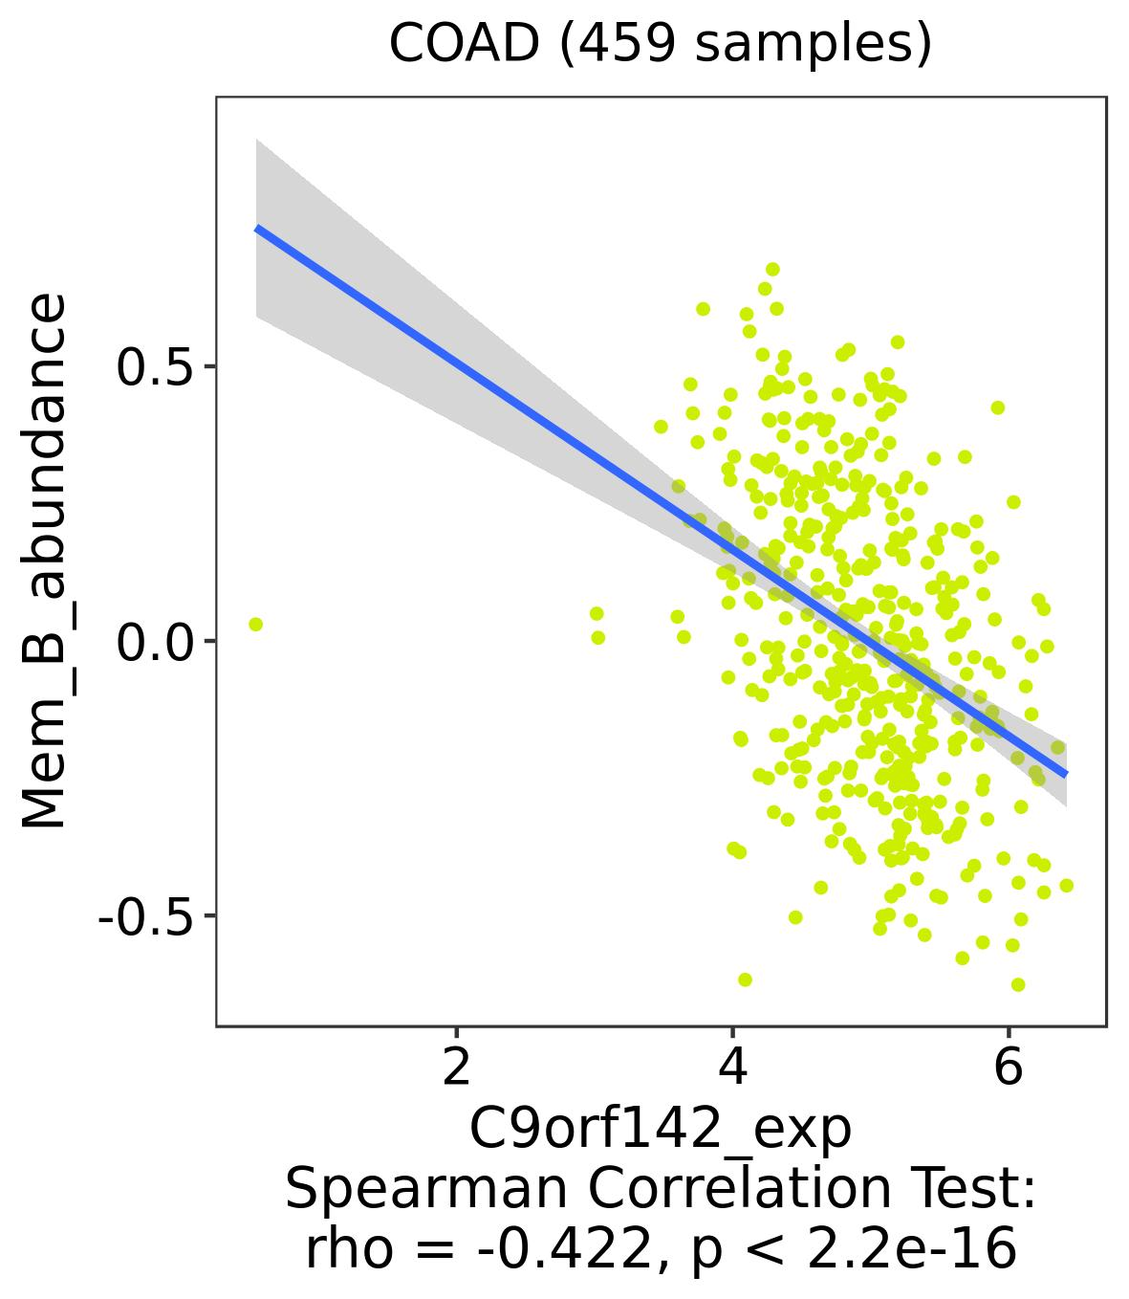
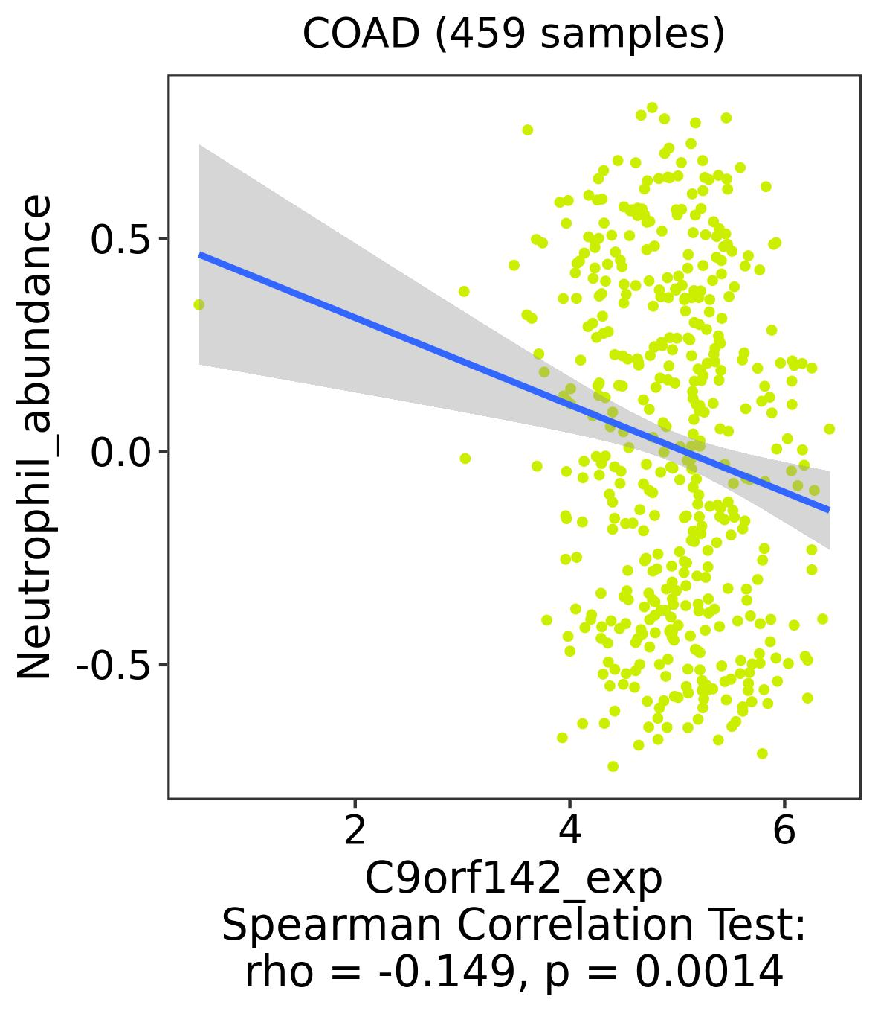
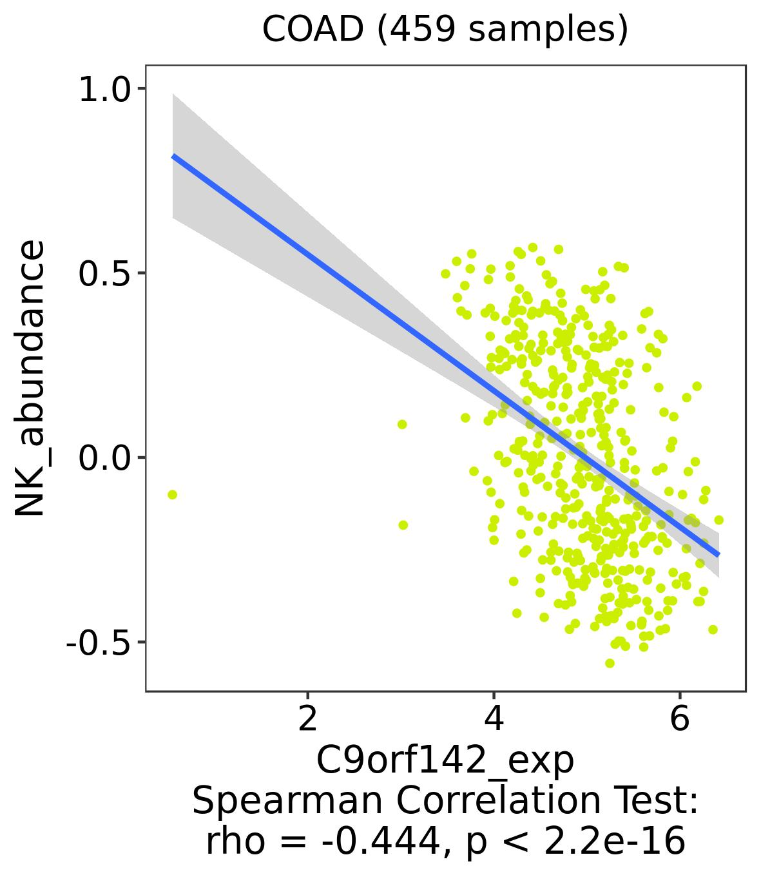
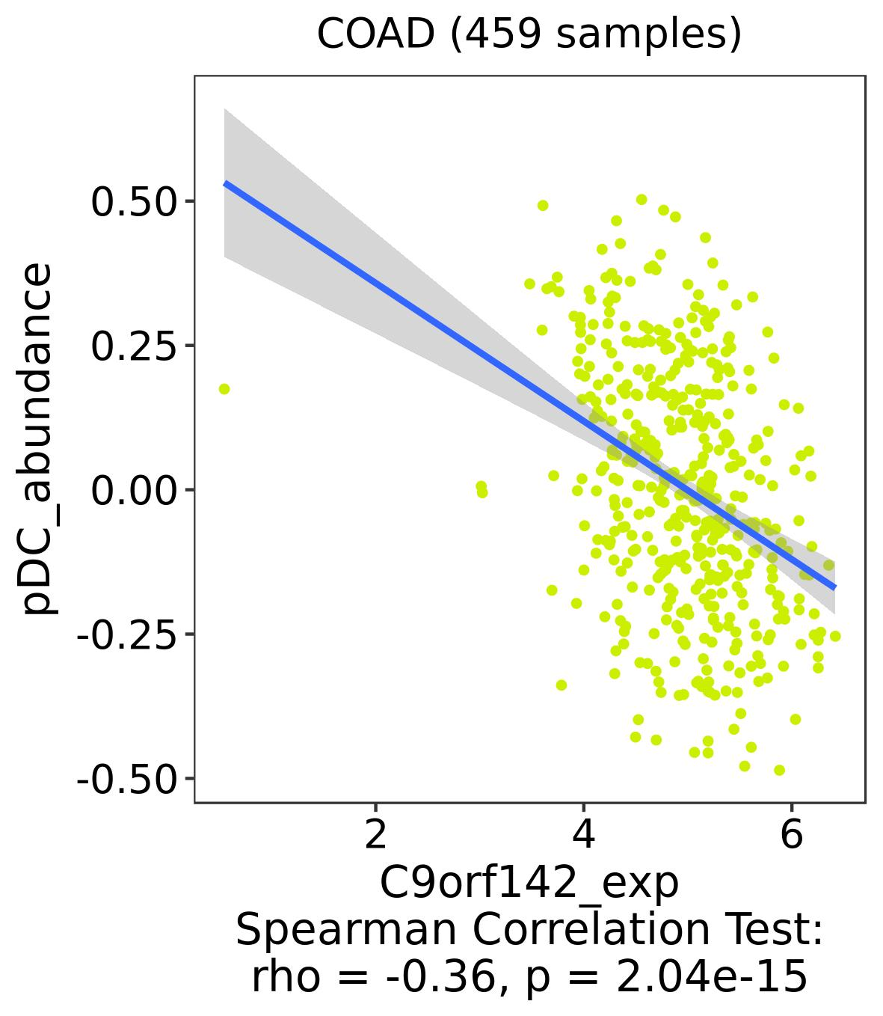
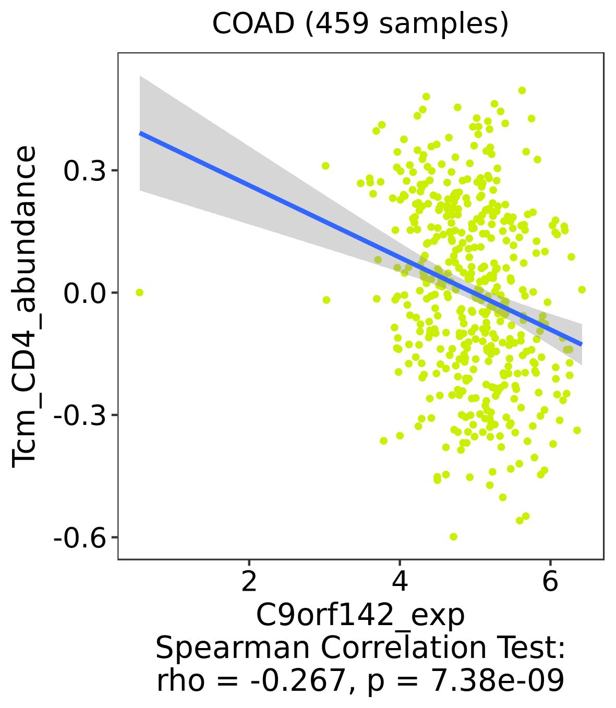
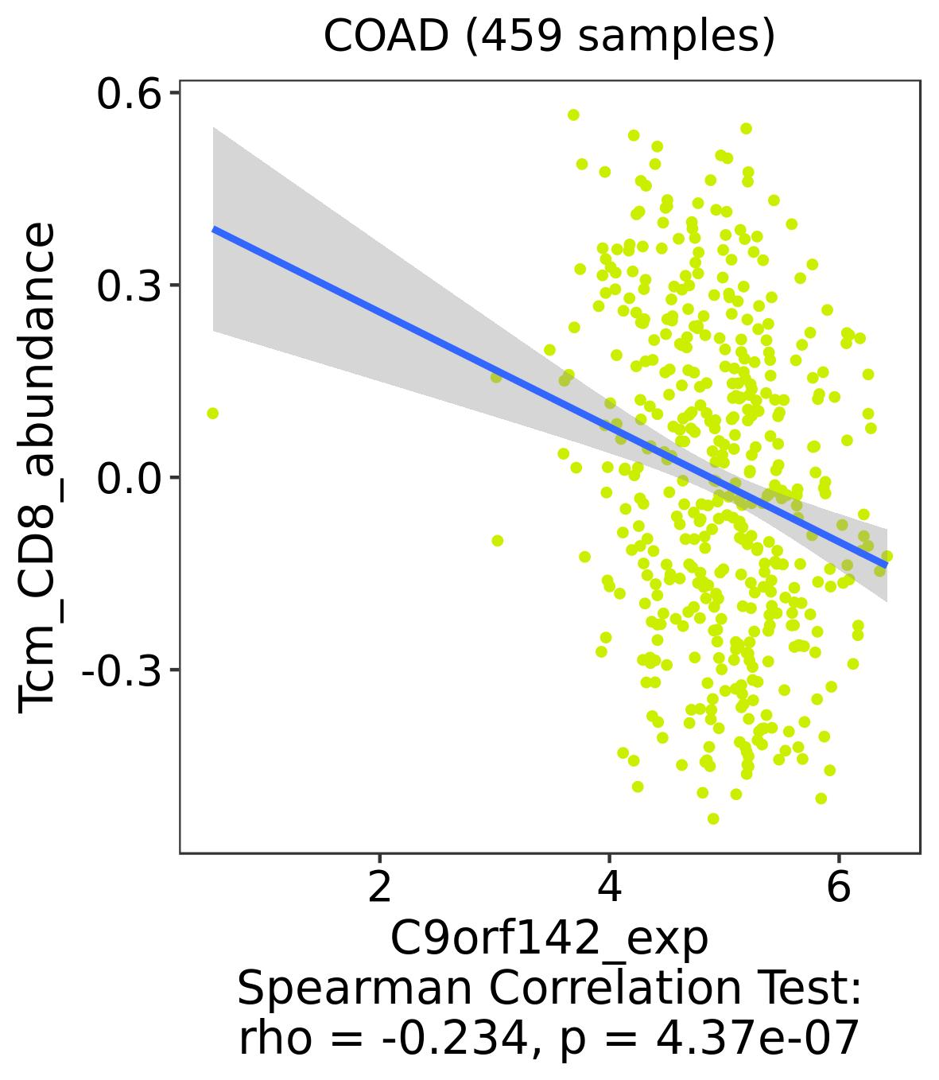
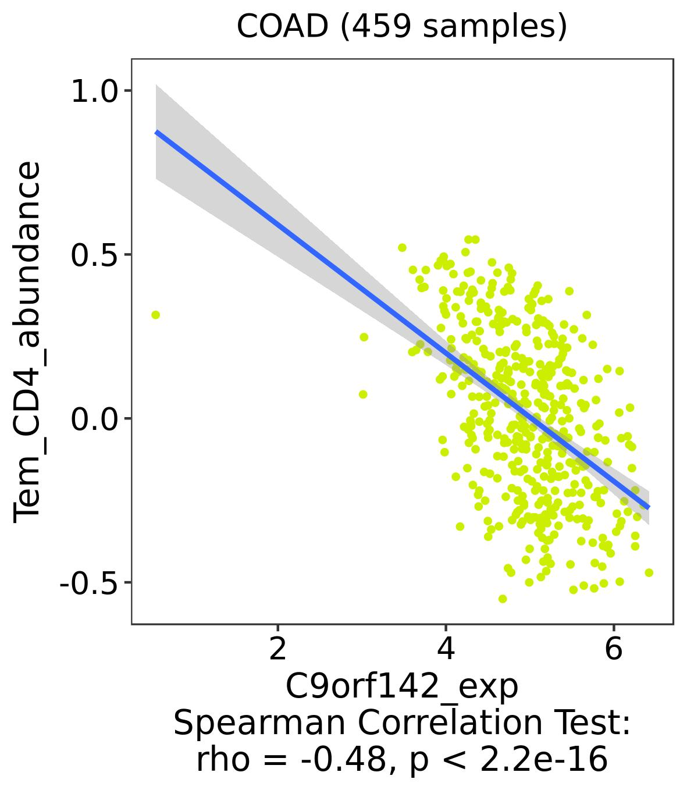
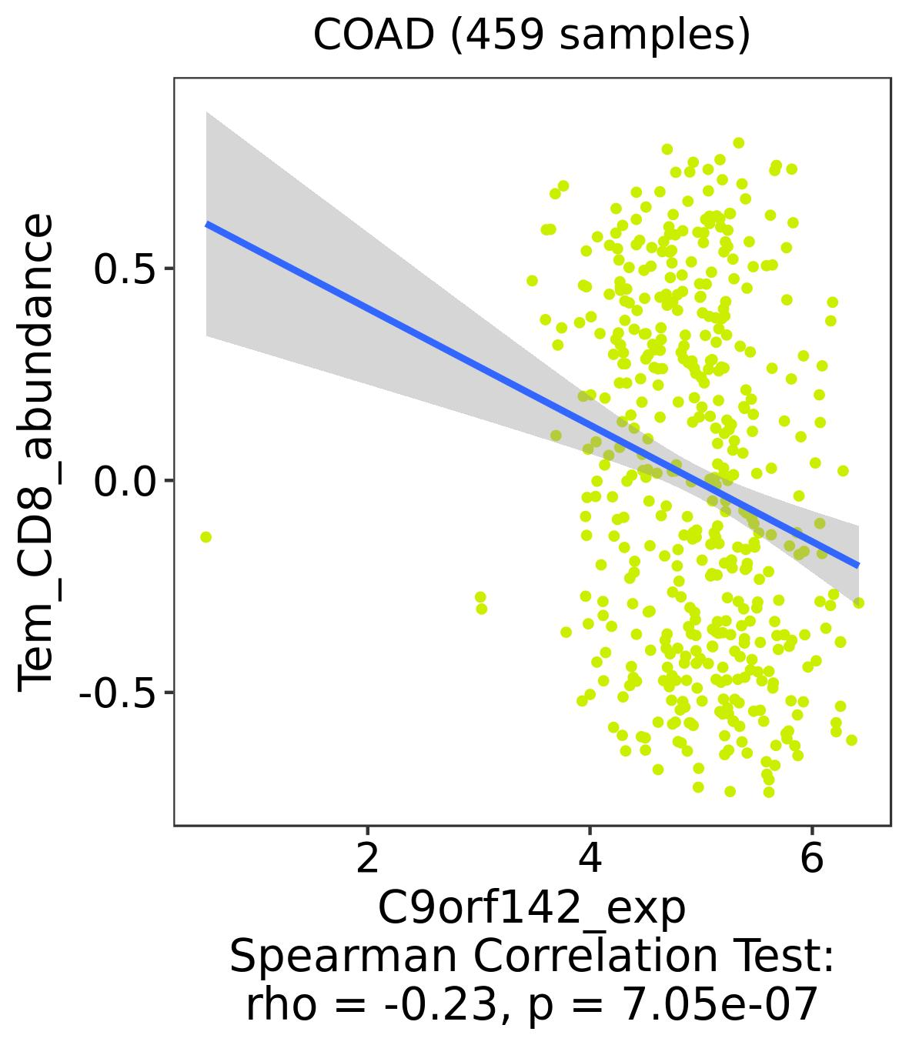

Supplementary Figure S9: Association of PAXX mRNA expression with 20 different immune cell types in TCGA-COAD dataset estimated from the TISIDB web server.

