Supplementary material

EFFICIENT PLANT PRODUCTION OF RECOMBINANT NS1 PROTEIN FOR DIAGNOSIS OF DENGUE

Mariana Fonseca Xisto¹, Roberto Sousa Dias¹, Elias Feitosa Araujo², John Willians Oliveira Prates³, Cynthia Canedo da Silva³, Sérgio Oliveira de Paula¹

¹ Department of General Biology, Federal University of Viçosa, Viçosa, Minas Gerais, Brazil.
² Department of Plant Biology, Federal University of Viçosa, Viçosa, Minas Gerais, Brazil.
³ Department of Microbiology, Federal University of Viçosa, Viçosa, Minas Gerais, Brazil.

* Corresponding author: e-mail: depaula@ufv.br Av. Peter Henry Rolfs, s / n - University campus (UFV), Laboratory of Molecular Immunovirology, Viçosa-MG, 36570-000, Tel: + 55-31-36125015

Key words: Dengue, NS1 protein, Arabidopsis thaliana, Diagnosis

Supplementary figure 1. Cloning of the NS1DENV2 gene in Agrobacterium tumefaciens. A) Double vector digestion pCAMBIA3301_empty. MM - Lambda/HindIII DNA molecular marker, 1 - digested plasmid, 2 - undigested plasmid; B) Double vector digest pUC57_NS1DENV2. MM - 100 bp DNA molecular marker, 1 - digested plasmid, 2 - undigested plasmid; C) Confirmation of transformation of E. coli with pCAMBIA3301_NS1DENV2. MM - 1 kb DNA molecular marker, 1-2 - digested plasmids; D) Confirmation of transformation of A. tumefaciens with pCAMBIA3301_NS1DENV2. MM – 1 kb DNA molecular marker, 1-5 - digested plasmids.

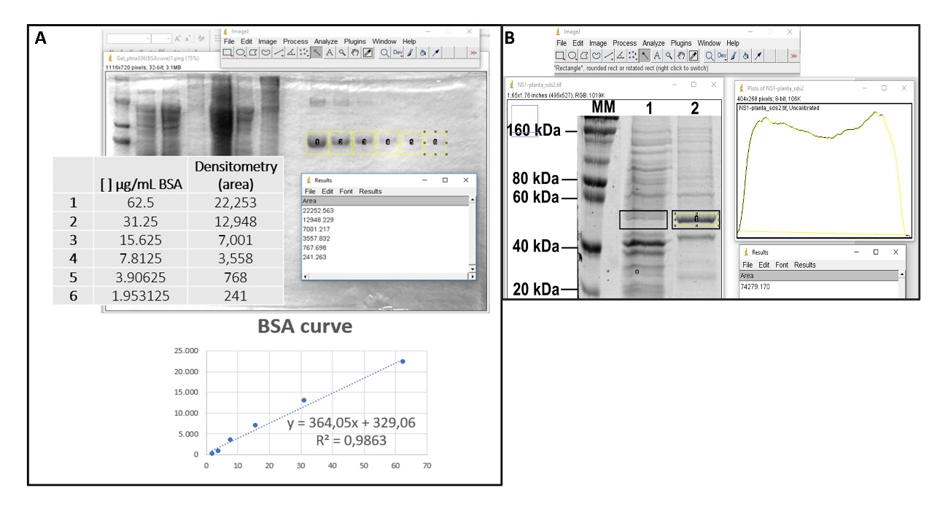
Supplementary figure 2. Densitometry analysis. Protein quantification was performed using ImageJ software, based on standard curve. A – Standard curve obtained by bovine serum albumin (BSA) dilution. B – Pixel density of the sample is interpolated with standard curve.

Total yield was obtained by multiplication of the quantity recovery from 1 gr of fresh leaf by the total weight. As resumed by this equation $Y=d x 1000$
Y = yield (mg/kg)
d = protein concentration by densitometry (µg/mL)
as each 1 mL comes from 1 gr of fresh leaf, the protein concentration obtained needs be multiplied by the total grams in one kilogram.

