Supplementary figures

Figure S1. ADL score of the participants in this study.
463 participants were involved in this study. 218 participants were healthy controls, and 245 participants were disability cases.
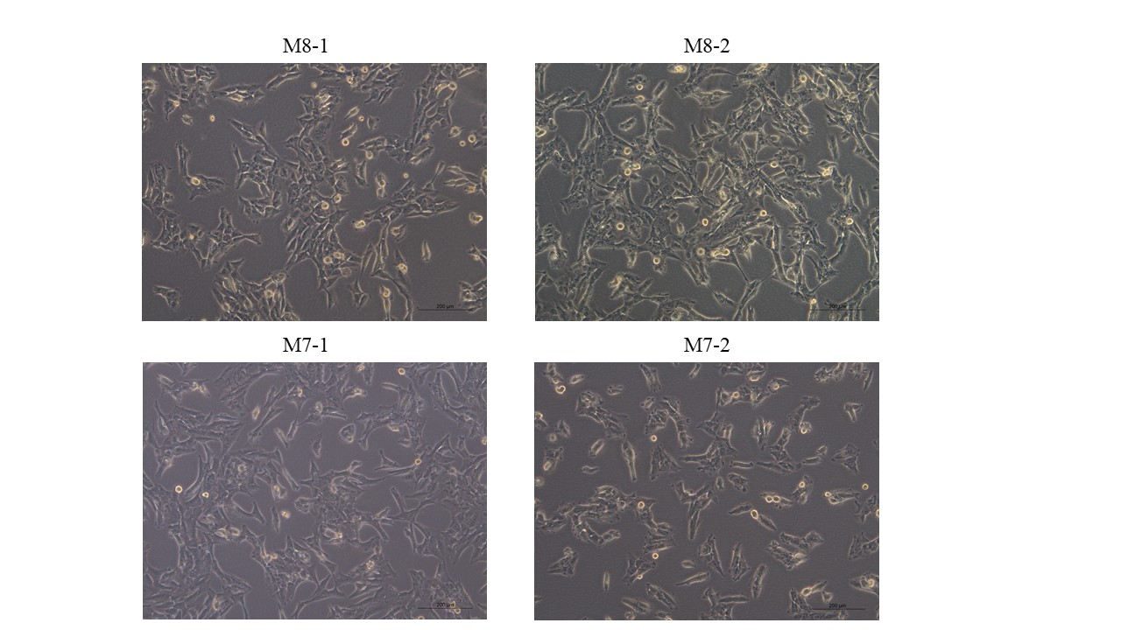
Figure S2. Morphometric analysis of M7 cybrids and M8 cybrids.
Morphology of M8 and M7 cybrids in their best growth conditions. The scale bar is 200 µm.
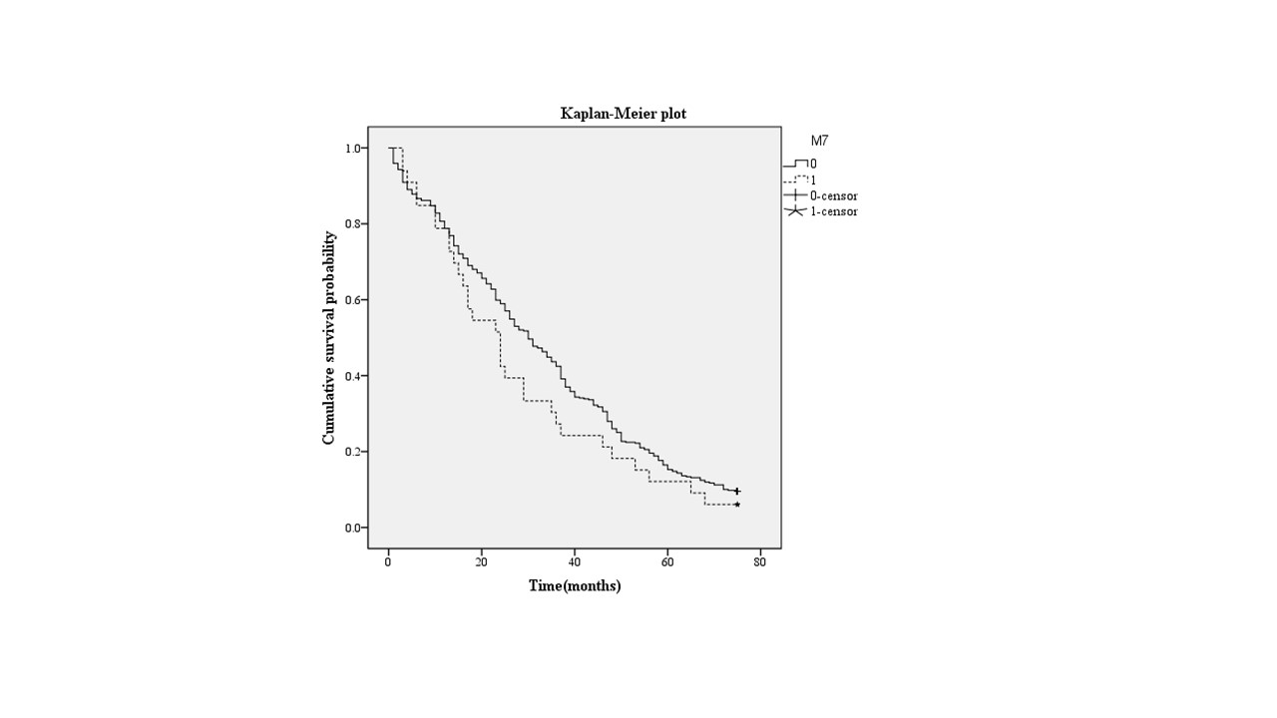
Figure S3. Kaplan-Meier survival analysis of M7 and non-M7 haplogroup groups.
Kaplan–Meier survival analysis shows the survival rate of the M7 haplogroup group and non-M7 haplogroup groups after a six-year follow-up. LogRank =0.188.

Table S1 Distribution of basic indicators in different disability groups

 | Normal | Disability | All | p-value
 | (n = 218) | (n = 245) | (n = 463)
Age | 97.25 ± 2.02 | 97.58 ± 2.16 | 97.42 ± 2.10 | 0.095
Gender (%) |  |  |  | 0.098
Male | 55 (25.2%) | 48 (19.5%) | 103 (22.2%)
Female | 163 (74.8%) | 197 (80.5%) | 360 (77.8%)
Marriage status |  |  |  | 0.875
Married | 12 (5.5%) | 11 (4.5%) | 23 (5.0%)
Widowed | 204 (93.6%) | 232 (94.7%) | 436 (94.2%)
Unmarried | 2 (0.9%) | 2 (0.8%) | 4 (0.9%)
Smoking habits |  |  |  | 0.292
Smoked | 20 (9.2%) | 18 (7.3%) | 38 (8.2%)
Never smoked | 198 (90.8%) | 227 (92.7%) | 425 (91.8%)
Drinking habits |  |  |  | 0.213
Drink | 78 (35.8%) | 78 (31.8%) | 156 (33.7%)
Never | 140 (64.2%0 | 167 (68.2%0 | 307 (66.3%)
Height (cm) | 153.47 ± 10.16 | 153.63 ± 11.78 | 153.55 ± 11.03 | 0.873
Weight (kg) | 52.01 ± 10.88 | 50.40 ± 11.53 | 51.17 ± 11.24 | 0.125
BMI (kg/m2) | 21.91 ± 4.19 | 21.18 ± 4.12 | 21.53 ± 4.17 | 0.062
SBP (mmHg) | 138.93 ± 22.62 | 134.72 ± 22.52 | 136.71 ± 22.64 | 0.046
DBP (mmHg) | 80.48 ± 11.05 | 79.59 ± 10.99 | 80.01 ± 11.02 | 0.382
Hypertension | 111 (50.9%) | 101 (41.2%) | 212 (45.8%) | 0.023
GLU (mmol/L) | 4.87 ± 1.23 | 5.01 ± 1.40 | 4.95 ± 1.32 | 0.381
ADL | 6.00 ± 0.00 | 11.06 ± 3.62 | 8.33 ± 3.66 | <0.001
IADL | 10.15 ± 3.00 | 14.55 ± 2.80 | 12.47 ± 3.64 | <0.001
Hemoglobin (g/L) | 128.44 ± 19.42 | 128.47 ± 20.68 | 128.45 ± 20.09 | 0.987
Platelets (10^⁹/L) | 158.65 ± 59.16 | 172.16 ± 73.94 | 165.87 ± 67.73 | 0.035
White blood cell (10^⁹/L) | 5.40 ± 1.60 | 5.44 ± 1.74 | 5.42 ± 1.67 | 0.79
Albumin (g/L) | 43.10 ± 4.23 | 41.56 ± 8.86 | 42.27 ± 4.64 | <0.001
Protein (g/L) | 70.61 ± 6.54 | 69.74 ± 6.55 | 70.15 ± 6.55 | 0.159
Phosphatase (IU/L) | 82.65 ± 23.23 | 89.40 ± 27.59 | 86.26 ± 25.85 | 0.006
Creatinine (µmol/L) | 67.92 ± 20.33 | 63.34 ± 19.36 | 65.43 ± 19.91 | 0.052
UA (µmol/L) | 286.97 ± 94.05 | 276.78 ± 92.83 | 281.55 ± 93.97 | 0.253
CHOL (mmol/L) | 4.79 ± 0.95 | 4.77 ± 0.96 | 4.78 ± 0.96 | 0.813
TG (mmol/L) | 1.07 ± 0.47 | 1.12 ± 0.52 | 1.10 ± 0.50 | 0.273
LDL (mmol/L) | 2.50 ± 0.70 | 2.49 ± 0.68 | 2.50 ± 0.69 | 0.923
HDL (mmol/L) | 1.40 ± 0.33 | 1.35 ± 0.34 | 1.37 ± 0.34 | 0.152
Status of survival (%) |  |  |  | 0.003
Survival | 29 (13.4%) | 13 (5.5%) | 42 (9.3%)
Death | 187 (86.6%) | 223 (94.5%) | 410 (90.7%)
Values in parentheses are the percentage of samples. BMI: body mass index; SBP: systolic blood pressure; DBP: diastolic blood pressure; GLU: glucose in urine; UA: uric acid; CHOL: cholesterol; TG: triglyceride; LDL: low density lipoprotein; HDL: high density lipoprotein. P-value: Chi-square test was used in the table.

Table S2 Multivariate regression analysis of mtDNA haplogroup M7 and disability
 | Model 1 | Model 2 | Model 3
 | OR (95% CI) | OR (95% CI) | OR (95% CI)
Non-M7 | Ref | ref | ref
M7 | 3.28 (1.46 - 7.39) | 3.20 (1.42 - 7.22) | 3.18 (1.29 - 7.83)
p-value | 0.004 | 0.005 | 0.012
CI, confidence interval; OR, odds ratio.
Model 1: Crude model;
Model 2: Age, Sex;
Model 3: Age, Sex, Marriage, Smoking habits, Drinking habits, Hemoglobin, BMI, SBP, DBP, Platelets, White blood cell, Albumin, Phosphatase, UA, CHOL, TG, LDL, HDL.

Table S3 Decision mtSNPs for haplogroup assignment
Haplogroup | Key multiplex SNP variants
A | 1736G 10873T
B | 9bp- deletion 10873T
B4 | T16217C 9bp- deletion 10873T
B5 | 8584A 9bp- deletion 10873T
D | 5178A 10400T
D4 | 3010A 5178A 10400T
D5 | 1107C 5178A 10400T
F | 3970T 12705C 10873T
F1 | 12406A 3970T 12705C 10873T
G | 4833G 14569A 10400T
G2 | 7600A 4833G 14569A 10400T
M7 | 6455T 9824C 10400T
M8 | 7196A 10400T
M9 | 4491A 3705G 10400T
M10 | 10646A 10400T
M12 | 14569A 10400T
N9 | 5417A 10873T

Table S4 Analysis of whole mitochondrial genome

position | Gene | rCRS base | mutation |  |  |  | AA change | mtDNA database**
 |  |  | M8-1 | M8-2 | M7-1 | M7-2
73 | D-loop | A | G | G | G | G | no | polymorphic site
150 | D-loop | C |  |  | T | T | no | polymorphic site
152 | D-loop | T | C |  |  |  | no | polymorphic site
199 | D-loop | T |  |  | C | C | no | polymorphic site
204 | D-loop | T |  |  | C | C | no | polymorphic site
263 | D-loop | A | G | G | G | G | no | polymorphic site
489 | D-loop | T | C | C | C | C | no | polymorphic site
509 | D-loop | C |  |  | T |  | no | polymorphic site
750 | 12S rRNA | A | G | G | G | G | no | polymorphic site
1438 | 12S rRNA | A | G | G | G | G | no | polymorphic site
2706 | 16S rRNA | A | G | G | G | G | no | polymorphic site
2835 | 16S rRNA | C |  | T |  |  | no | polymorphic site
3483 | ND1 | G |  |  |  | A | no | polymorphic site
4048 | ND1 | G |  |  | A | A | Asp > Asn | polymorphic site
4071 | ND1 | C |  |  | T | T | no | polymorphic site
4164 | ND1 | A |  |  | G | G | no | polymorphic site
4670 | ND2 | C |  | T |  |  | no | polymorphic site
4715 | ND2 | A | G | G |  |  | no | polymorphic site
4769 | ND2 | A | G | G | G | G | no | polymorphic site
4841 | ND2 | G | A |  |  |  | no | polymorphic site
5100 | ND2 | C | T |  |  |  | no | polymorphic site
5261 | ND2 | G |  |  | A |  | no | polymorphic site
5351 | ND2 | A |  |  | G | G | no | polymorphic site
5460 | ND2 | G |  |  | A | A | Ala > Thr | polymorphic site
6179 | COI | G | A | A |  |  | no | polymorphic site
6455 | COI | C |  |  | T | T | no | polymorphic site
6671 | COI | T |  | C |  |  | no | polymorphic site
6680 | COI | T |  |  | C | C | no | polymorphic site
7028 | COI | C | T | T | T | T | no | polymorphic site
7196 | COI | C | A | A |  |  | no | polymorphic site
7598 | COII | G |  |  |  | A | Ala > Thr | polymorphic site
7684 | COII | T |  |  | C | C | no | polymorphic site
7853 | COII | G |  |  | A | A | Val > Ile | polymorphic site
8572 | ATPase8 | G |  |  |  | A | no | polymorphic site
8584 | ATPase6 | G | A | A |  |  | Ala > Thr | polymorphic site
8684 | ATPase6 | C | T | T |  |  | Thr > Ile | polymorphic site
8701 | ATPase6 | A | G | G | G | G | Thr > Ala | polymorphic site
8860 | ATPase6 | A | G | G | G | G | Thr > Ala | polymorphic site
9540 | COIII | T | C | C | C | C | no | polymorphic site
9548 | COIII | G | A |  |  |  | no | polymorphic site
9824 | COIII | T |  |  | C | C | no | polymorphic site
10398 | ND3 | A | G | G | G | G | Thr > Ala | polymorphic site
10400 | ND3 | C | T | T | T | T | no | polymorphic site
10873 | ND4 | T | C | C | C | C | no | polymorphic site
11255 | ND4 | T |  | C |  |  | Tyr > His | polymorphic site
11719 | ND4 | G | A | A | A | A | no | polymorphic site
12405 | ND5 | C |  |  | T | T | no | polymorphic site
12705 | ND5 | C | T | T | T | T | no | polymorphic site
12811 | ND5 | T |  |  | C | C | Tyr > His | polymorphic site
13050 | ND5 | A |  | G |  |  | no | polymorphic site
13401 | ND5 | T |  |  | C |  | no | polymorphic site
13488 | ND5 | T | C |  |  |  | no | polymorphic site
14256 | ND6 | T |  |  | C |  | no | no
14470 | ND6 | T | C | C |  |  | no | polymorphic site
14766 | Cytb | C | T | T | T | T | Thr > Ile | polymorphic site
14783 | Cytb | T | C | C | C | C | no | polymorphic site
14893 | Cytb | A |  |  |  | G | no | polymorphic site
15043 | Cytb | G | A | A | A | A | no | polymorphic site
15301 | Cytb | G | A | A | A | A | no | polymorphic site
15326 | Cytb | A | G | G | G | G | Thr > Ala | polymorphic site
15487 | Cytb | A | T | T |  |  | no | polymorphic site
16129 | D-loop | G |  |  | A |  | no | polymorphic site
16153 | D-loop | G |  | A |  |  | no | polymorphic site
16184 | D-loop | C | T | T |  |  | no | polymorphic site
16192 | D-loop | C |  |  | T |  | no | polymorphic site
16223 | D-loop | C | T | T | T | T | no | polymorphic site
16245 | D-loop | C | T |  |  |  | no | polymorphic site
16278 | D-loop | C |  |  |  | T | no | polymorphic site
16291 | D-loop | C |  |  | T |  | no | polymorphic site
16293 | D-loop | A | G |  |  |  | no | polymorphic site
16297 | D-loop | T |  |  | C | C | no | polymorphic site
16298 | D-loop | T | C | C |  |  | no | polymorphic site
16319 | D-loop | G | A | A |  |  | no | polymorphic site
16519 | D-loop | T |  |  | C |  | no | polymorphic site
rCRS: revised Cambridge Reference Sequence
AA: Amino Acid
** databases: MITOMAP, mtDB, mtSNP and PhyloTree mt

