Supplemental Table 1: Three composite variables (neighborhood identity, pro-environmental orientations, and social cohesion) are presented with their Cronbach’s alpha and the verbatim questions that were combined to create the variable. Mean and standard deviation is reported for both the composite variables and the component variables that make up the composite variables.
Variable | Mean | Std. Dev.
Neighborhood Identity (0.96) | 3.66 | 1.09
I feel my neighborhood is a part of me | 3.61 | 1.17
My neighborhood is very special to me | 3.76 | 1.13
I identify strongly with my neighborhood | 3.57 | 1.19
I am very attached to my neighborhood | 3.58 | 1.24
My neighborhood means a lot to me | 3.76 | 1.164
Pro-Environmental Orientations (0.85) | 3.70 | 0.70
Despite our special abilities, humans are still subject to the laws of nature. | 4.41 | 0.791
Plants and animals have as much right as humans to exist. | 4.23 | 1.016
Humans are severely abusing the environment. | 4.08 | 1.099
The Earth has limited room and resources. | 4.00 | 1.097
When humans interfere with nature, it often produces disastrous consequences. | 3.88 | 1.090
The balance of nature is very delicate and easily upset. | 3.79 | 1.084
If things continue on their present course, we will soon experience a major ecological catastrophe. | 3.74 | 1.189
We are approaching the limit of the number of people the earth can support. | 3.44 | 1.227
The earth has plenty of natural resources if we just learn how to develop them. | 3.43 | 1.329
Human ingenuity will insure that we do not make the earth unlivable. | 2.87 | 1.257
Humans were meant to rule over the rest of nature. | 2.42 | 1.391
Humans will eventually learn enough about how nature works to be able to control it | 2.41 | 1.197
The balance of nature is strong enough to cope with the impacts of modern industrial nations. | 2.36 | 1.167
Humans have the right to modify the natural environment to suit their needs. | 2.28 | 1.212
The so–called ‘‘ecological crisis’’ facing humankind has been greatly exaggerated. | 2.27 | 1.290
Social Cohesion (0.78) | 3.07 | 0.70
I live in a close-knit neighborhood | 2.97 | 1.28
I can trust my neighbors | 3.63 | 1.22
My neighbors don’t get along | 3.81 | 1.07
If there were a serious problem in my neighborhood, the residents would get together to solve it | 3.50 | 1.24

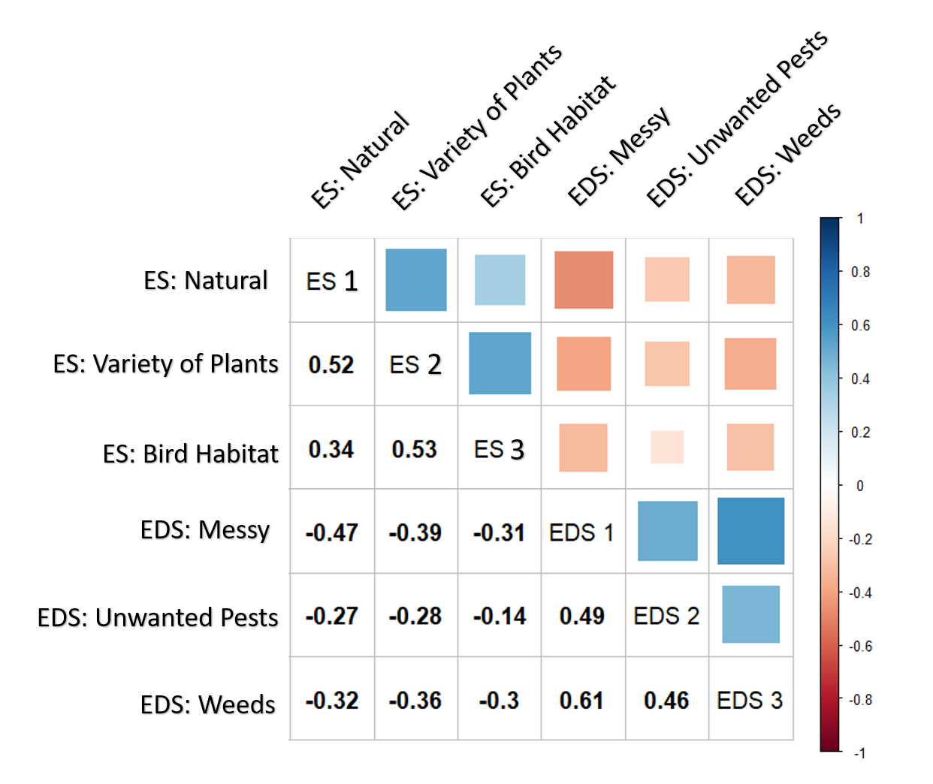
Supplemental Figure 2: Correlation between the component variables which make up the bio-cultural service and disservice composite variables. The positive correlation between component service and disservice variables re-affirms our decision to create composite variables. Additionally, services and disservices have negative correlation highlighting that if respondents perceived an area to provide a service, they were less likely to perceive it as providing a disservice.

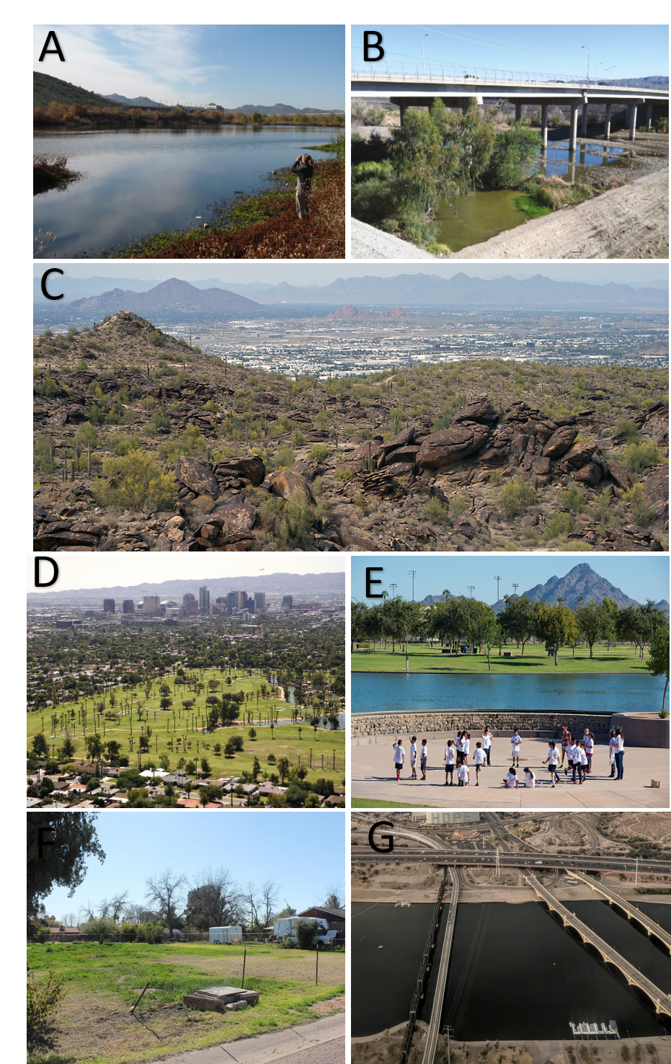
Supplemental Figure 3: Images of various types of UEI throughout the study region. A and B show the variability in the Salt River which includes larger restored natural areas as well as “accidental wetlands”. C is an image taken from within one of the various desert preserves in the city which are natural areas dominated by native vegetation and rock / bare soil. D and E are examples of community parks which are typically highly maintained and dominated by non-native vegetation. Community parks also may or may not include large artificial bodies of water. F shows and example of a vacant lot and G shows Tempe Town Lake as well as some of the surrounding landscape.

