Supplemental Material

Programmed cell death ligand (PD-L)-1 contributes to the regulation of CD4⁺ T effector and regulatory T cells in cutaneous leishmaniasis

Rafael de Freitas e Silva, Rosa Isela Gálvez, Valeria Rego Alves Pereira, Maria Edileuza Felinto de Brito, Siew Ling Choy, Hannelore Lotter, Lidia Bosurgi and Thomas Jacobs

Supplementary Figure 1. Flow cytometry data of human CD4+ T cells was analyzed according to the strategy shown.
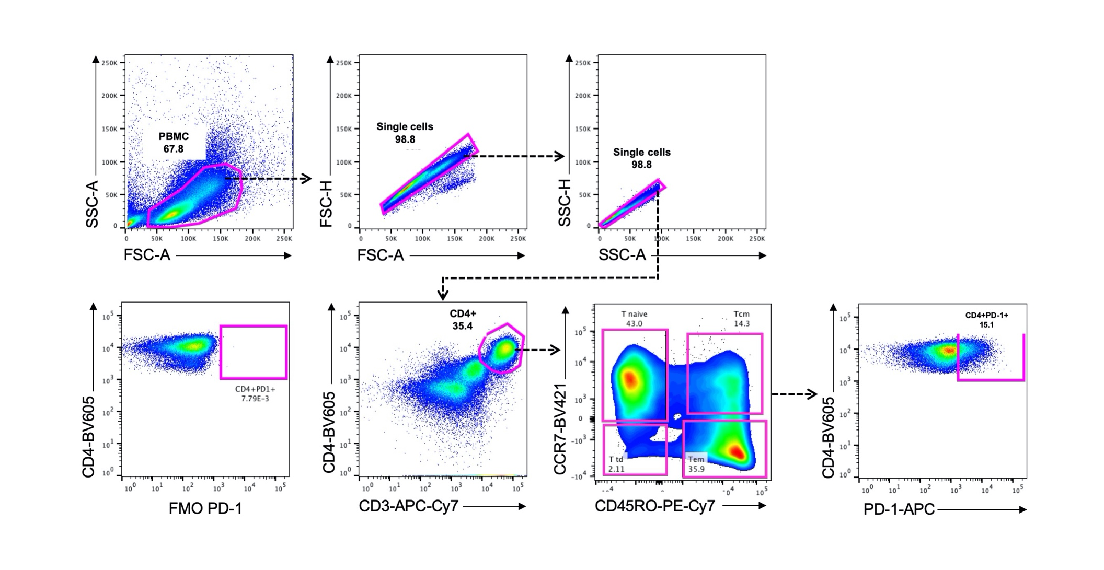

Supplementary Figure 2. Flow cytometry data of murine effector CD4+ T cells was analyzed according to the gate strategy shown.

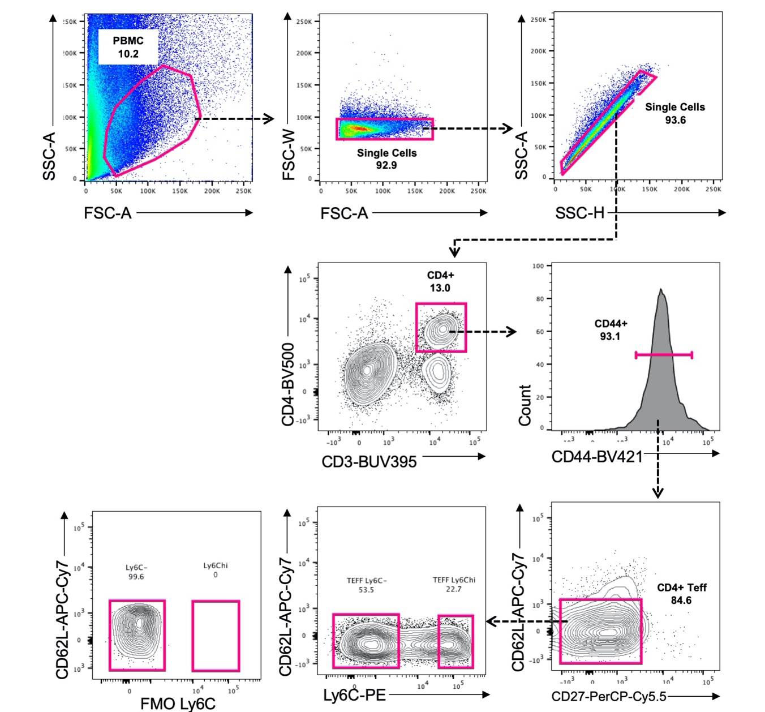

Supplementary Figure 3. Flow cytometry data of murine macrophages and monocytes was analyzed according to the gate strategy shown.
