Supplementary Material
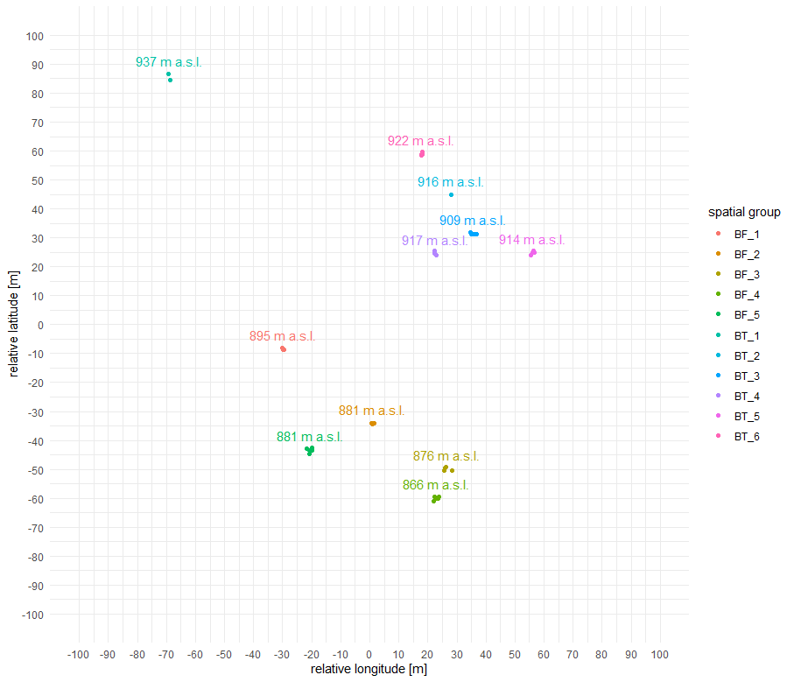

Figure S1: Map of sampled trees. Dots represent the sampled trees on a relative coordinate system in metric units. Distances were measured using a Vertex Laser Geo (Haglöf, Sweden). Colors indicate the spatial group. For some groups not all trees can be represented, since the distance between the trees was smaller than the measuring error (ultra-sound accuracy: 1%). Numbers above the groups show the group mean elevation in meters above sea level, derived from GPS coordinates measured with the Vertex Laser Geo (GPS accuracy: 2.5m in open terrain).

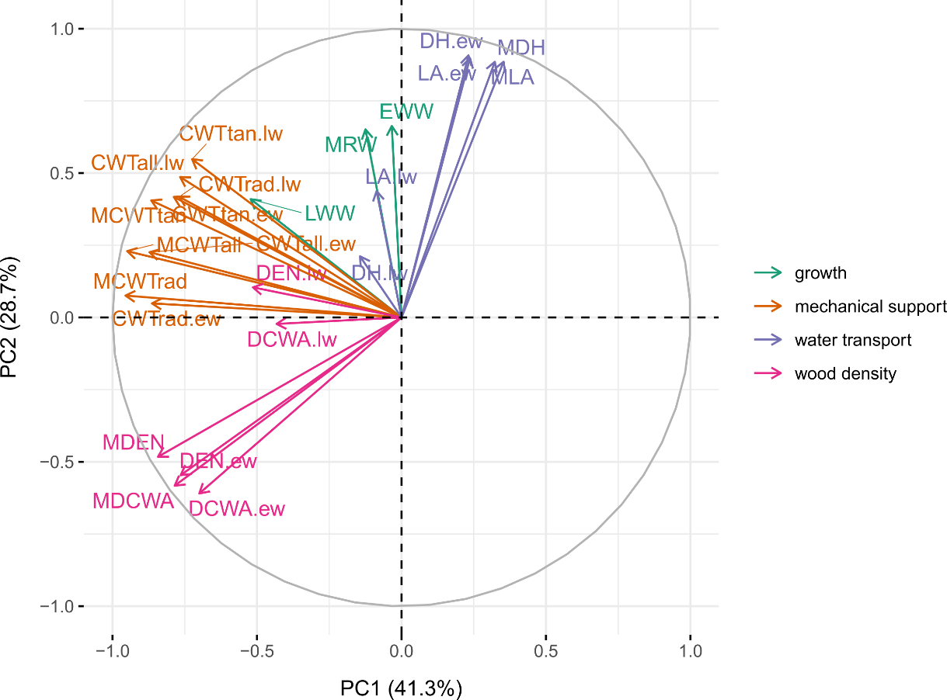

Figure S2: Principal component analysis (PCA) of all measured growth and xylem anatomical traits. Colors indicate different trait groups (green = growth, orange = mechanical support, purple = water transport, pink = wood density).

Table S1: Metadata on sampled trees
ID | coring direction | coring height (cm) | DBH (cm) | height (m) | clone_group | spatial_group | relative longitude (m) | relative latitude (m) | altitude (m a.s.l.)
101b | N_S | 130 | 18 | 11.2 | BT_F | BT_4 | 22.3 | 25.7 | 917
102b | E_W | 140 | 13 | 8.40 | BT_F | BT_4 | 22.4 | 24.6 | 917
103.1b | NE_SW | 110 | 11 | 7.70 | BT_F | BT_4 | 22.9 | 23.9 | 917
103.2b | N_S | 115 | 9 | 4.55 | BT_F | BT_4 | 22.9 | 23.9 | 917
112b | E_W | 80 | 6.5 | 3.60 | BT_B | BT_5 | 55.3 | 24.1 | 914
114b | N_S | 110 | 14.5 | 6.20 | BT_B | BT_5 | 56.4 | 25.6 | 914
115b | E_W | 100 | 11.5 | 5.58 | BT_B | BT_5 | 56.1 | 24.8 | 914
116b | N_S | 120 | 8 | 3.70 | BT_B | BT_5 | 56.6 | 24.9 | 914
126b | NE_SW | 110 | 8 | 4.12 | BT_D | BT_6 | 17.9 | 58.8 | 922
128b | NW_SE | 110 | 9 | 4.55 | BT_D | BT_6 | 17.6 | 58.5 | 922
131b | N_S | 145 | 13 | 7.50 | BT_D | BT_6 | 17.9 | 59.1 | 922
47b | N_S | 85 | 12 | 7.50 | BT_D | BT_6 | 17.9 | 59.6 | 922
150b | N_S | 100 | 8 | 5.00 | BF_C | BF_1 | -29.6 | -8.7 | 895
151b | N_S | 95 | 12 | 5.50 | BF_C | BF_1 | -29.8 | -8.7 | 895
152b | E_W | 75 | 10 | 6.80 | 152b | BF_1 | -30.3 | -8.0 | 895
216b | N_S | 150 | 16 | 7.33 | 216b | BF_2 | 0.6 | -34.1 | 881
217b | S_N | 120 | 14 | 6.57 | 217b | BF_2 | 1.0 | -34.4 | 881
218b | W_E | 135 | 16.5 | 7.52 | 218b | BF_2 | 1.5 | -34.1 | 881
279b | NW_SE | 150 | 15.5 | 7.14 | BF_A | BF_3 | 28.4 | -50.4 | 876
281b | N_S | 160 | 13.5 | 6.37 | BF_A | BF_3 | 26.1 | -49.3 | 876
284b | NW_SE | 115 | 15 | 6.95 | BF_A | BF_3 | 25.5 | -50.3 | 876
285b | N_S | 115 | 11.5 | 5.58 | BF_A | BF_3 | 26.0 | -49.5 | 876
292b | NE_SW | 80 | 11.5 | 5.58 | BF_D | BF_4 | 23.7 | -59.6 | 866
293b | NW_SE | 120 | 10.5 | 5.17 | BF_D | BF_4 | 23.4 | -60.2 | 866
294b | N_S | 135 | 10.5 | 5.17 | BF_D | BF_4 | 23.3 | -60.0 | 866
295b | NE_SW | 110 | 13.5 | 6.37 | BF_D | BF_4 | 22.4 | -59.6 | 866
296b | W_E | 115 | 12 | 5.78 | BF_D | BF_4 | 21.9 | -60.9 | 866
32.1a | N_S | 110 | 14 | 5.20 | BT_E | BT_1 | -69.2 | 86.7 | 937
32.2a | N_S | 110 | 11.5 | 5.58 | 32.2a | BT_1 | -69.2 | 86.7 | 937
32.3b | E_W | 135 | 8.5 | 4.34 | BT_E | BT_1 | -69.2 | 86.7 | 937
32.4b | NW_SE | 120 | 10.5 | 5.17 | BT_E | BT_1 | -69.2 | 86.7 | 937
33b | S_N | 75 | 11 | 8.00 | 33b | BT_1 | -68.8 | 84.5 | 937
355b | NW_SE | 115 | 15 | 6.95 | 355b | BF_5 | -20.0 | -42.7 | 881
356b | N_S | 100 | 9 | 4.55 | 356b | BF_5 | -19.8 | -43.4 | 881
357b | NW_SE | 95 | 13 | 6.17 | 357b | BF_5 | -20.8 | -43.5 | 881
358a | N_S | 50 | 24 | 10.27 | 358a | BF_5 | -20.7 | -44.6 | 881
361b | W_E | 130 | 15 | 6.95 | 361b | BF_5 | -21.6 | -42.9 | 881
81.1b | W_E | 125 | 18 | 8.00 | BT_C | BT_2 | 28.1 | 44.8 | 916
81.2b | N_S | 120 | 18.5 | 8.27 | BT_C | BT_2 | 28.1 | 44.8 | 916
81.3a | S_N | 100 | 18.5 | 8.27 | BT_C | BT_2 | 28.1 | 44.8 | 916
81.4b | SE_NW | 135 | 10.5 | 5.17 | BT_C | BT_2 | 28.1 | 44.8 | 916
81.5b | SE_NW | 130 | 9.5 | 4.76 | BT_C | BT_2 | 28.1 | 44.8 | 916
95b | S_N | 120 | 10.5 | 4.80 | 95b | BT_3 | 36.6 | 31.4 | 909
96a | N_S | 135 | 11.5 | 5.80 | BT_A | BT_3 | 35.7 | 31.3 | 909
97b | N_S | 115 | 8.5 | 3.80 | BT_A | BT_3 | 35.6 | 31.4 | 909
98b | NE_SW | 115 | 11.5 | 5.80 | BT_A | BT_3 | 34.8 | 31.2 | 909
99b | E_W | 125 | 11.5 | 5.40 | BT_A | BT_3 | 34.6 | 32.0 | 909

Table S2: List of all measured traits.

Abbreviation | Trait | Group
TRW | Tree ring width | Growth
EWW | Earlywood width | Growth
LWW | Latewood width | Growth
MCWT | Mean cell wall thickness | Mechanical support
CWT.ew | Earlywood cell wall thickness | Mechanical support
CWT.lw | Latewood cell wall thickness | Mechanical support
MCWTrad | Mean radial cell wall thickness | Mechanical support
CWTrad.ew | Earlywood radial cell wall thickness | Mechanical support
CWTrad.lw | Latewood radial cell wall thickness | Mechanical support
MCWTtan | Mean tangential cell wall thickness | Mechanical support
CWTtan.ew | Earlywood tangential cell wall thickness | Mechanical support
CWTtan.lw | Latewood tangential cell wall thickness | Mechanical support
MDEN | Mean wood density based on cwt | Wood density
DEN.ew | Earlywood density based on cwt | Wood density

DEN.lw | Latewood density based on cwt | Wood density
MDCWA | Mean wood density based on cell wall area | Wood density
DCWA.ew | Earlywood density based on cell wall area | Wood density
DCWA.lw | Latewood density based on cell wall area | Wood density
MLA | Mean lumen area | Water transport
LA.ew | Earlywood lumen area | Water transport
LA.lw | Latewood lumen area | Water transport
MDH | Mean hydraulic diameter | Water transport
DH.ew | Earlywood hydraulic diameter | Water transport
DH.lw | Latewood hydraulic diameter | Water transport

Equation S1 $σ_{P}^{2} = σ_{G}^{2} + {\overline{σ}}_{p}^{2}$
Where ${\overline{σ}}_{p}^{2}$ is the mean clonal group trait variance, calculated as:
Equation S2 ${\overline{σ}}_{p}^{2}= \frac{\sum_{j=1}^{N}{σ_{j}^{2}}}{N}$
Where $σ_{j}^{2}$is the trait variance in group j and N is the number of clonal groups:
Equation S3 $σ_{j}^{2} = \frac{\sum_{i = 1}^{n_{j}}{{(x_{ij} - {\overline{x}}_{j})}^{2} }}{n_{j}-1}$
Where $x_{ij}$ is the mean of the investigated trait across the study years 2007-2017 in individual i of clonal group j, ${\overline{x}}_{j}$ is the mean of the investigated trait in clonal group j and n is the number of individuals in group j:
Equation S4 ${\overline{x}}_{j} = \frac{\sum_{i = 1}^{n_{j}}{x_{ij}}}{n_{j}}$
Equation S5 $σ_{G}^{2} = \frac{\sum_{j = 1}^{N}{{({\overline{x}}_{j} - \overline{x})}^{2} }}{N-1}$
Where $\overline{x}$ is the trait total mean.

